## **IZMIR UNIVERSITY OF ECONOMICS**

## **FACULTY OF ENGINEERING**

## **COMPUTER ENGINEERING**

**CE 475 PROJECT REPORT**

Author: Atahan Ekici

Number: 2015 060 2015

**CONTENTS**

# **Methodology** ...............................................................................**3**

1.1) Pros .........................................................................................**4**

1.2) Cons ........................................................................................**5**

# **Implementation** ..........................................................................**6**

2.1) Coding Environment ..................................................................**6**

2.2) Libraries Used ...........................................................................**6**

# **Results** .........................................................................................**7**

3.1) Linear Regression ......................................................................**7**

3.2) Polynomial Regression ...............................................................**8**

3.3) Ridge Model..............................................................................**9**

3.4) Lasso Model............................................................................**10**

3.5) Random Forest Regression ........................................................**11**

3.6) Gradient Boosting Regression ...................................................**12**

3.7) XGB Regression ......................................................................**13**

3.8) Light GBM Regression .............................................................**14**

3.9) Cat Boost Regression ...............................................................**15**

3.10) K Nearest Neighbor ................................................................**16**

3.11) Decision Tree Regression ........................................................**17**

# **Conclusion** .................................................................................**18**

# **References** .................................................................................**19**

# **METHODOLOGY**

In this project we were asked to predict 20 Y values with using 100 x1 to x6 values so in order to accomplish this goal I have used various libraries and techniques such as K-Fold-CV and sklearn library functions to overcome this problem. The methods I used to achieve this goal is:

* Linear Regression
* Polynomial Regression
* Ridge Regression
* Lasso Regression
* Random Forest
* Gradient Boosting
* XGB Regression
* Light GBM Regression
* Cat Boost
* K Nearest Neighbor (KNN)
* Decision Tree

**Pros**

* For Linear Models such as Linear Regression, Polynomial Regression, Lasso and Ridge Regression; I would have chosen those even if we were not permitted to use libraries since Linear Models are easy to implement because of their simplicity.
* Since they are simple to implement they are easy to compute as well so this results a minimal waiting time compared to more complex models such as Gradient Boosting or Decision Tree since they are prone to iterate over the data more than 1 time.
* For Random Forest Model, it is a more complex version of the Decision Tree so it can be more accurate than most of the models and it does not require any normalization to work.
* For Gradient Boosting, it is an ensemble method that does not need any pre-processing of the data.
* For XGB Regression, this method is an ensemble method and implemented using decision trees with boosted gradient for enhanced accuracy.
* For Light GBM Regression, is a boosting model so it uses a histogram-based algorithm to “boost” its efficiency and since it replaces continuous values to discrete bins results a lower memory usage than most models.
* For Cat Boost, is another boosting model that does not require conversion of data set to any specific format.
* For K Nearest Neighbor, is a model that does not require any training period in order to function properly and it can be easily implemented since the model only requires to calculate distances between different points and as a result any data can be added instantly without any conversion.
* For Decision Tree, is a model that does not require any normalization or scaling of the data.

**Cons**

* For Linear Models, these models are sensitive to outliers and prone to underfitting
* For Random Forest, this model is hard to adjust variables through better fitting of the model, parameter complexity is high and overfitting is a risk for this model.
* For Gradient Boosting, since this model continue improving itself to minimize all errors this behavior causes it to be prone to overfitting so this model is almost always supposed to dependent for a cross validation technique in order to neutralize overfitting.
* This model is a highly complex model so the computation times are usually over the roof.
* For XGB Regression, this model is a highly sophisticated model and since it uses tree-based algorithms for prediction it falls short when it comes to tasks that involves extrapolation.
* For Light GBM Regression, is a boosting model so like all the boosting models this one is not different when it comes to overfitting.
* For Cat Boost, this model is combining both Decision Trees and Gradient Boosting methods together and since they are 2 complex models when combined resulting a slow computational performance like the Decision Tree and prone to overfitting like the Gradient Boost.
* For K Nearest Neighbor, this model does not work very well under large dataset since calculating distances between every node can be costly and this model can be very sensitive towards noisy or missing data.
* For Decision Tree, this model is a tree-based model and sometimes a small change in the training data can be cause this model to collapse and can lead to instability.
* Training this model is costly and its complexity grows geometrically.

# **IMPLEMENTATION**

**Coding Environment**

For implementation I have used PyCharm Community Edition 2020.3 as the Integrated Development Environment with accompanied by Python 3.9.0.





**Libraries Used**

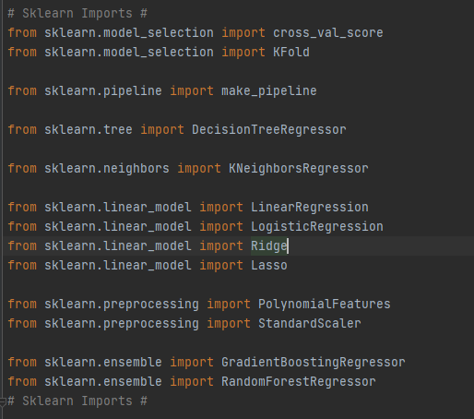

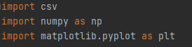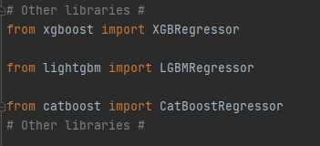

**RESULTS**

1. Linear Regression

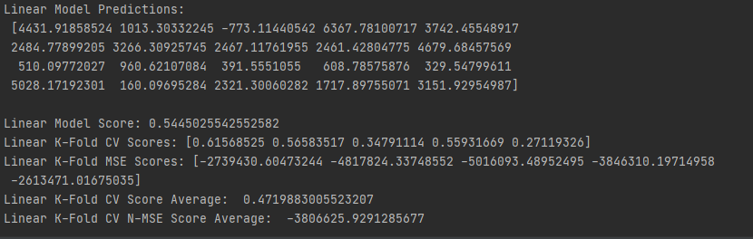

**Non-Validated Score: 0.5445025542552582**

**K-Fold CV Scores: [0.61568525 0.56583517 0.34791114 0.55931669 0.27119326]**

**K-Fold CV Score Average: 0.4719883005523207**

**K-Fold N-MSE Scores: [-2739430.60473244 -4817824.33748552 -5016093.48952495 -3846310.19714958 -2613471.01675035]**

**K-Fold CV N-MSE Score Average: -3806625.9291285677**

**Predictions:**

**[4431.91858524 1013.30332245 -773.11440542 6367.78100717 3742.45548917**

**2484.77899205 3266.30925745 2467.11761955 2461.42804775 4679.68457569**

**510.09772027 960.62107084 391.5551055 608.78575876 329.54799611**

**5028.17192301 160.09695284 2321.30060282 1717.89755071 3151.92954987]**

* **Since this model is a linear based model I did not have much hope for it to be the optimal solution for this data set but it was the first model we have been introduced in this lecture so I have featured this model in my project out of respect.**
* **With a Non-Validated Score of 0.54 and a Validated Score of 0.47 this model is consistent but far from optimal so I’m not choosing this model for submission.**

1. Polynomial Regression

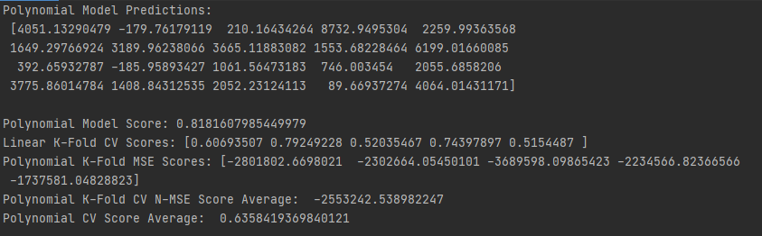

**Non-Validated Score: 0.8181607985449979**

**K-Fold CV Scores: [0.60693507 0.79249228 0.52035467 0.74397897 0.5154487]**

**K-Fold CV Score Average: 0.6358419369840121**

**K-Fold N-MSE Scores: [-2801802.6698021 -2302664.05450101 -3689598.09865423 -2234566.82366566 -1737581.04828823]**

**K-Fold CV N-MSE Score Average: -2553242.538982247**

**Model Predictions:**

**[4051.13290479 -179.76179119 210.16434264 8732.9495304 2259.99363568**

**1649.29766924 3189.96238066 3665.11883082 1553.68228464 6199.01660085**

**392.65932787 -185.95893427 1061.56473183 746.003454 2055.6858206**

**3775.86014784 1408.84312535 2052.23124113 89.66937274 4064.01431171]**

* **Since this model is another linear model I knew this model was not going to be the most optimized for this data set yet again this linear model has the best scores out of all other linear based models.**
* **With a Non-Validated Score of 0.81 and a Validated Score of 0.63 this model is not optimal considering the upcoming models so I’m not choosing this model for submission.**

1. **Ridge Regression**

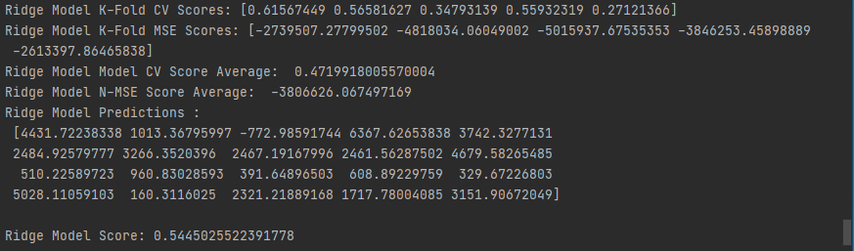

**Non-Validated Score: 0.5445025522391778**

**K-Fold CV Scores: [0.61567449 0.56581627 0.34793139 0.55932319 0.27121366]**

**K-Fold CV Score Average: 0.4719918005570004**

**K-Fold N-MSE Scores: [-2739507.27799502 -4818034.06049002 -5015937.67535353 -3846253.45898889 -2613397.86465838]**

**K-Fold CV N-MSE Score Average: -3806626.067497169**

**Model Predictions:**

**[4431.72238338 1013.36795997 -772.98591744 6367.62653838 3742.3277131**

**2484.92579777 3266.3520396 2467.19167996 2461.56287502 4679.58265485**

**510.22589723 960.83028593 391.64896503 608.89229759 329.67226803**

**5028.11059103 160.3116025 2321.21889168 1717.78004085 3151.90672049]**

* **Since this model is another linear model I knew this model was not going to be the most optimized for this data set but I wanted to try this model anyway.**
* **With a Non-Validated Score of 0.54 and a Validated Score of 0.47 this model is not optimal considering the upcoming models so I’m not choosing this model for submission.**

1. **Lasso Regression**

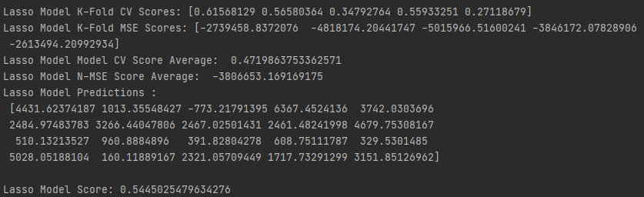

**Non-Validated Score: 0.5445025479634276**

**K-Fold CV Scores:** **[0.61568129 0.56580364 0.34792764 0.55933251 0.27118679]**

**K-Fold CV Score Average: 0.4719863753362571**

**K-Fold N-MSE Scores: [-2739458.8372076 -4818174.20441747 -5015966.51600241 -3846172.07828906 -2613494.20992934]**

**K-Fold CV N-MSE Score Average: -3806653.169169175**

**Model Predictions:**

**[4431.62374187 1013.35548427 -773.21791395 6367.4524136 3742.0303696**

**2484.97483783 3266.44047806 2467.02501431 2461.48241998 4679.75308167**

**510.13213527 960.8884896 391.82804278 608.75111787 329.5301485**

**5028.05188104 160.11889167 2321.05709449 1717.73291299 3151.85126962]**

* **This was the last linear model I have included in my project and admittedly it was not any different than the other Linear-based Models except the Polynomial Model.**
* **With a Non-Validated Score of 0.54 and a Validated Score of 0.47 this model is not optimal considering the upcoming models so I’m not choosing this model for submission.**

1. **Random Forest**

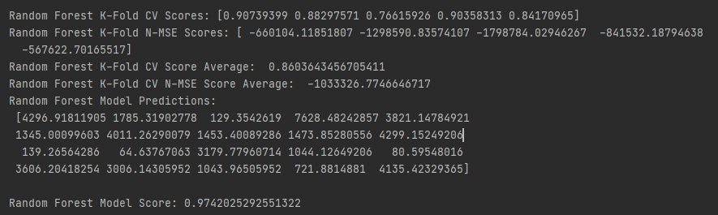

**Non-Validated Score: 0.9742025292551322**

**K-Fold CV Scores:** **[0.90739399 0.88297571 0.76615926 0.90358313 0.84170965]**

**K-Fold CV Score Average: 0.8603643456705411**

**K-Fold N-MSE Scores: [ -660104.11851807 -1298590.83574107 -1798784.02946267 -841532.18794638 -567622.70165517]**

**K-Fold CV N-MSE Score Average: -1033326.7746646717**

**Model Predictions:**

**[4296.91811905 1785.31902778 129.3542619 7628.48242857 3821.14784921**

**1345.00099603 4011.26290079 1453.40089286 1473.85280556 4299.15249206**

**139.26564286 64.63767063 3179.77960714 1044.12649206 80.59548016**

**3606.20418254 3006.14305952 1043.96505952 721.8814881 4135.42329365]**

* **This model was the first complex model we used in this course. In fact, this model was so complex to implement that, our lab assistant decided to let us use libraries in order to implement this model in our lab.**
* **With a Non-Validated Score of 0.97 and a Validated Score of 0.86 this model was the one of the best results I have acquired in this project.**

1. **Gradient Boosting**

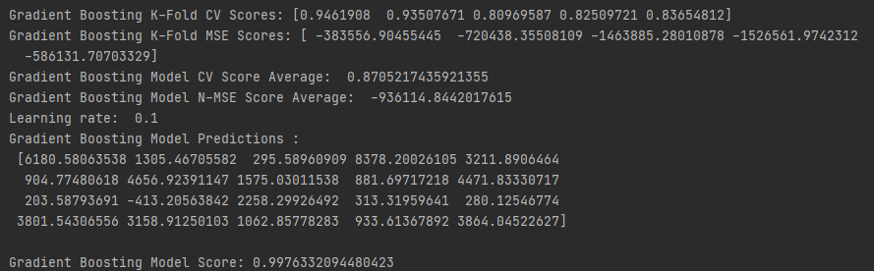

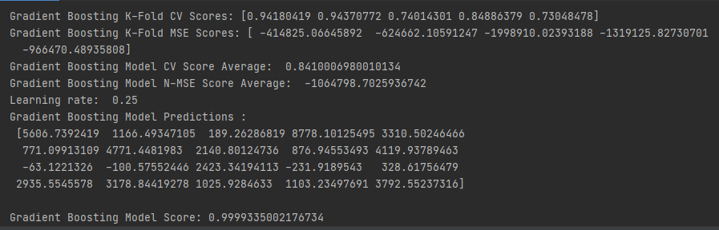

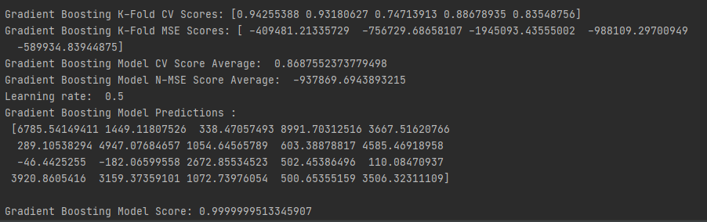

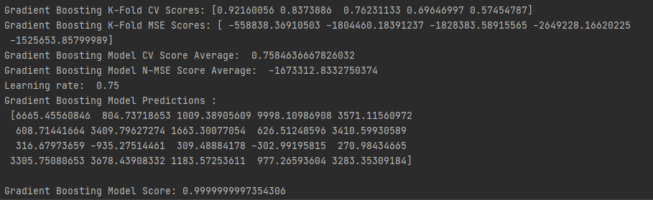

* **For this model I have used various learning rates to find the sweet-spot for optimization and I have concluded that the learning rate 0.1 is the most optimized one since it has the highest Cross Validation Score (0.8705217435921355) out of them all.**

1. **XGB Regression**

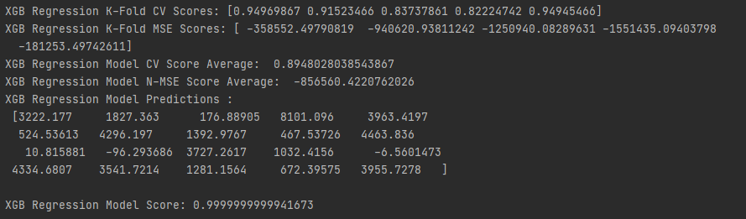

**Non-Validated Score: 0.9999999999941673**

**K-Fold CV Scores:** **[0.94969867 0.91523466 0.83737861 0.82224742 0.94945466]**

**K-Fold CV Score Average: 0.8948028038543867**

**K-Fold N-MSE Scores: [ -358552.49790819 -940620.93811242 -1250940.08289631 -1551435.09403798 -181253.49742611]**

**K-Fold CV N-MSE Score Average: -856560.4220762026**

**Model Predictions:**

**[3222.177 1827.363 176.88905 8101.096 3963.4197**

**524.53613 4296.197 1392.9767 467.53726 4463.836**

**10.815881 -96.293686 3727.2617 1032.4156 -6.5601473**

**4334.6807 3541.7214 1281.1564 672.39575 3955.7278]**

* **This model was the merged version of the Gradient Boosting and Decision Tree Models so my expectations for this model was high and after testing I have seen that it was not misplaced since it has the highest Validated Cross Validation Score out of my models and I have picked this model for submission.**
* **With a Non-Validated Score of 0.99 and a Validated Score of 0.89 this model generated the highest Cross Validated Score in my project.**

1. **Light GBM Regression**

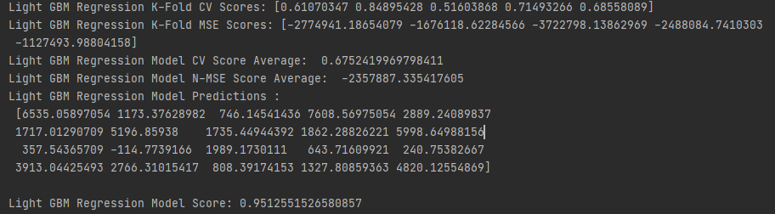

**Non-Validated Score: 0.9512551526580857**

**K-Fold CV Scores:** **[0.61070347 0.84895428 0.51603868 0.71493266 0.68558089]**

**K-Fold CV Score Average: 0.6752419969798411**

**K-Fold N-MSE Scores: [-2774941.18654079 -1676118.62284566 -3722798.13862969 -2488084.7410303 -1127493.98804158]**

**K-Fold CV N-MSE Score Average: -2357887.335417605**

**Model Predictions:**

**[6535.05897054 1173.37628982 746.14541436 7608.56975054 2889.24089837**

**1717.01290709 5196.85938 1735.44944392 1862.28826221 5998.64988156**

**357.54365709 -114.7739166 1989.1730111 643.71609921 240.75382667**

**3913.04425493 2766.31015417 808.39174153 1327.80859363 4820.12554869]**

* **This model was a bit of a disappointment really since it could not maintain its accuracy scores when subjected to a Cross Validation method and it dropped more significantly considering other models.**
* **With a Non-Validated Score of 0.95 and a Validated Score of 0.67 this model proved itself to be an unreliable one so I’m not choosing this failed model as my submission.**

1. **Cat Boost**

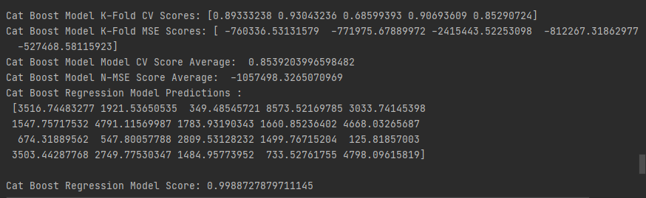

**Non-Validated Score: 0.9988727879711145**

**K-Fold CV Scores:** **[0.89333238 0.93043236 0.68599393 0.90693609 0.85290724]**

**K-Fold CV Score Average: 0.8539203996598482**

**K-Fold N-MSE Scores: [ -760336.53131579 -771975.67889972 -2415443.52253098 -812267.31862977 -527468.58115923]**

**K-Fold CV N-MSE Score Average: -1057498.3265070969**

**Model Predictions:**

**[3516.74483277 1921.53650535 349.48545721 8573.52169785 3033.74145398**

**1547.75717532 4791.11569987 1783.93190343 1660.85236402 4668.03265687**

**674.31889562 547.80057788 2809.53128232 1499.76715204 125.81857003**

**3503.44287768 2749.77530347 1484.95773952 733.52761755 4798.09615819]**

* **This model was one of the most promising models that I have experienced in this project. While its score was high it could not beat my XGB Model.**
* **With a Non-Validated Score of 0.99 and a Validated Score of 0.85 this model proved itself to be an unreliable one so I’m not choosing this model as my submission.**

1. **K- Nearest Neighbor**

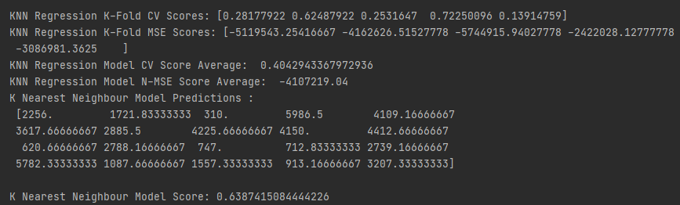

**Non-Validated Score: 0.6387415084444226**

**K-Fold CV Scores:** **[0.28177922 0.62487922 0.2531647 0.72250096 0.13914759]**

**K-Fold CV Score Average: 0.4042943367972936**

**K-Fold N-MSE Scores: [-5119543.25416667 -4162626.51527778 -5744915.94027778 -2422028.12777778 -3086981.3625]**

**K-Fold CV N-MSE Score Average: -4107219.04**

**Model Predictions:**

**[2256. 1721.83333333 310. 5986.5 4109.16666667**

**3617.66666667 2885.5 4225.66666667 4150. 4412.66666667**

**620.66666667 2788.16666667 747. 712.83333333 2739.16666667**

**5782.33333333 1087.66666667 1557.33333333 913.16666667 3207.33333333]**

* **This model scored was one of the worst Cross Validated Score in my project. To be honest I have expected better results from this model.**
* **With a Non-Validated Score of 0.63 and a Validated Score of 0.40 this model proved itself to be an unoptimized one for this data set.**

1. **Decision Tree Regression**

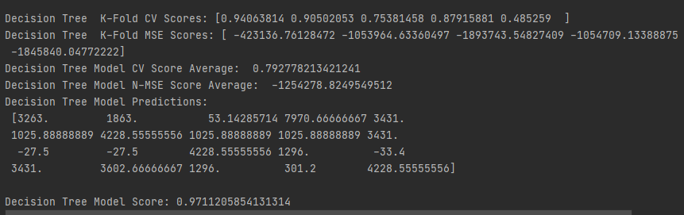

**Non-Validated Score: 0.9711205854131314**

**K-Fold CV Scores:** **[0.94063814 0.90502053 0.75381458 0.87915881 0.485259]**

**K-Fold CV Score Average: 0.792778213421241**

**K-Fold N-MSE Scores: [ -423136.76128472 -1053964.63360497 -1893743.54827409 -1054709.13388875 -1845840.04772222]**

**K-Fold CV N-MSE Score Average: -1254278.8249549512**

**Model Predictions:**

**[3263. 1863. 53.14285714 7970.66666667 3431.**

**1025.88888889 4228.55555556 1025.88888889 1025.88888889 3431.**

**-27.5 -27.5 4228.55555556 1296. -33.4**

**3431. 3602.66666667 1296. 301.2 4228.55555556]**

* **I expected this model to be fall a little short of more complex variants of this model like Cat Boost or Gradient Boost and I was right. This model follows its more complex brothers very close.**
* **With a Non-Validated Score of 0.97 and a Validated Score of 0.79 this model proved itself to be one of the most optimized choice for this data set.**

# **CONCLUSION**

To summarize, I was going to try implementing every one of these Models by hand and as we progressed further through our semester I have realized that I lack both Python Programming experience as well as the knowledge about the Prediction Algorithms and how they work so I have decided to use libraries for this problem and I have glad that I did.

The implementation was not difficult since individually all Models can be used with only 3 lines of code thanks to sklearn and other libraries I have used. In this semester, I have learned both Python Programming as well as some Prediction Models that I have researched while trying to implement this project.

The only models that have failed in my project is Logistic Regression and I have not included that model in my report since their accuracy scores dropped more significantly with respect to their Non-Validated Accuracy Scores.

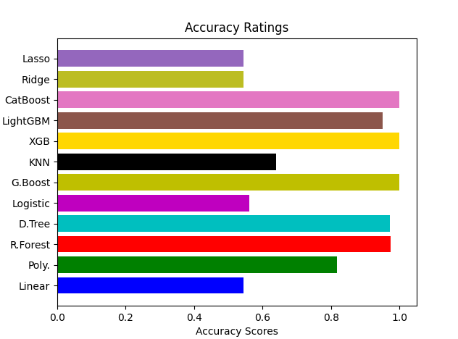

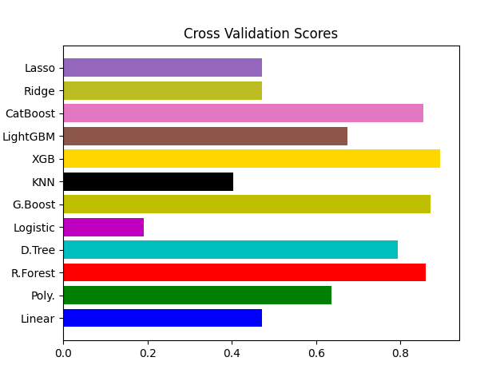

# **REFERENCES**

* **quora.com ______________________ Information about Gradient Boosting**
* **holypython.com _______________________ Information about Random Forest**
* **medium.com __________________________ Information about Linear Regression**
* **scikit-learn.org ________________________ Information about the sklearn library**
* **towardsdatascience.com _________________ Information about the KNN Model**
* **kaggle.com ____________________________ Information about the Light GBM**
* **analyticsvidhya.com _____________________ Information about the Cat Boost**
* **iq.opengenus.org ________________________ Information about XGB Regressor**
* **dhirajkumarblog.medium.com ______________ information about the Decision Trees**