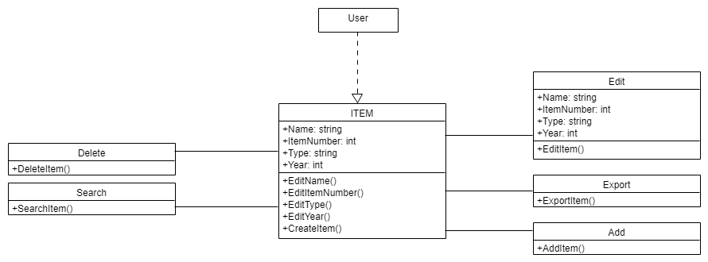

Firstly, user should be create the item by using the CreateItem function then it’s stored in library. After that, if user desires to do delete item which is already in library should be use the DeleteItem function and if user wants to change item properties then should be use the EditItem function.Also, user can search the items in the library by using SearchItem function and if user wants to add another item to library then user should be use AddItem function. If user wants to take item in library, user should be use the ExportItem function.