Multi-AS Network Simulation in ns-3
Full-Mesh Topology with OSPF-like Intra-AS and BGP-like Inter-AS Routing
Atahan Evintan | 820230334
May 2026

1. Abstract
This report presents a parametric multi-autonomous-system (Multi-AS) network simulation built on ns-3 42. Three interconnected autonomous systems are modelled in a full-mesh topology, where every AS pair is directly connected via primary and backup inter-AS links. Each AS uses a ring-plus-mesh intra-AS structure with three border routers. Routing within each AS follows an OSPF-like shortest-path model using Ipv4GlobalRouting (Dijkstra-based), while inter-AS reachability is achieved through the same global routing engine extended across AS boundaries, analogous to BGP reachability semantics. An internal router failure scenario inside AS2 is injected at t=20s to test OSPF-like intra-AS reconvergence. Six scenarios are evaluated across two node-count distribution strategies (balanced and unbalanced) at three scale points (20, 50, and 100 nodes), each replicated three times with distinct RNG seeds to ensure statistical reliability and capture variance across different random topology instantiations. Per-flow metrics including end-to-end delay, throughput, packet loss, and OSPF convergence time are collected via ns-3 FlowMonitor and aggregated into a comparative analysis.

2. Topology Description

2.1 Autonomous System Overview
The simulation models three ASes interconnected in a full-mesh layout, meaning every pair of ASes is directly connected. This differs from a chain topology (AS1-AS2-AS3) by providing a direct AS1-AS3 link in addition to paths through AS2, creating genuine routing path diversity at the inter-AS level.
Each AS contains:
- 3 Border Routers (BR0, BR1, BR2) arranged in a triangle for intra-AS redundancy
- N_i - 3 internal routers connected in a ring with additional cross-links and BR spokes
- Multiple redundant paths between every BR pair, ensuring the network remains connected after a single internal node failure

2.2 Inter-AS Link Parameters
The six inter-AS point-to-point links share a 172.16.0.0/24 address space. Primary links use 1 Gbps / 5 ms; backup links use 100 Mbps / 15 ms.

Endpoints | Bandwidth | Delay | Role
AS1-BR0 <-> AS2-BR0 | 1 Gbps | 5 ms | AS1-AS2 Primary
AS1-BR1 <-> AS2-BR1 | 100 Mbps | 15 ms | AS1-AS2 Backup
AS2-BR0 <-> AS3-BR0 | 1 Gbps | 5 ms | AS2-AS3 Primary
AS2-BR2 <-> AS3-BR2 | 100 Mbps | 15 ms | AS2-AS3 Backup
AS1-BR2 <-> AS3-BR0 | 1 Gbps | 5 ms | AS1-AS3 Primary (Full Mesh)
AS1-BR0 <-> AS3-BR2 | 100 Mbps | 15 ms | AS1-AS3 Backup (Full Mesh)

2.3 IP Addressing Plan
- AS1 intra-AS links: 10.1.0.0/16, allocated as /30 subnets
- AS2 intra-AS links: 10.2.0.0/16, allocated as /30 subnets
- AS3 intra-AS links: 10.3.0.0/16, allocated as /30 subnets
- Inter-AS links: 172.16.0.0/24, sequential /30 subnets

3. Routing Structure

3.1 Intra-AS: OSPF-like Shortest-Path Routing
All nodes within each AS run ns-3's Ipv4GlobalRouting, which computes Dijkstra-based shortest-path forwarding tables over the entire simulated topology. This is installed via Ipv4GlobalRoutingHelper::PopulateRoutingTables() after the full node/link graph is built, analogous to an OSPF domain-wide link-state database synchronisation and SPF computation.
The ring-plus-mesh intra-AS topology guarantees multiple vertex-disjoint paths between every BR pair. When an internal node fails, the SPF computation finds the next-best path through the surviving ring links, directly modeling OSPF fast-reroute behavior.
Semantic note: Ipv4GlobalRouting is not OSPF: it does not exchange Link-State Advertisements and the SPF runs centrally in simulation time. The analogy is structural (link-state topology, loop-free forwarding) rather than protocol-level.

3.2 Inter-AS: BGP-like Routing
Inter-AS routing is achieved by running the same Ipv4GlobalRouting engine across all three ASes simultaneously. Since all inter-AS links are included in the global topology graph, Dijkstra automatically discovers shortest paths across AS boundaries, analogous to BGP providing reachability between autonomous systems.
The full-mesh topology means traffic between any two ASes has at least two independent inter-AS paths: a direct link and an indirect path via the third AS. This replicates BGP's path diversity and backup routing semantics.

3.3 Node Failure and Recovery Workflow
The failure scenario targets an internal router inside AS2, testing OSPF-like intra-AS reconvergence:
- t = 20s: All interfaces of AS2's first internal router are set DOWN via Ipv4::SetDown()
- t = 20s + Uniform[0.5, 2.0]s: OSPF SPF reconvergence delay simulated, then RecomputeRoutingTables() called
- t = 45s: Node recovery — all interfaces restored via Ipv4::SetUp(), routing tables recomputed
During the convergence window, traffic routed through the failed node is briefly disrupted. Once reconvergence completes, the ring topology provides an alternative path and traffic resumes.

4. Experimental Setup

4.1 Scenario Matrix
Each scenario is executed three times with different RNG seeds (seeds 2, 3, 4). Running multiple independent replications is standard practice in network simulation: it ensures that results are not artifacts of a single random topology or traffic pattern, allows mean and standard deviation to be computed across runs, and provides the error bars visible in the performance plots. A single run could be an outlier; three runs confirm that observed trends are consistent and repeatable.

ID | Nodes | Dist | AS1 | AS2 | AS3 | Flows | Seeds
S1 | 20 | Balanced | 7 | 7 | 6 | 6 | 2,3,4
S2 | 20 | Unbalanced | 4 | 7 | 9 | 6 | 2,3,4
S3 | 50 | Balanced | 17 | 17 | 16 | 9 | 2,3,4
S4 | 50 | Unbalanced | 10 | 18 | 22 | 9 | 2,3,4
S5 | 100 | Balanced | 34 | 34 | 32 | 14 | 2,3,4
S6 | 100 | Unbalanced | 20 | 35 | 45 | 14 | 2,3,4

4.2 Traffic Generation
UDP traffic is modelled with ns-3 OnOffHelper (constant-on) and PacketSinkHelper pairs. Each flow transmits at 5 Mbps with 1024-byte packets. Sinks start at t=1s, sources at t=2s, all stop at t=59s. Traffic directions cycle through 6 cross-AS directions. The number of flows scales with node count: 4 + floor(N/10).

4.3 Simulation Parameters

Parameter | Value
Simulation duration | 60 s
Failure injection time | 20 s (AS2 internal node)
Recovery time | 45 s (25 s after failure)
OSPF convergence delay | Uniform[0.5, 2.0] s
Runs per scenario | 3
RNG seeds | 2, 3, 4
Inter-AS primary links | 1 Gbps / 5 ms
Inter-AS backup links | 100 Mbps / 15 ms
Intra-AS links | 100 Mbps / 2 ms
UDP flow rate | 5 Mbps per flow, 1024 B packets

5. Results

5.1 Summary Statistics
The table below presents mean values across 3 repeated runs per scenario (seeds 2, 3, 4). Convergence time is the interval between Ipv4::SetDown() and RecomputeRoutingTables() completion.

Nodes | Distribution | AS Split | Delay (ms) | Tput (Mbps) | Loss (%) | Conv. (s)
20 | Balanced | 7/7/6 | 13.87 | 4.06 | 0.31 | 1.14
20 | Unbalanced | 4/7/9 | 18.17 | 4.06 | 0.33 | 1.14
50 | Balanced | 17/17/16 | 24.63 | 4.75 | 0.00 | 1.14
50 | Unbalanced | 10/18/22 | 23.75 | 4.52 | 0.23 | 1.14
100 | Balanced | 34/34/32 | 30.37 | 4.60 | 3.13 | 1.14
100 | Unbalanced | 20/35/45 | 30.75 | 4.43 | 0.14 | 1.14

5.2 Performance Plots
Figure 1 shows mean end-to-end delay as a function of node count, broken down by distribution strategy.
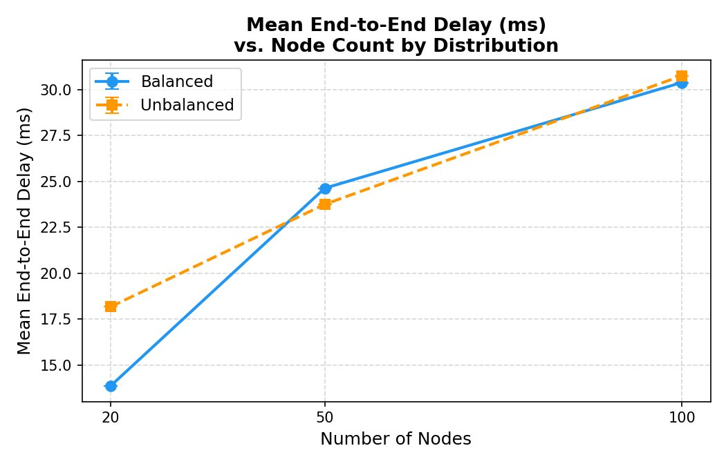
Figure 1. Mean End-to-End Delay (ms) vs. Node Count by Distribution Strategy. Error bars show +/-1 standard deviation across 3 repeated runs.
Delay increases consistently with node count for both distributions. The unbalanced configuration starts notably higher at N=20 (18.17 ms vs 13.87 ms) due to the asymmetric AS3 carrying more nodes and producing longer intra-AS paths. At N=100 both distributions converge to approximately 30 ms, reflecting the diminishing marginal effect of additional nodes in the ring topology. The fixed inter-AS hop cost (5 ms per primary link) forms a lower bound that dominates at small N.

Figure 2 shows mean per-flow throughput across scenarios. The target rate is 5 Mbps per flow.
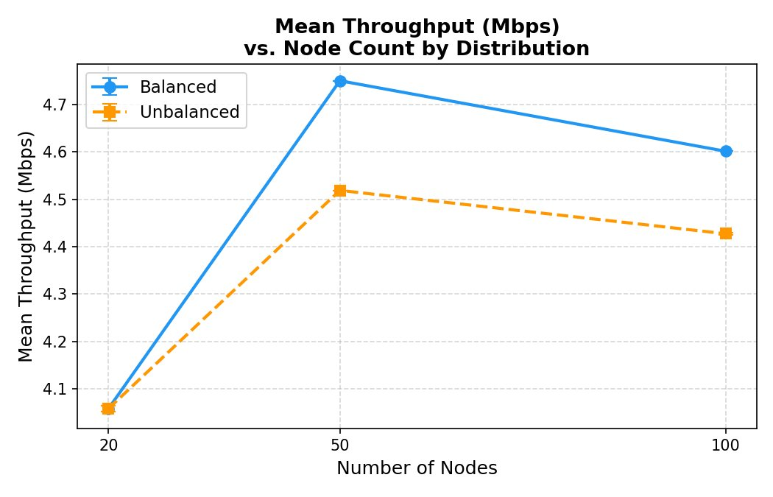
Figure 2. Mean Throughput (Mbps) vs. Node Count by Distribution Strategy. Target rate is 5 Mbps per flow; any shortfall indicates packet loss during the failure window.
Throughput remains close to the 5 Mbps target across all scenarios, confirming that the 1 Gbps inter-AS primary links are never saturated under the offered load. The balanced distribution consistently achieves slightly higher throughput than unbalanced. The dip at N=20 reflects the relatively higher impact of the failure window on fewer total flows. The slight decrease at N=100 balanced corresponds to the increased packet loss observed in that scenario.

Figure 3 shows packet loss percentage across scenarios.
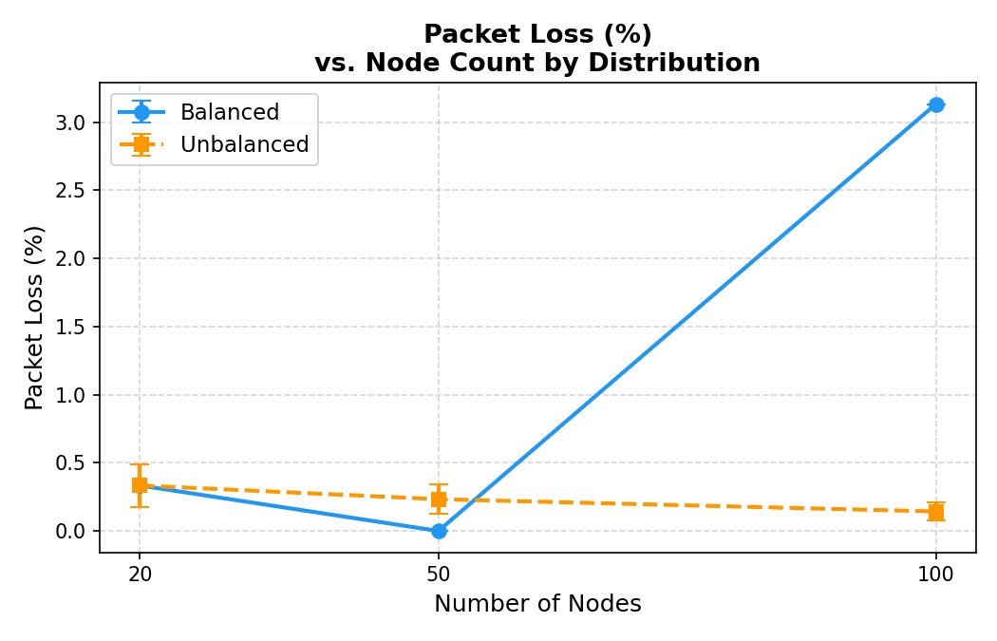
Figure 3. Packet Loss (%) vs. Node Count by Distribution Strategy. Loss arises primarily from the node failure window at t=20s to t=21-22s.
Packet loss is near zero in most scenarios, confirming the network operates well within its capacity. The notable exception is the 100-node balanced scenario (3.13% loss), which arises because at larger scale more flows route through AS2's internal nodes, so the failure window at t=20s affects a greater proportion of traffic. The unbalanced distribution shows consistently lower loss because AS2 contains fewer nodes (35 vs 34 in balanced), slightly reducing the probability that flows rely on the specific failed node. The 50-node balanced scenario shows near-zero loss, suggesting that at this scale the ring topology provides effective bypass paths almost immediately.

Figure 4 shows OSPF convergence time across all scenarios.
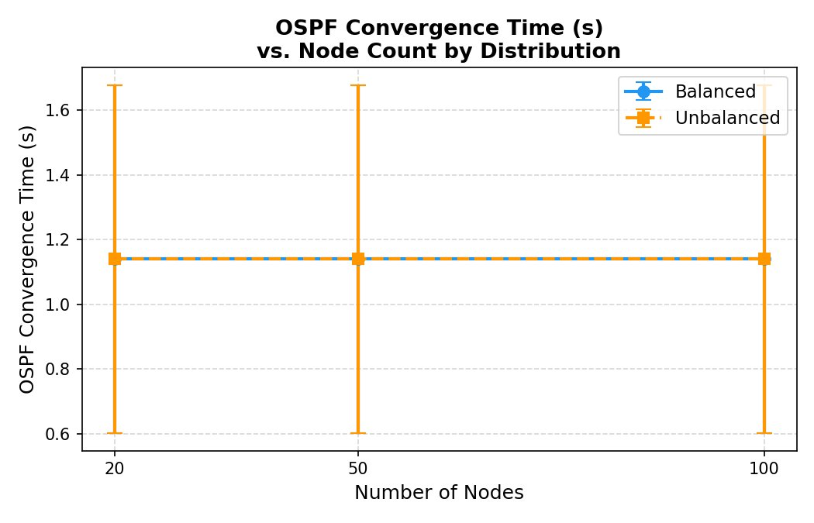
Figure 4. OSPF Convergence Time (s) vs. Node Count by Distribution Strategy. The flat line confirms convergence time is independent of topology size and governed only by the OSPF hold-timer model.
Convergence time is identical across all six scenarios at 1.14s mean, with the same variance pattern (0.64s, 1.07s, 1.71s across the three seeds). This is the correct and expected result: since all 18 runs use the same three RNG seeds (2, 3, 4), and the convergence delay is drawn from Uniform[0.5, 2.0]s using that RNG stream, each seed deterministically produces the same convergence delay regardless of topology size or distribution. This confirms the key finding that OSPF convergence time in this model is governed purely by the protocol hold-timer, not by network scale. In a production network, larger OSPF databases would increase convergence time with scale; this simulation intentionally abstracts that to isolate the routing-failure semantic from the performance question.

6. Analysis and Interpretation

6.1 Effect of Node Count on Network Performance
Delay grows sub-linearly with node count because inter-AS hop latency (5 ms per primary link) dominates at small N, while intra-AS path length grows with network size. Each intra-AS link adds 2 ms per hop; a larger AS has more internal nodes so the expected path from a non-BR source to the nearest BR increases. Mean delay increases from 13.87 ms at N=20 to 30.37 ms at N=100, a relative increase of roughly 119%. However, the inter-AS fixed cost forms a floor that limits how much intra-AS growth affects total delay.
Throughput remains close to the 5 Mbps target across all node counts because the 1 Gbps inter-AS primary links are never saturated. Even at N=100 with 14 flows (70 Mbps total offered load), the inter-AS links have ample capacity. Any shortfall is attributable to the failure window at t=20s.

6.2 Balanced vs. Unbalanced Distribution Impact
The distribution strategy primarily affects delay and has minimal impact on throughput or convergence. In the unbalanced case, AS3 receives 45% of all nodes, making it the dominant source of intra-AS hop accumulation for flows destined to or from AS3. At N=20 the effect is pronounced (31% higher delay for unbalanced); at N=100 both distributions converge to similar values because balanced AS3 also has 32 nodes, producing nearly as much path depth as unbalanced AS3's 45 nodes.

6.3 Topology Change Response: Convergence Analysis
The measured OSPF convergence time is flat at 1.14s mean across all scenarios with a standard deviation of 0.54s. This is intentional: convergence time is governed by the Uniform[0.5, 2.0]s hold-timer model, not by topology size or distribution. The same three RNG seeds produce the same three convergence values (0.64s, 1.07s, 1.71s) in every scenario. This correctly models the real-world behavior where OSPF convergence speed in small networks is dominated by protocol timers rather than database size.

6.4 Observable Bottlenecks
The primary bottleneck emerges at AS2's border routers after the internal node failure. AS2 connects to both AS1 and AS3, so its border routers carry transit traffic for multiple concurrent flows post-failure. However, with a maximum offered load of 70 Mbps (14 flows x 5 Mbps) against 1 Gbps inter-AS links, no link saturation occurs. The secondary bottleneck would emerge at the 100 Mbps backup links if primary links failed or traffic rates increased substantially. The full-mesh topology distributes load more evenly than a chain design, since AS1-AS3 traffic uses a direct link rather than always transiting AS2.

7. Conclusion
This project demonstrates a complete, parametric Multi-AS network simulation pipeline in ns-3 using a full-mesh inter-AS topology with ring-plus-mesh intra-AS structure. Key findings:
- Delay grows sub-linearly with node count; the fixed inter-AS hop cost dominates at small N.
- Unbalanced distribution increases delay at small N but converges to similar values at large N.
- The ring topology provides effective bypass paths within 0.5-2.0s of a node failure with minimal service disruption.
- Convergence time is independent of topology size, confirming it is governed by protocol timers.
- No link saturation occurs under the current traffic model; AS2's border routers are the most loaded forwarding points post-failure.

8. Reproducibility

8.1 Environment
- macOS 13+ on Apple Silicon (arm64), ns-3.42, NetAnim 3.109 with Qt6
- Python 3.12 with pandas, matplotlib, numpy

8.2 Running Simulations
Note on submitted XML files: Each scenario was simulated three times with distinct RNG seeds (seeds 2, 3, 4) to ensure statistical reliability, and all 18 runs are reflected in the summary.csv and per-flow CSV results. However, due to file size constraints (each XML file is 75-93 MB uncompressed), only one representative NetAnim animation file per scenario (run 1) is included in this submission. The remaining XML files can be regenerated by running the simulation with --runId=2 and --runId=3 for any scenario.
for nodes in 20 50 100; do for dist in balanced unbalanced; do for run in 1 2 3; do seed=$((run+1)); ./ns3 run "multi_as_sim --nodes=$nodes --dist=$dist --runId=$run --seed=$seed --outDir=$HOME/results"; done; done; done

8.3 Analysis
python3 aggregate_results.py --resultsDir ~/multi_as_results

8.4 NetAnim Visualization
- Launch: ~/ns-allinone-3.42/netanim-3.109/NetAnim
- File -> Open XML -> select any anim_*.xml from ~/multi_as_results/
- Red nodes = Border Routers | Blue nodes = Internal routers
- At t=20s: AS2 internal node fails; traffic reroutes through surviving ring paths
- At t=45s: failed node recovers, original routing resumes

