NextStay
Hotel Property Management System
Software Engineering Project Report

Team: Dair (Backend) · Turat (Frontend) · Atai (Data Architecture & BI)

Table of Contents
Right-click → Update Field to build the contents.

1. Introduction

1.1 PROJECT GOALS AND METHOD
The central objective of NextStay is to create a comprehensive, full-stack hotel management platform that eliminates the need for third-party Property Management Systems (PMS) by consolidating every aspect of hotel operations into a single, purpose-built web application. Today, small and mid-sized hotels are forced to juggle multiple disconnected tools — spreadsheets for staff scheduling, external platforms for bookings, manual price adjustments based on intuition, and separate communication channels for task delegation. This fragmentation leads to inefficiencies, missed revenue opportunities, and an overall lack of operational visibility for hotel owners and managers. NextStay addresses all of these challenges by providing an integrated platform where room inventory, guest bookings, dynamic pricing, staff shifts, and task management are all handled from one interface.
At the heart of the system is an AI-driven pricing engine that continuously learns from historical booking data and generates dynamic price recommendations for each room type and future stay date. Rather than relying on fixed seasonal rates, the hotel can publish machine-learning-based prices that adapt to occupancy patterns, demand signals, and configurable business rules. Beyond pricing, the platform supports a direct guest booking channel with Stripe-powered payments, removing dependency on commission-heavy booking aggregators. Staff members interact with the system through a dedicated interface that tracks their shifts, displays assigned tasks, and receives work through an automated round-robin assignment mechanism — ensuring fair and accountable task distribution without manual intervention by management.
Given the iterative nature of building such a multi-layered system and the need to validate each module before building on top of it, the team adopted the Scrum methodology. Development was divided into five sprints, each delivering a functional increment of the platform — from authentication and room management in the early sprints, to the pricing engine and payment integration in the later ones. This approach allowed each team member to work within their technical domain while maintaining shared visibility over progress, and it provided a structured process for identifying and resolving integration issues between the backend, frontend, and database layers before they could accumulate.

1.2 PROJECT BACKGROUND
Independent hotels and small hotel groups face a structural problem that large chains have long solved through enterprise software: the absence of a unified operational system. A typical independent hotel manager starts their day by checking booking status on one platform, adjusting prices manually on another, communicating tasks to staff via phone or messaging apps, and reviewing revenue figures in a spreadsheet — all without these tools ever talking to each other. The result is not only wasted time but also a persistent risk of errors: double bookings, mispriced rooms during high-demand events, and tasks that fall through the cracks because there is no system-level accountability.
The direct booking problem is particularly significant. Without a custom booking page, hotels are entirely dependent on platforms such as Booking.com or Airbnb, which charge commissions ranging from 15% to 25% per reservation. For a small property, this represents a substantial portion of revenue paid to an intermediary that also controls the guest relationship. A hotel that can accept bookings directly — with its own payment flow and its own guest communication — retains both the margin and the data.
NextStay was designed to directly address these challenges. By providing a fully integrated platform where every operational function is connected — pricing informs inventory, bookings trigger task assignments, shifts determine which staff receive those tasks — the hotel gains a level of operational coherence that was previously only achievable with expensive enterprise PMS solutions. The platform was built with the specific constraints of independent hoteliers in mind: it is lightweight, deployable without cloud infrastructure expertise, and manageable entirely through a web browser by users with no technical background.

1.3 THE REQUEST OF THE PROJECT
The initial request for the project was to design and implement a full-stack hotel management web application capable of supporting the complete operational cycle of a property — from room setup and guest booking through to staff management, dynamic pricing, and revenue reporting. To achieve this goal, the platform was required to incorporate several core functional areas.
At the foundation of the system is a secure authentication module using email-based One-Time Passwords (OTP) and JWT session management. The system supports five distinct user roles — OWNER, SYS_ADMIN, DIRECTOR, MANAGER, and STAFF — each with a precisely defined set of accessible features, ensuring that sensitive operations such as model training or engine configuration are restricted to authorized personnel only.
The project also required a complete room and inventory management layer, allowing administrators to define room numbers, categories, capacities, amenities, and base prices, and to track real-time availability as bookings and holds are created. Connected to this is a direct guest booking portal, publicly accessible without a login, where guests can select dates and rooms and complete payment through Stripe. After payment, guests receive a tokenized private link that grants them access to their booking details without requiring an account.
A major component of the request was the development of a machine-learning pricing engine capable of training a per-hotel model on synthetic or historical booking data, generating dynamic price recommendations for future stay dates, and publishing those prices through a rules-validated pipeline. Managers should be able to view published prices, compare them against base prices, monitor occupancy rates, and roll back model versions if needed — all through dedicated frontend pages.
Finally, the project required a staff management module with shift tracking, round-robin automatic task assignment to active staff members, and a staff-facing interface where employees can clock in, view their assigned tasks, and update task statuses. All of these modules were to be surfaced through an admin dashboard and a reports page that give owners and directors a consolidated, real-time view of the hotel's operational and financial state.

1.4 WEBSITE DESCRIPTION
NextStay was designed and developed as a full-stack web platform built with a modular, layered architecture that separates concerns cleanly between the database, backend API, and frontend application. The system brings together a modern single-page application, a RESTful backend, a relational database, and external payment and email services to deliver a complete hotel management experience.
The frontend was implemented as a React 18 Single-Page Application written in TypeScript and bundled with Vite, delivering a fast and responsive interface across desktop and mobile screen sizes. Routing is managed by React Router v6, with role-aware ProtectedRoute components that enforce access control at the page level — redirecting users whose role does not match the allowed roles for a given route. Global state, including authentication tokens, user roles, and UI preferences, is managed through Zustand stores. The UI is composed of a shared component library (Button, Card, Modal, Drawer, PageHeader) built on a centralized design token system, ensuring visual consistency across all pages.
The backend is powered by Python 3.11 with FastAPI, structured around 14 independent APIRouter modules registered under the /api/v1/ prefix — each responsible for a distinct domain: authentication, rooms, bookings, holds, guests, staff, tasks, Stripe payments, pricing lab, pricing configuration, pricing pipeline, model training, inventory setup, and system health. Security is implemented through HMAC-signed OTP codes, JWT tokens issued on successful verification, and a get_current_user FastAPI dependency that validates tokens and enforces role-based access on every protected endpoint. Cross-origin requests from the frontend are handled through FastAPI's CORSMiddleware.
Data persistence is handled by a SQLite database in development, accessed exclusively through SQLAlchemy ORM models. The schema consists of seven core tables — users, rooms, bookings, auth_sessions, email_otps, guest_tokens, and tasks — each designed to support the full lifecycle of its domain. Alembic is used for schema migrations, ensuring that database changes are versioned and reproducible across environments.
The pricing engine is a standalone Python module that operates alongside the main API. It uses scikit-learn to train gradient-boosted regression models on historical or synthetic booking data, engineers features such as occupancy rate, days-to-arrival, seasonality, and room category, and produces dynamic price recommendations for each hotel, room type, and future stay date. The engine supports backtesting, model comparison, champion promotion, and a rules layer that caps price deltas and enforces business constraints before prices are published.
The platform integrates two external services to complete its functionality:
Stripe API for guest checkout session creation, payment confirmation, and webhook-based booking status updates.
SMTP email service for transactional delivery of OTP codes to users during login and for sending guests their tokenized booking confirmation link after a successful payment.
This architecture enables NextStay to function as a production-ready hotel management system that is modular enough to extend — for example, with mobile applications, calendar integrations, or connections to external booking aggregators — without requiring changes to its core structure.

2. Agile Methodology

2.1 Agile Framework Overview
Agile development favours short, iterative cycles that deliver working software frequently, with continuous feedback and the freedom to adapt scope. NextStay was delivered in five fixed-length sprints, each producing a demonstrable increment.

2.2 Motivation to Choose Scrum
Scrum fit a three-person student team well: clear roles, time-boxed sprints to force prioritisation, and a shared board for transparency. The vertical-slice nature of the features (each touching DB, backend, and frontend) mapped naturally to per-sprint goals.

2.3 Scrum Methodology
Roles: Product Owner (curates the backlog and acceptance), Scrum Master (removes blockers, guards the process), and the Development Team (Dair, Turat, Atai). Ceremonies: sprint planning, a short daily sync, a sprint review/demo, and a retrospective.

2.4 Scrum Implementation
Work was tracked on a GitHub-based task board; code moved to the main branch via pull requests gated by pre-commit (Ruff for Python, SQLFluff for SQL) and a CI workflow. Sprints were approximately ten working days each.

3. Software Requirements

3.1 Functional Requirements
The functional requirements of NextStay were organized into several major domains, reflecting the different operational areas of the platform and the distinct groups of users it serves. Each domain captures a cohesive set of features that together deliver a complete hotel management experience.
- Authentication and User Management
At the foundation of the platform lies a secure and role-aware authentication system. Rather than relying on traditional password-based login, NextStay uses an email-based One-Time Password (OTP) mechanism. When a user submits their email address, the system generates a time-limited, HMAC-signed code and delivers it through a transactional email service. Upon successful verification, a signed JWT token is issued and stored as an active session record in the database. This session-tracking approach means that tokens can be individually revoked — for example, on logout — without invalidating all active sessions simultaneously.
To enforce permissions across the platform, the system implements Role-Based Access Control (RBAC) with five distinct user roles: OWNER, SYS_ADMIN, DIRECTOR, MANAGER, and STAFF. Each role maps to a precisely defined set of accessible pages and API endpoints. The require_roles dependency, applied on every protected backend route, ensures that a user cannot perform any action outside the scope of their assigned role, regardless of how the request is formed.
- Guest Booking and Payments
A core requirement of the project was to provide hotels with a direct booking channel that removes dependency on third-party platforms. The booking portal is publicly accessible without any login, allowing guests to browse available rooms, select check-in and check-out dates, and proceed to payment. The system creates a temporary hold on the selected room during checkout to prevent conflicts with other simultaneous booking attempts.
Payment processing is handled entirely through the Stripe API. When a guest confirms their booking, the system creates a Stripe Checkout Session and redirects the guest to a secure hosted payment page. Once payment is confirmed, a Stripe webhook notifies the backend, which marks the booking as confirmed and releases the hold. If the guest exits before paying, the hold is released automatically and the booking expires.
After a successful payment, the system generates a unique guest token and sends the guest a confirmation email containing a private link. This link grants access to a tokenized guest page where the guest can view their booking details at any time, without needing to create an account.
- Room and Inventory Management
The platform provides a complete room management layer that gives administrators full control over the hotel's physical inventory. Rooms can be created, updated, and removed through a dedicated interface, with each room record capturing its number, category, capacity, pricing baseline, amenities, and current availability status. A separate inventory setup module allows managers to configure the full room catalogue from scratch, making the platform usable for any property size or room structure.
Availability is tracked in real time. As bookings and temporary holds are created or released, the system recalculates which rooms are open for a given date range, ensuring that guests are only presented with genuinely available options and that double bookings cannot occur.
- Staff Management and Task Assignment
The platform includes a dedicated module for managing hotel staff, their working shifts, and the tasks they are assigned during each shift. Managers can view all registered staff members, check their current availability, and monitor task completion rates over time. When a staff member begins their shift by clocking in through the platform, the system registers an active session for that employee and makes them eligible for task assignment.
Task delegation is handled through an automated round-robin mechanism. When a new task is created — for example, a room cleaning request triggered by a checkout — the system assigns it to the next eligible active staff member in rotation, ensuring that workload is distributed fairly and that no task is left unassigned due to oversight. Staff members interact with the platform through a dedicated interface that displays their current tasks, allows them to update task statuses, and tracks their shift history.
- AI-Driven Pricing Engine
The pricing engine is the most technically advanced component of the platform. It provides hotel managers with machine-learning-based dynamic price recommendations that adapt to historical booking patterns, occupancy levels, demand signals, and configurable business rules — replacing the manual, intuition-based pricing that most independent hotels rely on.
The engine operates as a standalone Python pipeline. It begins with feature engineering, extracting signals such as days-to-arrival, day of week, seasonal factors, room category, and rolling occupancy rates from historical data. A gradient-boosted regression model is then trained per hotel on this dataset, and its performance is evaluated through backtesting against held-out periods. Once a model passes validation, it can be promoted to champion status and used to generate a price grid covering each room type and future stay date.
Published prices flow through a rules layer before reaching the frontend. This layer enforces business constraints such as maximum price delta percentages, minimum price floors, and rollout percentage controls, ensuring that machine-generated recommendations always stay within acceptable bounds. Managers can view the published price grid in the Pricing Lab, compare dynamic prices against base prices, inspect occupancy and booking data alongside pricing decisions, and roll back to a previous model version if needed.
- Administration and Reporting
The administrative layer of the platform gives owners, directors, and managers a consolidated view of the hotel's operational and financial state. The admin dashboard presents key performance indicators — today's bookings, current occupancy rate, active staff count, and recent revenue — alongside quick-access links to every management module.
A dedicated reports page provides aggregated views of booking trends, occupancy over time, and revenue summaries, giving management the data they need to make informed operational and pricing decisions. Administrative users can also manage the hotel's user accounts — creating new staff profiles, adjusting roles, and deactivating accounts when staff members leave the property.
Together, these functional requirements define the scope of NextStay as a fully integrated, AI-enhanced hotel management platform that balances operational depth with accessibility for non-. technical users

3.2 Non-Functional Requirements
In addition to its functional capabilities, NextStay was designed to satisfy a series of non-functional requirements. These requirements ensure that the platform is not only feature-complete but also secure, reliable, maintainable, and suitable for real-world hotel operations.
- Security
Security is a foundational concern across every layer of the system. Authentication is based on HMAC-signed, time-limited OTP codes — valid for five minutes and limited to five verification attempts before expiry — combined with JWT session tokens that are individually tracked in the database and can be revoked on demand. This dual-layer approach ensures that stolen tokens cannot be reused after a session is invalidated. All role-based access controls are enforced server-side through a require_roles dependency applied to every protected endpoint, meaning that frontend routing restrictions are a convenience layer on top of genuine backend enforcement. Environment variables are used exclusively to manage all secrets, API keys, and credentials, ensuring that no sensitive configuration is ever committed to the codebase.
- Performance
The platform was built to deliver a responsive experience under realistic hotel operating loads. The backend is implemented with FastAPI, an asynchronous Python framework that handles concurrent requests efficiently without blocking. The pricing pipeline, which is the most computationally intensive operation in the system, runs as a background process decoupled from the main API, ensuring that training jobs do not impact the responsiveness of the booking or management interfaces. Database queries are scoped precisely to what each endpoint requires, avoiding unnecessary data loading across the ORM layer.
- Reliability
Reliability is ensured through strict transactional integrity on all operations that modify booking state. Creating a booking, processing a payment confirmation, and releasing a hold are handled as atomic operations — either fully completing or rolling back — preventing inconsistent states such as a charged booking that was never confirmed. A global exception handler is registered on the FastAPI application to ensure that unhandled errors return structured JSON responses with appropriate HTTP status codes, rather than crashing or leaking stack traces to the client. The health endpoint provides a lightweight probe that can be used by deployment infrastructure to verify that the API is operational.
- Usability
The frontend was designed to minimize the learning curve for hotel staff and management who may not have a technical background. The interface follows a consistent visual language built on a shared design token system, ensuring that spacing, typography, and color usage are uniform across all pages. Role-aware routing ensures that users only ever see the pages and controls relevant to their responsibilities — a staff member logging in is taken directly to their task dashboard, while a manager sees the admin overview. The booking portal, which is used by guests who have no familiarity with the system, was deliberately kept simple and linear, guiding the user through room selection, date picking, and payment in a single uninterrupted flow.
- Scalability
The backend was designed as a stateless API, meaning that no session state is stored in application memory — all session data lives in the database. This makes horizontal scaling straightforward, as multiple instances of the API can run in parallel without coordination. The database configuration is environment-driven, allowing the application to connect to either a local SQLite database during development or a production PostgreSQL instance through a single configuration variable, without any code changes.
- Maintainability
Maintainability is supported by a strictly modular codebase in which each API domain has its own independent router file, each database entity has its own SQLAlchemy model, and each frontend feature has its own page component. This separation of concerns means that changes to one module — for example, modifying the task assignment logic — do not require touching unrelated parts of the system. Code quality is enforced at the commit level through pre-commit hooks that run the Ruff linter and formatter, preventing style inconsistencies and common errors from entering the repository. All configuration is centralized in a single config.py module on the backend, making it straightforward to adjust operational parameters such as OTP expiry times, token lifetimes, or pricing engine thresholds across environments.
Collectively, these non-functional requirements ensure that NextStay is not only functional at launch but also secure, stable, and built to evolve alongside the needs of its users.

3.3 Consolidated Requirements & Data-Platform Additions
Table 1 — Consolidated functional requirements (FR-1…FR-14).
# | Requirement | Owner
FR-1 | Email OTP login + JWT session management | Dair
FR-2 | Role-based access (OWNER, STAFF, MANAGER, DIRECTOR, SYS_ADMIN) | Dair + Atai
FR-3 | Room CRUD + inventory setup | Dair
FR-4 | Guest booking flow with availability check + holds | Dair
FR-5 | Stripe payment integration | Dair
FR-6 | Per-hotel ML pricing engine (training, backtesting, publishing) | Dair
FR-7 | Staff management + shift system + round-robin task assignment | Dair
FR-8 | Admin dashboard with all sub-pages | Turat
FR-9 | Guest portal (token-based, no login) | Turat
FR-10 | Booking pages (book, success, cancel) | Turat
FR-11 | Staff shift start / task views | Turat
FR-12 | Reports page | Turat
FR-13 | Multi-hotel registry + two-way hotel-site sync (HMAC) | Atai
FR-14 | Data warehouse (stg/core/mart) + BI dashboards | Atai

4. Before Sprints

4.1 Definition of Done
- Code merged to main via pull request.
- No Ruff/SQLFluff lint errors (enforced by pre-commit + CI).
- Endpoints return the expected HTTP status codes; automated tests pass.
- UI renders without console errors.
- Feature manually tested end-to-end.

4.2 Sprint Calendar
Table 2 — Sprint calendar.
Sprint | Theme | Length
Sprint 1 | Auth & User Foundation | ~10 days
Sprint 2 | Rooms, Inventory & Booking Core | ~10 days
Sprint 3 | Pricing Engine (ML) | ~12 days
Sprint 4 | Staff, Shifts & Task Management | ~10 days
Sprint 5 | Payments, Guest Portal & Polish | ~10 days
Post-MVP | Hotel-Sync Simulator, DWH, Airflow, Superset | ~10 days

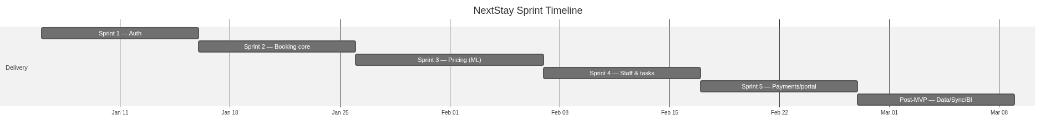
Figure 4.1 — Sprint timeline (Gantt).

4.3 Product Backlog
User stories derived from FR-1…FR-14, estimated in story points (SP).
Table 3 — Product backlog — user stories and story points.
FR | User story | SP
FR-1 | As a user I log in via email OTP and receive a JWT so access is secure | 5
FR-2 | As an admin I have role-based access so permissions are enforced | 3
FR-3 | As staff I create/read/update/delete rooms and set up inventory | 5
FR-4 | As a guest I check availability and hold a room before paying | 8
FR-5 | As a guest I pay via Stripe so my booking is confirmed | 8
FR-6 | As an owner I train a per-hotel model and publish dynamic prices | 13
FR-7 | As a manager I schedule shifts and auto-assign housekeeping tasks | 8
FR-8 | As an admin I see a dashboard with KPIs and quick links | 5
FR-9 | As a guest I access my stay details by token without logging in | 5
FR-10 | As a guest I complete booking with success/cancel pages | 3
FR-11 | As staff I start my shift and see my assigned tasks | 5
FR-12 | As a manager I view bookings/revenue reports | 5
FR-13 | As an external hotel site I sync bookings two-way with the PMS (HMAC) | 13
FR-14 | As a manager I view occupancy/RevPAR/loyalty dashboards | 8

5. Sprint Development & Results

Sprint 1 — Auth & User Foundation
Sprint goal: any user can log in via email OTP and receive a JWT that gates all subsequent pages.
Table 4 — Sprint 1 task breakdown.
Task | Owner | Days
[DB] users, auth_sessions, email_otp tables | Atai | 2
[DB] SQLAlchemy models: User, AuthSession, EmailOtp | Atai | 2
[DB] DB session factory + initial migration | Atai | 1
[BE] OTP request/verify, HMAC signing, expiry | Dair | 3
[BE] JWT issue + get_current_user dependency | Dair | 2
[BE] Role-based permission guards | Dair | 1
[FE] Login page + OTP form | Turat | 2
[FE] authStore (Zustand) + token persistence | Turat | 1
[FE] ProtectedRoute + role redirect | Turat | 2

Sprint 2 — Rooms, Inventory & Booking Core
Sprint goal: a guest can browse rooms, hold one, and complete a booking.
Table 5 — Sprint 2 task breakdown.
Task | Owner | Days
[DB] rooms, bookings, guest_tokens models | Atai | 2
[DB] FK constraints + indexes on room_id, check_in/out | Atai | 1
[BE] Room CRUD endpoints | Dair | 2
[BE] Inventory setup + availability logic | Dair | 2
[BE] Booking create/confirm/cancel + hold system | Dair | 3
[FE] BookingPage / Success / Cancel, RoomCard | Turat | 6

Sprint 3 — Pricing Engine (ML)
Sprint goal: admin can train a per-hotel model, publish dynamic prices, and view them in the Pricing Lab.
Table 6 — Sprint 3 task breakdown.
Task | Owner | Days
[DB] Pricing tables (config, model registry, jobs) | Atai | 3
[DB] Synthetic data generation script | Atai | 2
[BE] Feature engineering + training pipeline | Dair | 3
[BE] Optimizer + rules engine + Pricing Lab API | Dair | 4
[FE] PricingLab / ModelTraining / EngineHub pages | Turat | 6

Sprint 4 — Staff, Shifts & Task Management
Sprint goal: managers schedule shifts, tasks auto-assign round-robin, staff start their shifts.
Table 7 — Sprint 4 task breakdown.
Task | Owner | Days
[DB] tasks table + staff fields; shift session model | Atai | 3
[BE] Staff CRUD + shift start/end + round-robin tasks | Dair | 5
[FE] StaffPlanner / Staff / ShiftStart / TaskCard | Turat | 6

Sprint 5 — Payments, Guest Portal & Polish
Sprint goal: end-to-end paid booking; guest receives email; token portal; admin reports.
Table 8 — Sprint 5 task breakdown.
Task | Owner | Days
[DB] Stripe fields on bookings; OTP seeding/cleanup | Atai | 2
[BE] Stripe checkout + webhook; email service; /guest | Dair | 5
[FE] GuestPage / AdminPage / ReportsPage / Settings | Turat | 8

Post-MVP — Hotel-Sync Simulator, DWH, Airflow & Superset (Atai)
Beyond the five MVP sprints, the data layer was extended (see Chapter 10): a multi-hotel registry and a secure two-way synchronization simulator; a dbt data warehouse (staging → core dimensions + fact + SCD2 → analytics marts); Airflow orchestration of the ELT; and Superset dashboards. The whole pipeline was validated end-to-end on PostgreSQL.

6. Project & Code Architecture

6.1 Class Diagram (core domain)
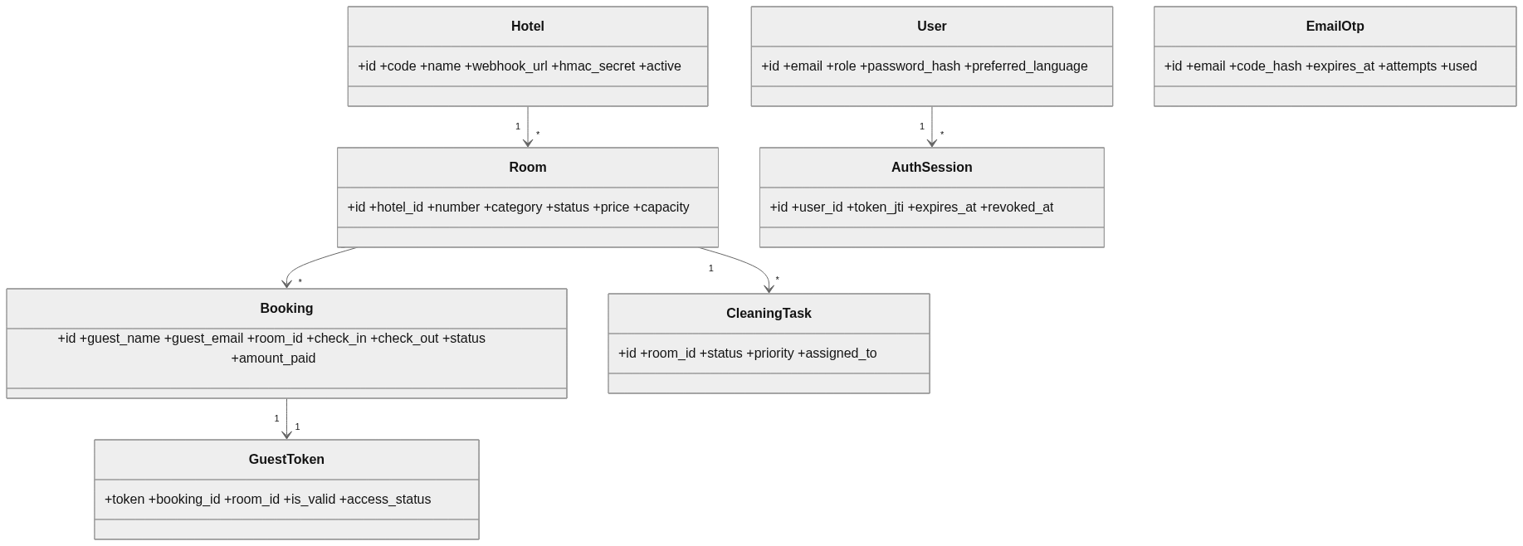
Figure 6.1 — Core domain class diagram.

6.2 Use Case Diagram
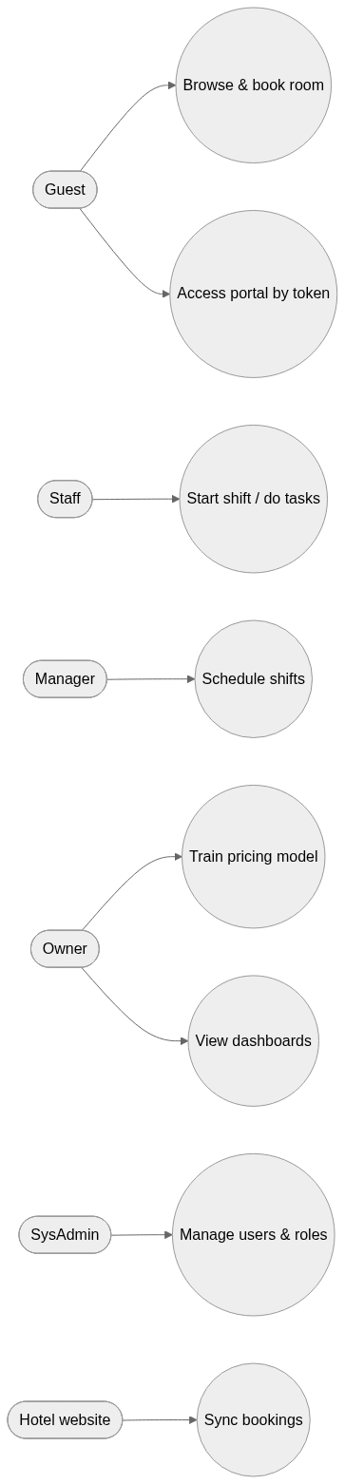
Figure 6.2 — Use case overview.

6.3 Component Diagram
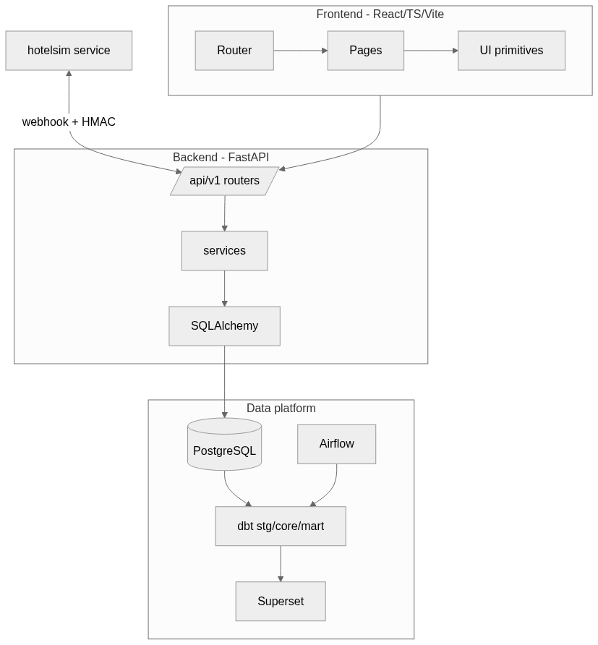
Figure 6.3 — System component diagram.

6.4 Database Diagram (ER)
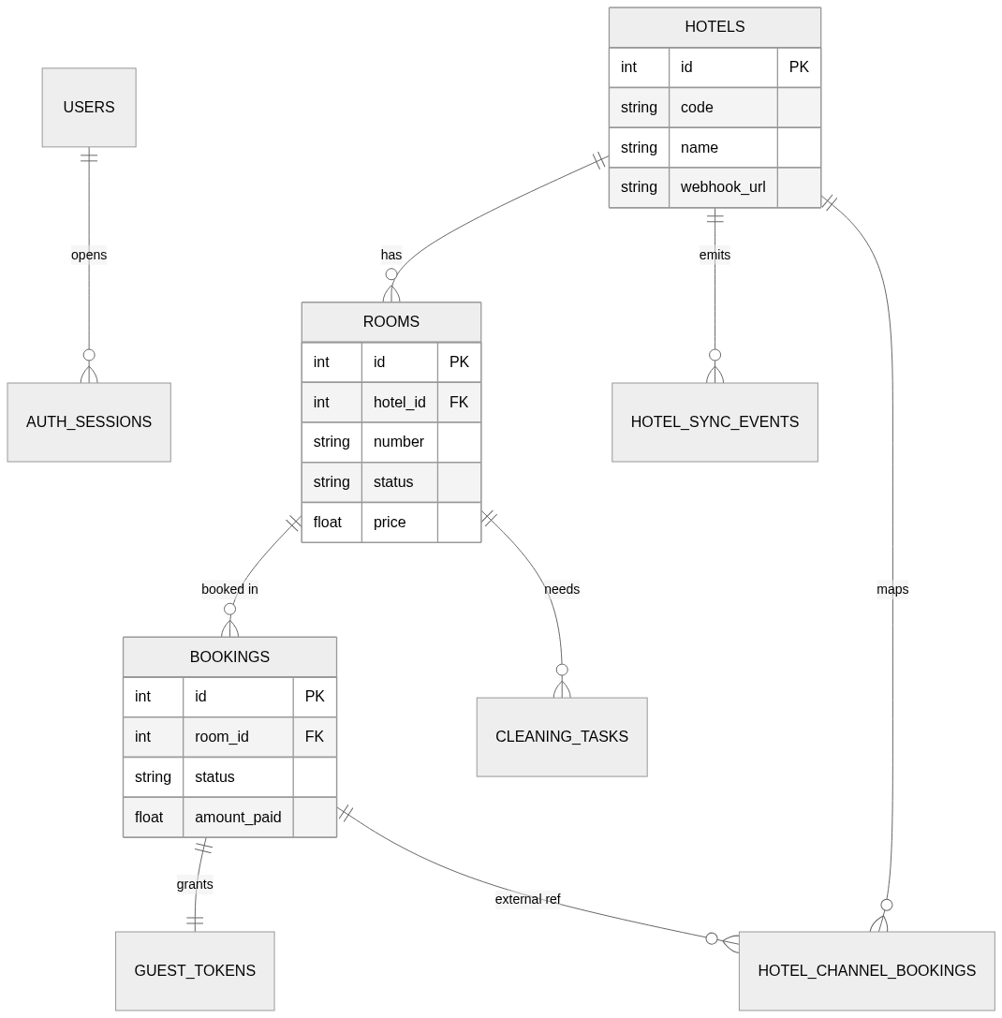
Figure 6.4 — OLTP entity-relationship diagram (public schema).

6.5 Data Flow Diagrams
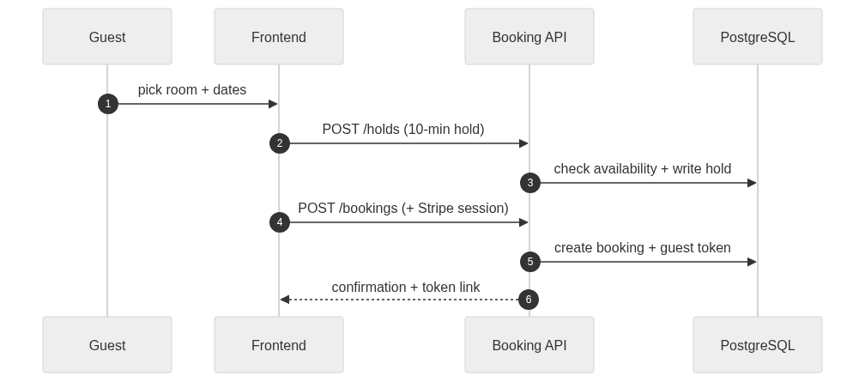
Figure 6.5a — Booking & hold flow.

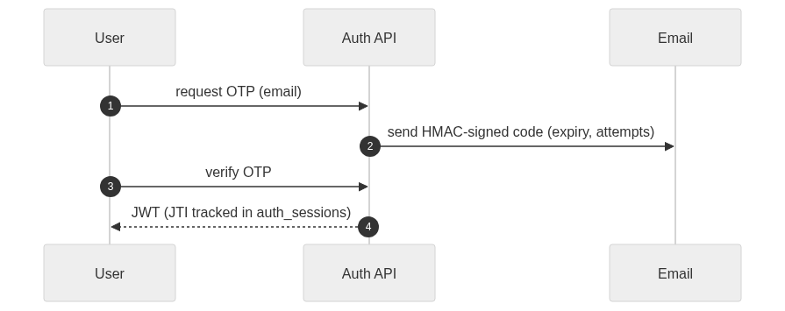
Figure 6.5b — Email-OTP authentication flow.

Figure 6.5c — ML pricing pipeline.

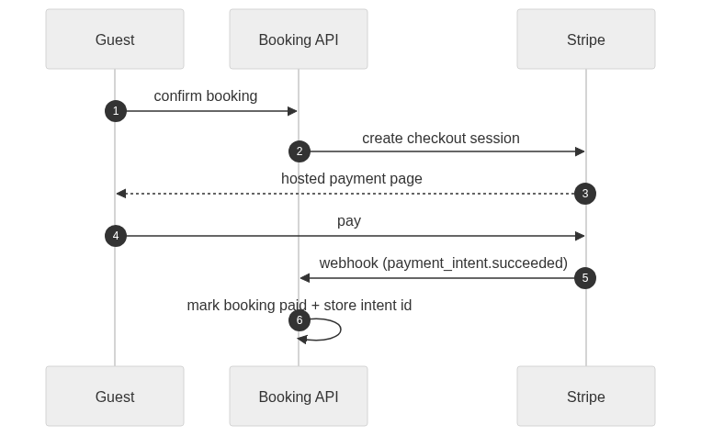
Figure 6.5d — Stripe payment & webhook flow.

6.6 Deployment Diagram
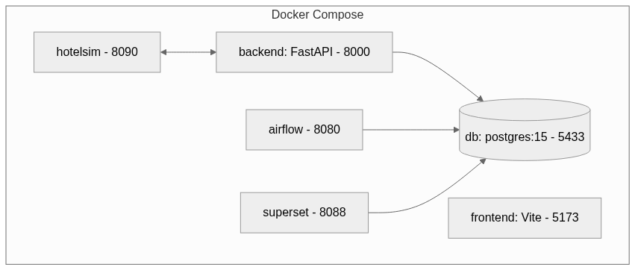
Figure 6.6 — Local deployment (Docker Compose).

6.7 State Machines
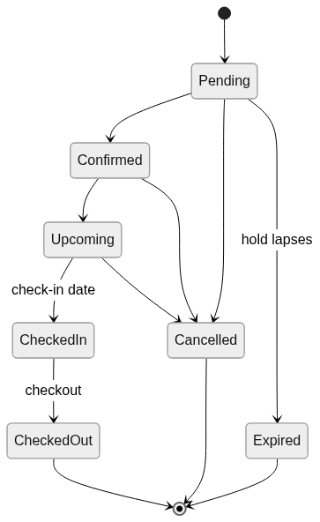
Figure 6.7a — Booking lifecycle state machine.

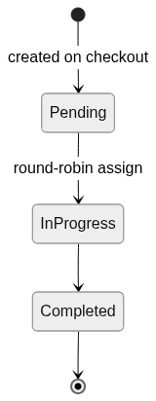
Figure 6.7b — Housekeeping task state machine (task_utils).

7. Tools & Technologies Used
Table 9 — Tools and technologies by layer.
Layer | Technology
Backend | Python 3.11/3.12, FastAPI, Uvicorn
Auth | JWT (python-jose), bcrypt/passlib, HMAC email-OTP
ORM / Migrations | SQLAlchemy; raw-SQL migrations + startup bootstrap (no Alembic in use)
Database | PostgreSQL 15 (prod), SQLite (unit tests), DuckDB (dbt local)
ML / Pricing | scikit-learn, pandas, numpy
Payments | Stripe
Warehouse | dbt Core (dbt-postgres / dbt-duckdb)
Orchestration | Apache Airflow
BI | Apache Superset
Frontend | React 19, TypeScript, Vite
FE state / routing / styling | Zustand, React Router v6, Tailwind CSS
Sync simulator | FastAPI + SQLite + vanilla HTML/JS (hotelsim)
CI / Hooks | pre-commit, Ruff, SQLFluff, GitHub Actions, Docker Compose

8. Features Implemented
Table 10 — Implemented features.
Feature | Description | Owner | Sprint
OTP auth + JWT | Passwordless login, role-gated sessions | Dair/Atai | 1
Room & inventory | CRUD, availability, holds | Dair/Atai | 2
Booking + guest token | Reserve, confirm, cancel; token portal | Dair/Turat | 2/5
ML pricing engine | Per-hotel training, backtest, publish | Dair/Atai | 3
Staff & tasks | Shifts, round-robin housekeeping | Dair/Turat | 4
Stripe payments | Checkout session + webhook | Dair | 5
Hotel-sync simulator | Two-way HMAC sync + mini-site | Atai | Post-MVP
Data warehouse | dbt stg/core/mart + SCD2 | Atai | Post-MVP
Airflow ELT | Nightly dbt orchestration | Atai | Post-MVP
Superset BI | Occupancy / RevPAR / loyalty dashboards | Atai | Post-MVP

9. Website Mock-ups

9.1 PC Browser View
Admin dashboard, Booking portal, Guest page, and Staff planner on desktop. [Insert screenshots — capture from the running app at localhost:5173.]

9.2 Mobile View
Responsive layouts for the booking and guest flows. [Insert mobile screenshots — narrow-viewport captures.]
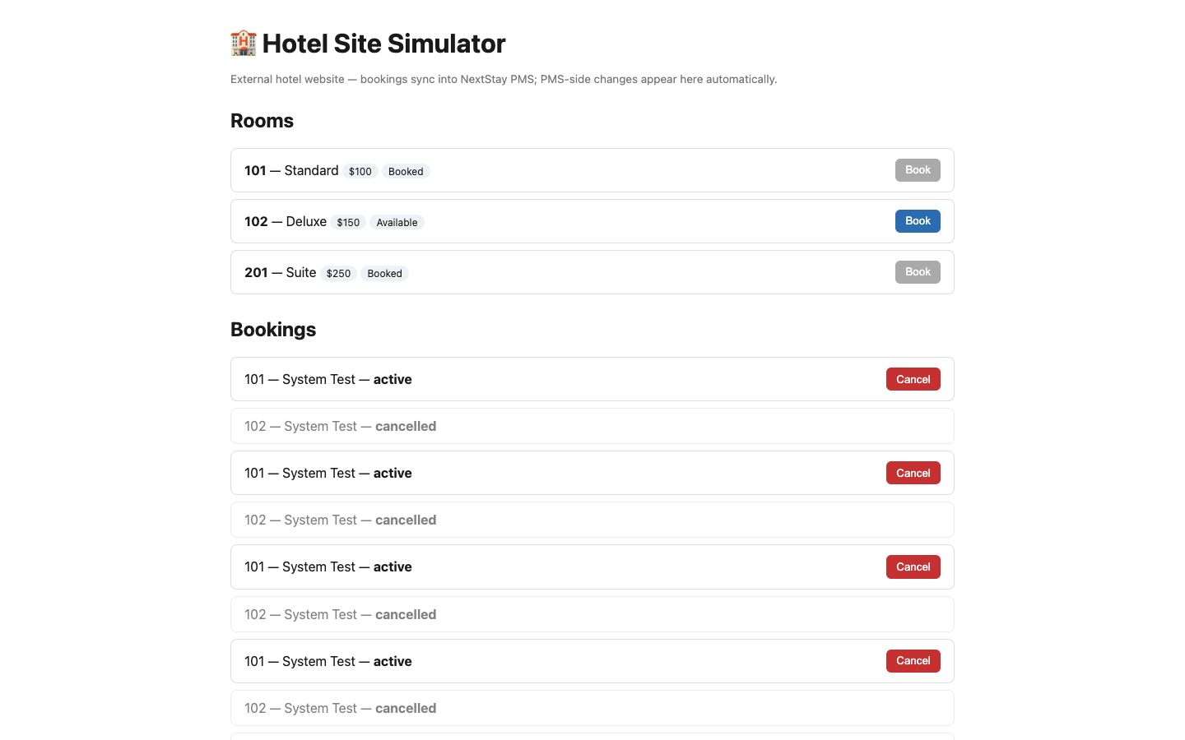
Figure 9.1 — External hotel-site simulator (booking UI).

[INSERT SCREENSHOTS — frontend at http://localhost:5173 (after login): Admin dashboard, Booking page, Guest portal, Staff planner, Pricing Lab for §9.1 Desktop; narrow-viewport captures for §9.2 Mobile.]

10. Data Architecture, Synchronization & BI (Atai)
This chapter details the data layer: the six-schema architecture, the multi-hotel synchronization simulator, the dbt data warehouse, Airflow orchestration, and Superset BI.

10.1 Six-Schema Architecture
- public — OLTP source of truth (rooms, bookings, holds, tasks, guest_tokens, users, hotels, sync tables).
- stg — staging mirror with ETL technical columns.
- core — dimensional warehouse (dim_dates/hotels/room_types/rooms/guests, fct_bookings, SCD2 snapshot).
- mart — analytics marts (occupancy, RevPAR, loyalty).
- ml — feature-engineered pricing dataset.
- pricing — pricing engine tables (snapshots, decisions, published prices, model registry, jobs, config).

10.2 Hotel-Site Synchronization (multi-hotel, two-way, HMAC)
A standalone hotelsim service plays the role of an external hotel website. Bookings made there are pushed to the PMS as HMAC-signed webhook events; PMS-side changes (e.g. a cancellation) are pushed back to the hotel. Idempotency is enforced by a unique event id; anti-echo is guaranteed by call-site separation (inbound writes never re-publish).
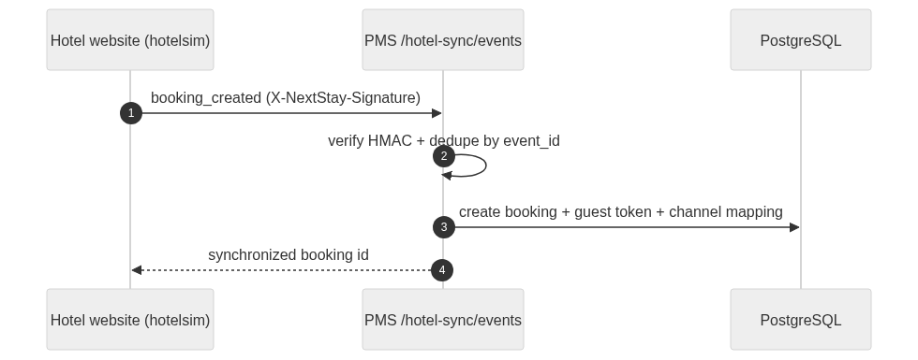
Figure 10.1 — Inbound sync: hotel website → PMS.

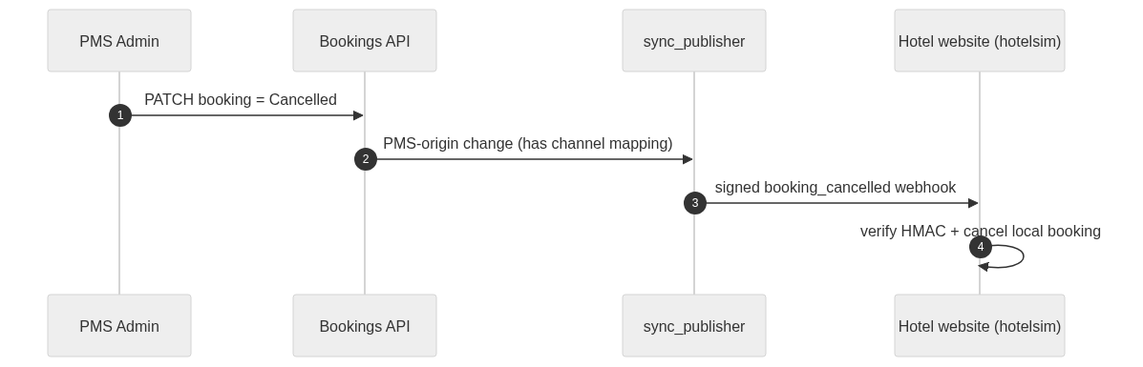
Figure 10.2 — Outbound sync: PMS → hotel website (anti-echo).

10.3 Data Warehouse (dbt)
dbt transforms the OLTP source into a dimensional model. Staging reads live public.* tables on the PostgreSQL target (and CSV seeds on the DuckDB local target). Core builds conformed dimensions, a booking-grain fact, and a SCD2 snapshot of room price/status history. Marts compute occupancy, RevPAR, and guest loyalty. The build is fully tested (unique / not-null / relationships / accepted-values / a custom occupancy-range test) — 49 checks pass on both targets.
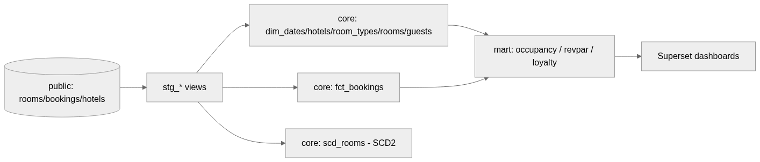
Figure 10.3 — Warehouse data flow (OLTP → stg → core → mart → BI).

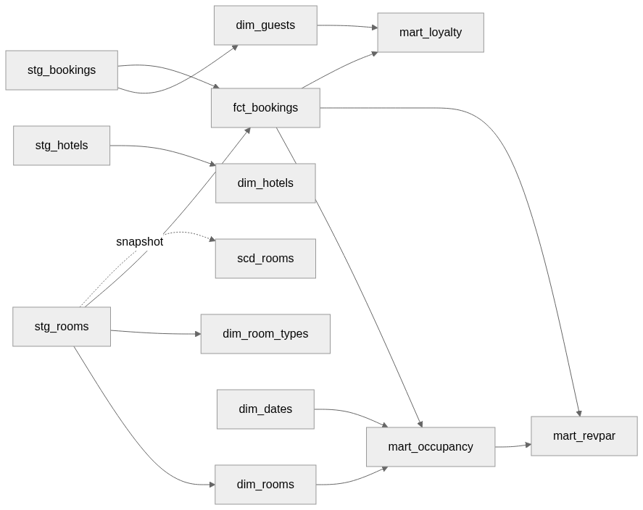
Figure 10.3b — dbt model-level lineage.

10.4 Orchestration (Airflow)
An Airflow DAG (nextstay_dbt_elt) runs the warehouse build nightly against PostgreSQL as a linear pipeline. It was validated with `airflow dags test`: all tasks succeeded and dbt's data tests passed.
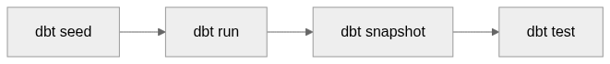
Figure 10.4 — Airflow ELT DAG (nextstay_dbt_elt).

10.5 Business Intelligence (Superset)
Superset connects to the warehouse and exposes the marts as datasets, surfaced on the “NextStay — Hotel Analytics” dashboard: occupancy by date, RevPAR by date, and guest loyalty tiers. [Insert dashboard screenshot from localhost:8088.]

10.6 End-to-End Validation
The full stack was brought up with Docker Compose (db, backend, hotelsim, airflow, superset) and exercised end-to-end: a booking made on the hotel website appeared in the PMS with a channel mapping and a processed sync event; a cancellation in the PMS propagated back to the hotel site; duplicate events were ignored idempotently; an invalid token/signature was rejected with HTTP 401; and the dbt warehouse rebuilt green on PostgreSQL, feeding the Superset dashboards. These checks are automated as system tests — see Chapter 11.
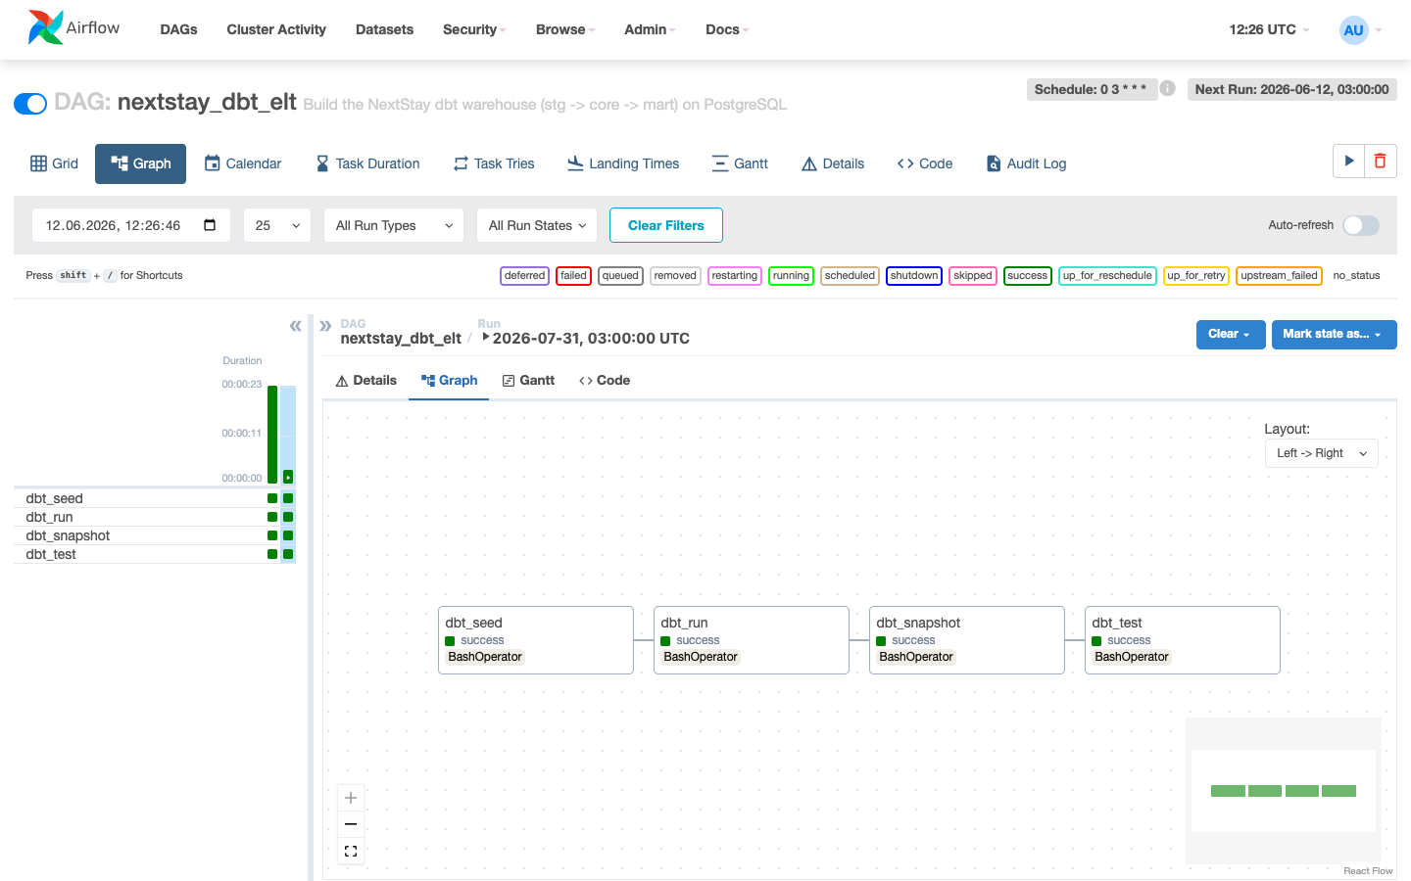
Figure 10.7 — Airflow DAG nextstay_dbt_elt: all tasks succeeded.

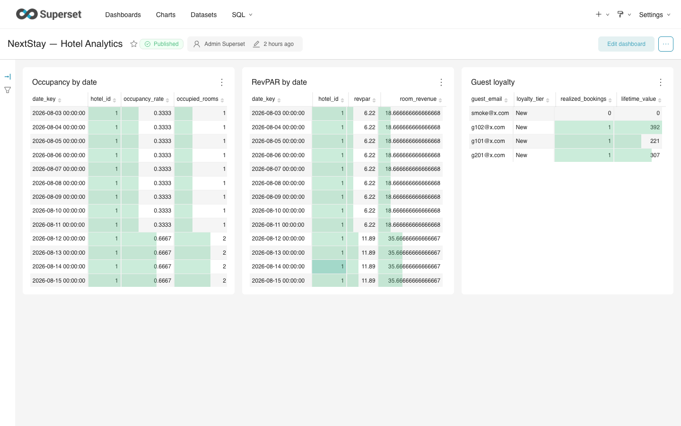
Figure 10.8 — Superset dashboard 'NextStay — Hotel Analytics'.

11. System Testing

11.1 Test Strategy
Testing follows the classic pyramid: many fast unit tests at the base, fewer integration tests that exercise the API and database together, data-quality tests over the warehouse, and a thin layer of end-to-end system tests that drive the whole running stack. All layers are automated and gated by pre-commit and CI; the warehouse layer is checked by dbt, and the system layer is skipped automatically when the Dockerised stack is not running, so it never blocks the unit pipeline.
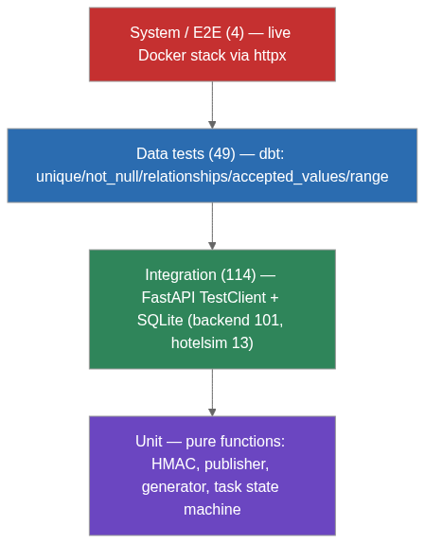
Figure 11.1 — Test pyramid (counts as of the latest run).

11.2 Test Inventory
Table 11 — Test inventory across the pyramid.
Layer | Scope | Tooling | Count
Unit | HMAC, sync publisher, generator, task state machine | pytest | incl. below
Integration | Backend API + DB (auth, rooms, bookings, staff, tasks, sync) | pytest + TestClient | 101
Integration | Hotel simulator (store, signing, client, app, generator) | pytest + TestClient | 13
Data quality | Warehouse keys, FKs, accepted values, occupancy range | dbt test | 49
System / E2E | Bidirectional sync, idempotency, auth (live stack) | pytest + httpx | 4
Total | Automated checks | — | 167

11.3 System (End-to-End) Test Cases
Table 12 — System (end-to-end) test cases.
# | Scenario | Expected result
E2E-1 | Guest books on the hotel website | Booking + active channel mapping appear in the PMS
E2E-2 | Admin cancels the booking in the PMS | Signed webhook cancels the booking on the hotel site
E2E-3 | Same sync event delivered twice | Second is ignored (duplicate_event_ignored); no dup
E2E-4 | Event sent with an invalid sync token | Rejected with HTTP 401

Location: tests/system/test_e2e_hotel_sync.py. Run with the stack up: `docker compose up -d db backend hotelsim` then `pytest tests/system -q`. The suite is self-skipping when the stack is unreachable.

11.4 Data-Quality Tests
dbt enforces 49 tests across the warehouse: primary-key uniqueness and not-null on every dimension/fact key, referential-integrity (relationships) from facts to dimensions, accepted-values on booking and loyalty status fields, and a custom singular test asserting occupancy_rate stays within [0, 1]. The suite is green on both the DuckDB (local) and PostgreSQL (prod) targets.

11.5 Results & Continuous Integration
- Backend integration: 101 passed.
- Hotel simulator: 13 passed.
- Warehouse data tests (dbt): 49 passed on DuckDB and PostgreSQL.
- System / E2E: 4 passed against the live Docker stack.
- Quality gates: pre-commit (Ruff, SQLFluff) + a GitHub Actions workflow run on every push.

11.6 Requirements Traceability
Links each functional requirement to the sprint that delivered it, its verifying test layer, and its owner.
Table 13 — Requirements traceability (FR → sprint → test → owner).
FR | Sprint | Verified by | Owner
FR-1 | 1 | Integration (test_auth) | Dair
FR-2 | 1 | Integration (role guards) | Dair + Atai
FR-3 | 2 | Integration (test_hotel_scoping/rooms) | Dair
FR-4 | 2 | Integration (test_bookings) | Dair
FR-5 | 5 | Manual + Stripe webhook | Dair
FR-6 | 3 | Unit + priceengine tests | Dair
FR-7 | 4 | Integration (test_staff/test_tasks) | Dair
FR-8…12 | 2–5 | Manual UI / frontend (planned, see #45) | Turat
FR-13 | Post-MVP | Integration + System E2E (E2E-1…4) | Atai
FR-14 | Post-MVP | dbt data tests (49) + freshness | Atai

12. Conclusion & Future Work

12.1 Conclusion
NextStay delivers an integrated hotel PMS across five sprints plus a post-MVP data platform: secure OTP/JWT auth, room inventory and booking with holds, an ML pricing engine, staff and task management, Stripe payments, a token-gated guest portal, a multi-hotel two-way synchronization simulator, a dbt data warehouse with Airflow orchestration, and Superset dashboards. Quality is anchored by 167 automated checks across a four-layer test pyramid, all green, and the bidirectional sync was validated end-to-end on PostgreSQL.

12.2 Future Work
Tracked as GitHub issues on the project repository:
- Frontend automated tests (Vitest + RTL) — the main remaining test gap (#45).
- Reconcile the multi-hotel/tenancy work across branches (#46) and unify init-db/bootstrap (#47).
- Add report screenshots for the UI and the Superset dashboard (#48).
- A CI-friendly integration test for the inbound sync handler on PostgreSQL (#49).
- Clear remaining framework deprecation warnings (#51).
- Large-data benchmarking of the warehouse marts.

Appendix A — Key Listings

A.1 OLTP schema (excerpt)
CREATE TABLE rooms (
id SERIAL PRIMARY KEY,
hotel_id INTEGER REFERENCES hotels (id),
number VARCHAR(10) NOT NULL,
category VARCHAR(50) NOT NULL,
status VARCHAR(20) NOT NULL DEFAULT 'Available',
price FLOAT NOT NULL,
capacity INT NOT NULL DEFAULT 2,
CONSTRAINT uq_rooms_hotel_number UNIQUE (hotel_id, number)
);

A.2 HMAC sign / verify (hotel-sync security)
def sign_payload(raw_body: bytes, secret: str) -> str:
digest = hmac.new(secret.encode(), raw_body, hashlib.sha256).hexdigest()
return f"sha256={digest}"
def verify_signature(raw_body, secret, provided) -> bool:
if not provided or not provided.startswith('sha256='):
return False
return hmac.compare_digest(sign_payload(raw_body, secret), provided)

A.3 dbt mart — occupancy (excerpt)
select
a.hotel_id, a.date_key, a.available_rooms,
coalesce(o.occupied_rooms, 0) as occupied_rooms,
round(coalesce(o.occupied_rooms,0)*1.0 / nullif(a.available_rooms,0), 4) as occupancy_rate
from available a
left join occupied o on a.hotel_id=o.hotel_id and a.date_key=o.date_key

A.4 Airflow ELT DAG (excerpt)
with DAG('nextstay_dbt_elt', schedule_interval='0 3 * * *', ...) as dag:
seed = BashOperator(task_id='dbt_seed', bash_command=DBT.format(cmd='seed'))
run = BashOperator(task_id='dbt_run', bash_command=DBT.format(cmd='run'))
snap = BashOperator(task_id='dbt_snapshot', bash_command=DBT.format(cmd='snapshot'))
test = BashOperator(task_id='dbt_test', bash_command=DBT.format(cmd='test'))
seed >> run >> snap >> test

A.5 System E2E test (excerpt)
def test_booking_on_hotel_site_appears_in_pms(client):
ext = _book_on_site(client, room='101')
row = _pms_channel_row(client, ext)
assert row and row['status'] == 'active'
assert row['bookingId'] is not None

