NextStay Project Report
- INTRODUCTION
- Project Goals and Method
- Project Background
- Project Request
- Website Description

- 2. PROJECT MANAGEMENT METHODOLOGY
- 2.1 Agile Framework Overview
- 2.2 Motivation for Choosing Scrum
- 2.3 Scrum Roles
- 2.4 Scrum Events
- 2.5 Scrumban Implementation
- 2.6 Sprint Calendar

- 3. SOFTWARE REQUIREMENTS
- 3.1 Functional Requirements
- 3.2 Non-Functional Requirements
- 3.3 Constraints and Assumptions

- PROJECT PLANNING
- 4.1 Product Vision
- 4.2 Product Backlog
- 4.3 Story Point Estimation
- 4.4 Definition of Don
- 4.5 Risk Analysis

5. SPRINT DEVELOPMENT & RESULTS

6.1 Unit Testing

6.2 Integration Testing

6.3 Security Testing

6.4 UI Testing

6.5 ML Validation

7. SYSTEM ARCHITECTURE

7.1 Use Case Diagram
Actors:
- Guest
- Staff
- Manager
- Owner
- SysAdmin

7.2 Class Diagram
Classes:
- User
- Room
- Booking
- AuthSession
- EmailOtp
- GuestToken
- Task

7.3 Component Diagram
App
├── Layout
├── Pages
├── Components
├── API Layer
└── State Store

7.4 Database Diagram
ER Diagram.

7.5 Data Flow Diagrams

Authentication Flow
OTP → Verification → JWT

Booking Flow
Guest → Booking → Payment → Confirmation

Pricing Flow
Training → Validation → Publish Prices

7.6 Deployment Diagram
Browser
↓
React/Vite
↓
FastAPI
↓
SQLite

8. TOOLS & TECHNOLOGIES

9. FEATURES IMPLEMENTED

10. WEBSITE MOCKUPS

10.1 Desktop Layouts
- Dashboard
- Booking
- Staff
- Pricing Lab

10.2 Mobile Layouts
Responsive screenshots.

11. PROJECT EVALUATION

11.1 Objectives Achieved
Compare objectives vs delivered features.
Objective | Status
Authentication | Completed
Booking | Completed
Pricing Engine | Completed
Staff Management | Completed
Payments | Completed

11.2 Sprint Performance Analysis
Sprint | Planned SP | Completed SP
Sprint 1 | xx | xx
Sprint 2 | xx | xx
Sprint 3 | xx | xx
Sprint 4 | xx | xx
Sprint 5 | xx | xx
Discuss velocity and delivery.

12. CONCLUSIONS

12.1 Results Achieved
Summary of system capabilities.

12.2 Lessons Learned
- Agile development
- FastAPI architecture
- React state management
- Payment integration
- Machine learning deployment

12.3 Future Improvements
- PostgreSQL
- Docker deployment
- Multi-hotel support
- Revenue forecasting
- Mobile application
- AI concierge assistant
This version is much closer to what would be expected in a 50–80 page Software Engineering capstone/project report and provides enough structure to naturally incorporate Scrum/Scrumban evidence, diagrams, code snippets, testing, and project management artifacts.

1. INTRODUCTION

1.1 PROJECT GOALS AND METHOD
The central objective of NextStay is to create a comprehensive, full-stack hotel management platform that eliminates the need for third-party Property Management Systems (PMS) by consolidating every aspect of hotel operations into a single, purpose-built web application. Today, small and mid-sized hotels are forced to juggle multiple disconnected tools — spreadsheets for staff scheduling, external platforms for bookings, manual price adjustments based on intuition, and separate communication channels for task delegation. This fragmentation leads to inefficiencies, missed revenue opportunities, and an overall lack of operational visibility for hotel owners and managers. NextStay addresses all of these challenges by providing an integrated platform where room inventory, guest bookings, dynamic pricing, staff shifts, and task management are all handled from one interface.
At the heart of the system is an AI-driven pricing engine that continuously learns from historical booking data and generates dynamic price recommendations for each room type and future stay date. Rather than relying on fixed seasonal rates, the hotel can publish machine-learning-based prices that adapt to occupancy patterns, demand signals, and configurable business rules. Beyond pricing, the platform supports a direct guest booking channel with Stripe-powered payments, removing dependency on commission-heavy booking aggregators. Staff members interact with the system through a dedicated interface that tracks their shifts, displays assigned tasks, and receives work through an automated round-robin assignment mechanism — ensuring fair and accountable task distribution without manual intervention by management.
Given the iterative nature of building such a multi-layered system and the need to validate each module before building on top of it, the team adopted the Scrum methodology. Development was divided into five sprints, each delivering a functional increment of the platform — from authentication and room management in the early sprints, to the pricing engine and payment integration in the later ones. This approach allowed each team member to work within their technical domain while maintaining shared visibility over progress, and it provided a structured process for identifying and resolving integration issues between the backend, frontend, and database layers before they could accumulate.

1.2 PROJECT BACKGROUND
Independent hotels and small hotel groups face a structural problem that large chains have long solved through enterprise software: the absence of a unified operational system. A typical independent hotel manager starts their day by checking booking status on one platform, adjusting prices manually on another, communicating tasks to staff via phone or messaging apps, and reviewing revenue figures in a spreadsheet — all without these tools ever talking to each other. The result is not only wasted time but also a persistent risk of errors: double bookings, mispriced rooms during high-demand events, and tasks that fall through the cracks because there is no system-level accountability.
The direct booking problem is particularly significant. Without a custom booking page, hotels are entirely dependent on platforms such as Booking.com or Airbnb, which charge commissions ranging from 15% to 25% per reservation. For a small property, this represents a substantial portion of revenue paid to an intermediary that also controls the guest relationship. A hotel that can accept bookings directly — with its own payment flow and its own guest communication — retains both the margin and the data.
NextStay was designed to directly address these challenges. By providing a fully integrated platform where every operational function is connected — pricing informs inventory, bookings trigger task assignments, shifts determine which staff receive those tasks — the hotel gains a level of operational coherence that was previously only achievable with expensive enterprise PMS solutions. The platform was built with the specific constraints of independent hoteliers in mind: it is lightweight, deployable without cloud infrastructure expertise, and manageable entirely through a web browser by users with no technical background.

1.3 THE REQUEST OF THE PROJECT
The initial request for the project was to design and implement a full-stack hotel management web application capable of supporting the complete operational cycle of a property — from room setup and guest booking through to staff management, dynamic pricing, and revenue reporting. To achieve this goal, the platform was required to incorporate several core functional areas.
At the foundation of the system is a secure authentication module using email-based One-Time Passwords (OTP) and JWT session management. The system supports five distinct user roles — OWNER, SYS_ADMIN, DIRECTOR, MANAGER, and STAFF — each with a precisely defined set of accessible features, ensuring that sensitive operations such as model training or engine configuration are restricted to authorized personnel only.
The project also required a complete room and inventory management layer, allowing administrators to define room numbers, categories, capacities, amenities, and base prices, and to track real-time availability as bookings and holds are created. Connected to this is a direct guest booking portal, publicly accessible without a login, where guests can select dates and rooms and complete payment through Stripe. After payment, guests receive a tokenized private link that grants them access to their booking details without requiring an account.
A major component of the request was the development of a machine-learning pricing engine capable of training a per-hotel model on synthetic or historical booking data, generating dynamic price recommendations for future stay dates, and publishing those prices through a rules-validated pipeline. Managers should be able to view published prices, compare them against base prices, monitor occupancy rates, and roll back model versions if needed — all through dedicated frontend pages.
Finally, the project required a staff management module with shift tracking, round-robin automatic task assignment to active staff members, and a staff-facing interface where employees can clock in, view their assigned tasks, and update task statuses. All of these modules were to be surfaced through an admin dashboard and a reports page that give owners and directors a consolidated, real-time view of the hotel's operational and financial state.

1.4 WEBSITE DESCRIPTION
NextStay was designed and developed as a full-stack web platform built with a modular, layered architecture that separates concerns cleanly between the database, backend API, and frontend application. The system brings together a modern single-page application, a RESTful backend, a relational database, and external payment and email services to deliver a complete hotel management experience.
- The frontend was implemented as a React 18 Single-Page Application written in TypeScript and bundled with Vite, delivering a fast and responsive interface across desktop and mobile screen sizes. Routing is managed by React Router v6, with role-aware ProtectedRoute components that enforce access control at the page level — redirecting users whose role does not match the allowed roles for a given route. Global state, including authentication tokens, user roles, and UI preferences, is managed through Zustand stores. The UI is composed of a shared component library (Button, Card, Modal, Drawer, PageHeader) built on a centralized design token system, ensuring visual consistency across all pages.
- The backend is powered by Python 3.11 with FastAPI, structured around 14 independent APIRouter modules registered under the /api/v1/ prefix — each responsible for a distinct domain: authentication, rooms, bookings, holds, guests, staff, tasks, Stripe payments, pricing lab, pricing configuration, pricing pipeline, model training, inventory setup, and system health. Security is implemented through HMAC-signed OTP codes, JWT tokens issued on successful verification, and a get_current_user FastAPI dependency that validates tokens and enforces role-based access on every protected endpoint. Cross-origin requests from the frontend are handled through FastAPI's CORSMiddleware.
- Data persistence is handled by a SQLite database in development, accessed exclusively through SQLAlchemy ORM models. The schema consists of seven core tables — users, rooms, bookings, auth_sessions, email_otps, guest_tokens, and tasks — each designed to support the full lifecycle of its domain. Alembic is used for schema migrations, ensuring that database changes are versioned and reproducible across environments.
- The pricing engine is a standalone Python module that operates alongside the main API. It uses scikit-learn to train gradient-boosted regression models on historical or synthetic booking data, engineers features such as occupancy rate, days-to-arrival, seasonality, and room category, and produces dynamic price recommendations for each hotel, room type, and future stay date. The engine supports backtesting, model comparison, champion promotion, and a rules layer that caps price deltas and enforces business constraints before prices are published.
The platform integrates two external services to complete its functionality:
- Stripe API for guest checkout session creation, payment confirmation, and webhook-based booking status updates.
- SMTP email service for transactional delivery of OTP codes to users during login and for sending guests their tokenized booking confirmation link after a successful payment.
This architecture enables NextStay to function as a production-ready hotel management system that is modular enough to extend — for example, with mobile applications, calendar integrations, or connections to external booking aggregators — without requiring changes to its core structure.

3. SOFTWARE REQUIREMENTS

3.1 Functional Requirements
The functional requirements of NextStay were organized into several major domains, reflecting the different operational areas of the platform and the distinct groups of users it serves. Each domain captures a cohesive set of features that together deliver a complete hotel management experience.

- Authentication and User Management
At the foundation of the platform lies a secure and role-aware authentication system. Rather than relying on traditional password-based login, NextStay uses an email-based One-Time Password (OTP) mechanism. When a user submits their email address, the system generates a time-limited, HMAC-signed code and delivers it through a transactional email service. Upon successful verification, a signed JWT token is issued and stored as an active session record in the database. This session-tracking approach means that tokens can be individually revoked — for example, on logout — without invalidating all active sessions simultaneously.
To enforce permissions across the platform, the system implements Role-Based Access Control (RBAC) with five distinct user roles: OWNER, SYS_ADMIN, DIRECTOR, MANAGER, and STAFF. Each role maps to a precisely defined set of accessible pages and API endpoints. The require_roles dependency, applied on every protected backend route, ensures that a user cannot perform any action outside the scope of their assigned role, regardless of how the request is formed.
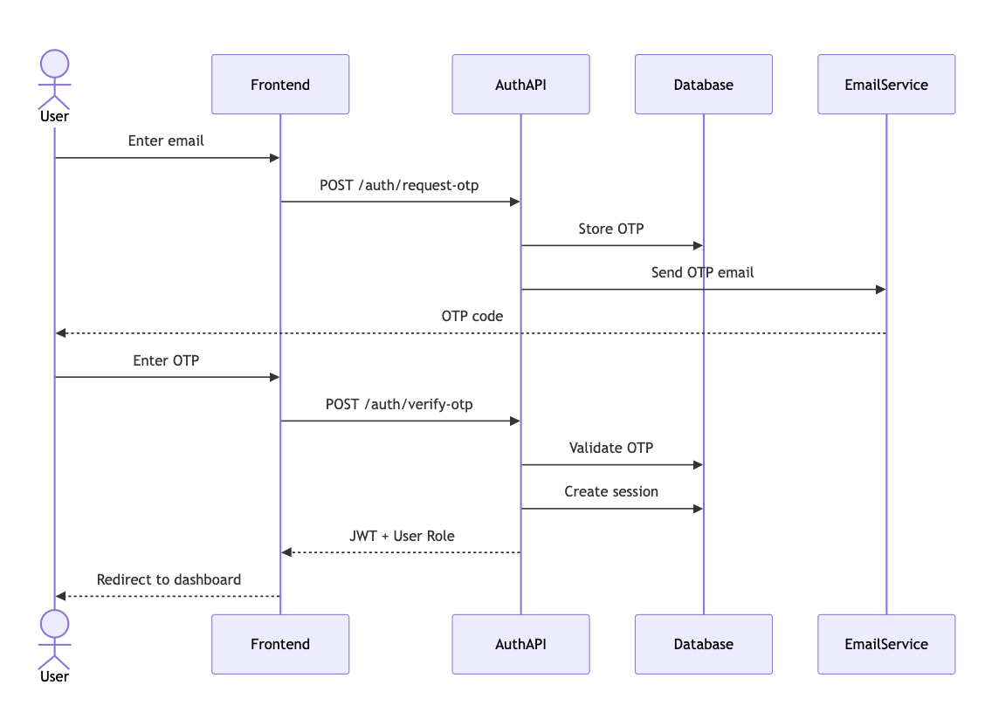

- Guest Booking and Payments
A core requirement of the project was to provide hotels with a direct booking channel that removes dependency on third-party platforms. The booking portal is publicly accessible without any login, allowing guests to browse available rooms, select check-in and check-out dates, and proceed to payment. The system creates a temporary hold on the selected room during checkout to prevent conflicts with other simultaneous booking attempts.
Payment processing is handled entirely through the Stripe API. When a guest confirms their booking, the system creates a Stripe Checkout Session and redirects the guest to a secure hosted payment page. Once payment is confirmed, a Stripe webhook notifies the backend, which marks the booking as confirmed and releases the hold. If the guest exits before paying, the hold is released automatically and the booking expires.
After a successful payment, the system generates a unique guest token and sends the guest a confirmation email containing a private link. This link grants access to a tokenized guest page where the guest can view their booking details at any time, without needing to create an account.
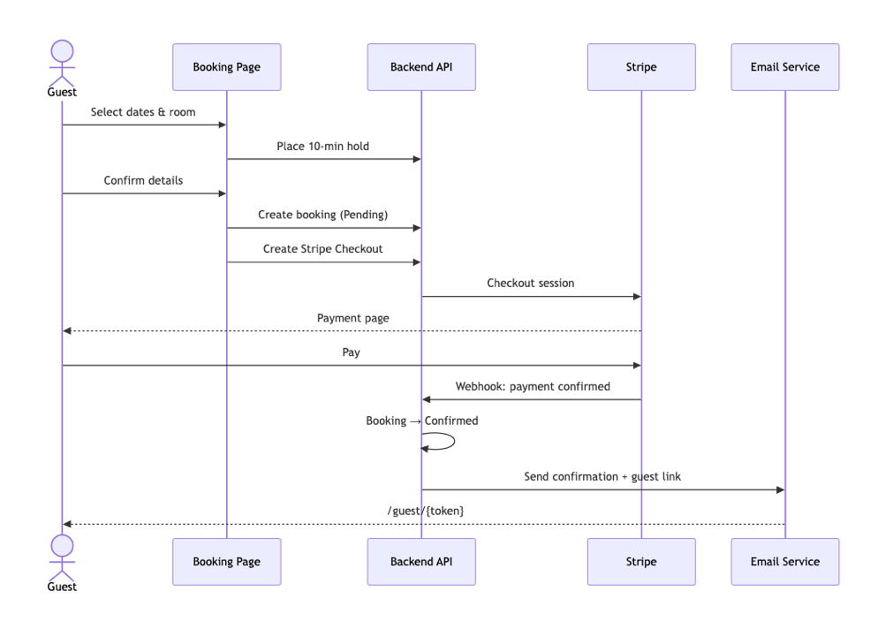

- Room and Inventory Management
The platform provides a complete room management layer that gives administrators full control over the hotel's physical inventory. Rooms can be created, updated, and removed through a dedicated interface, with each room record capturing its number, category, capacity, pricing baseline, amenities, and current availability status. A separate inventory setup module allows managers to configure the full room catalogue from scratch, making the platform usable for any property size or room structure.
Availability is tracked in real time. As bookings and temporary holds are created or released, the system recalculates which rooms are open for a given date range, ensuring that guests are only presented with genuinely available options and that double bookings cannot occur.

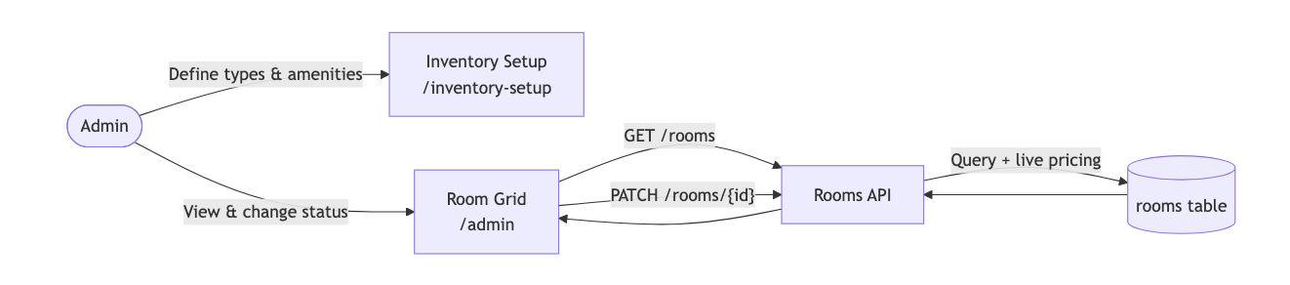

- Staff Management and Task Assignment
The platform includes a dedicated module for managing hotel staff, their working shifts, and the tasks they are assigned during each shift. Managers can view all registered staff members, check their current availability, and monitor task completion rates over time. When a staff member begins their shift by clocking in through the platform, the system registers an active session for that employee and makes them eligible for task assignment.
Task delegation is handled through an automated round-robin mechanism. When a new task is created — for example, a room cleaning request triggered by a checkout — the system assigns it to the next eligible active staff member in rotation, ensuring that workload is distributed fairly and that no task is left unassigned due to oversight. Staff members interact with the platform through a dedicated interface that displays their current tasks, allows them to update task statuses, and tracks their shift history.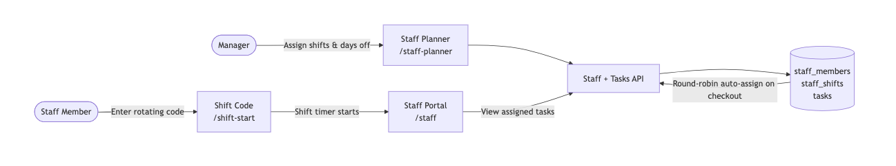

- AI-Driven Pricing Engine
The pricing engine is the most technically advanced component of the platform. It provides hotel managers with machine-learning-based dynamic price recommendations that adapt to historical booking patterns, occupancy levels, demand signals, and configurable business rules — replacing the manual, intuition-based pricing that most independent hotels rely on.
The engine operates as a standalone Python pipeline. It begins with feature engineering, extracting signals such as days-to-arrival, day of week, seasonal factors, room category, and rolling occupancy rates from historical data. A gradient-boosted regression model is then trained per hotel on this dataset, and its performance is evaluated through backtesting against held-out periods. Once a model passes validation, it can be promoted to champion status and used to generate a price grid covering each room type and future stay date.
Published prices flow through a rules layer before reaching the frontend. This layer enforces business constraints such as maximum price delta percentages, minimum price floors, and rollout percentage controls, ensuring that machine-generated recommendations always stay within acceptable bounds. Managers can view the published price grid in the Pricing Lab, compare dynamic prices against base prices, inspect occupancy and booking data alongside pricing decisions, and roll back to a previous model version if needed.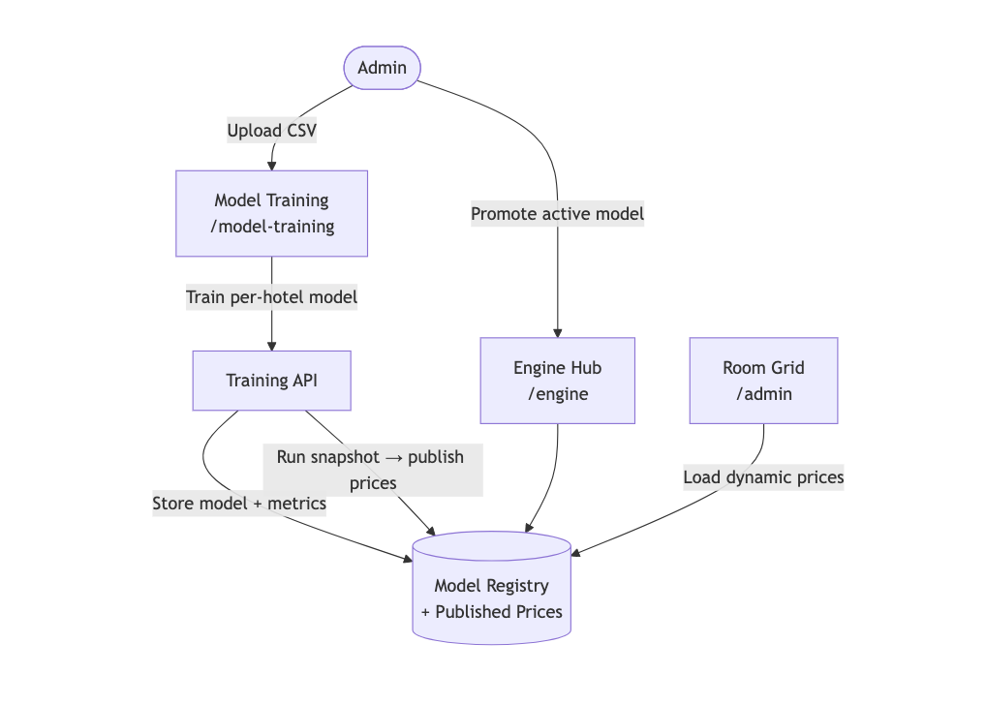

- Administration and Reporting
The administrative layer of the platform gives owners, directors, and managers a consolidated view of the hotel's operational and financial state. The admin dashboard presents key performance indicators — today's bookings, current occupancy rate, active staff count, and recent revenue — alongside quick-access links to every management module.
A dedicated reports page provides aggregated views of booking trends, occupancy over time, and revenue summaries, giving management the data they need to make informed operational and pricing decisions. Administrative users can also manage the hotel's user accounts — creating new staff profiles, adjusting roles, and deactivating accounts when staff members leave the property.
Together, these functional requirements define the scope of NextStay as a fully integrated, AI-enhanced hotel management platform that balances operational depth with accessibility for non-. technical users

3.2 Non-Functional Requirements
In addition to its functional capabilities, NextStay was designed to satisfy a series of non-functional requirements. These requirements ensure that the platform is not only feature-complete but also secure, reliable, maintainable, and suitable for real-world hotel operations.

- Security
Security is a foundational concern across every layer of the system. Authentication is based on HMAC-signed, time-limited OTP codes — valid for five minutes and limited to five verification attempts before expiry — combined with JWT session tokens that are individually tracked in the database and can be revoked on demand. This dual-layer approach ensures that stolen tokens cannot be reused after a session is invalidated. All role-based access controls are enforced server-side through a require_roles dependency applied to every protected endpoint, meaning that frontend routing restrictions are a convenience layer on top of genuine backend enforcement. Environment variables are used exclusively to manage all secrets, API keys, and credentials, ensuring that no sensitive configuration is ever committed to the codebase.

- Performance
The platform was built to deliver a responsive experience under realistic hotel operating loads. The backend is implemented with FastAPI, an asynchronous Python framework that handles concurrent requests efficiently without blocking. The pricing pipeline, which is the most computationally intensive operation in the system, runs as a background process decoupled from the main API, ensuring that training jobs do not impact the responsiveness of the booking or management interfaces. Database queries are scoped precisely to what each endpoint requires, avoiding unnecessary data loading across the ORM layer.

- Reliability
Reliability is ensured through strict transactional integrity on all operations that modify booking state. Creating a booking, processing a payment confirmation, and releasing a hold are handled as atomic operations — either fully completing or rolling back — preventing inconsistent states such as a charged booking that was never confirmed. A global exception handler is registered on the FastAPI application to ensure that unhandled errors return structured JSON responses with appropriate HTTP status codes, rather than crashing or leaking stack traces to the client. The health endpoint provides a lightweight probe that can be used by deployment infrastructure to verify that the API is operational.

- Usability
The frontend was designed to minimize the learning curve for hotel staff and management who may not have a technical background. The interface follows a consistent visual language built on a shared design token system, ensuring that spacing, typography, and color usage are uniform across all pages. Role-aware routing ensures that users only ever see the pages and controls relevant to their responsibilities — a staff member logging in is taken directly to their task dashboard, while a manager sees the admin overview. The booking portal, which is used by guests who have no familiarity with the system, was deliberately kept simple and linear, guiding the user through room selection, date picking, and payment in a single uninterrupted flow.

- Scalability
The backend was designed as a stateless API, meaning that no session state is stored in application memory — all session data lives in the database. This makes horizontal scaling straightforward, as multiple instances of the API can run in parallel without coordination. The database configuration is environment-driven, allowing the application to connect to either a local SQLite database during development or a production PostgreSQL instance through a single configuration variable, without any code changes.

- Maintainability
Maintainability is supported by a strictly modular codebase in which each API domain has its own independent router file, each database entity has its own SQLAlchemy model, and each frontend feature has its own page component. This separation of concerns means that changes to one module — for example, modifying the task assignment logic — do not require touching unrelated parts of the system. Code quality is enforced at the commit level through pre-commit hooks that run the Ruff linter and formatter, preventing style inconsistencies and common errors from entering the repository. All configuration is centralized in a single config.py module on the backend, making it straightforward to adjust operational parameters such as OTP expiry times, token lifetimes, or pricing engine thresholds across environments.
Collectively, these non-functional requirements ensure that NextStay is not only functional at launch but also secure, stable, and built to evolve alongside the needs of its users.

4. BEFORE SPRINTS

4.1 Definition of Done
Before beginning development, the team established a clear and shared Definition of Done (DoD). This served as a quality benchmark that every user story or feature had to meet before it could be considered complete and moved to the next sprint. The DoD acted as both a checklist and a shared agreement between team members, eliminating ambiguity around what "done" truly meant and preventing partially finished work from accumulating across sprints.
A feature was only considered complete if it satisfied the following criteria:
- Code implementation: The functionality had to be fully implemented and merged into the main branch of the repository through a reviewed pull request. This step ensured that all code changes were visible to the entire team and that no work existed only on a personal branch. On the backend, all new routes had to be registered in the main application and confirmed reachable. On the frontend, new pages had to be wired into the router and accessible through navigation.
- Linting and code quality: All committed code had to pass the Ruff linter and formatter without errors or warnings. This was enforced automatically through pre-commit hooks, meaning that non-compliant code was rejected before it could enter the repository. This guaranteed a consistent code style across all three team members throughout the project.
- Functional correctness: Every API endpoint had to return the correct HTTP status codes for both success and error cases — for example, 401 Unauthorized for missing or invalid tokens, 403 Forbidden for insufficient role permissions, and 422 Unprocessable Entity for invalid input payloads. Frontend pages had to render without console errors and display the correct content for each user role.
- Security validation: Every new protected endpoint had to have the get_current_user or require_roles dependency applied and verified. It was not sufficient for an endpoint to work correctly for authorized users — it also had to reject unauthorized requests with the appropriate error response. Role-restricted frontend pages had to be covered by the ProtectedRoute component, ensuring that access control was enforced at both layers.
- Integration testing: New features had to be tested end-to-end across the full stack — from the frontend UI action through the API call to the database and back. For payment-related features, this included verifying that Stripe webhook events correctly updated booking states. For pricing features, this included confirming that published prices appeared correctly in the Pricing Lab after a pipeline run.
- Deployment verification: The feature had to run correctly in the local development environment with both the FastAPI backend and the Vite frontend server active simultaneously. Database migrations had to apply cleanly without errors, and the application had to start without requiring manual intervention or undocumented configuration steps.
By adhering to this definition, the team maintained consistent quality standards across all three technical layers — backend, frontend, and database — throughout the project. It prevented the accumulation of half-finished features and ensured that the end of each sprint genuinely represented a stable, working increment of the platform.

Pricing Engine — System Description

Overview
NextStay's pricing engine is a per-hotel, ML-powered dynamic pricing system that continuously optimises room prices across all hotel segments. It operates as a pipeline that sits between the property management OLTP layer and the public booking API: it reads live inventory and booking data, scores a set of candidate prices using a trained logistic-regression model, applies a layered set of business rules, and publishes the final price so that the Rooms API can serve it to guests in real time.
The engine supports four hotel segments — budget city, business, beach resort, and premium luxury — each with its own price bounds, volatility limits, and seasonal floor multipliers. Every hotel can have its own privately trained model; hotels without a trained model fall back to a shared global model.

Architecture
The system is divided into four logical layers.
1. Data Layer (PostgreSQL)
Schema | Table | Purpose
core | dim_hotels | Hotel master data: segment, city, timezone
core | dim_room_types | Room amenity flags, max occupancy
ml | pricingdata | Feature store for model training
pricing | inventory_snapshots | Point-in-time inventory state per stay-date
pricing | price_decisions | Raw model output before rules
pricing | published_prices | Final price surfaced to the booking API
pricing | hotel_model_registry | Trained model artefacts and metrics
pricing | hotel_pricing_config | Per-hotel overrides (min/max, multipliers)
pricing | training_jobs | Async training job tracker

2. Pricing Engine Core (/backend/priceengine/src/)
Module | Responsibility
price_engine.py | Orchestrator; loads model, calls candidates → scorer → rules
candidates.py | Generates discrete candidate prices around the base price
optimizer.py | Scores candidates with the model, selects maximum expected revenue
rules.py | Applies business-rule guardrails to the model recommendation
features.py | Feature schema validation and optional-column injection
preprocessing.py | Scikit-learn ColumnTransformer (OHE + imputer + scaler)
ml_utils.py | Time-based train/val/test split and classification metrics

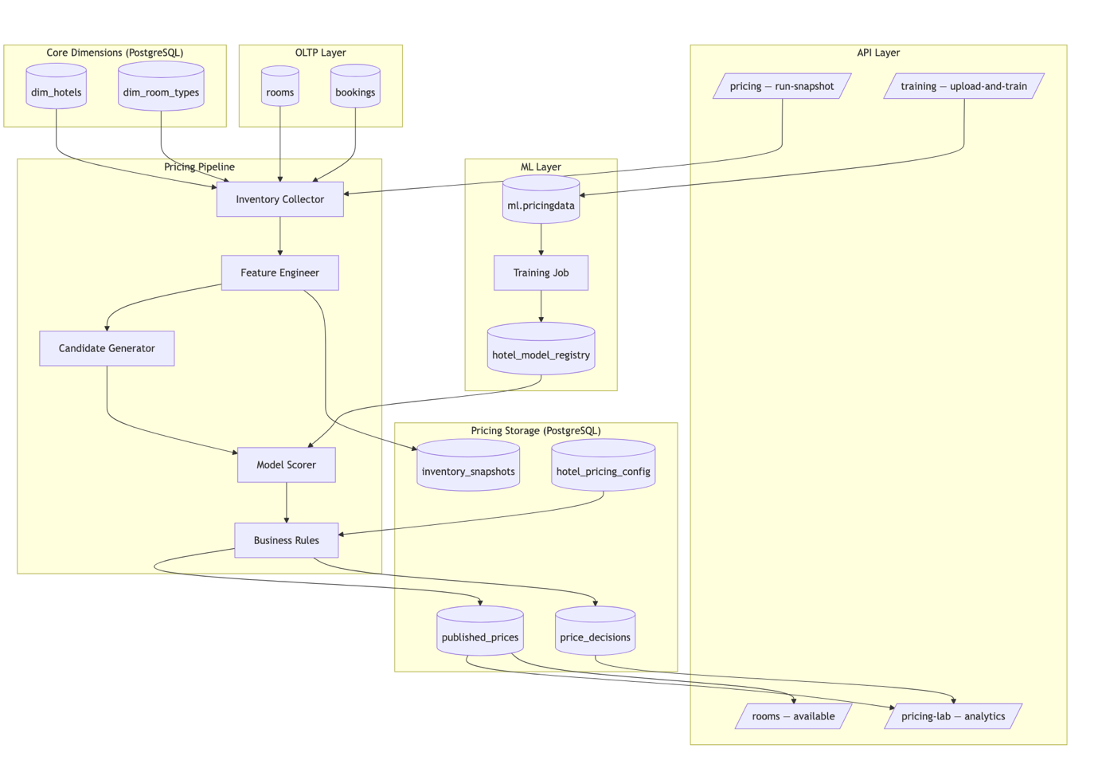

13. DATA ARCHITECTURE, SYNCHRONIZATION & BUSINESS INTELLIGENCE
This chapter documents the data-platform work added on top of the MVP: a six-schema database architecture, a multi-hotel two-way synchronization simulator, a dbt data warehouse, Airflow orchestration of the ELT, and Superset dashboards. It complements Chapter 7 (System Architecture).
13.1 Six-Schema Database Architecture
• public — OLTP source of truth (rooms, bookings, holds, tasks, guest_tokens, users, hotels, sync tables).
• stg — staging mirror with ETL technical columns.
• core — dimensional warehouse (dim_dates/hotels/room_types/rooms/guests, fct_bookings, SCD2 snapshot).
• mart — analytics marts (occupancy, RevPAR, loyalty).
• ml — feature-engineered pricing dataset.
• pricing — pricing engine tables (snapshots, decisions, published prices, registry, jobs, config).
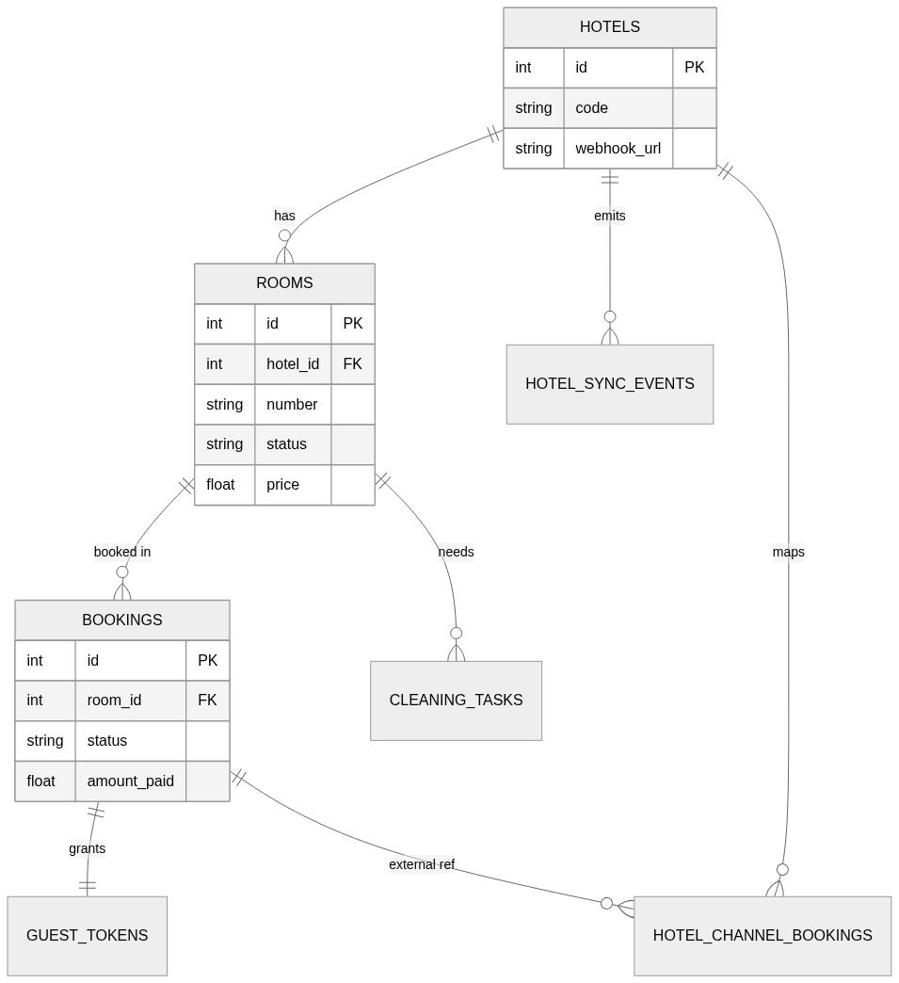
Figure 13.1 — OLTP ER diagram (with multi-hotel + sync tables).

13.2 Hotel-Site Synchronization (multi-hotel, two-way, HMAC)
A standalone hotelsim service plays the role of an external hotel website. Bookings made there are pushed to the PMS as HMAC-signed webhook events; PMS-side changes (e.g. a cancellation) are pushed back. Idempotency is enforced by a unique event id; anti-echo by call-site separation (inbound writes never re-publish).
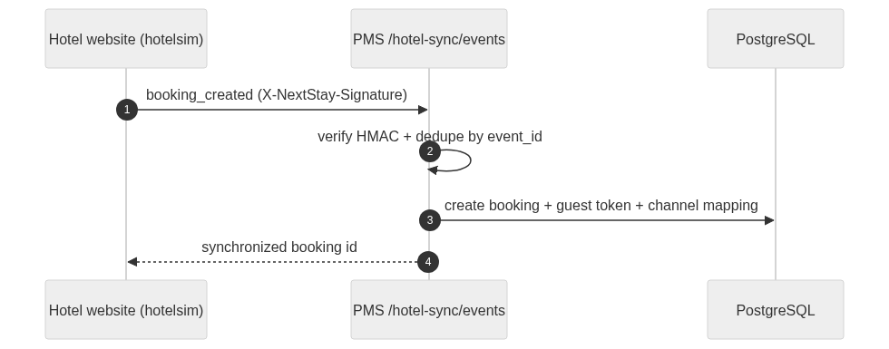
Figure 13.2 — Inbound sync: hotel website → PMS.

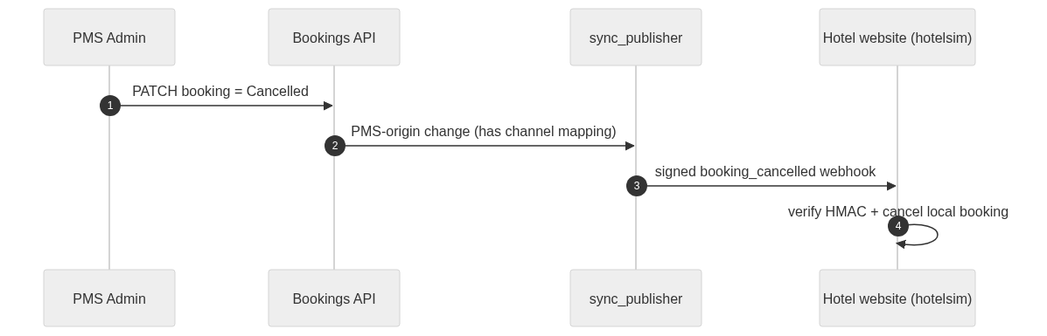
Figure 13.3 — Outbound sync: PMS → hotel website (anti-echo).

13.3 Data Warehouse (dbt)
dbt transforms OLTP into a dimensional model: staging reads live public.* on PostgreSQL (and CSV seeds on the DuckDB local target); core builds conformed dimensions, a booking-grain fact and a SCD2 room snapshot; marts compute occupancy, RevPAR and loyalty. 49 dbt tests pass on both targets.
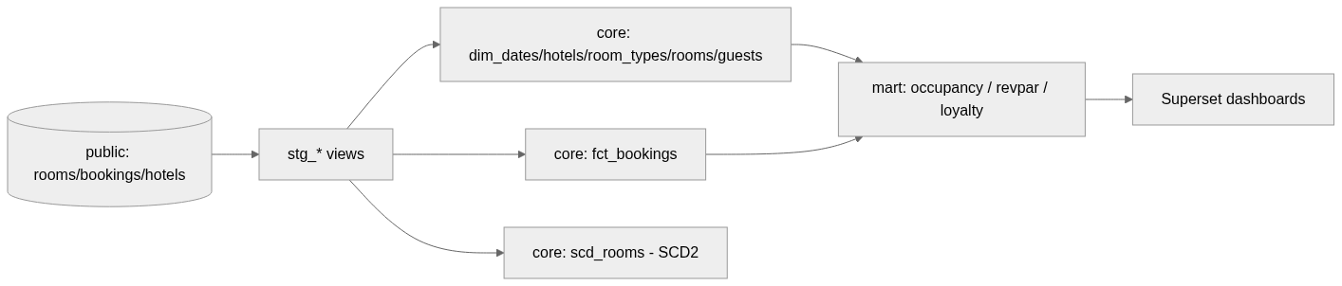
Figure 13.4 — Warehouse data flow (OLTP → stg → core → mart → BI).

13.4 Orchestration (Airflow)
The Airflow DAG nextstay_dbt_elt runs the warehouse build nightly on PostgreSQL as a linear pipeline. Validated via `airflow dags test`: all tasks succeeded and dbt's data tests passed.
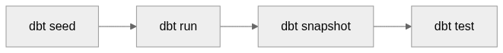
Figure 13.5 — Airflow ELT DAG (nextstay_dbt_elt).

13.5 Business Intelligence (Superset)
Superset connects to the warehouse and exposes the marts as datasets on the 'NextStay — Hotel Analytics' dashboard: occupancy by date, RevPAR by date, and guest loyalty tiers. [INSERT SCREENSHOT: Superset dashboard from http://localhost:8088 — see notes.]
13.6 End-to-End Validation
The full stack (db, backend, hotelsim, airflow, superset) was exercised end-to-end on PostgreSQL: a booking on the hotel website appeared in the PMS with a channel mapping and a processed sync event; a PMS cancellation propagated back to the hotel site; duplicate events were ignored idempotently; an invalid token/signature was rejected with HTTP 401; and dbt rebuilt green, feeding Superset.

14. EXTENDED SYSTEM TESTING
Building on the testing described in Chapter 6, the platform is covered by a four-layer test pyramid totalling 167 automated checks — all green.
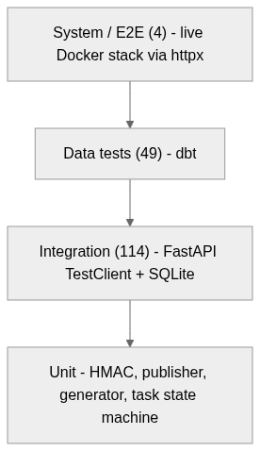
Figure 14.1 — Test pyramid (counts as of the latest run).

14.1 Test Inventory
Table 1 — Test inventory across the pyramid.
Layer | Scope | Tooling | Count
Integration | Backend API + DB | pytest + TestClient + SQLite | 101
Integration | Hotel simulator | pytest + TestClient | 13
Data quality | Warehouse keys/FKs/ranges | dbt test | 49
System / E2E | Bidirectional sync, idempotency, auth | pytest + httpx | 4
Total | Automated checks | — | 167

14.2 System (End-to-End) Test Cases
Table 2 — System (end-to-end) test cases (tests/system/test_e2e_hotel_sync.py).
# | Scenario | Expected result
E2E-1 | Guest books on the hotel website | Booking + active channel mapping appear in the PMS
E2E-2 | Admin cancels the booking in the PMS | Signed webhook cancels the booking on the hotel site
E2E-3 | Same sync event delivered twice | Second is ignored (duplicate_event_ignored); no dup
E2E-4 | Event sent with an invalid sync token | Rejected with HTTP 401

14.3 Requirements Traceability
Table 3 — Requirements traceability (FR → sprint → test → owner).
FR | Sprint | Verified by | Owner
FR-1 | 1 | Integration (test_auth) | Dair
FR-3/4 | 2 | Integration (rooms/bookings) | Dair
FR-6 | 3 | Unit + priceengine tests | Dair
FR-7 | 4 | Integration (staff/tasks) | Dair
FR-8…12 | 2–5 | Frontend tests (planned, #45) | Turat
FR-13 | Post-MVP | Integration + System E2E | Atai
FR-14 | Post-MVP | dbt data tests (49) + freshness | Atai

