NextStay
Hotel Property Management System
Software Engineering Project Report

Team: Dair (Backend) · Turat (Frontend) · Atai (Data Architecture & BI)

1. Introduction

1.1 Project Goals and Method
NextStay is a full-stack Property Management System (PMS) for small and mid-sized hotels. It automates the core operational loop — room inventory, guest booking, dynamic ML-based pricing, staff scheduling and housekeeping, payments, and a token-gated guest portal — and layers a data warehouse and BI dashboards on top for management analytics. The platform is built with Python/FastAPI on the backend, React/TypeScript/Vite on the frontend, and PostgreSQL with SQLAlchemy for persistence, following an Agile (Scrum) delivery method.

1.2 Project Background
Independent hotels often juggle several disconnected tools — a spreadsheet for rooms, a third-party booking channel, a chat group for housekeeping, and manual pricing. NextStay consolidates these into one integrated system with an ML-driven pricing engine and a synchronization layer that keeps the hotel's own website and the PMS in lock-step, removing the dependency on an expensive external PMS.

1.3 The Request of the Project
The brief was to build a secure web platform for hotel staff and guests: email-OTP login with JWT sessions and role-based access; room and inventory management; an AI-driven per-hotel pricing engine; staff shift scheduling with round-robin task delegation; Stripe payments; and a guest portal accessible by token without login. A further request added a two-way synchronization simulator between an external hotel website and the PMS.

1.4 Website Description
The application exposes five primary surfaces: the Admin dashboard (KPIs and management), the Booking portal (availability, holds, checkout), the Guest page (token-based stay details), the Staff planner (shifts and tasks), and the Pricing Lab (model training and published prices). Mock-ups are shown in Section 9.

2. Agile Methodology

2.1 Agile Framework Overview
Agile development favours short, iterative cycles that deliver working software frequently, with continuous feedback and the freedom to adapt scope. NextStay was delivered in five fixed-length sprints, each producing a demonstrable increment.

2.2 Motivation to Choose Scrum
Scrum fit a three-person student team well: clear roles, time-boxed sprints to force prioritisation, and a shared board for transparency. The vertical-slice nature of the features (each touching DB, backend, and frontend) mapped naturally to per-sprint goals.

2.3 Scrum Methodology
Roles: Product Owner (curates the backlog and acceptance), Scrum Master (removes blockers, guards the process), and the Development Team (Dair, Turat, Atai). Ceremonies: sprint planning, a short daily sync, a sprint review/demo, and a retrospective.

2.4 Scrum Implementation
Work was tracked on a GitHub-based task board; code moved to the main branch via pull requests gated by pre-commit (Ruff for Python, SQLFluff for SQL) and a CI workflow. Sprints were approximately ten working days each.

3. Software Requirements

3.1 Functional Requirements
# | Requirement | Owner
FR-1 | Email OTP login + JWT session management | Dair
FR-2 | Role-based access (OWNER, STAFF, MANAGER, DIRECTOR, SYS_ADMIN) | Dair + Atai
FR-3 | Room CRUD + inventory setup | Dair
FR-4 | Guest booking flow with availability check + holds | Dair
FR-5 | Stripe payment integration | Dair
FR-6 | Per-hotel ML pricing engine (training, backtesting, publishing) | Dair
FR-7 | Staff management + shift system + round-robin task assignment | Dair
FR-8 | Admin dashboard with all sub-pages | Turat
FR-9 | Guest portal (token-based, no login) | Turat
FR-10 | Booking pages (book, success, cancel) | Turat
FR-11 | Staff shift start / task views | Turat
FR-12 | Reports page | Turat
FR-13 | Multi-hotel registry + two-way hotel-site synchronization (HMAC) | Atai
FR-14 | Data warehouse (stg/core/mart) + BI dashboards | Atai

3.2 Non-Functional Requirements
- Security: JWT sessions with JTI revocation, email-OTP, HMAC-signed sync webhooks, role-gated APIs.
- Performance: asynchronous pricing pipeline; indexed availability and payment lookups.
- Usability: role-gated UI; token-only guest access without an account.
- Maintainability: modular FastAPI routers, component-based frontend, dbt-managed warehouse, IaC via Docker Compose.
- Portability: SQL kept ANSI-compatible so dbt models run on both DuckDB (local) and PostgreSQL (prod).

4. Before Sprints

4.1 Definition of Done
- Code merged to main via pull request.
- No Ruff/SQLFluff lint errors (enforced by pre-commit + CI).
- Endpoints return the expected HTTP status codes; automated tests pass.
- UI renders without console errors.
- Feature manually tested end-to-end.

4.2 Sprint Calendar
Sprint | Theme | Length
Sprint 1 | Auth & User Foundation | ~10 days
Sprint 2 | Rooms, Inventory & Booking Core | ~10 days
Sprint 3 | Pricing Engine (ML) | ~12 days
Sprint 4 | Staff, Shifts & Task Management | ~10 days
Sprint 5 | Payments, Guest Portal & Polish | ~10 days
Post-MVP | Hotel-Sync Simulator, DWH, Airflow, Superset | ~10 days

4.3 Product Backlog
User stories were derived from FR-1…FR-14 and estimated in story points. Examples: “As a guest I can log in with an email OTP so that I can access the portal securely” (FR-1, 5pts); “As an owner I can train a per-hotel pricing model so that prices adapt to demand” (FR-6, 13pts); “As a manager I can see occupancy and RevPAR dashboards so that I can plan” (FR-14, 8pts).

5. Sprint Development & Results

Sprint 1 — Auth & User Foundation
Sprint goal: any user can log in via email OTP and receive a JWT that gates all subsequent pages.
Task | Owner | Days
[DB] users, auth_sessions, email_otp tables | Atai | 2
[DB] SQLAlchemy models: User, AuthSession, EmailOtp | Atai | 2
[DB] DB session factory + initial migration | Atai | 1
[BE] OTP request/verify, HMAC signing, expiry | Dair | 3
[BE] JWT issue + get_current_user dependency | Dair | 2
[BE] Role-based permission guards | Dair | 1
[FE] Login page + OTP form | Turat | 2
[FE] authStore (Zustand) + token persistence | Turat | 1
[FE] ProtectedRoute + role redirect | Turat | 2

Sprint 2 — Rooms, Inventory & Booking Core
Sprint goal: a guest can browse rooms, hold one, and complete a booking.
Task | Owner | Days
[DB] rooms, bookings, guest_tokens models | Atai | 2
[DB] FK constraints + indexes on room_id, check_in/out | Atai | 1
[BE] Room CRUD endpoints | Dair | 2
[BE] Inventory setup + availability logic | Dair | 2
[BE] Booking create/confirm/cancel + hold system | Dair | 3
[FE] BookingPage / Success / Cancel, RoomCard | Turat | 6

Sprint 3 — Pricing Engine (ML)
Sprint goal: admin can train a per-hotel model, publish dynamic prices, and view them in the Pricing Lab.
Task | Owner | Days
[DB] Pricing tables (config, model registry, jobs) | Atai | 3
[DB] Synthetic data generation script | Atai | 2
[BE] Feature engineering + training pipeline | Dair | 3
[BE] Optimizer + rules engine + Pricing Lab API | Dair | 4
[FE] PricingLab / ModelTraining / EngineHub pages | Turat | 6

Sprint 4 — Staff, Shifts & Task Management
Sprint goal: managers schedule shifts, tasks auto-assign round-robin, staff start their shifts.
Task | Owner | Days
[DB] tasks table + staff fields; shift session model | Atai | 3
[BE] Staff CRUD + shift start/end + round-robin tasks | Dair | 5
[FE] StaffPlanner / Staff / ShiftStart / TaskCard | Turat | 6

Sprint 5 — Payments, Guest Portal & Polish
Sprint goal: end-to-end paid booking; guest receives email; token portal; admin reports.
Task | Owner | Days
[DB] Stripe fields on bookings; OTP seeding/cleanup | Atai | 2
[BE] Stripe checkout + webhook; email service; /guest | Dair | 5
[FE] GuestPage / AdminPage / ReportsPage / Settings | Turat | 8

Post-MVP — Hotel-Sync Simulator, DWH, Airflow & Superset (Atai)
Beyond the five MVP sprints, the data layer was extended (see Chapter 10): a multi-hotel registry and a secure two-way synchronization simulator; a dbt data warehouse (staging → core dimensions + fact + SCD2 → analytics marts); Airflow orchestration of the ELT; and Superset dashboards. The whole pipeline was validated end-to-end on PostgreSQL.

6. Project & Code Architecture

6.1 Class Diagram (core domain)
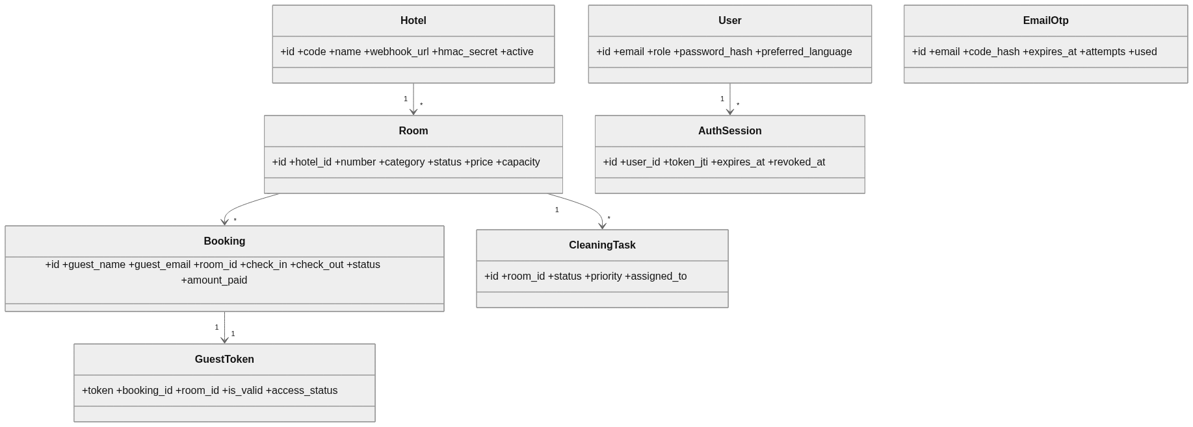
Figure 6.1 — Core domain class diagram.

6.2 Use Case Diagram
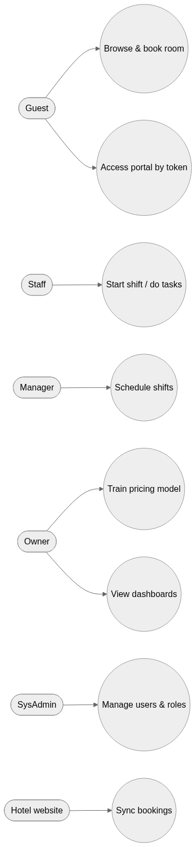
Figure 6.2 — Use case overview.

6.3 Component Diagram
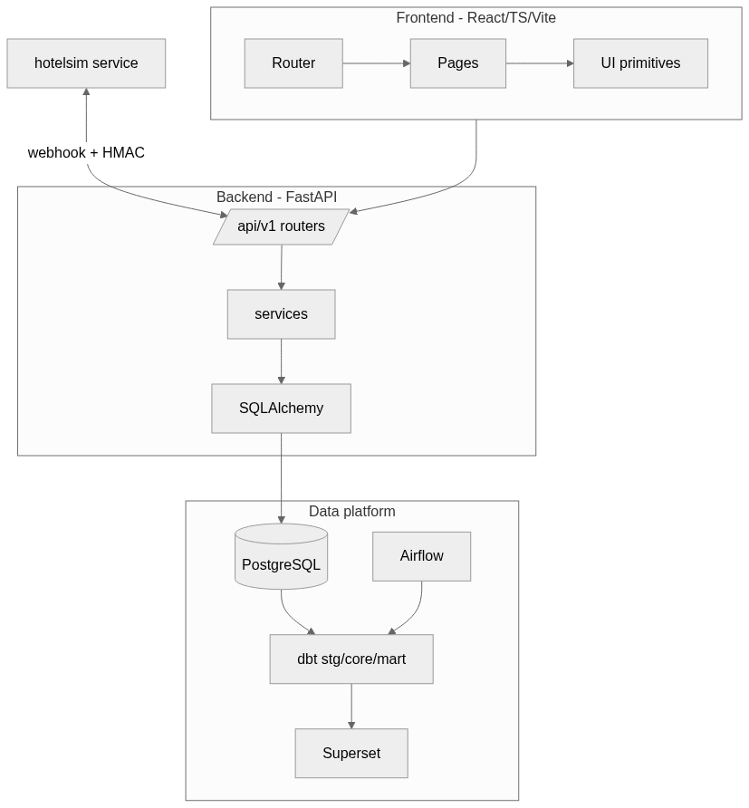
Figure 6.3 — System component diagram.

6.4 Database Diagram (ER)
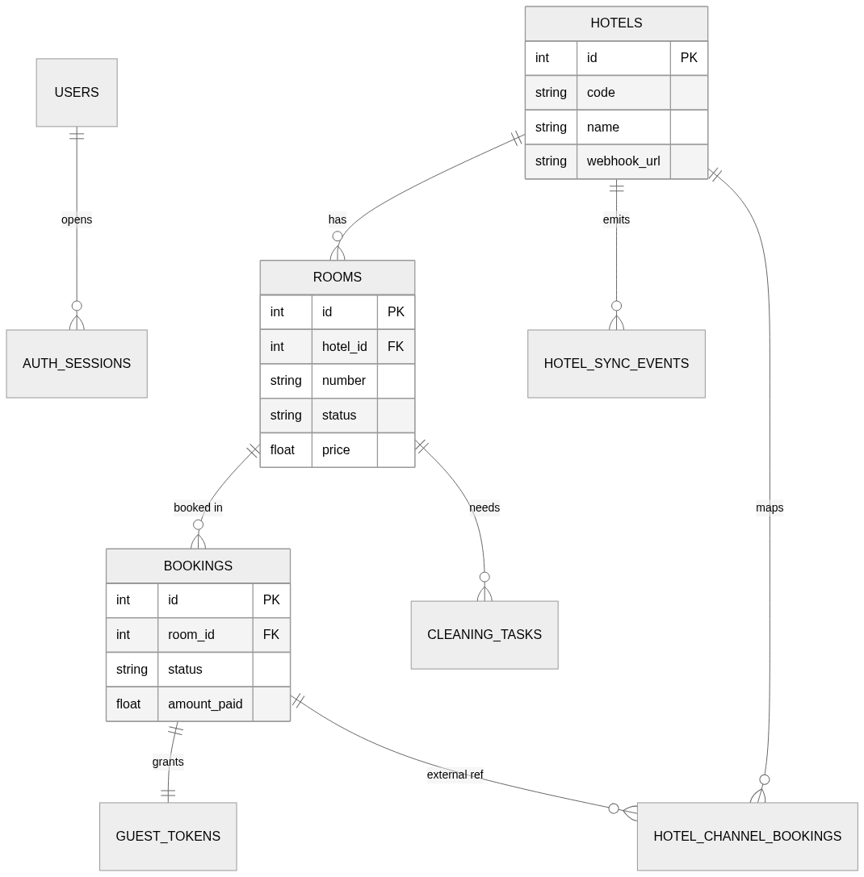
Figure 6.4 — OLTP entity-relationship diagram (public schema).

6.5 Data Flow Diagrams
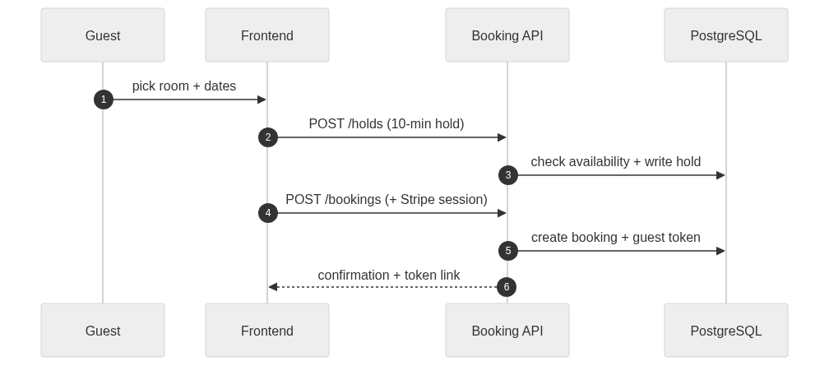
Figure 6.5a — Booking & hold flow.

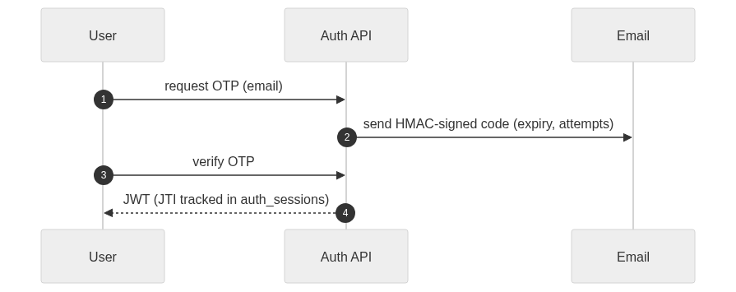
Figure 6.5b — Email-OTP authentication flow.

Figure 6.5c — ML pricing pipeline.

6.6 Deployment Diagram
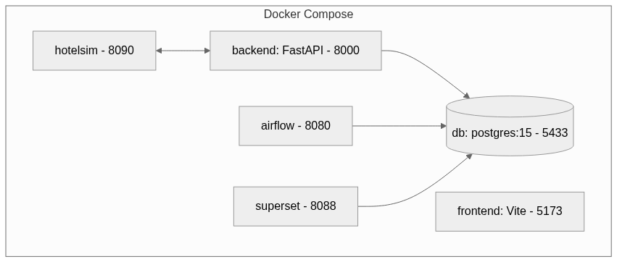
Figure 6.6 — Local deployment (Docker Compose).

7. Tools & Technologies Used
Layer | Technology
Backend | Python 3.11/3.12, FastAPI, Uvicorn
Auth | JWT (python-jose), bcrypt/passlib, HMAC OTP
ORM / Migrations | SQLAlchemy, raw SQL migrations + startup bootstrap
Database | PostgreSQL 15 (prod), SQLite (tests), DuckDB (dbt local)
ML / Pricing | scikit-learn, pandas, numpy
Payments | Stripe
Warehouse | dbt Core (dbt-postgres / dbt-duckdb)
Orchestration | Apache Airflow
BI | Apache Superset
Frontend | React 19, TypeScript, Vite, Zustand, React Router
Sync simulator | FastAPI + SQLite + vanilla HTML/JS (hotelsim)
CI / Hooks | pre-commit, Ruff, SQLFluff, GitHub Actions, Docker Compose

8. Features Implemented
Feature | Description | Owner | Sprint
OTP auth + JWT | Passwordless login, role-gated sessions | Dair/Atai | 1
Room & inventory | CRUD, availability, holds | Dair/Atai | 2
Booking + guest token | Reserve, confirm, cancel; token portal | Dair/Turat | 2/5
ML pricing engine | Per-hotel training, backtest, publish | Dair/Atai | 3
Staff & tasks | Shifts, round-robin housekeeping | Dair/Turat | 4
Stripe payments | Checkout session + webhook | Dair | 5
Hotel-sync simulator | Two-way HMAC sync + mini-site | Atai | Post-MVP
Data warehouse | dbt stg/core/mart + SCD2 | Atai | Post-MVP
Airflow ELT | Nightly dbt orchestration | Atai | Post-MVP
Superset BI | Occupancy / RevPAR / loyalty dashboards | Atai | Post-MVP

9. Website Mock-ups

9.1 PC Browser View
Admin dashboard, Booking portal, Guest page, and Staff planner on desktop. [Insert screenshots — capture from the running app at localhost:5173.]

9.2 Mobile View
Responsive layouts for the booking and guest flows. [Insert mobile screenshots — narrow-viewport captures.]

10. Data Architecture, Synchronization & BI (Atai)
This chapter details the data layer: the six-schema architecture, the multi-hotel synchronization simulator, the dbt data warehouse, Airflow orchestration, and Superset BI.

10.1 Six-Schema Architecture
- public — OLTP source of truth (rooms, bookings, holds, tasks, guest_tokens, users, hotels, sync tables).
- stg — staging mirror with ETL technical columns.
- core — dimensional warehouse (dim_dates/hotels/room_types/rooms/guests, fct_bookings, SCD2 snapshot).
- mart — analytics marts (occupancy, RevPAR, loyalty).
- ml — feature-engineered pricing dataset.
- pricing — pricing engine tables (snapshots, decisions, published prices, model registry, jobs, config).

10.2 Hotel-Site Synchronization (multi-hotel, two-way, HMAC)
A standalone hotelsim service plays the role of an external hotel website. Bookings made there are pushed to the PMS as HMAC-signed webhook events; PMS-side changes (e.g. a cancellation) are pushed back to the hotel. Idempotency is enforced by a unique event id; anti-echo is guaranteed by call-site separation (inbound writes never re-publish).
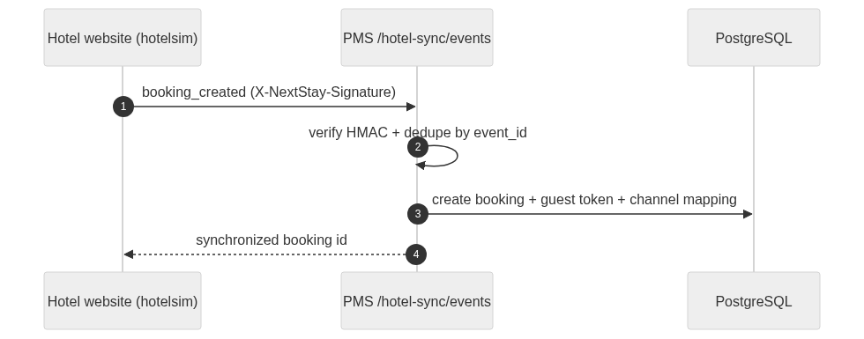
Figure 10.1 — Inbound sync: hotel website → PMS.

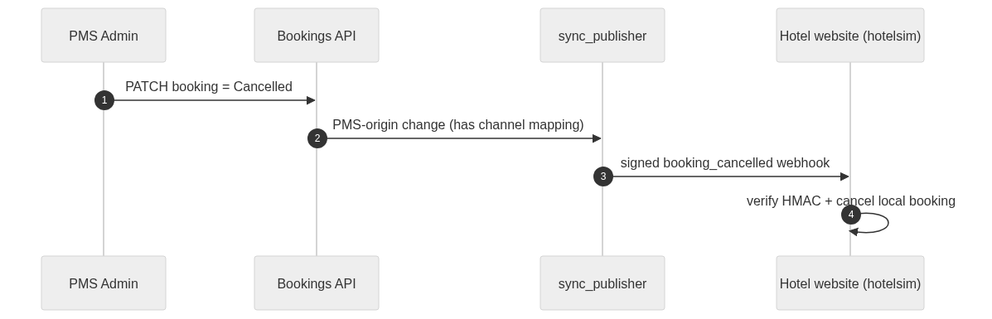
Figure 10.2 — Outbound sync: PMS → hotel website (anti-echo).

10.3 Data Warehouse (dbt)
dbt transforms the OLTP source into a dimensional model. Staging reads live public.* tables on the PostgreSQL target (and CSV seeds on the DuckDB local target). Core builds conformed dimensions, a booking-grain fact, and a SCD2 snapshot of room price/status history. Marts compute occupancy, RevPAR, and guest loyalty. The build is fully tested (unique / not-null / relationships / accepted-values / a custom occupancy-range test) — 49 checks pass on both targets.
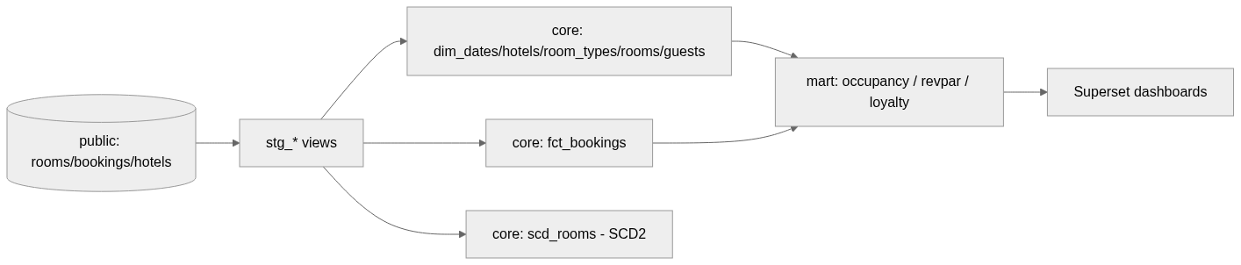
Figure 10.3 — Warehouse data flow (OLTP → stg → core → mart → BI).

10.4 Orchestration (Airflow)
An Airflow DAG (nextstay_dbt_elt) runs the warehouse build nightly against PostgreSQL as a linear pipeline. It was validated with `airflow dags test`: all tasks succeeded and dbt's data tests passed.
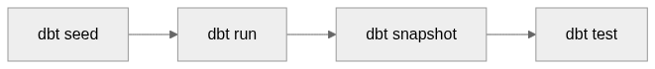
Figure 10.4 — Airflow ELT DAG (nextstay_dbt_elt).

10.5 Business Intelligence (Superset)
Superset connects to the warehouse and exposes the marts as datasets, surfaced on the “NextStay — Hotel Analytics” dashboard: occupancy by date, RevPAR by date, and guest loyalty tiers. [Insert dashboard screenshot from localhost:8088.]

10.6 End-to-End Validation
The full stack was brought up with Docker Compose (db, backend, hotelsim, airflow, superset) and exercised end-to-end: a booking made on the hotel website appeared in the PMS with a channel mapping and a processed sync event; a cancellation in the PMS propagated back to the hotel site; duplicate events were ignored idempotently; an invalid token/signature was rejected with HTTP 401; and the dbt warehouse rebuilt green on PostgreSQL, feeding the Superset dashboards.

