End User Documentation

This document will give you a step by step guide on how to navigate, and successful utilise, our system.

1. To access the program, unzip the file into the folder that you want and navigate to the Jar file and double click it.
2. This should start to execute our program
3. 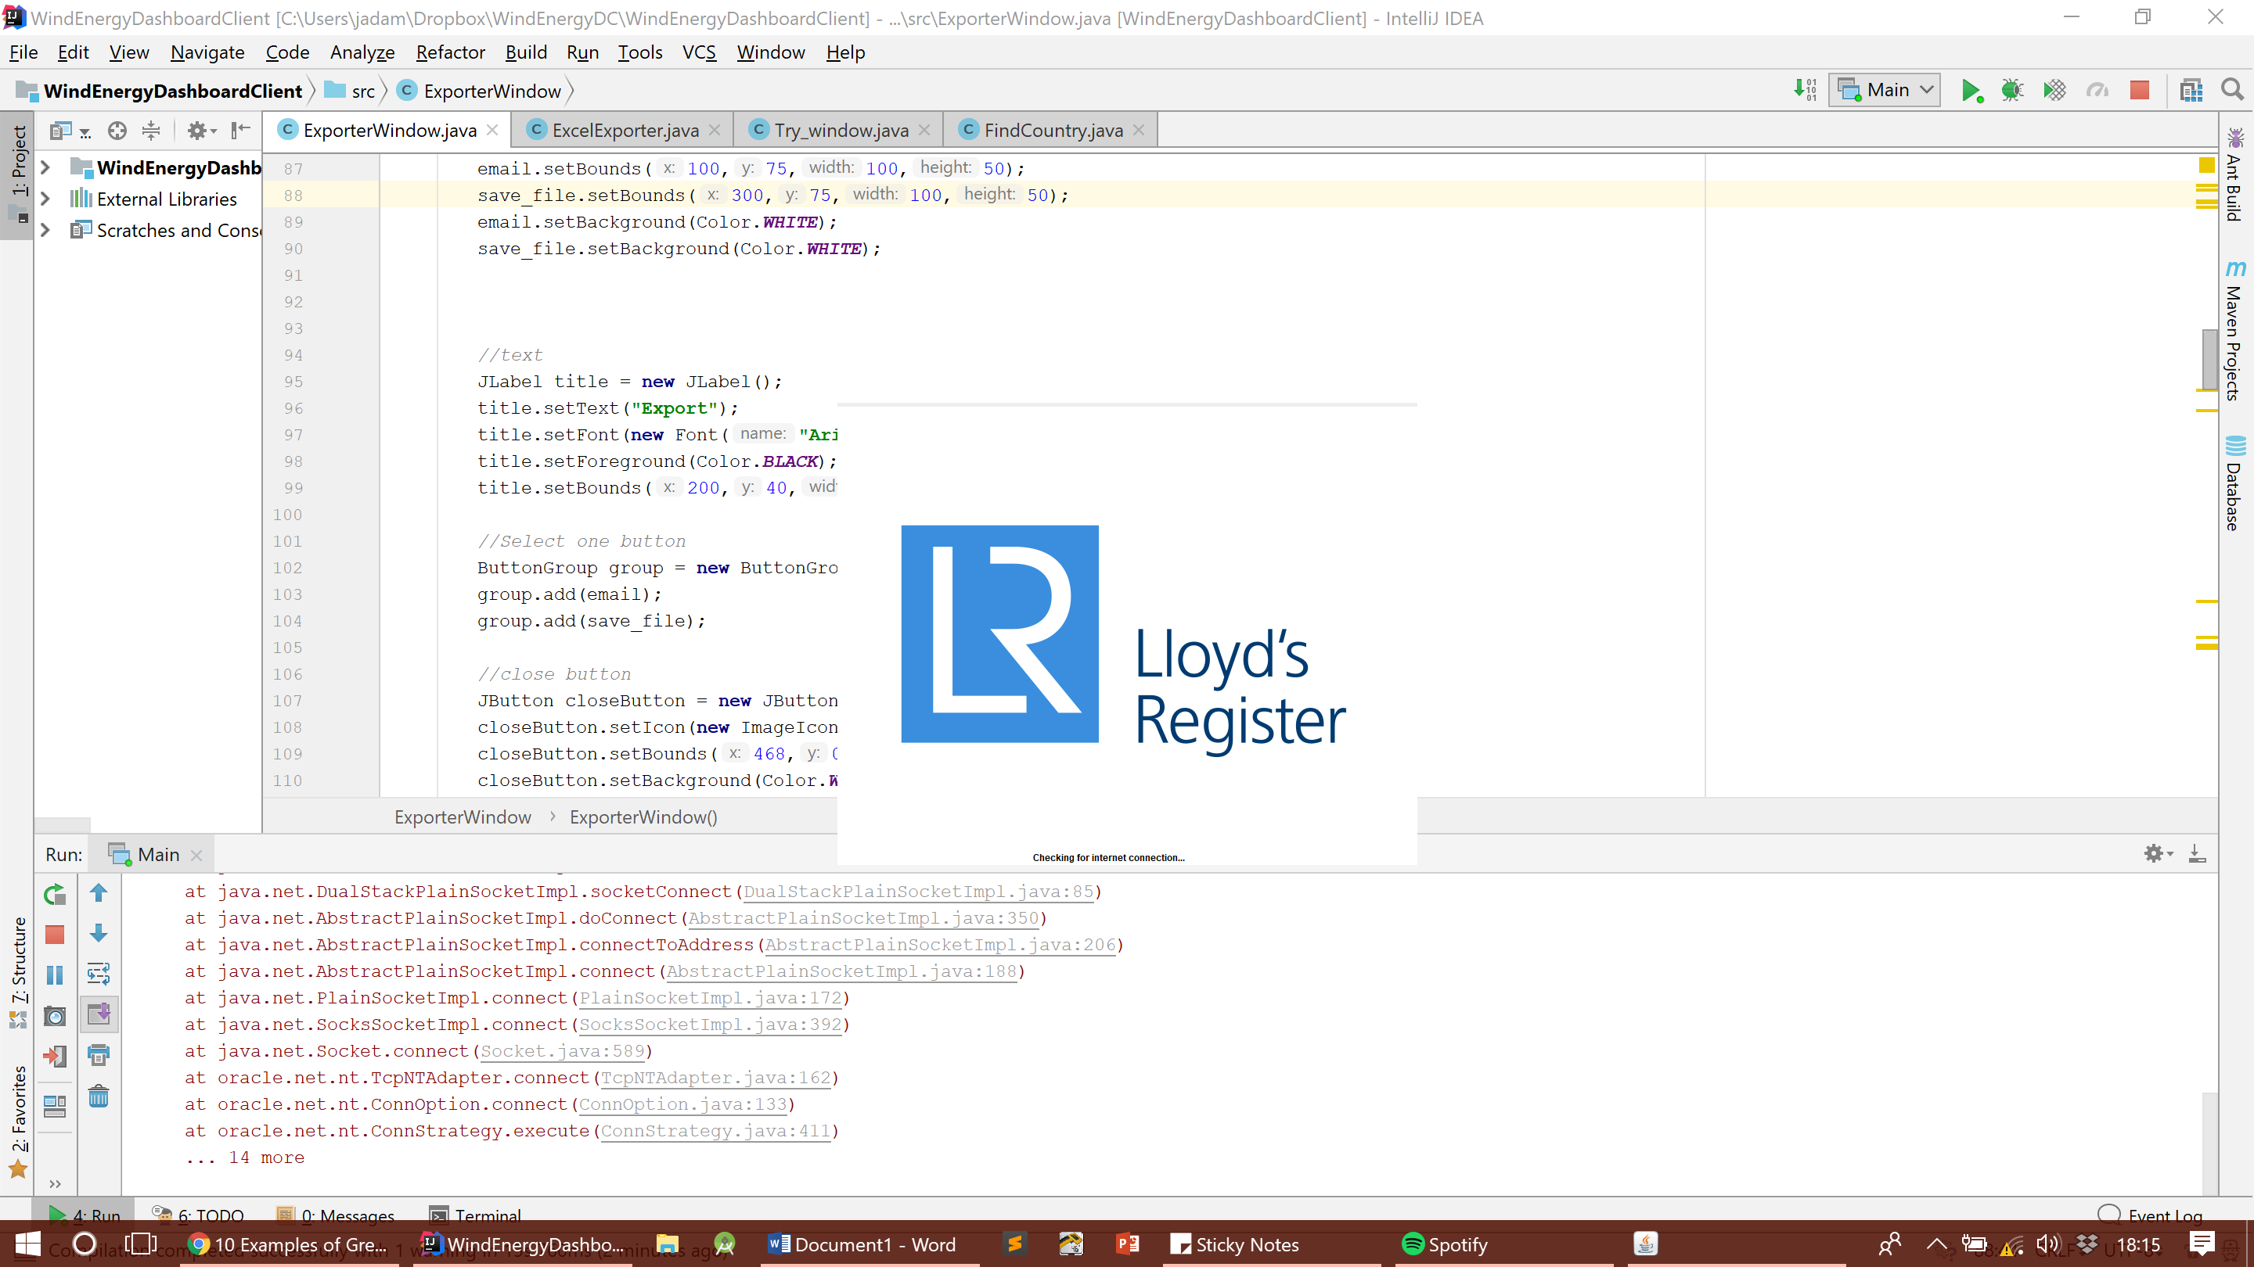The opening screen should be like below, where it will check to see if there is a network connection as this is a necessary requirement when using our system.
4. 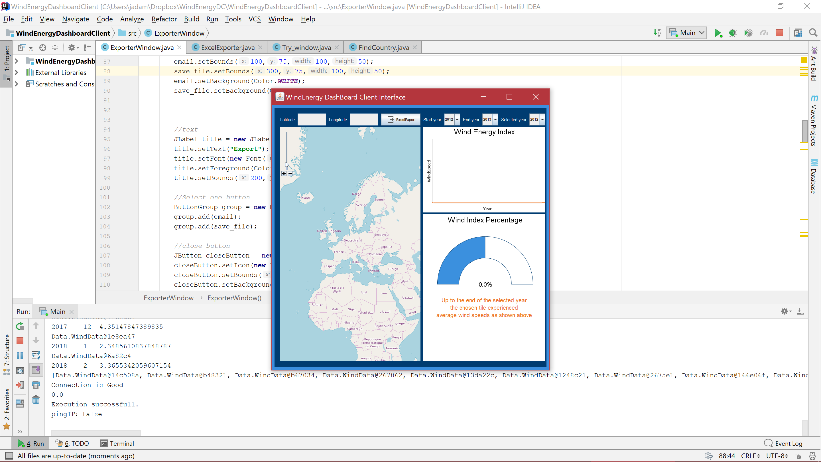It will then get placeholder data, and open up to a screen looking like the following:
5. To input Longitude and Latitude, you can use the text boxes which can be seen below
6. 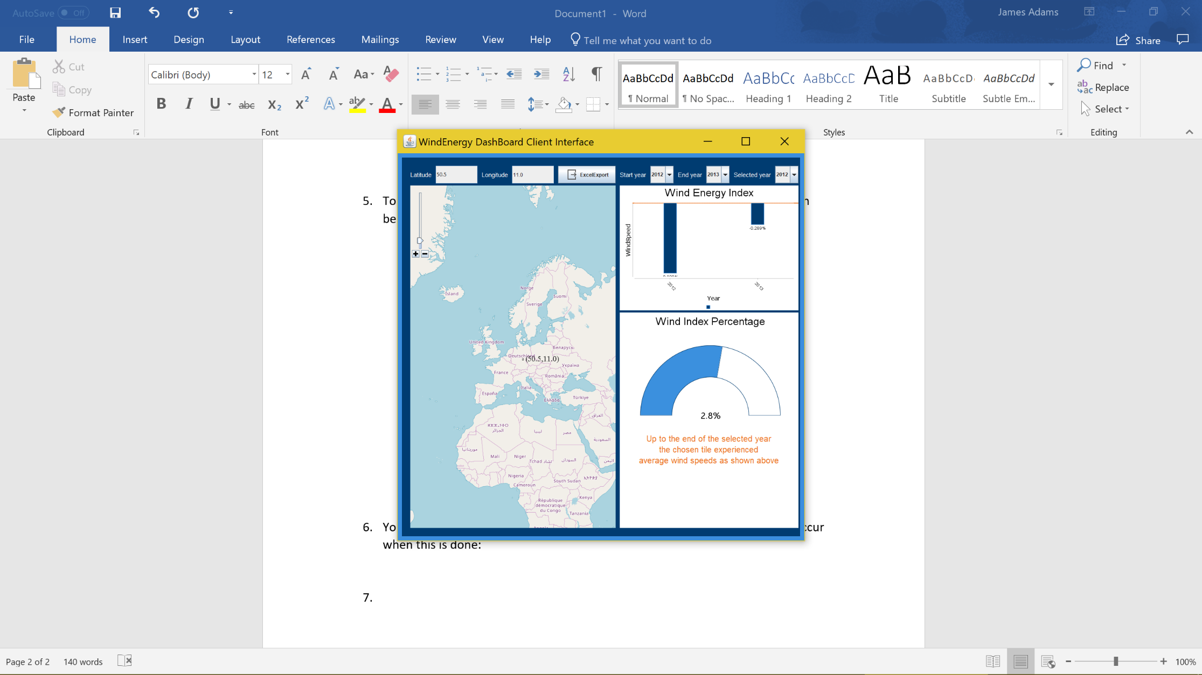You can do the above, or select a location on the map, which should update the graphs to show the information of the selected location, show the coordinates on the map and update the Longitude and Latitude. This can be seen below:
7.  To alter the timeframe of the displayed graphs, you can select the Start and End years, with these being regarding the bar char, the bar chart is able to display a wide range of data if there is data available. The selected year field will alter the speedometer as this only displays 1 year of data.
8. To export the current information selected, click the Excel Export button which will open a popup window. You can then select the file location for the file to be saved using the Choose file location button. You can do that, or manually input the file location in the File save location textbox. Once that is done, you can click the Save File button and It will create an excel file which the graphs and information inside.



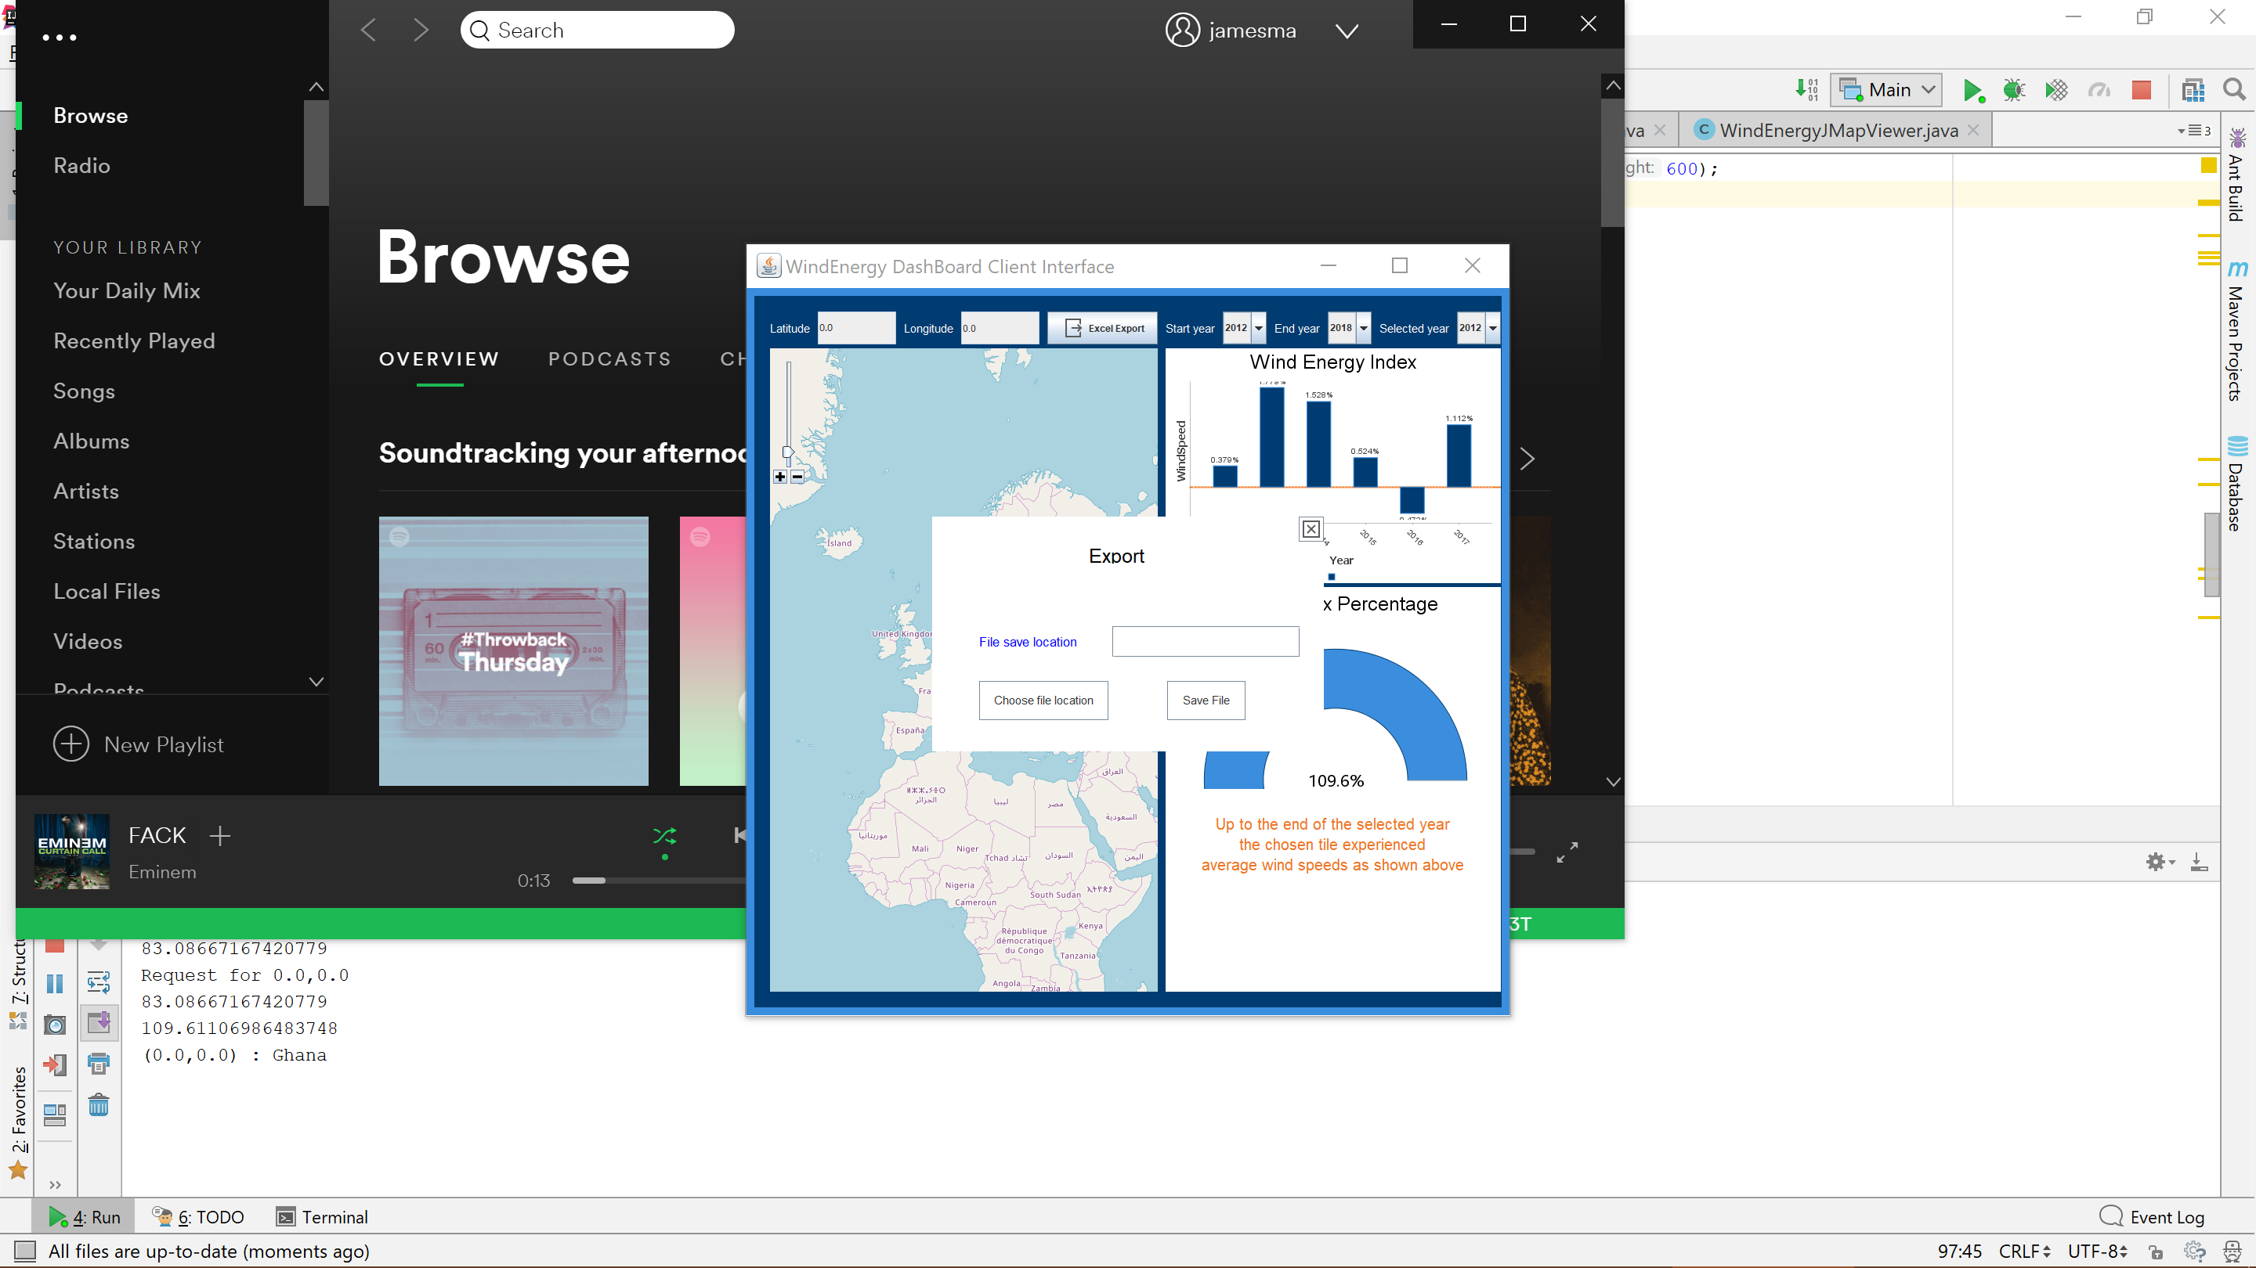

1. The map can be used just like any other normal map, with the scroll wheel being used to zoom in and out, or you can use the ‘+’ and ‘-’buttons on the upper left hand corner. To navigate the map, you can left click and move around.