**Lane Path Geometry (Lane Drive Path)**

1. “Each Lane has a single 3D Lane Path geometry, or Lane Drive Path, representing a **nominal** path through the lane.

Lane Path Geometries are expected to be 3D continuous where they meet at Lane Group Connectors.

Lane-level geometries (e.g. lane boundary lines, lane paths, lane group reference lines) are represented by polylines. Each polyline consists of an ordered series of 2D or 3D shape points.”

It seems like HERE maps represent roads as consecutive points consisting of latitude and longitude. This representation does not include curvature. My planning algorithms so far required initial and final curvature for path planning. A simple spline interpolation algorithm can be used here to derive initial and final curvature.

We can also check whether the vehicle will stay in road throughout the trajectory or not easily with this representation. For this case spline interpolation may not be necessary.

Link for lane geometry information:

<https://developer.here.com/documentation/here-lanes/dev_guide/topics_api/lanes/com.here.hdlm.protobuf.schema.v1.lane.geometrypolyline.lanegeometry.html>

This link states that the deviation from real road is set to 10 cm maximum and the roads are represented as polylines. Therefore simple spline interpolation may be used.

<https://developer.here.com/documentation/here-lanes/dev_guide/topics/hdlm2-appendix-lane-model-geometry-polyline-sampling.html>

I also have found some calculations for typical roads and limits for vehicle speeds and turning radii.

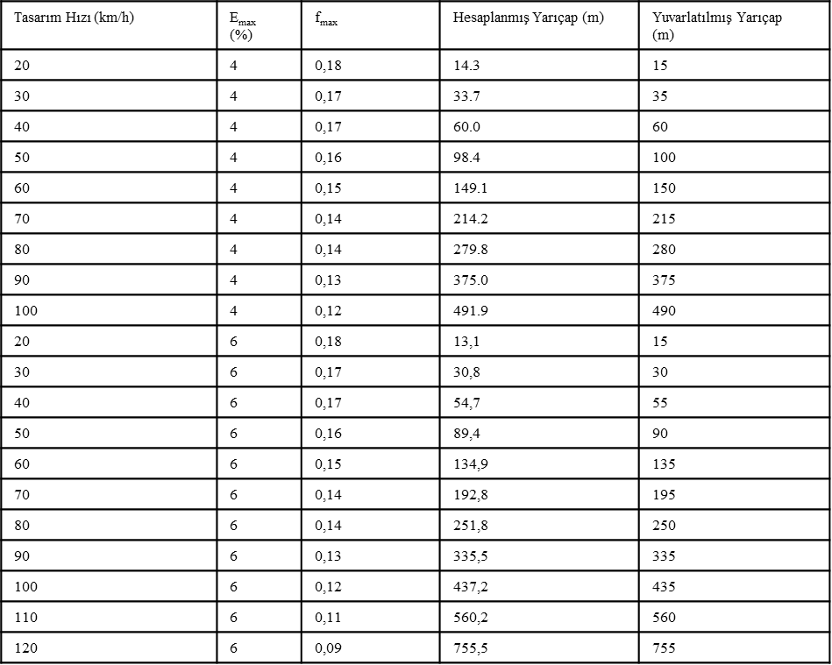

Since I mostly consider highway scenarios I have picked my car’s velocity as 100 km/h. Therefore minimum turning radius is 435 meters.

1. Tried to find a way to estimate DeltaX similar to DeltaY. This would help me to better generate path candidates. Not sure if it exists therefore researched the thesis and the references. The thesis directs to [60] and this paper directs to [16]. I couldn’t find the exact equation. ChatGPT produces some results but I don’t think those results are exactly implementable. I do not want to spend more time on it.

Papers:

Simple clothoid lane change trajectories for automated vehicles incorporating friction constraints [60]

Smooth Local-Path Planning for Autonomous Vehicles [16]

1. Tried to generate paths with exact final heading rather than generating a variety of curves by changing final heading. For this implementation the path lengths of curves are varied. Elementary curves are used.

The red path is the real path. (Radius = 490meters, Path Length = 98 )

The result:



Figure 1: All paths

Figure 3: Data points at high deviation parts

Figure 2: Close up to destination point

All paths seem to reach to goal. However, as seen in Figure 3 the deviation is way too high. The vehicle leaves the lane if it follows the generated path. The first part and the final part of the generated curves seems to be okay. At this point I thought now may be the time to generate intermediate paths. I thought I could divide the road into a sensible number of subroads. Next section describes this procedure.

1. In this implementation the total path is divided to a number of segments. Number of segments should be varied according to path length. Information known about the road consists of the curvature of the road and the requested path length. Considering real cases these information can be gathered. Again heading is not varied

For every segment 100 different path lengths are tried. After calculating the first segment the second segment’s initial point is randomly selected between final points of first segment’s path candidates and the procedure keeps calculating. Constant curvature is assumed therefore if the path calculation is successful for the first segment, the path calculation will be successful for second segment as well.

Red curve is the real path.

Here are the results:

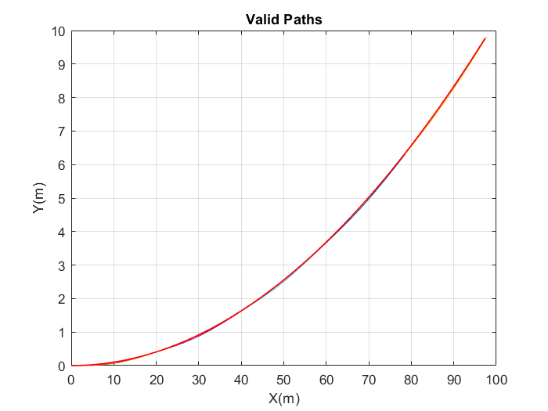

Figure 4:Overall result for 5 path segments

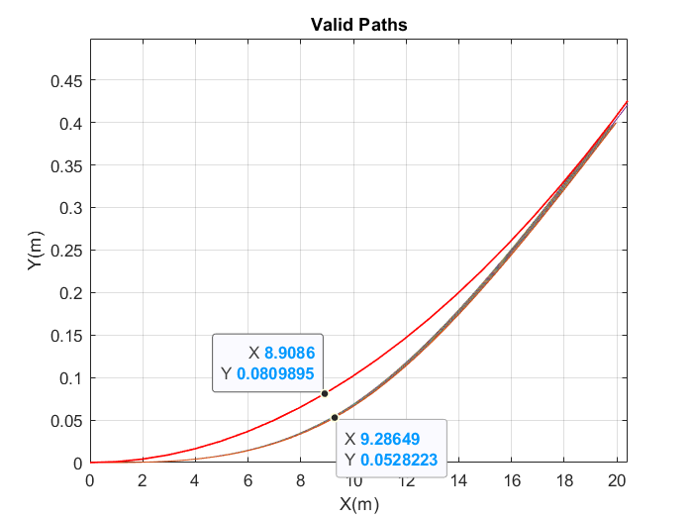

Figure 5: Close up to first segment of generated paths

Figure 5 show that the generated paths deviate from real road more than 50 centimetres. This performance is not acceptable since it would lead the vehicle out of the lane.

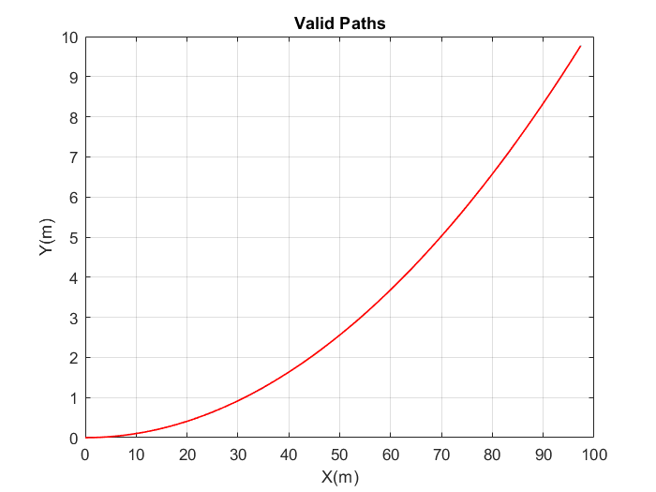

Figure 6: Overall result for 10 path segments

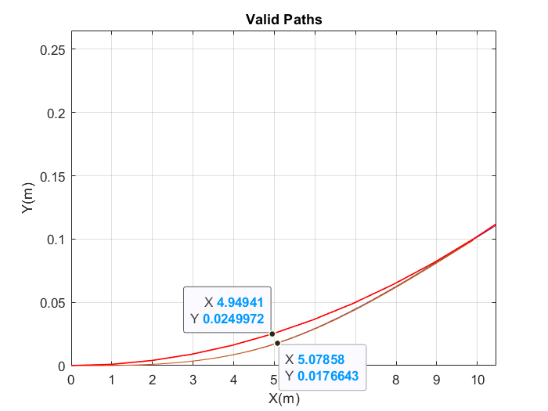

Figure 7: Close up to first segment of generated paths

Figure 7 shows that the deviation is around 10 centimetres. This performance is more acceptable.