
OPTIYOU 3D Plantar Scanner Data Report

No. | 20251104003 | Date | 2025-11-04 | Time | 23:38:55 | Store | tuerqi020001 | Address
Name | çiğdem öztürk | Gender | Female | Age | 50 | Tel | 1
Thumb analysis：
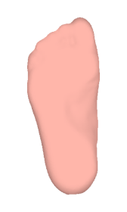 |  | 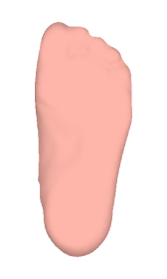
Left foot |  |  | Right foot
9.3 | Thumb angle(°) |  | 7.5
Normal Hallgux | Type |  | Normal Hallgux
Evaluation criteria:Normal: 0 °~10 °Mild: 10°~20 °Moderate:20°~30 °
Severity: > 30 °
Heel Analysis：
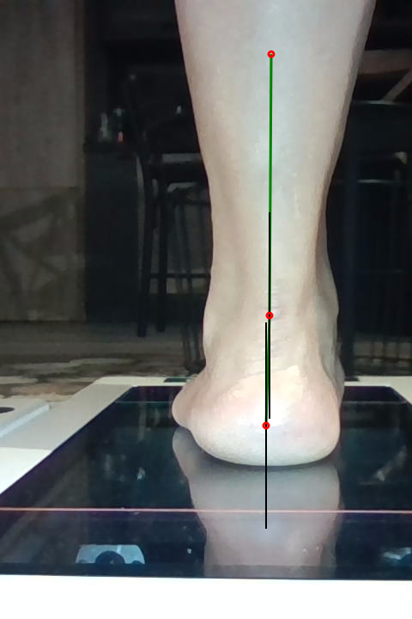 |  | 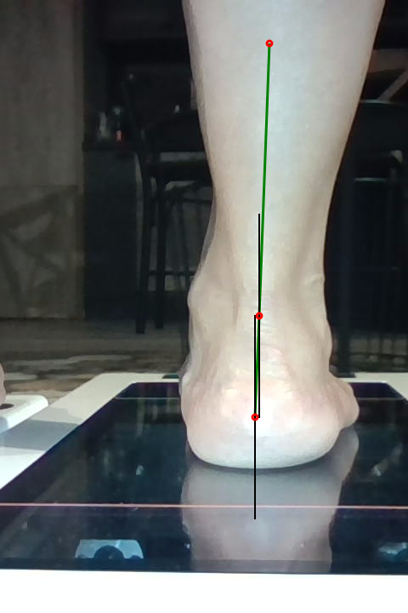
Left foot |  |  | Right foot
1.8 | Heel angle(°) |  | 2.4
Normal Heel | Heel type |  | Normal Heel
0.4 | Knee angle(°) |  | 2.1
Normal Heel | Knee type |  | Normal Heel
Normal: 0 °~4 ° Mild: 4 ° ~ 8 ° Moderate: 8 °~15 °Severity: >15 °
Schematic diagram of heel inversion:
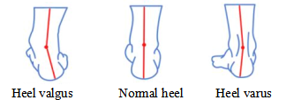

Arch analysis：
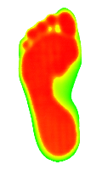 |  | 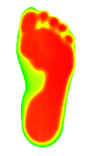
Left foot |  |  | Right foot
Mild Flat | Arch Type |  | Mild Flat
0.278 | Arch Index |  | 0.269
low Left foot high

low Right foot high

High arch foot: < 0.21Normal arch: 0.21 ~ 0.26Mild flatfoot: 0.26 ~ 0.28
Moderate flatfoot: 0.28 ~ 0.3
Arch height：
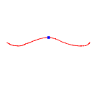 |  | 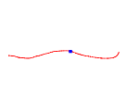
Left foot |  |  | Right foot
18.2 | Arch height（mm) |  | 13.4
0.953 | Arch width factor |  | 0.873
Schematic diagram of arch width coefficient:
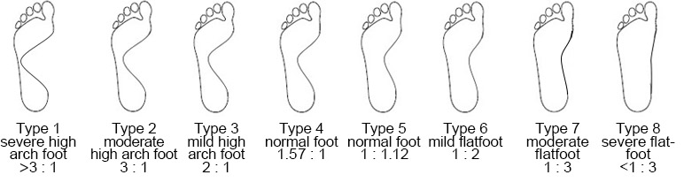

Parameter dimension measurement
Length measurement
Item description | Left foot（mm） | Right foot（mm）
Foot length | 222.8 | 224.2
Sole length | 214.6 | 215.6
Arch length | 99.7 | 92.0
First meta length | 161.5 | 162.6
Fifth meta length | 141.5 | 142.4
Thumb bumps length | 200.6 | 201.0
Foot flank length | 91.3 | 91.9
Heel center length | 33.5 | 34.0
Heel margin length | 8.2 | 8.7

Width measurement
Item description | Left foot（mm） | Right foot（mm）
Foot width | 90.5 | 93.2
Slant width | 92.7 | 95.4
Toe width | 82.6 | 87.1
Arch outside width | 34.5 | 31.9
Foot flank width | 6.2 | 5.0
Heel center width | 67.6 | 65.0
Total heel width | 40.6 | 38.6

Height measurement
Item description | Left foot（mm） | Right foot（mm）
Arch height | 18.2 | 13.4
First meta joint height | 2.1 | 1.9
Heel protrusion height | 14.3 | 15.9

Angle measurement
Item description | Left foot(°) | Right foot(°)
Thumb angle | 9.3 | 7.5
Pronator angle | -1.8 | -2.4
Knee angle | -0.4 | -2.1

Shoe size/Insole recommendation
Item description | Left foot | Right foot
Shoe size | 36(WD) | 36(WD)
Insole recommendation | 36(WD) | 36(WD)

Service demand
Item description
Customized insole service | □Yes | □No
Recommendation:
Low arch and heel valgus usually indicate excessive pronation (foot rolling inward in the gait cycle). Excessive varus may cause foot, ankle and knee injuries, and further affect the balance of pelvis, spine and shoulder. Stability shoes and motion control shoes have solid inner support, which is most suitable for over-pronated foot type;High arch and heel inversion, neutral shock absorption shoes are the most suitable. Normal arch and heel are most suitable for stabilizing shoes.For any type of arch or heel deformity, proper design and manufacture of foot correction insole can promote the normal biomechanical function of lower limbs, better adjust your whole body, improve your posture, and prevent injury or damage to your body。

