Falsifying 15-Minute Crypto Prediction
Research report · Final-year project handoff · 28 September 2026
A leakage-controlled evaluation of gradient boosting, recurrent networks, quantile forecasting and rule filters on BTC, ETH and SOL, with a measured detection power for the evaluation harness itself.
Code: crypto-research-desk.zip · Data frozen: 2026-09-28 15:14:59 UTC

Abstract
Short-horizon cryptocurrency prediction is a common machine-learning exercise, and published results often report accuracies that a near-random-walk price series should not allow. We ask whether signals from public market data can predict 15-minute outcomes for BTC, ETH and SOL well enough to trade after costs, and how much a negative answer is worth. We build an evaluation harness combining triple-barrier labels, purged k-fold cross-validation with an embargo, label-uniqueness weights, cost-aware one-position simulation, the deflated Sharpe ratio (DSR) and random-entry baselines, run on a frozen data snapshot, and we measure its detection power by planting signals of graded strength.
LightGBM, XGBoost, LSTM and BiLSTM classifiers (27 features, 11 more from open interest and order-book data) fit their training folds to 75–79% accuracy but reach only 36–43% out of fold. They exceed the majority-class baseline on accuracy, yet direction accuracy averages 50.8% and no result is significant; most models' log-loss is worse than the class prior. None of fifteen model–asset results reaches DSR 0.95 (maximum 0.38), and the two gradient-boosting libraries agree closely. The harness detects a planted feature correlated 0.33 with the label and misses a profitable one correlated 0.20, so the null excludes strong signals but not modest ones. Quantile range forecasts beat volatility scaling by at most 3% at 15 minutes, lose to it at longer horizons, and flagged none of the liquidation-sized 15-minute dips in advance. An ablation of a trader's rule filters, replicated on two non-overlapping windows, shows their effect changing sign.
Keywords: cryptocurrency, perpetual futures, triple-barrier labelling, purged cross-validation, deflated Sharpe ratio, LightGBM, LSTM, BiLSTM, quantile regression, data leakage, positive control, statistical power.

1 Introduction

1.1 Problem statement
A retail trader on the MEXC exchange trades cryptocurrency perpetual futures at 45 to 60 times leverage, holding positions for minutes to an hour and reading 15-minute candles. At 60x, an adverse move of about 1.67% liquidates the position. The trader wanted to know whether any signal computed from market data could tell him which way the next 15 minutes to an hour would go, well enough to pay for trading costs.
That practical question sits on top of a methodological one. Short-horizon price prediction is a popular machine-learning exercise, and published results often report directional accuracies far above what a near-random-walk price series allows. Many of these results come from well-known evaluation mistakes: labels that overlap in time and leak across ordinary cross-validation folds, features or scalers computed with future data, bidirectional networks that read the future of the points they label, many variants tried with only the best reported, and costs ignored (López de Prado, 2018; Bailey et al., 2014; Kapoor and Narayanan, 2023). A trader who acts on such a result pays for the mistake directly.
The problem this project solves is therefore twofold: (1) give a definite, cost-aware answer to whether 15-minute signals from public market data carry a tradeable edge, and (2) build an evaluation harness whose negative answers can be trusted, because it is shown to detect planted signals and its sensitivity is measured.

1.2 Research questions
- RQ1. Do supervised classifiers (LightGBM, XGBoost, LSTM, BiLSTM) predict 15-minute triple-barrier outcomes on BTC, ETH and SOL better than naive baselines, in standard classification metrics?
- RQ2. Does any predictive signal survive realistic trading costs, one-position-at-a-time execution, correction for the number of variants tried, and comparison against random entries?
- RQ3. How sensitive is the evaluation harness? What is the weakest planted signal it reports as an edge?
- RQ4. Do the trader's rule filters (a multi-timeframe "gate cascade") improve a mechanical strategy, and is any effect stable across time windows?
- RQ5. Do conditional quantile forecasts of price ranges beat a rolling-volatility baseline, and do they anticipate liquidation-sized moves?

1.3 Contributions
- An open, reproducible evaluation harness combining triple-barrier labels, purged k-fold cross-validation with embargo, uniqueness weighting, cost-aware trade simulation, the deflated Sharpe ratio, random-entry baselines, and positive controls. It runs on a frozen data snapshot.
- A detection-power curve for the harness: planted signals of graded strength, pushed through the unchanged pipeline, to measure the weakest edge it can see. Negative results in this area rarely come with such a measurement.
- Negative results for two gradient-boosting libraries matched in capacity (LightGBM and XGBoost), two recurrent networks, quantile regression and rule systems on three assets, reported in both classification and trading terms, with training dynamics and the gap between training and held-out performance.
- An ablation of rule filters replicated on two non-overlapping windows, showing that their effect changes sign.

2 Background and related work

2.1 Predictability of short-horizon returns
The efficient-market hypothesis (Fama, 1970) predicts that past prices carry little exploitable information about future returns once costs are counted. Momentum effects do exist at monthly horizons in equities (Jegadeesh and Titman, 1993), but that evidence does not transfer to 15-minute crypto candles, and this project does not cite it as support for any intraday rule. Volatility, unlike direction, clusters and is partly predictable; this is the basis of the GARCH family and the reason RQ5 asks about ranges rather than direction.

2.2 Evaluation pitfalls in financial machine learning
López de Prado (2018) describes the core problems this harness addresses: labels defined over future windows overlap, so ordinary k-fold validation leaks test information into training; overlapping samples are not independent; and a fixed-horizon label ignores the path a trade actually takes. His remedies are triple-barrier labels, purged k-fold with an embargo, and sample weights based on label uniqueness. Bailey and López de Prado (2014) introduce the deflated Sharpe ratio, which corrects the best observed Sharpe ratio for the number of trials and for non-normal returns. Bailey et al. (2014) show how easily backtests overfit when many configurations are tried. Harvey, Liu and Zhu (2016) and White (2000) make the same point about multiple testing in the discovery of return predictors.

2.3 Data leakage
Kaufman et al. (2012) define leakage as information in training that would not be available at prediction time. Kapoor and Narayanan (2023) survey leakage across ML-based science and find it widespread, including preprocessing on the full dataset before splitting and temporal leakage. For sequence models, a bidirectional network that labels every timestep reads the future of each interior step; this is a specific form of temporal leakage relevant to many published BiLSTM price predictors.

2.4 Models
Gradient-boosted decision trees (Friedman, 2001) are a strong default for tabular data. The two most used implementations are XGBoost (Chen and Guestrin, 2016), which chooses trees with a regularised second-order objective, and LightGBM (Ke et al., 2017), which uses histogram-based, leaf-wise tree growth. Long short-term memory networks (Hochreiter and Schmidhuber, 1997) and their bidirectional form (Schuster and Paliwal, 1997) are the most common neural models for price sequences. Quantile regression (Koenker and Bassett, 1978) predicts conditional quantiles through the pinball loss. Probability forecasts are scored with proper scoring rules such as the Brier score (Brier, 1950) and log-loss (Gneiting and Raftery, 2007).

3 System overview
The project has three parts that share a data layer. The live desk produces trade reads for the trader. The research harness tests whether any mechanical signal survives honest evaluation; it is the subject of this report. The journal records every live read and grades it afterwards. An AI coding agent (Claude Code) wrote most of the code in conversation with the trader and follows a written operating manual, SKILL.md, when producing reads. OpenAI's Codex wrote the MEXC research desk, which was merged in later.
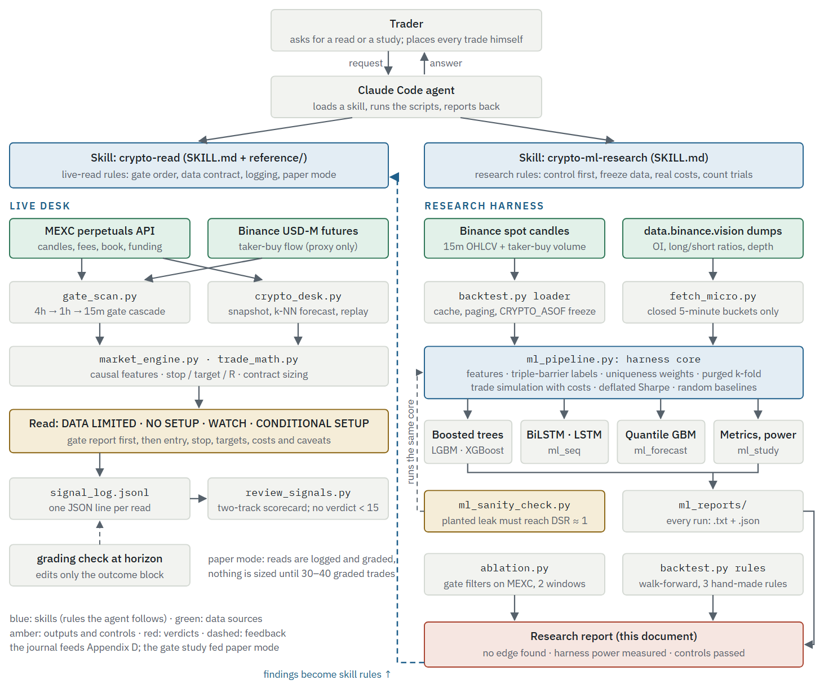
Figure 1. How the whole project fits together. The trader works through the Claude Code agent, which follows one of two written skills. The left lane produces live reads and grades them; the right lane is the research harness this report evaluates. Measured findings flow back into the skill rules (dashed blue): for example, the ablation led to demoting the order-flow gate, and the ML nulls led to the rule that no mechanical signal is pitched as an edge.
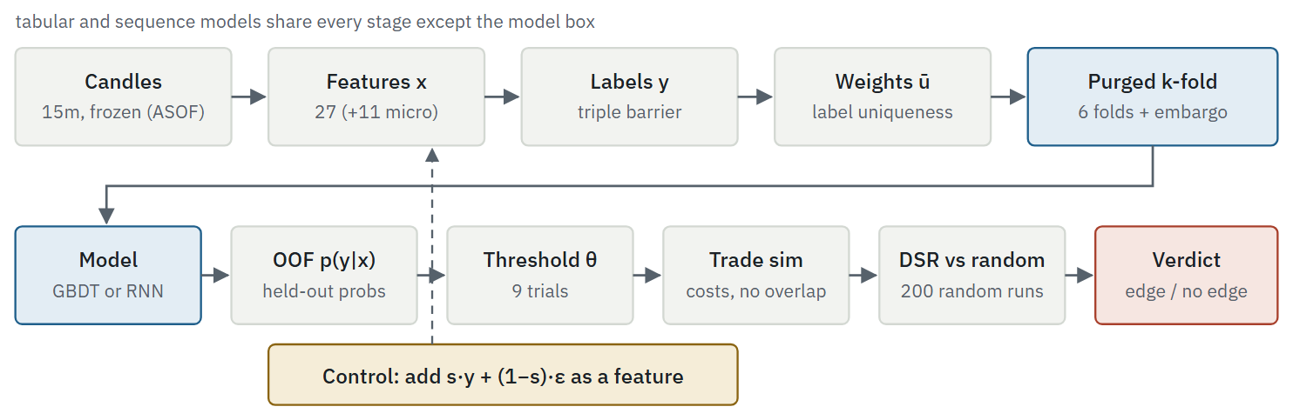
Figure 2. The evaluation pipeline. The positive control (bottom) injects a noisy copy of the true label into the features and runs the identical pipeline; the harness must then report an edge.

4 Data
Source | Content | Used by
Binance spot REST API | 15m OHLCV plus taker-buy volume for BTCUSDT, ETHUSDT, SOLUSDT; 5,000 most recent closed candles (about 52 days) | ML harness, rule backtester
data.binance.vision (futures dumps) | 5-minute open interest, top-trader and global long/short ratios, taker long/short ratio; order-book depth at ±1–5% every ~25 s | ML harness with --micro
MEXC perpetual futures API | 15m OHLCV (no taker-buy field), contract specifications and fees, funding, ticker, order book, trades; about 2,000 candles | live desk, ablation
Binance USD-M futures API | taker-buy volume per candle, as a cross-venue order-flow proxy | live desk, ablation
Table 1. Data sources. No private or paid data is used, and no API keys are required.
Snapshot. All ML experiments in Section 7 read a frozen cache: every run sets CRYPTO_ASOF=1790608499999 (28 September 2026, 15:14:59.999 UTC), so the loader uses only candles closed by that instant and makes no network calls. Each symbol's 5,000-candle window spans 7 August to 28 September 2026.
Preprocessing. Only closed candles are used. Features at bar $i$ use bars $≤i$. Samples with any missing feature are dropped, which removes the first 95 bars (the 96-bar volatility window) and bars without a resolvable label.
Data cleaning. Before the study the cache was re-downloaded in full and 13 candles that had been stored while still forming (holding 10–95% of their final volume) were replaced with their final values. Only closed candles are stored. The ablation study reads MEXC data directly and was not affected.
Instrument mismatch. The ML harness uses Binance spot candles because they offer long free history, while trades happen on MEXC perpetuals. Resting prices agree to about 0.05%, but candle extremes can differ by more (0.36% on one ADA candle), which matters for stops. This is a threat to external validity (Section 9).

5 Methodology

5.1 Labels: the triple-barrier method
Each sample is a hypothetical trade entered at the close $P_{i}$ of bar $i$. Let $σ_{i}={ATR}_{14}(i)/P_{i}$ be volatility as a fraction of price, using Wilder's 14-bar average true range. Two horizontal barriers and one vertical barrier are placed:
$$B_{i}^{+}=P_{i} (1+π σ_{i}), B_{i}^{−}=P_{i} (1−λ σ_{i}), \text{vertical barrier at }i+h,$$
with $π=λ=1.5$ and $h=8$ bars (two hours). With $H_{k},L_{k}$ the high and low of bar $k$, the first touches are
$$τ^{+}=min\{k∈(i,i+h]:H_{k}≥B_{i}^{+}\}, τ^{−}=min\{k∈(i,i+h]:L_{k}≤B_{i}^{−}\}.$$
The label is $y_{i}=+1$ if $τ^{+}<τ^{−}$, $y_{i}=−1$ if $τ^{−}<τ^{+}$, and $y_{i}=0$ if neither barrier is touched by $i+h$. If both barriers are crossed inside the same candle, the order is unknown from 15-minute data; the sample is dropped rather than assumed to win. The realised long-side return used for trading is
$$r_{i}=\left\{\begin{matrix}+πσ_{i} & y_{i}=+1 \\ −λσ_{i} & y_{i}=−1 \\ (P_{i+h}−P_{i})/P_{i} & y_{i}=0\end{matrix}\right.$$
and $t_{1,i}$ records the bar at which the label resolved, which the purging step needs.
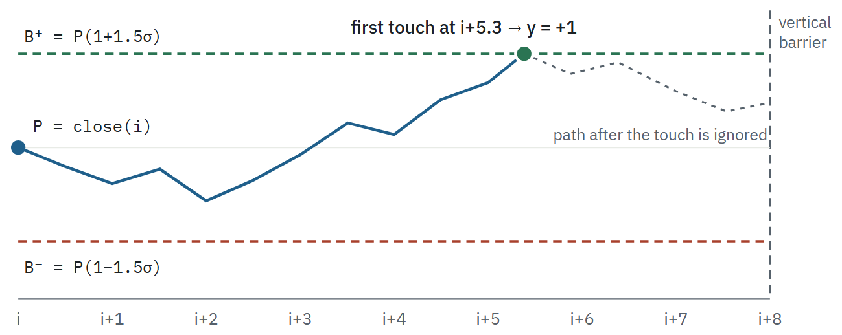
Figure 3. Triple-barrier labelling (illustration). The label is set by whichever barrier the price reaches first. Nothing after that touch affects the label.

5.2 Sample weights: label uniqueness
Consecutive labels share future bars, so samples are not independent. With concurrency $c_{t}$ (the number of labels whose window $[i_{j},t_{1,j}]$ contains bar $t$), each sample's average uniqueness is
ct=j​1ij≤t≤t1,j, uj=1t1,j−ij+1t=ijt1,j1ct.
Models are trained with ${\overset{‾}{u}}_{j}$ as the sample weight. The mean uniqueness is about 0.175 on all three assets, so roughly $N_{\text{eff}}≈N\overset{‾}{u}≈850$ of the ~4,900 samples carry independent information. This effective sample size bounds how precisely any metric can be estimated.

5.3 Validation: purged k-fold with embargo
Samples are split into $K$ contiguous folds in time order. For a test fold covering samples $a$ to $b−1$, let $T_{s}=i_{a}$ and $T_{e}=t_{1,b−1}$. A training sample $j$ is kept only if its label window cannot overlap the test period or the embargo after it:
$$\text{keep }j⇔t_{1,j}<T_{s} ∨ i_{j}>T_{e}+e, e=max\left(h, ⌊0.01 N⌋\right).$$
For sequence models a sample at bar $i$ also reads the $L−1$ bars before it, so its footprint is $[i−L+1, t_{1,i}]$ and the rule becomes $t_{1,j}<T_{s}∨i_{j}−L+1>T_{e}+e$. Without this left-side widening, a training window that starts inside the test block would read test bars. LightGBM uses $K=6$; the recurrent models use $K=5$ because each fold is slower to train. Every model's metrics are computed on out-of-fold (OOF) predictions: each sample is predicted by a model that never trained on it or on anything overlapping it.
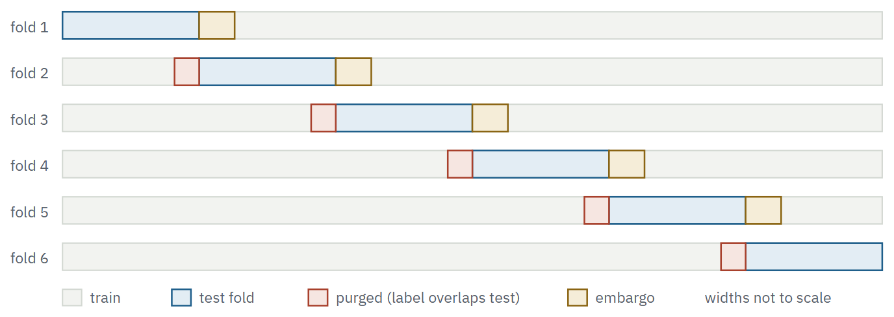
Figure 4. Purged k-fold cross-validation with embargo (K = 6). Purged and embargo regions are drawn wider than their real size (8 bars and max(8, 1% of N) bars) so they are visible.

5.4 Models

5.4.1 LightGBM classifier
A gradient-boosted ensemble of regression trees produces one score per class, $F_{k}(x)=\sum_{m=1}^{M}{η} f_{k,m}(x)$, turned into probabilities with the softmax and trained on the uniqueness-weighted multiclass log-loss with an L2 penalty on leaf values $w$:
pk(x)=eFk(x)l​eFl(x), L=−j​ujlogpyj(xj)+λ22leaves​w2.
Hyperparameters (Appendix A) were fixed before any result was seen and never tuned: 300 rounds per class, learning rate 0.05, at most 15 leaves and depth 4, at least 60 samples per leaf, 80% row and 70% column subsampling, L2 penalty 5. These choices keep capacity low on purpose, since tuning on the evaluation data would add hidden trials. There is no early stopping and no validation split inside the training fold.

5.4.2 XGBoost classifier
XGBoost (Chen and Guestrin, 2016) fits the same additive softmax model but chooses each tree with a second-order approximation of the regularised objective. At round $m$, with per-sample gradient $g_{j}$ and Hessian $h_{j}$ of the weighted log-loss at the current prediction, a tree with $T$ leaves and leaf weights $w_{t}$ is scored by
L(m)=t=1TGt wt+12Ht+λ2wt2+γT, Gt=j∈It​gj, Ht=j∈It​hj,
so the best weight of leaf $t$ is $w_{t}^{*}=−G_{t}/(H_{t}+λ_{2})$, and splitting a node into left and right children is kept only if the gain is positive:
$$\text{Gain}=\frac{1}{2}\left[\frac{G_{L}^{2}}{H_{L}+λ_{2}}+\frac{G_{R}^{2}}{H_{R}+λ_{2}}−\frac{(G_{L}+G_{R})^{2}}{H_{L}+H_{R}+λ_{2}}\right]−γ.$$
For the softmax loss, $g_{jk}={\overset{‾}{u}}_{j} (p_{jk}−1[y_{j}=k])$ and $h_{jk}∝{\overset{‾}{u}}_{j} p_{jk}(1−p_{jk})$, so the uniqueness weights enter both. To compare the two libraries rather than two capacities, XGBoost uses the same 300 rounds, learning rate 0.05, depth 4, 80% row and 70% column subsampling and L2 penalty $λ_{2}=5$, with $γ=0$. The libraries differ in how they grow trees: XGBoost grows each tree level by level to depth 4 (up to 16 leaves), while LightGBM grows leaf by leaf up to 15 leaves. XGBoost limits leaf size by a minimum Hessian sum (min_child_weight = 2.0) rather than a sample count; with the uniqueness weights this corresponds to a floor of roughly 25–50 samples per leaf, somewhat looser than LightGBM's 60. XGBoost runs on one thread, because its parallel histogram sums round differently with different thread counts and that changes some splits (Section 7.4).

5.4.3 LSTM and BiLSTM
Each sample is a window of the last $L=24$ feature vectors (6 hours), $x_{t−23},…,x_{t}∈R^{27}$, standardised with the mean and standard deviation of the training fold only and clipped to $[−8,8]$. A single-layer LSTM with $H=48$ hidden units updates, at each step,
$$\begin{aligned}f_{t}&=σ(W_{f}x_{t}+U_{f}h_{t−1}+b_{f}),&i_{t}&=σ(W_{i}x_{t}+U_{i}h_{t−1}+b_{i}), \\ o_{t}&=σ(W_{o}x_{t}+U_{o}h_{t−1}+b_{o}),&{\tilde{c}}_{t}&=tanh(W_{c}x_{t}+U_{c}h_{t−1}+b_{c}), \\ c_{t}&=f_{t}⊙c_{t−1}+i_{t}⊙{\tilde{c}}_{t},&h_{t}&=o_{t}⊙tanh(c_{t}),\end{aligned}$$
where $σ$ is the logistic sigmoid and $⊙$ the element-wise product. The gates use the sigmoid activation and the cell candidate and output use tanh. The BiLSTM runs a second LSTM from $x_{t}$ back to $x_{t−23}$ and concatenates the two states at the last step, $h_{t}=[{\vec{h}}_{t}; {\overset{⃖}{h}}_{t}]∈R^{96}$. Only the final step feeds the classifier, so both directions stay inside the window and nothing after $t$ is read. The head is dropout ($p=0.3$), a linear layer to 3 logits, and a softmax:
z=Wout Dropout0.3(ht)+bout, p=softmax(z), LB=1|B|j∈B​uj−logpyj.
Training uses Adam (Kingma and Ba, 2015) with learning rate ${10}^{−3}$ and weight decay ${10}^{−4}$, batches of 128, gradient-norm clipping at 1.0, and a fixed 25 epochs with no early stopping. An LSTM layer has $4H(d+H)+8H$ parameters per direction (PyTorch keeps two bias vectors), so with $d=27$ and $H=48$ the LSTM has 14,784 recurrent + 147 head = 14,931 parameters and the BiLSTM 29,568 + 291 = 29,859. The unidirectional LSTM is trained alongside the BiLSTM as a leak detector: on a causal task the bidirectional model should not clearly win.
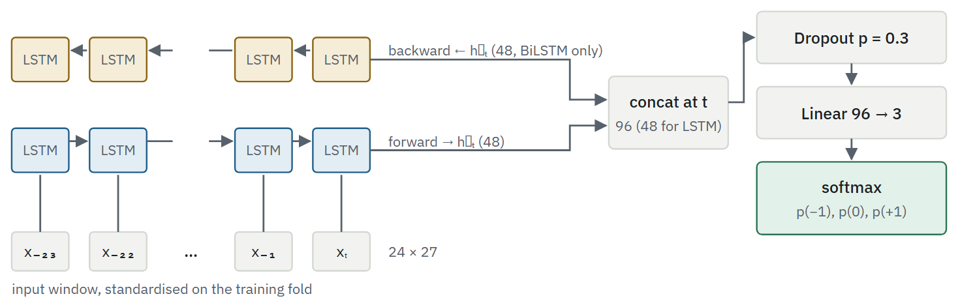
Figure 5. Recurrent classifier. Sigmoid gates and tanh cell activations inside each LSTM cell; softmax on the output. Only the final timestep reaches the head.

5.4.4 Quantile regression for ranges
Instead of direction, LightGBM regressors predict nine conditional quantiles $q∈\{0.01,0.05,0.10,0.25,0.5,0.75,0.90,0.95,0.99\}$ of three targets over $H$ bars: the forward log return $logP_{i+H}−logP_{i}$; the worst dip $\min_{i<k≤i+H}L_{k}/P_{i}−1$; and the best spike $\max_{i<k≤i+H}H_{k}/P_{i}−1$. Each quantile model minimises the pinball loss
$$ρ_{q}(u)=max\left(q u, (q−1) u\right), u=y−{\hat{y}}_{q}.$$
Calibration is the fraction of outcomes below the predicted quantile, which should equal $q$. Skill is measured against a baseline with the same shape as the target: standardise the target by the 20-bar realised volatility ${\hat{σ}}_{20}$, take the empirical quantile of that ratio over the whole sample, and rescale by current volatility, ${\hat{y}}_{q}^{\text{vol}}={\hat{σ}}_{20}\sqrt{H} Q_{q}​\left(y/({\hat{σ}}_{20}\sqrt{H})\right)$. This baseline is given a look at the full sample, which makes it harder to beat. Skill is $S=1−{\overset{‾}{ρ}}_{\text{model}}/{\overset{‾}{ρ}}_{\text{baseline}}$, averaged over the nine quantiles. Hyperparameters equal the classifier's except for 200 boosting rounds instead of 300, and no sample weights.

5.4.5 Nearest-neighbour forecaster (live desk)
The live desk describes each MEXC 15m candle by five causal numbers (20-bar change in ATR units, EMA9–EMA21 gap in ATR units, path efficiency, log relative volume, distance from the 20-bar volume-weighted mean), finds the $K=60$ most similar past candles whose outcomes were already known, and shrinks the neighbours' up-rate toward the base rate: $\hat{p}=w {\hat{p}}_{\text{kNN}}+(1−w) {\hat{p}}_{\text{base}}$ with $w=K/(K+30)=2/3$. It is scored by the Brier skill score $BSS=1−BS/{BS}_{\text{base}}$ over up to 120 non-overlapping replays. It is described here for completeness; its results are reported only in passing because its data window is three weeks.

5.4.6 Rule systems
Walk-forward rules (backtest.py): three hand-written strategies (order-flow reversal at a swing level, trend pullback to the fast EMA, volume breakout), each with a grid of 8–12 parameter sets chosen on the first 60% of each of 5 folds and evaluated on the remaining 40%, at 50x leverage with liquidation checked inside each bar.
Gate cascade (ablation.py): a mechanical long/short rule filtered by the trader's four gates: 4h EMA stack for direction, a 1h level within 1.5 ATR, 15m volume at least 0.8 times its 20-bar mean, and 20-bar taker-buy share above 50%. Entry at the next open, stop 1 ATR, target 2 ATR, 16-bar time exit, one position per symbol. Gates are removed one at a time.

5.5 Evaluation

Classification metrics
On OOF predictions $p_{jk}$ with true class $y_{j}$ and prediction ${\hat{y}}_{j}=arg\max_{k}p_{jk}$:
Acc=1nj​1[yj=yj],BalAcc=13k​Recallk, LogLoss=−1nj​logpjyj,Brier=1nj​k​pjk−1[yj=k]2.
Macro-F1 averages the per-class F1 scores. Two baselines are fitted on each training fold and applied to its test fold: the majority class (always predict the most common training label) and the class prior (always output the training label frequencies). Accuracy and F1 judge the hard decision; log-loss and Brier judge the probabilities, which is what the trading rule actually uses.

Trading simulation
Walking forward through OOF predictions, a trade is opened when one direction's probability reaches a threshold $θ$ and exceeds the other direction's; it is held until its label resolves, and no new trade opens while one is open. Per-trade profit is $d_{i}r_{i}−2c$ for direction $d_{i}∈\{−1,+1\}$ and cost per side $c$. The threshold is swept over $θ∈\{0.30,0.35,…,0.70\}$: nine trials, all counted.
PF=pnl>0​pnlpnl<0​pnl, SR=pnlspnl.

Deflated Sharpe ratio
Selecting the best of $N$ trials inflates $\hat{SR}$. Following Bailey and López de Prado (2014), the expected maximum Sharpe ratio under the null of no skill is
$$SR_{0}=\sqrt{V[{\hat{SR}}_{n}]}\left((1−γ) Φ^{−1}​\left(1−1/N\right)+γ Φ^{−1}​\left(1−1/{Ne}\right)\right),$$
where $γ≈0.5772$ is the Euler–Mascheroni constant, $Φ$ the standard normal CDF and $V[{\hat{SR}}_{n}]$ the variance of Sharpe ratios across the nine thresholds. With $T$ trades, skewness ${\hat{γ}}_{3}$ and kurtosis ${\hat{γ}}_{4}$ of the chosen trial's returns,
$$DSR=Φ​\left(\frac{(\hat{SR}−SR_{0})\sqrt{T−1}}{\sqrt{1−{\hat{γ}}_{3} \hat{SR}+\frac{{\hat{γ}}_{4}−1}{4} {\hat{SR}}^{2}}}\right).$$
DSR estimates the probability that the true Sharpe ratio is positive after accounting for selection. The random baseline repeats the simulation 200 times (100 for recurrent models) with random entries at the model's trade frequency and random direction.
Decision rule, fixed in advance
A model is reported as a candidate edge only if DSR ≥ 0.95, profit factor exceeds 1.15 times the random baseline's, and it made at least 15 trades. A candidate would still need to replicate on another asset and pass a forward test on data collected after the model was frozen. Otherwise the verdict is no edge.

Positive control and detection power
The control adds a feature that is a noisy copy of the true label, with $ε_{i}∼N(0,1)$:
$$x_{i}^{\text{leak}}=s y_{i}+(1−s) ε_{i}, s∈\{0,0.02,0.05,0.10,0.15,0.20,0.30,0.55\}.$$
At $s=0.55$ (the standard control) the signal dominates. Sweeping $s$ downward measures the weakest planted edge that the full pipeline, unchanged, still reports as DSR ≥ 0.95. At $s=0$ the extra feature is pure noise, which checks that the harness does not report an edge from an irrelevant column.

6 Experimental setup
Assets | BTCUSDT, ETHUSDT, SOLUSDT (Binance spot, 15m)
Samples per asset | 5,000 candles → about 4,900 labelled samples after warm-up and label resolution
Cost per side $c$ | MEXC taker fee + 2 bp slippage: BTC 0.04%, ETH 0.03%, SOL 0.02% (the rule and control runs use the default 0.04%)
Data freeze | CRYPTO_ASOF=1790608499999
Seeds | 7 for models and random baselines; 0 for leak noise
Software | Python 3.11.3, NumPy 2.4.4, LightGBM 4.7.0, XGBoost 3.2.0, scikit-learn 1.9.0, PyTorch 2.14.0 (CPU)
Hardware | 8-core laptop CPU; 2 threads per job; three assets in parallel. BiLSTM ≈ 4 minutes per asset (5 folds × 25 epochs); XGBoost pinned to one thread for exact reproducibility
Trials counted in DSR | 9 thresholds per model per asset. Model families, assets and feature sets are reported in full rather than selected, and are not deflated jointly.
Table 2. Experimental configuration. Every run command is listed in Appendix C.

7 Results

7.1 Harness validity and detection power (RQ3)
The standard control ($s=0.55$) is detected on every asset with DSR 1.000 and profit factors of 5.90 (BTC), 6.84 (ETH) and 7.66 (SOL), against random-entry baselines of 0.57–0.74. The pure-noise feature ($s=0$) never produces a claim. The sweep in Figure 6 locates where detection starts. At $s=0.30$, a planted feature whose correlation with the label is about 0.33, all three assets cross the threshold (DSR 0.974, 0.997, 1.000). At $s=0.20$, a correlation of about 0.20, the planted feature is already profitable, with profit factors of 1.02, 1.38 and 1.47 against random baselines of 0.58, 0.73 and 0.87, yet DSR stays at 0.18, 0.71 and 0.86 and the harness reports no edge. At $s=0.15$ and below, the planted feature is lost among the other 27 features.
What the null results can and cannot exclude
With about 52 days of 15-minute data, the harness reliably detects a signal as strong as a feature correlated about 0.33 with the triple-barrier label, and misses a profitable one correlated about 0.20. "No edge found" in Sections 7.4 and 7.6 therefore rules out strong signals, not modest ones. Confirming a modest edge would take more data or a forward test, not a different model.
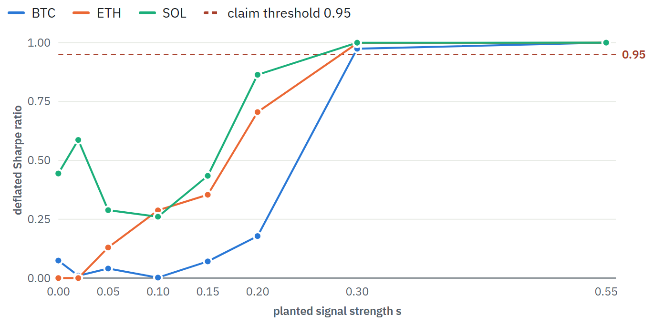
Figure 6. Deflated Sharpe ratio reported by the unchanged LightGBM harness when a feature $s y+(1−s) ε$ is added, by planted strength $s$. The dashed line is the 0.95 claim threshold.
Table view: detection power
s | corr(x, y) | BTC DSR | BTC PF / rand | BTC trades | ETH DSR | ETH PF / rand | ETH trades | SOL DSR | SOL PF / rand | SOL trades
0.00 | 0.00 | 0.075 | 0.85 / 0.60 | 116 | 0.000 | 0.76 / 0.74 | 746 | 0.444 | 1.27 / 0.91 | 57
0.02 | 0.02 | 0.010 | 0.75 / 0.58 | 223 | 0.000 | 0.75 / 0.74 | 779 | 0.587 | 1.63 / 0.93 | 47
0.05 | 0.04 | 0.041 | 0.76 / 0.60 | 124 | 0.130 | 0.87 / 0.74 | 79 | 0.289 | 0.97 / 0.91 | 58
0.10 | 0.09 | 0.002 | 0.77 / 0.57 | 488 | 0.288 | 1.07 / 0.73 | 85 | 0.261 | 0.91 / 0.90 | 71
0.15 | 0.14 | 0.071 | 0.87 / 0.59 | 178 | 0.354 | 1.13 / 0.73 | 117 | 0.434 | 1.10 / 0.87 | 212
0.20 | 0.20 | 0.178 | 1.02 / 0.58 | 222 | 0.705 | 1.38 / 0.73 | 175 | 0.864 | 1.46 / 0.87 | 247
0.30 | 0.33 | 0.974 | 1.90 / 0.57 | 363 | 0.997 | 1.91 / 0.74 | 298 | 1.000 | 2.31 / 0.86 | 310
0.55 | 0.71 | 1.000 | 5.90 / 0.57 | 712 | 1.000 | 7.79 / 0.74 | 682 | 1.000 | 9.21 / 0.86 | 682

7.2 Classification performance (RQ1)
All twelve model–asset combinations reach a three-class accuracy of 36.3–43.0%, against 36.1–36.7% for the majority class, and a balanced accuracy of 36.1–42.8% against 33.3%. On accuracy alone this looks like a weak but real signal. The probability scores disagree. Only the two boosted models on BTC have a lower log-loss than simply predicting the class frequencies (XGBoost 1.072 and LightGBM 1.086, against 1.095). The boosted models on ETH and SOL are slightly worse than the prior, and every recurrent model is far worse (log-loss 1.57–1.83, Brier 0.85–0.94 against 0.67): they are confident and often wrong.
LightGBM against XGBoost. With matched capacity the two libraries are close to interchangeable. Accuracy differs by at most one point on each asset (BTC 43.0% and 42.9%, ETH 38.9% and 39.9%, SOL 36.9% and 36.5%), and XGBoost's log-loss is slightly lower on all three (1.072 against 1.086, 1.103 against 1.119, 1.126 against 1.135), so its probabilities are a little less overconfident. Neither difference changes a conclusion, and both are smaller than the change in XGBoost's own trading result when only its thread count changed (Section 7.4).
Model | Accuracy | Bal. acc. | Macro-F1 | Log-loss | Brier
BTC · n = 4886 (LightGBM), labels −1/0/+1 = 1692 / 1400 / 1794
LightGBM | 43.0% | 42.8% | 0.430 | 1.086 | 0.660
XGBoost | 42.9% | 42.7% | 0.429 | 1.072 | 0.652
BiLSTM | 38.4% | 38.3% | 0.385 | 1.594 | 0.873
LSTM | 39.5% | 39.2% | 0.394 | 1.572 | 0.852
majority class | 36.7% | 33.3% | 0.179 | 21.857 | 1.266
class prior | 36.7% | 33.3% | 0.179 | 1.095 | 0.664
ETH · n = 4892 (LightGBM), labels −1/0/+1 = 1570 / 1542 / 1780
LightGBM | 38.9% | 38.6% | 0.388 | 1.119 | 0.682
XGBoost | 39.9% | 39.6% | 0.398 | 1.103 | 0.673
BiLSTM | 38.2% | 38.0% | 0.380 | 1.677 | 0.887
LSTM | 38.0% | 37.9% | 0.378 | 1.705 | 0.890
majority class | 36.4% | 33.3% | 0.178 | 21.972 | 1.272
class prior | 36.4% | 33.3% | 0.178 | 1.097 | 0.666
SOL · n = 4886 (LightGBM), labels −1/0/+1 = 1620 / 1501 / 1765
LightGBM | 36.9% | 36.6% | 0.366 | 1.135 | 0.691
XGBoost | 36.5% | 36.1% | 0.361 | 1.126 | 0.685
BiLSTM | 38.0% | 37.8% | 0.378 | 1.701 | 0.880
LSTM | 36.3% | 36.2% | 0.362 | 1.829 | 0.936
majority class | 36.1% | 33.3% | 0.177 | 22.062 | 1.278
class prior | 36.1% | 33.3% | 0.177 | 1.098 | 0.666
Table 3. Out-of-fold classification metrics for three classes (−1, 0, +1). Baselines are fitted on each training fold. Higher is better for accuracy, balanced accuracy and macro-F1; lower is better for log-loss and Brier. A log-loss or Brier value above the class-prior row is worse than knowing only the class frequencies.
Table 3b explains the gap. Splitting each prediction into "will a barrier be reached?" and "which one?" shows that no model beats the majority baseline on the first question, and direction accuracy ranges from 47.8% to 53.8% with a mean of about 50.8%. The largest, 53.8% for LightGBM on BTC (XGBoost reaches 53.7% on the same asset), is 1.7 standard errors above 50% on the effective sample, which is not significant at the 5% level before, let alone after, correcting for twelve comparisons. The three-class accuracy exceeds the majority baseline mainly because that baseline only ever predicts one class. For RQ1, the answer is no: none of the classifiers shows directional skill that survives this decomposition.
Asset | Model | Hit vs time-out | Majority | Diff. | Direction | n | n eff. | z vs 50%
BTC | LightGBM | 70.2% | 71.3% | -1.1% | 53.8% | 2873 | 519 | +1.74
BTC | XGBoost | 70.1% | 71.3% | -1.2% | 53.7% | 2864 | 517 | +1.67
BTC | BiLSTM | 67.4% | 71.3% | -3.8% | 48.6% | 2749 | 496 | -0.61
BTC | LSTM | 68.2% | 71.3% | -3.0% | 50.8% | 2837 | 512 | +0.37
ETH | LightGBM | 66.6% | 68.5% | -1.9% | 49.1% | 2663 | 466 | -0.38
ETH | XGBoost | 66.7% | 68.5% | -1.8% | 50.5% | 2650 | 464 | +0.23
ETH | BiLSTM | 64.3% | 68.4% | -4.1% | 51.3% | 2620 | 459 | +0.57
ETH | LSTM | 62.8% | 68.4% | -5.6% | 53.0% | 2566 | 449 | +1.26
SOL | LightGBM | 65.5% | 69.3% | -3.8% | 48.2% | 2697 | 470 | -0.78
SOL | XGBoost | 65.5% | 69.3% | -3.7% | 47.8% | 2724 | 475 | -0.94
SOL | BiLSTM | 62.1% | 69.4% | -7.3% | 53.5% | 2512 | 438 | +1.47
SOL | LSTM | 63.3% | 69.4% | -6.1% | 48.7% | 2557 | 446 | -0.55
Table 3b. The three-class task split into its two parts, from the confusion matrices. Barrier hit vs time-out: did the model predict correctly whether either barrier would be reached (a volatility question)? Direction: among samples where a barrier was reached and the model predicted one, did it pick the right side? The z-score for direction uses the effective sample size $n \overset{‾}{u}$, because overlapping labels make the raw count overstate the evidence.

7.3 Training dynamics and overfitting
Every model fits its training folds well and fails to generalise. Training accuracy is 75–79% for all twelve combinations against 36–43% out of fold, a gap of 33 to 41 points. The boosted models' training log-loss is 0.71–0.77 against 1.07–1.13 held out, even with depth-4 trees, a minimum leaf size, subsampling and an L2 penalty. The recurrent models go further: their training loss falls steadily for all 25 epochs, from about 1.10 (the level of the class prior) to 0.58–0.67, without levelling off (Figure 7), while held-out log-loss ends at 1.57–1.83. With no early stopping, each extra epoch memorises more of the training folds. Early stopping on a validation split inside the training fold would reduce the overconfidence, but Table 3b gives no reason to expect it to create directional skill. The BiLSTM does not consistently beat the LSTM (it is better on SOL, worse on BTC, level on ETH), which is the pattern expected when the windowing does not leak.
Asset | Model | Train acc. | Test acc. | Gap | Train log-loss | Test log-loss
BTC | LightGBM | 77.0% | 43.0% | -34.0% | 0.712 | 1.086
BTC | XGBoost | 76.0% | 42.9% | -33.0% | 0.735 | 1.072
BTC | BiLSTM | 75.2% | 38.4% | -36.8% | 0.617 | 1.594
BTC | LSTM | 77.2% | 39.5% | -37.7% | 0.581 | 1.572
ETH | LightGBM | 76.8% | 38.9% | -37.9% | 0.726 | 1.119
ETH | XGBoost | 75.9% | 39.9% | -36.1% | 0.746 | 1.103
ETH | BiLSTM | 76.4% | 38.2% | -38.2% | 0.587 | 1.677
ETH | LSTM | 79.0% | 38.0% | -41.0% | 0.536 | 1.705
SOL | LightGBM | 76.3% | 36.9% | -39.5% | 0.744 | 1.135
SOL | XGBoost | 75.4% | 36.5% | -38.9% | 0.765 | 1.126
SOL | BiLSTM | 74.9% | 38.0% | -36.9% | 0.611 | 1.701
SOL | LSTM | 76.7% | 36.3% | -40.4% | 0.569 | 1.829
Table 4. Mean training-fold metrics against out-of-fold metrics. The gap is the overfitting the regularisation did not prevent.
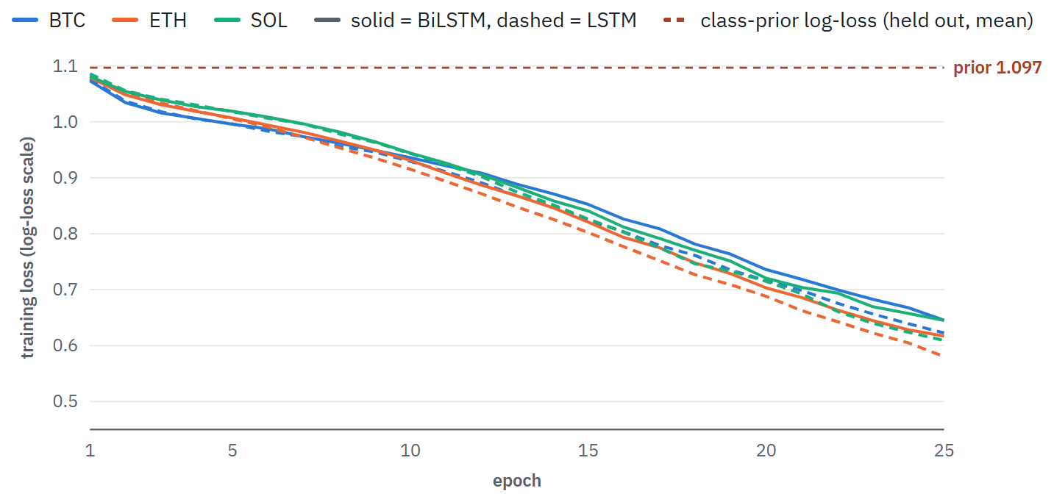
Figure 7. Mean training loss per epoch (averaged over folds), divided by the asset's mean sample weight so it sits on the log-loss scale. Dashed horizontal line: the class-prior log-loss on held-out data, the score of a model that learns nothing. Training loss falls below it while held-out log-loss stays above it.

7.4 Trading performance (RQ2)
No model on any asset meets the decision rule (Table 5). Thirteen of the fifteen profit factors are below 1.0. The two exceptions are both on SOL and both rest on few trades: LightGBM at 1.01 over 57 trades (DSR 0.26, total +0.15%) and XGBoost at 1.15 over 36 trades (DSR 0.38, total +1.4%), over a period in which SOL rose 59%. The highest DSR among the fifteen is 0.38, far from 0.95. XGBoost's own positive control is detected on every asset (DSR 1.000, profit factors 5.76–8.25), so the harness sees planted signals through either library. Adding the eleven microstructure features lowered the profit factor on all three assets in this run (in an earlier run on 6 September the effect was mixed): open interest and positioning features rank high in feature importance but do not add profit.
One pattern needs care. In 14 of 15 cases the model's profit factor is above the random-entry baseline (LightGBM on BTC: 0.73 against 0.57, a ratio of 1.28). This does not show directional skill, since Table 3b finds none. A likely explanation, not tested here, is volatility timing: every trade pays the same cost while its payoff scales with $σ_{i}$, so a model that trades more in volatile periods loses less to costs than random entries, without predicting direction. A baseline of random entries matched on volatility would test this and is left as future work.
The chosen threshold is also unstable. In a run earlier the same day on ETH, at the same cost and on data two candles shorter, LightGBM's best threshold made 751 trades; in this run the best of nine thresholds made 73. Picking the best of several thresholds on noisy data gives unstable choices, which is the selection effect the deflated Sharpe ratio corrects for.
XGBoost showed the same fragility under a purely numerical change. Its histogram sums are computed in parallel, and floating-point addition in a different order rounds differently, which moves some split points. On ETH, with data, seed and settings fixed, the best-of-nine result was a profit factor of 0.83 on 2 threads, 0.96 on 4 and 1.08 on 8 (DSR 0.17, 0.11 and 0.29). The verdict never changed, but the chosen threshold and trade count did. The results reported here use one thread, which reproduces exactly on any machine; LightGBM gave identical results on 2 and 8 threads.
Model | Trades | θ | PF | Random PF | DSR | Total | Verdict
BTC · cost 0.04% per side · buy-and-hold +28.3%
LightGBM | 752 | 0.40 | 0.730 | 0.569 | 0.000 | -32.8% | no edge
LightGBM + micro | 780 | 0.30 | 0.613 | 0.577 | 0.000 | -53.8% | no edge
XGBoost | 278 | 0.60 | 0.708 | 0.577 | 0.002 | -13.3% | no edge
BiLSTM | 780 | 0.30 | 0.583 | 0.577 | 0.000 | -59.7% | no edge
LSTM | 502 | 0.70 | 0.615 | 0.583 | 0.000 | -31.3% | no edge
Control, LightGBM (s = 0.55) | 712 | 0.70 | 5.900 | 0.569 | 1.000 | +120.5% | detected
Control, XGBoost (s = 0.55) | 708 | 0.70 | 5.762 | 0.569 | 1.000 | +115.7% | detected
ETH · cost 0.03% per side · buy-and-hold +39.9%
LightGBM | 73 | 0.70 | 0.861 | 0.737 | 0.104 | -2.3% | no edge
LightGBM + micro | 718 | 0.35 | 0.760 | 0.735 | 0.000 | -37.5% | no edge
XGBoost | 108 | 0.65 | 0.829 | 0.732 | 0.080 | -4.0% | no edge
BiLSTM | 668 | 0.50 | 0.823 | 0.742 | 0.002 | -25.0% | no edge
LSTM | 612 | 0.60 | 0.871 | 0.737 | 0.030 | -15.9% | no edge
Control, LightGBM (s = 0.55) | 682 | 0.70 | 6.843 | 0.666 | 1.000 | +175.6% | detected
Control, XGBoost (s = 0.55) | 675 | 0.70 | 7.450 | 0.666 | 1.000 | +177.7% | detected
SOL · cost 0.02% per side · buy-and-hold +58.6%
LightGBM | 57 | 0.70 | 1.010 | 0.908 | 0.262 | +0.2% | no edge
LightGBM + micro | 175 | 0.65 | 0.947 | 0.871 | 0.184 | -2.4% | no edge
XGBoost | 36 | 0.70 | 1.152 | 0.941 | 0.383 | +1.4% | no edge
BiLSTM | 494 | 0.70 | 0.923 | 0.881 | 0.099 | -9.4% | no edge
LSTM | 557 | 0.65 | 0.798 | 0.877 | 0.003 | -30.2% | no edge
Control, LightGBM (s = 0.55) | 682 | 0.70 | 7.655 | 0.738 | 1.000 | +256.6% | detected
Control, XGBoost (s = 0.55) | 678 | 0.70 | 8.251 | 0.738 | 1.000 | +262.3% | detected
Table 5. Best-of-nine-thresholds trading result for each model and asset, after costs. PF = profit factor; "random" = mean PF of random entries at the same trade frequency. Total return is the sum of per-trade returns without leverage, next to buy-and-hold over the same period. Control rows use the harness default cost of 0.04% per side.

7.5 Range forecasts and tail risk (RQ5)
Range forecasts are well calibrated at short horizons: the mean absolute gap between nominal and observed quantile coverage is 0.013–0.015 at 15 minutes, growing to about 0.06 at 24 hours. Skill against the rolling-volatility baseline falls with horizon (Figure 8). For the forward return it is +0.7% to +3.0% at 15 minutes, −1.1% to +0.7% at one hour, −2.9% to −10.2% at four hours and −10.1% to −12.2% at 24 hours. The model therefore adds a few percent at 15 minutes over scaling recent volatility and is worse than that simple rule at four hours and beyond, where fewer independent training examples exist.
The tail is where a leveraged trader is exposed. At 15 minutes, dips of 1.67% or more (the 60x liquidation distance) occurred on 0.08–0.35% of bars, and the model's 5th-percentile band flagged none of them in advance on any asset. At one hour, it flagged 0–31% of them. The high recall at four and 24 hours is not protection: there the band is wide, the dips are common (4–45% of windows), and the model is worse than the baseline. For RQ5: conditional ranges are calibrated and marginally better than volatility scaling at 15 minutes, and they do not anticipate the moves that liquidate a high-leverage position.
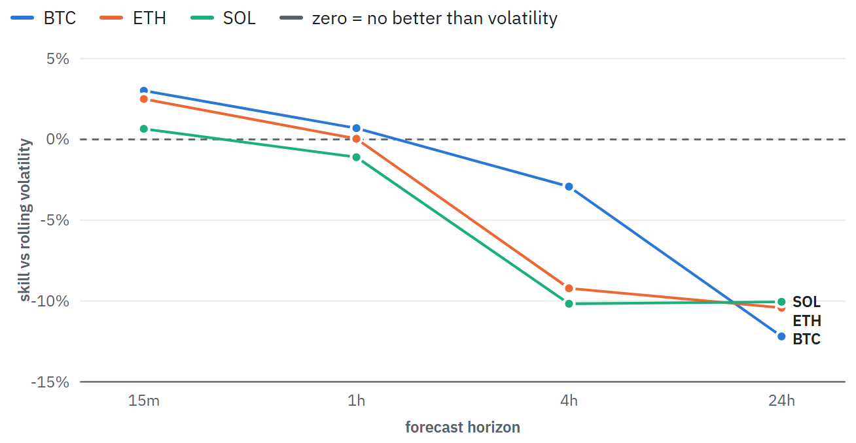
Figure 8. Quantile-forecast skill against the rolling-volatility baseline for the forward return, by horizon. Above zero means the model beats scaling recent volatility.
Asset | Calib. error | Return skill | Dip skill | Spike skill | 60x dips | Recall p05
horizon 15m
BTC | 0.015 | +3.0% | +1.9% | +4.0% | 0.08% | 0%
ETH | 0.013 | +2.5% | +2.7% | +3.7% | 0.24% | 0%
SOL | 0.014 | +0.7% | -0.6% | +3.2% | 0.35% | 0%
horizon 1h
BTC | 0.025 | +0.7% | +0.2% | +2.9% | 0.61% | 0%
ETH | 0.024 | +0.0% | +1.0% | +2.5% | 1.63% | 12%
SOL | 0.022 | -1.1% | -1.4% | +0.7% | 2.59% | 31%
horizon 4h
BTC | 0.039 | -2.9% | +0.4% | -4.7% | 4.09% | 30%
ETH | 0.038 | -9.2% | -4.1% | -4.9% | 8.37% | 51%
SOL | 0.039 | -10.2% | -7.8% | -6.5% | 12.85% | 74%
horizon 24h
BTC | 0.062 | -12.2% | +1.5% | -14.4% | 25.43% | 98%
ETH | 0.061 | -10.4% | +3.9% | -10.0% | 36.41% | 99%
SOL | 0.059 | -10.1% | -2.4% | -15.6% | 44.77% | 98%
Table 6. Range-forecast calibration and skill by horizon and target; tail recall = share of liquidation-sized dips (60x, 1.67%) that the predicted 5th percentile flagged in advance.

7.6 Rule filters (RQ4)
In window A, adding gates made results monotonically worse: all gates on gave −0.308R per trade on the held-out half, against −0.174R with no gates. In window B, which does not overlap A, the ordering reversed: all gates on gave −0.040R against −0.114R with no gates. Every variant in both windows has a non-positive mean, and most intervals overlap. For RQ4: no gate shows a stable contribution; the sign of the effect depends on the window. MEXC changed its fees between the windows (BTC from 4 to 2 bp, SOL from 0 to 1 bp), which the ablation reads from the live contract.
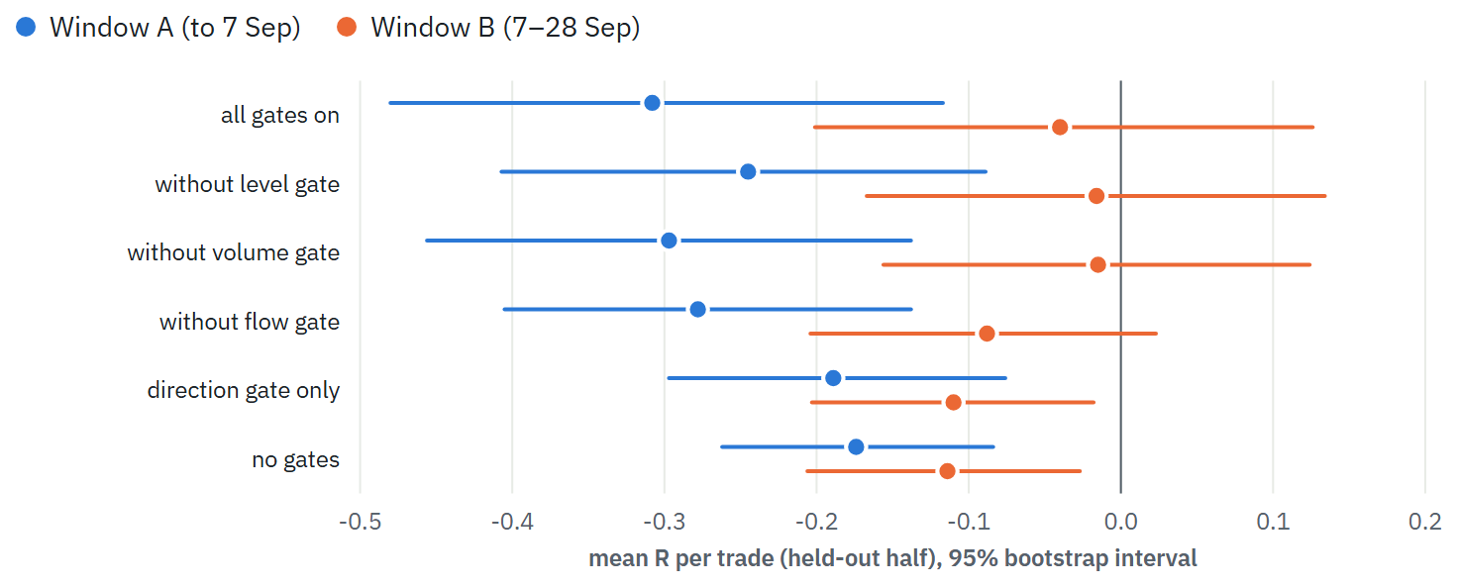
Figure 9. Mean R per trade with bootstrap 95% intervals, held-out (second) half of each window, pooled over six MEXC perpetuals. Window A: about 17 Aug – 7 Sep 2026. Window B: about 7 – 28 Sep 2026. The intervals ignore clustering by symbol and session and are too narrow.
Table view: ablation
Variant | A trades | A mean R | A 95% CI | B trades | B mean R | B 95% CI
all gates on | 215 | -0.308 | [-0.480, -0.117] | 299 | -0.040 | [-0.201, 0.126]
without level gate | 261 | -0.245 | [-0.407, -0.089] | 341 | -0.016 | [-0.167, 0.134]
without volume gate | 270 | -0.297 | [-0.456, -0.138] | 366 | -0.015 | [-0.156, 0.124]
without flow gate | 379 | -0.278 | [-0.405, -0.138] | 571 | -0.088 | [-0.204, 0.023]
direction gate only | 548 | -0.189 | [-0.297, -0.076] | 818 | -0.110 | [-0.203, -0.018]
no gates | 896 | -0.174 | [-0.262, -0.084] | 924 | -0.114 | [-0.206, -0.027]
Walk-forward rules. The three hand-written strategies produced out-of-sample profit factors between 0.68 and 1.07 across the three assets (trend pullback 0.79–1.00, flow reversal 0.68–1.07, breakout 0.83–1.00), with no rule above 1.07 on any asset. The parameter grid was chosen on training slices only, but the choice of which rule to report was not deflated.
Structural direction bias. Over 7,104 MEXC bars the 4h direction gate allowed longs on 49.1% of bars, shorts on 14.2%, and neither on 36.7%; on BTC and SOL shorts were never allowed during the three-week window because prices rose. The 50% order-flow threshold sat at the centre of a distribution with mean 49.2% and standard deviation 2.4 points, and passed longs 36.2% of the time and shorts 65.1%. A filter set chosen by hand can therefore carry directional biases its designer did not intend.

8 Discussion

8.1 Why the classifiers fail
Three things combine. First, direction at 15 minutes behaves close to a coin flip in these data: direction accuracy averages about 50.8% across twelve model–asset pairs, and the largest deviation is not significant (Table 3b). Second, costs are large relative to the move being predicted: a round trip costs 0.04–0.08% while a barrier sits 1.5 ATR away, a few tenths of a percent, so even a small directional edge would be taxed heavily. Third, the effective sample is small. Mean label uniqueness of 0.175 means about 850 independent observations per asset, not 4,900, and models with thousands of free parameters (29,859 for the BiLSTM) fit the training folds to 75–79% accuracy and learn nothing that transfers.

8.2 Accuracy is the wrong headline metric
Three-class accuracy exceeded the majority baseline for every model, which on its own would read as a positive result. Log-loss showed that most models' probabilities were worse than knowing only the class frequencies, and decomposing the confusion matrix showed no directional skill. A study that reported accuracy alone would have claimed a weak edge. Reporting proper scoring rules against a class-prior baseline, and separating the volatility and direction parts of a barrier label, are cheap checks against this.

8.3 What a negative result is worth
A negative result is only as informative as the test's power. The detection sweep shows that this harness, on 52 days of data, detects a feature correlated about 0.33 with the label but misses a profitable one correlated about 0.20 (Figure 6). So the finding is not "no edge exists" but "no edge as strong as a 0.33-correlated feature exists in these features and models, over this period". A modest edge would need more data or a forward test to confirm, and a threshold of DSR ≥ 0.95 deliberately trades sensitivity for protection against false discoveries. Reporting the power curve next to the verdict makes that trade-off explicit, which negative results in this area rarely do.

8.4 Discretionary rules
The trader's gates were adopted after individual losses, not from evidence. When measured, their effect reversed sign between two adjacent three-week windows (Figure 9), and the direction gate carried a strong structural long bias that its designer had not intended. Rules added in response to single losses are hypotheses, and a hypothesis tested on the losses that suggested it cannot be confirmed by them.

8.5 Implications
For the trader, no automated 15-minute signal tested here justifies risking money, and the ranges do not protect against liquidation; his decision to move to paper trading until a forward sample exists is consistent with the evidence. For researchers, the results agree with the efficient-market view at short horizons after costs (Fama, 1970), and they suggest that published high accuracies in this setting should be checked for label overlap, preprocessing on the full series, bidirectional labelling, ignored costs and uncounted trials (Sections 2.3 and 5.3) before they are believed. The harness, controls and power curve are a reusable way to do that check.

9 Threats to validity

Internal validity
- Purged k-fold trains on the future. For middle folds, part of the training data comes after the test block. Purging removes label overlap, but a model can still learn later market conditions. This favours the model, so it strengthens a negative result and would weaken a positive one; a walk-forward split should be used before believing any positive finding.
- Optimistic fills. The classifier trades at the close of the signal bar, and barrier exits fill exactly at the barrier with no gap slippage. Both favour the model.
- Fixed hyperparameters. Untuned models may underperform tuned ones. Tuning was avoided deliberately because every tuned setting is another trial; a fair test of tuning needs nested cross-validation inside the training folds.
- Numerical non-determinism. Multi-threaded XGBoost changes some splits with the thread count (Section 7.4). It is pinned to one thread here; LightGBM gave identical results on 2 and 8 threads.
- Single seed. Recurrent results depend on initialisation. Seed variation was not measured.
- Train-loss scale. The recurrent training curves are divided by the asset's global mean sample weight, while each fold's mean weight differs slightly, so the curves are approximately, not exactly, on the log-loss scale.

Construct validity
- Spot versus perpetual. Labels are computed on Binance spot candles while trades happen on MEXC perpetuals, whose extremes differ. Stops and liquidations trigger on the venue's own wicks.
- Leverage and liquidation are not modelled in the ML harness; returns are unlevered. At 45–60x, a sequence of trades with positive expectancy can still be liquidated.

External validity
- About 52 days of data on three large assets, mostly in a rising market. Results may not hold in other regimes, on smaller assets, or at other horizons.
- The ablation windows are three weeks each; the effect of the gates is not estimable from them beyond its sign instability.

Statistical conclusion validity
- Effective sample size is about 850 per asset, not 4,900. Differences of one to three accuracy points are within sampling noise at this size (the standard error of an accuracy near 0.37 with $N_{\text{eff}}=850$ is about 1.7 points).
- DSR deflates only the nine thresholds. Model families, assets and feature sets were all reported rather than selected; if a reader were to pick the best of them, a further correction would apply.
- Bootstrap intervals in the ablation ignore dependence across symbols and time.

10 Conclusion and future work
This report tested whether signals from public market data can predict 15-minute moves in BTC, ETH and SOL well enough to trade after costs, using an evaluation harness built to resist the usual sources of false discovery and shown to detect planted signals.
- RQ1: No. LightGBM, XGBoost, LSTM and BiLSTM classifiers beat the majority class on three-class accuracy, but show no directional skill once the task is decomposed, and most of their probabilities score worse than the class prior.
- RQ2: No. None of the fifteen model–asset results reaches DSR 0.95; the highest is 0.38. Thirteen of fifteen lose money after costs, and the two that do not rest on 36 and 57 trades. LightGBM and XGBoost reach the same conclusion on every asset.
- RQ3: The harness always detects the standard control, with LightGBM and with XGBoost, and never flags pure noise. It detects a planted feature correlated about 0.33 with the label and misses one correlated about 0.20, even when that feature is profitable.
- RQ4: No gate shows a stable contribution; the effect of the full filter set changed sign between two non-overlapping windows.
- RQ5: Ranges are calibrated and beat volatility scaling by at most 3% at 15 minutes, lose to it at 4 and 24 hours, and missed every liquidation-sized 15-minute dip.

Directions for a final-year project
- Leakage audit of published models. Reproduce three to five published crypto predictors that report high accuracy, then close each leakage source in turn (label overlap, full-series preprocessing, bidirectional labelling, costs, uncounted trials) and measure how much reported performance each step removes. The harness, the controls and the power curve provide the method. The result is useful in either direction.
- Walk-forward replication. Replace purged k-fold with an expanding-window walk-forward split and repeat Section 7 on a longer history (the loader can page back years). This closes the largest internal-validity gap.
- Rare-event tail prediction. Treat liquidation-sized moves as a rare-event classification problem and measure precision and recall against volatility rules, since the quantile models are calibrated in the middle but blind in the tails.
- Power analysis as a method. Extend Section 7.1 into a general procedure: for a given data size and effective sample size, what is the smallest edge any harness can detect? This gives future negative results a stated sensitivity.

References
- Bailey, D. H., Borwein, J. M., López de Prado, M., and Zhu, Q. J. (2014). Pseudo-mathematics and financial charlatanism: The effects of backtest overfitting on out-of-sample performance. Notices of the American Mathematical Society, 61(5), 458–471.
- Bailey, D. H., and López de Prado, M. (2014). The deflated Sharpe ratio: Correcting for selection bias, backtest overfitting and non-normality. Journal of Portfolio Management, 40(5), 94–107.
- Chen, T., and Guestrin, C. (2016). XGBoost: A scalable tree boosting system. Proceedings of the 22nd ACM SIGKDD International Conference on Knowledge Discovery and Data Mining, 785–794.
- Brier, G. W. (1950). Verification of forecasts expressed in terms of probability. Monthly Weather Review, 78(1), 1–3.
- Fama, E. F. (1970). Efficient capital markets: A review of theory and empirical work. Journal of Finance, 25(2), 383–417.
- Friedman, J. H. (2001). Greedy function approximation: A gradient boosting machine. Annals of Statistics, 29(5), 1189–1232.
- Gneiting, T., and Raftery, A. E. (2007). Strictly proper scoring rules, prediction, and estimation. Journal of the American Statistical Association, 102(477), 359–378.
- Harvey, C. R., Liu, Y., and Zhu, H. (2016). … and the cross-section of expected returns. Review of Financial Studies, 29(1), 5–68.
- Hochreiter, S., and Schmidhuber, J. (1997). Long short-term memory. Neural Computation, 9(8), 1735–1780.
- Jegadeesh, N., and Titman, S. (1993). Returns to buying winners and selling losers: Implications for stock market efficiency. Journal of Finance, 48(1), 65–91.
- Kapoor, S., and Narayanan, A. (2023). Leakage and the reproducibility crisis in machine-learning-based science. Patterns, 4(9), 100804.
- Kaufman, S., Rosset, S., Perlich, C., and Stitelman, O. (2012). Leakage in data mining: Formulation, detection, and avoidance. ACM Transactions on Knowledge Discovery from Data, 6(4), 15.
- Ke, G., Meng, Q., Finley, T., Wang, T., Chen, W., Ma, W., Ye, Q., and Liu, T.-Y. (2017). LightGBM: A highly efficient gradient boosting decision tree. Advances in Neural Information Processing Systems 30.
- Kingma, D. P., and Ba, J. (2015). Adam: A method for stochastic optimization. International Conference on Learning Representations.
- Koenker, R., and Bassett, G. (1978). Regression quantiles. Econometrica, 46(1), 33–50.
- López de Prado, M. (2018). Advances in Financial Machine Learning. Wiley.
- Schuster, M., and Paliwal, K. K. (1997). Bidirectional recurrent neural networks. IEEE Transactions on Signal Processing, 45(11), 2673–2681.
- Srivastava, N., Hinton, G., Krizhevsky, A., Sutskever, I., and Salakhutdinov, R. (2014). Dropout: A simple way to prevent neural networks from overfitting. Journal of Machine Learning Research, 15, 1929–1958.
- White, H. (2000). A reality check for data snooping. Econometrica, 68(5), 1097–1126.
- Wilder, J. W. (1978). New Concepts in Technical Trading Systems. Trend Research.

Appendix A: Hyperparameters
Model | Parameter | Value
Labels and validation (all ML models)
 | take-profit / stop barrier $π,λ$ | 1.5 × ATR%
 | vertical barrier $h$ | 8 bars (2 h)
 | ambiguous bars | dropped
 | folds (LightGBM / recurrent) | 6 / 5
 | embargo | max(8, 1% of N) bars
 | thresholds swept | 0.30 … 0.70 step 0.05 (9)
 | minimum trades for a claim | 15
LightGBM classifier and quantile regressors
LightGBM | objective | multiclass (softmax) / quantile
 | n_estimators (classifier / quantile) | 300 / 200
 | learning_rate | 0.05
 | num_leaves / max_depth | 15 / 4
 | min_child_samples | 60
 | subsample (freq 1) / colsample_bytree | 0.8 / 0.7
 | reg_lambda (L2) | 5.0
 | sample weight | label uniqueness (classifier only)
 | random_state | 7
XGBoost classifier
XGBoost | objective | multi:softprob
 | n_estimators / learning_rate | 300 / 0.05
 | max_depth (level-wise growth) | 4 (≤ 16 leaves)
 | min_child_weight | 2.0
 | subsample / colsample_bytree | 0.8 / 0.7
 | reg_lambda (L2) / gamma | 5.0 / 0
 | tree_method / threads | hist / 1 (pinned)
 | sample weight / random_state | label uniqueness / 7
LSTM / BiLSTM
Recurrent | window length $L$ | 24 bars (6 h)
 | input features $d$ | 27
 | hidden units $H$ / layers | 48 / 1
 | gate / cell activations | sigmoid / tanh
 | output | last step → dropout 0.3 → linear → softmax
 | loss | uniqueness-weighted cross-entropy
 | optimiser | Adam, lr 1e-3, weight decay 1e-4
 | batch / epochs | 128 / 25 (no early stopping)
 | gradient clipping | L2 norm 1.0
 | input scaling | z-score on train fold, clip ±8
 | parameters (LSTM / BiLSTM) | 14,931 / 29,859
Nearest-neighbour forecaster (live desk)
k-NN | neighbours / prior weight | 60 / 30
 | features / clip | 5 / ±5
 | horizons | 1, 4, 16 bars
 | replay points | ≤ 120 non-overlapping

Appendix B: Features
All features are computed from bars up to and including $i$. $C,O,H,L,V$ are close, open, high, low and volume; $V^{b}$ is taker-buy volume; $r_{1}=ΔlogC$; ${\overset{‾}{V}}_{20}$ the 20-bar mean volume; ${\hat{σ}}_{n}$ the standard deviation of $r_{1}$ over $n$ bars.
Group | Feature | Definition
Order flow (4)
 | buy_ratio | $V^{b}/V$
 | buy_ratio_ma6 | 6-bar mean of buy_ratio
 | cvd_slope6, cvd_slope24 | change in cumulative $(2V^{b}/V−1)V$ over 6 / 24 bars, divided by ${\overset{‾}{V}}_{20}$
Volume and volatility (4)
 | vol_ratio | $V/{\overset{‾}{V}}_{20}$
 | realized_vol20 | ${\hat{σ}}_{20}$
 | vol_expansion | ${\hat{σ}}_{20}/{\hat{σ}}_{96}$
 | atr_pct | Wilder ATR(14) / $C$
Position in range (3)
 | range_pos | $(C−minL_{20})/(maxH_{20}−minL_{20})$
 | dist_hh20, dist_ll20 | $(maxH_{20}−C)/C$, $(C−minL_{20})/C$
Candle shape (3)
 | body_frac, upper_wick, lower_wick | $(C−O)$, $(H−max(O,C))$, $(min(O,C)−L)$, each over $H−L$
Momentum (4)
 | ret{1,4,16,48}_z | $log(C_{i}/C_{i−k})/({\hat{σ}}_{20}\sqrt{k})$
Lagging indicators (7)
 | lag_d_ema{9,21,50} | $(C−{EMA}_{n})/C$
 | lag_ema9_21 | $({EMA}_{9}−{EMA}_{21})/C$
 | lag_rsi14 | Wilder RSI(14)
 | lag_macd_hist | (MACD(12,26) − EMA₉ of MACD) / $C$
 | lag_bb_width | $4 {sd}_{20}(C)/{SMA}_{20}(C)$
Session clock (2)
 | hour_sin, hour_cos | $sin,cos(2π⋅\text{hour}/24)$, UTC
Microstructure, with --micro (11)
 | m_book_imb_near/far, m_book_imb_slope6 | bid–ask depth imbalance near and far from mid; its 6-bar change
 | m_depth_ratio | near depth over its 20-bar mean
 | m_oi_chg6/24, m_oi_price_quadrant | open-interest % change over 6 / 24 bars; $1000⋅ΔOI_{6}⋅r_{6}$
 | m_taker_ls, m_global_ls, m_tt_pos_ls, m_tt_acct_ls | taker, global-account, top-trader position and top-trader account long/short ratios (closed 5-minute buckets only)

Appendix C: Reproduction
The package keeps the same folder layout the scripts expect. Each file below belongs to one of the three parts of the system.
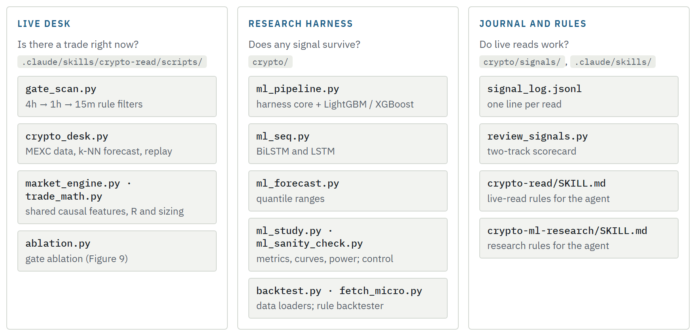
Figure 10. File map of the package, grouped by the part of the system each file belongs to. Figure 1 shows how these parts connect.
pip install -r requirements.txt
cd crypto
python -c "import backtest as b; [b.load_klines(s,'15m',5000) for s in ('BTCUSDT','ETHUSDT','SOLUSDT')]"
export CRYPTO_ASOF=<epoch ms of the last closed bar> # freeze; this report used 1790608499999
# per asset: FEE = MEXC taker fee + 0.0002 (BTC 0.0004, ETH 0.0003, SOL 0.0002)
python ml_sanity_check.py ETHUSDT # must print HARNESS SOUND
python ml_sanity_check.py ETHUSDT --xgb # the same control for XGBoost
python ml_study.py --symbol ETHUSDT --fee 0.0003 # Tables 3-4, Figures 6-7 (LightGBM, BiLSTM, LSTM)
python ml_study.py --symbol ETHUSDT --fee 0.0003 --gbdt xgb --skip-seq --skip-power # XGBoost rows
python ml_pipeline.py --symbols ETHUSDT --fee 0.0003 # Table 5, LightGBM
python ml_pipeline.py --symbols ETHUSDT --fee 0.0003 --micro
python ml_pipeline.py --symbols ETHUSDT --fee 0.0003 --model xgb
python ml_seq.py --symbols ETHUSDT --fee 0.0003 # Table 5, BiLSTM / LSTM
for h in 1 4 16 96; do python ml_forecast.py --symbols ETHUSDT --horizon $h; done
cd ../.claude/skills/crypto-read/scripts
python ablation.py # Figure 9 (live MEXC data; not frozen)
Outputs are written to crypto/ml_reports/ as paired .txt and .json files. The report files behind every number in Section 7 are included in the package. The ablation reads live MEXC data and cannot be frozen with CRYPTO_ASOF; its two runs are saved in crypto/evidence-v2/ablation/.

Appendix D: Live journal (descriptive)
The trader's discretionary reads are logged in signal_log.jsonl and graded afterwards on two separate tracks: trades with a real entry in R-multiples at the actual fill, and 4h/24h direction calls as right, partial or wrong. As of 28 September 2026: 36 reads logged, 15 with a real entry and stop, 8 of those never filled (53%), 6 graded trades with 1 win (16.7%), total −0.76R, profit factor 0.82, best +3.47R and worst −1.00R; 4 of 6 scored direction calls correct. Since 7 September 2026 new reads are logged in paper mode, without real money, until 30–40 graded trades exist. Six trades cannot distinguish skill from chance, and these numbers are not used as evidence anywhere in this report.

Appendix E: Glossary
Perpetual future
A futures contract with no expiry, kept near the spot price by periodic funding payments between long and short holders.
Leverage, liquidation
At 60x, a margin of $50 controls $3,000. A move of about 1/60 against the position exhausts the margin and the exchange closes it.
ATR
Average true range: the typical size of one candle's move, used to scale barriers, stops and features.
Taker fee, slippage
The fee for an order that fills immediately, paid on entry and exit; slippage is the gap between expected and actual fill price.
Order flow, CVD
The share of volume from aggressive buyers; CVD is the running total of buy minus sell volume.
R-multiple
Profit or loss in units of the risk taken; a stop-out is −1R.
Out-of-fold (OOF)
A prediction for a sample made by a model that did not train on it.
Effective sample size
The number of independent observations the data are worth, here about the sample count times the mean uniqueness.
Positive control
A test with a known answer, run through the same pipeline to show the pipeline can find it.
Detection power
The probability that a test reports an effect of a given size when it exists; here, the planted strength at which the harness starts to report an edge.
All numbers in Section 7 are generated from the saved run reports listed in Appendix C and embedded in this page as data. The report was compiled with the help of Claude Code from the project's code, reports and notes.

