# 

# **FARMART**

**MWA-Team02**

**Rina Tamrakar**

**Ruby Tamrakar**

**Tijesunimi Omotosho**

**Perry Luigi Broglia**

**Ataklete Teffera**

**August 12, 2020**

**Maharishi International University**

The team came together to plan and design for the project. After the discussion, we used Trello to document and list all our tasks and plans. We prioritized, broke down, and divided the tasks amongst the team members. With this document, you can find the attached rough planning in a classroom board and also a snippet of our Trello board plan.

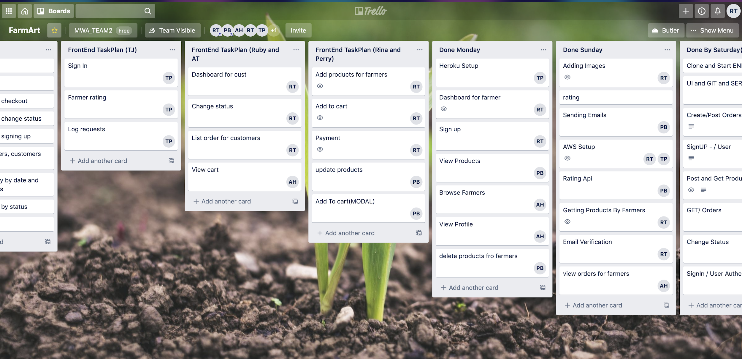

**Fig: Trello Snippet (**[**https://trello.com/b/7yzaDegR/farmart**](https://trello.com/b/7yzaDegR/farmart)**)**

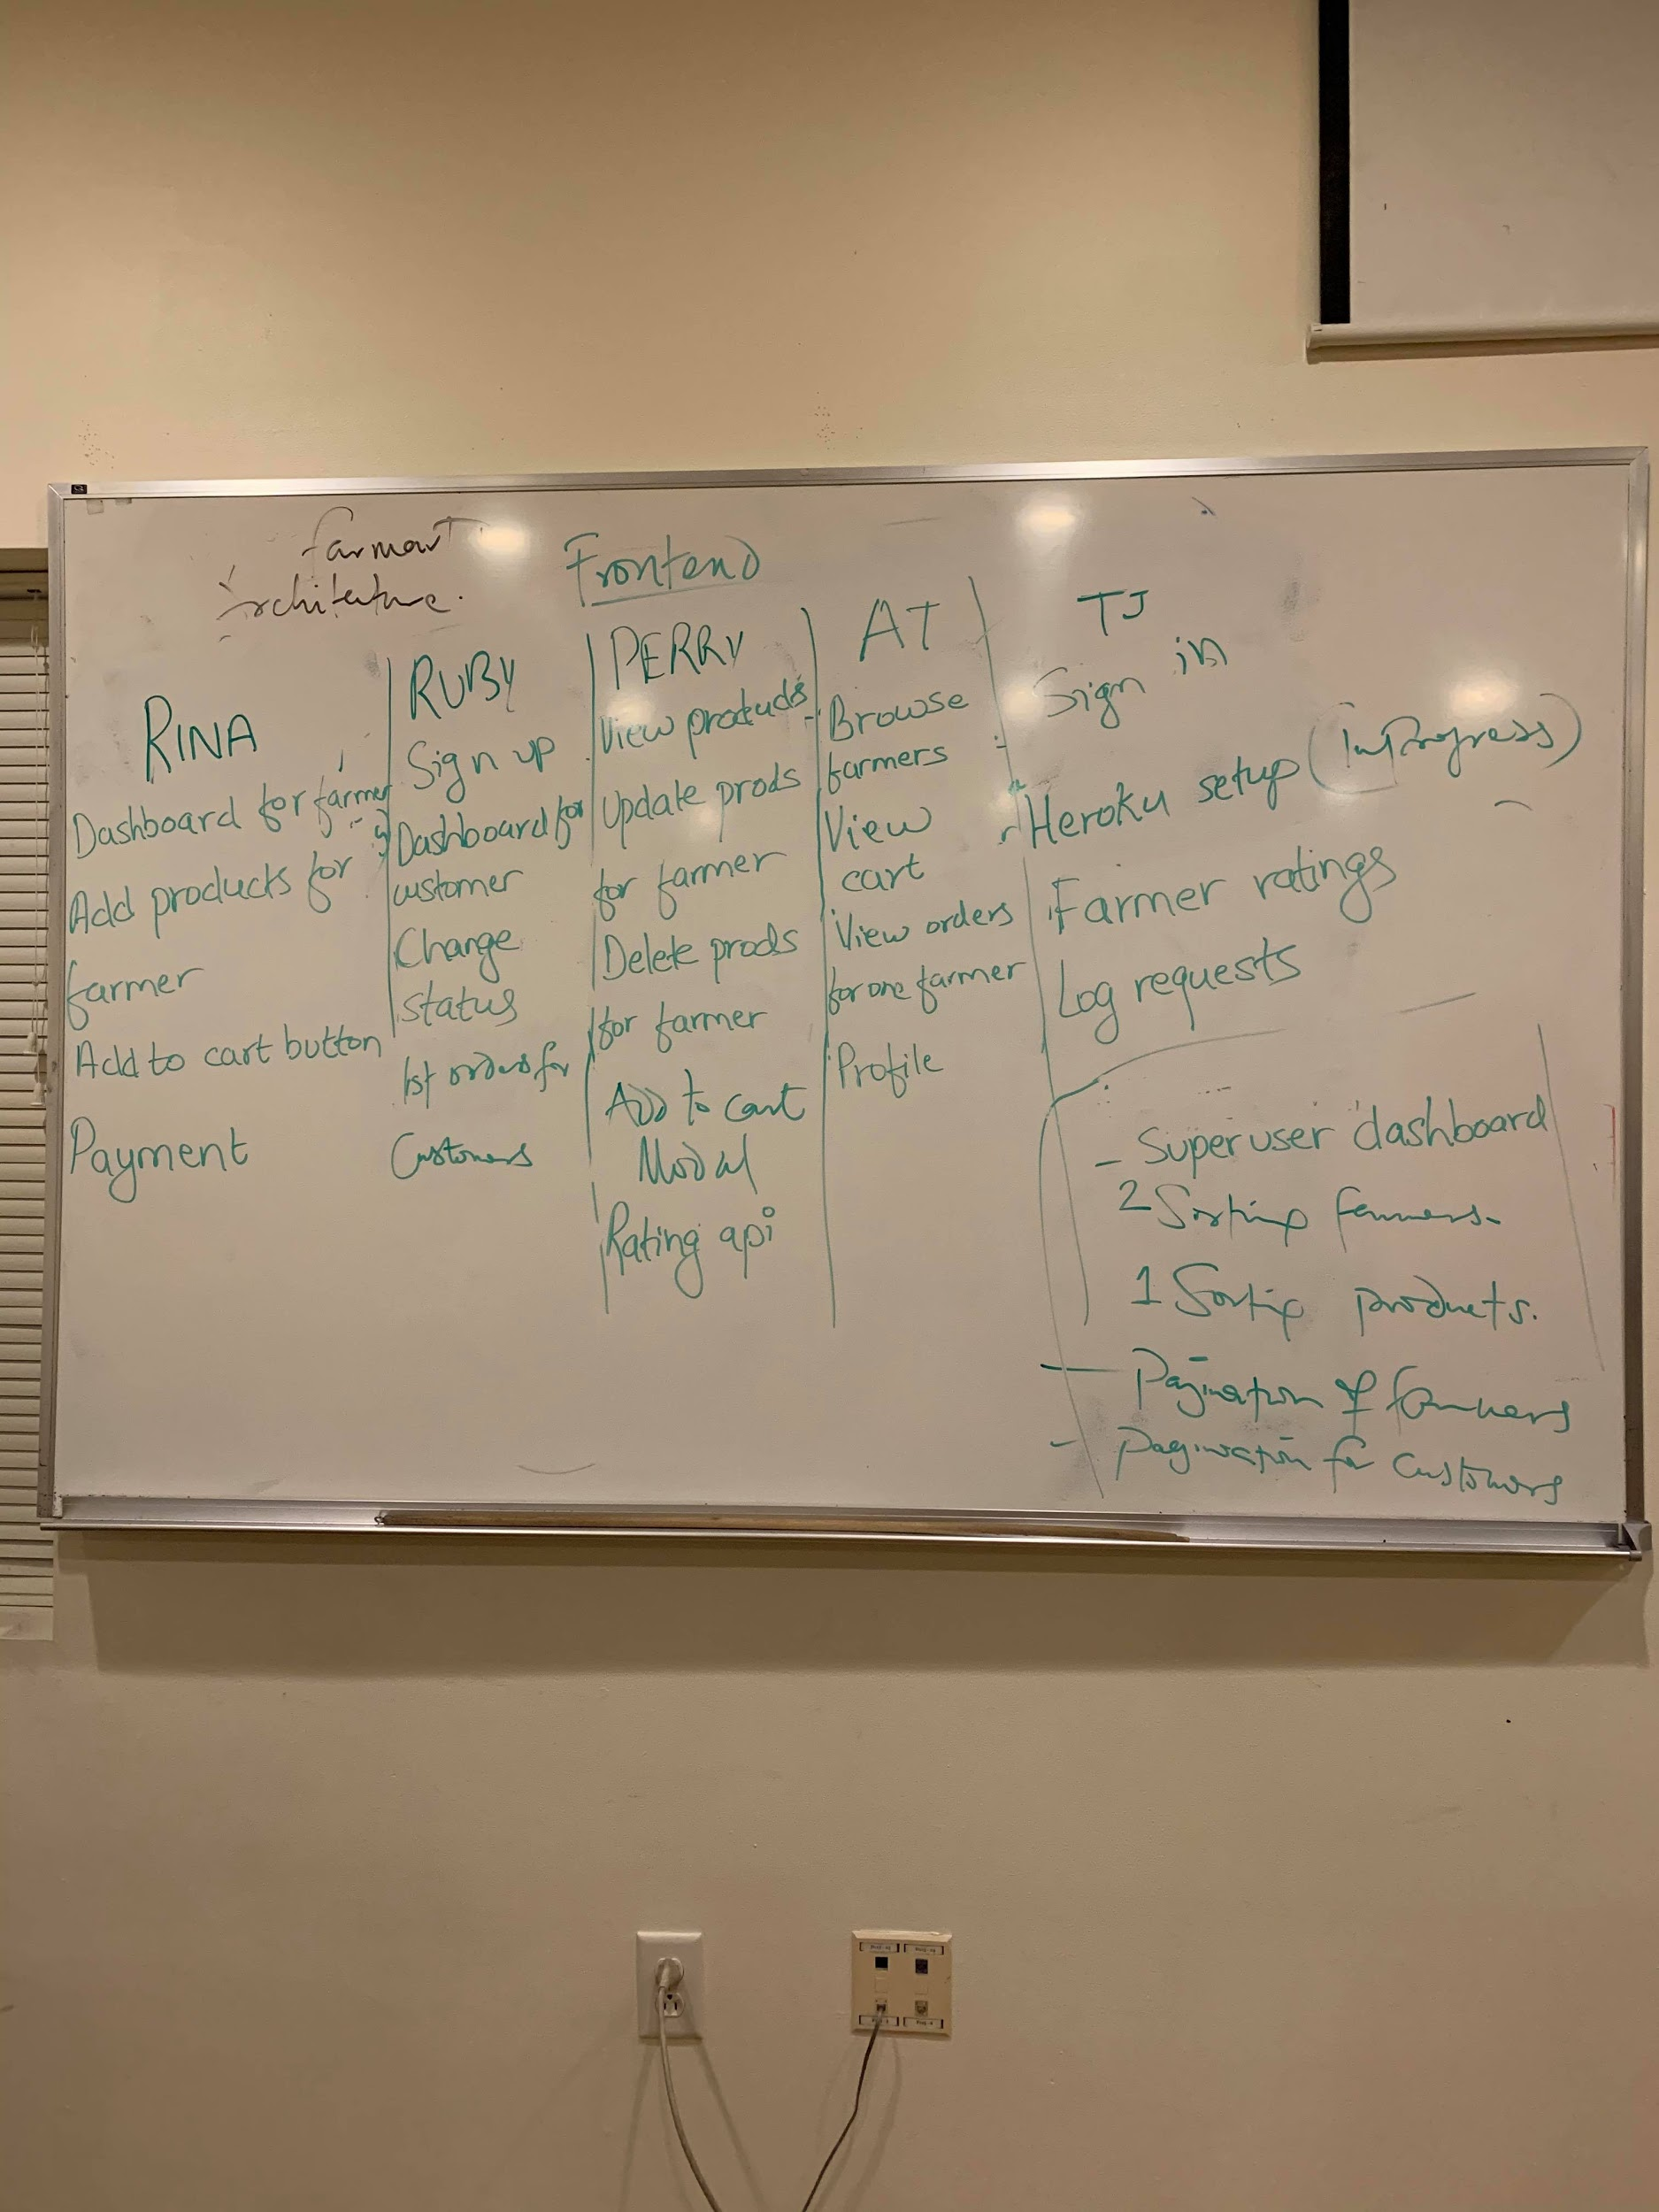

**Fig: Front End Task Division**

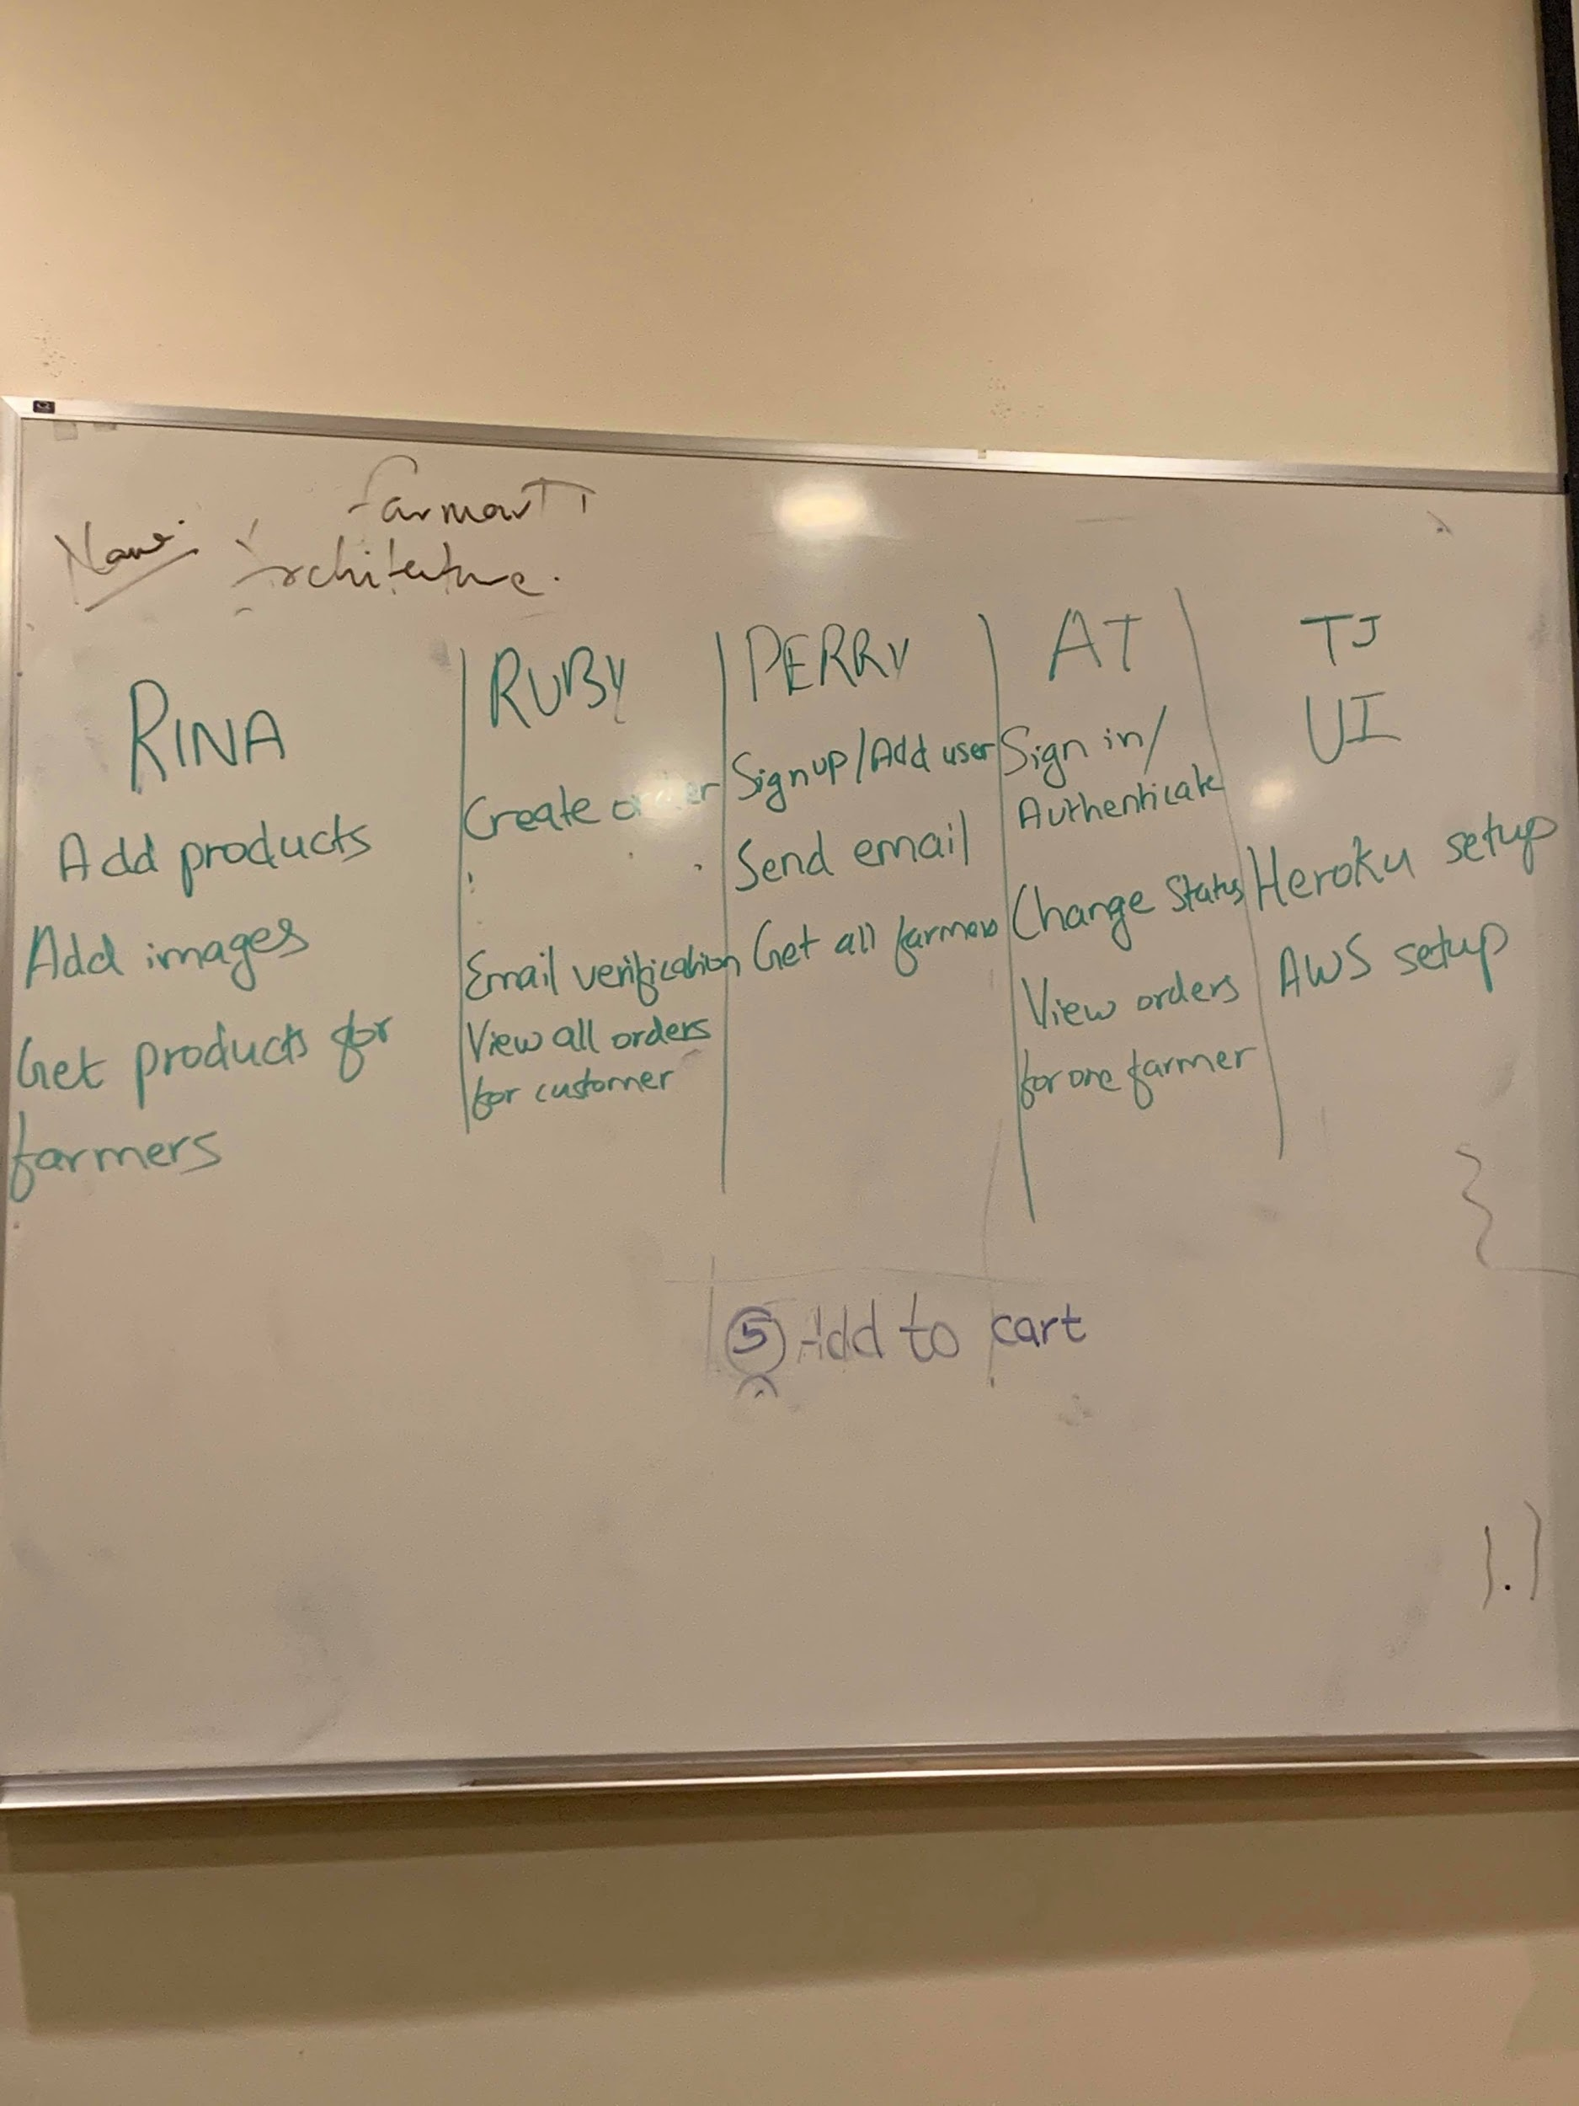

**Fig: Back End and Setup Task Division**

**Github Repo:** [**https://github.com/tijesunimi-peters/mwa_final**](https://github.com/tijesunimi-peters/mwa_final)

**Frontend URL:** [**https://farmart.herokuapp.com/app/home**](https://farmart.herokuapp.com/app/home)

# Features

**Signup with Email verification**

**Signin**

**Add products with image upload to AWS S3 Bucket**

**Authorization (Farmer, Customer)**

**Add to Cart**

**Username and Email validation**