Week 2 – Atamjon’s report
Original posts (1):
1. Received: 7 comments and 48 reactions 1 Repost.
https://www.linkedin.com/posts/atamjonraximov_linkedincompetition-activity-7365974478335455232-t5AP?utm_source=share&utm_medium=member_desktop&rcm=ACoAAEWJaG4BfzzjZoOR5N1JVaFI6V85rvUjCeU
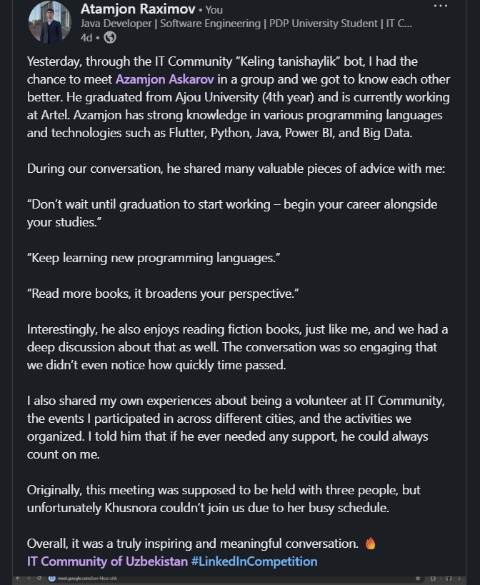

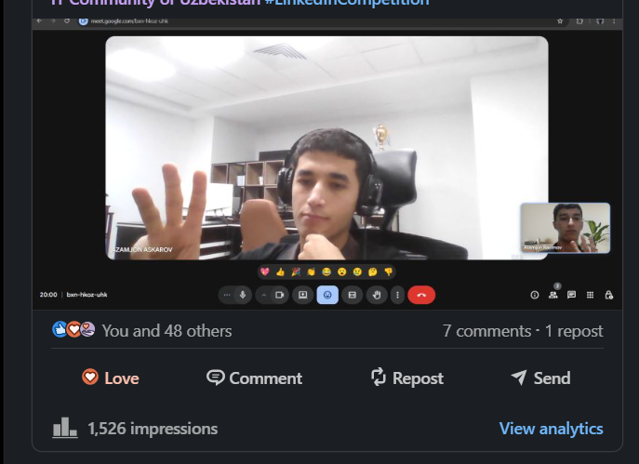

Original posts (2):
2. Received: 9 comments and 50 reactions .
https://www.linkedin.com/posts/atamjonraximov_itcommunityuzb-linkedincompetition-activity-7366312059342323712-gAUP?utm_source=share&utm_medium=member_desktop&rcm=ACoAAEWJaG4BfzzjZoOR5N1JVaFI6V85rvUjCeU
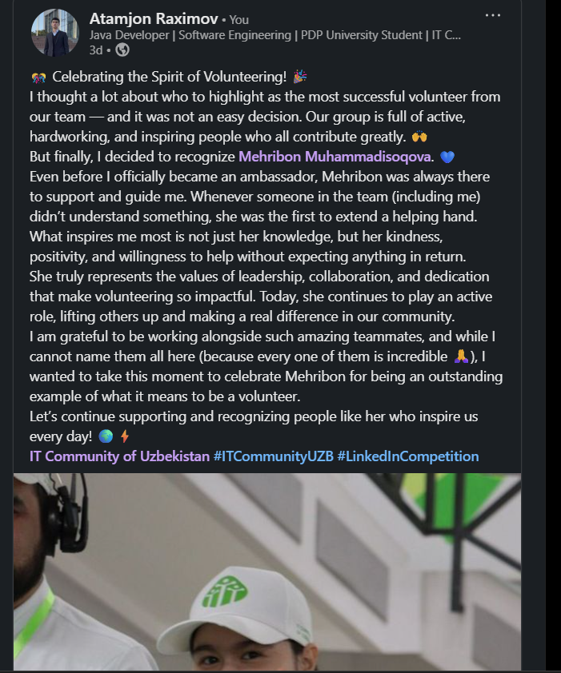

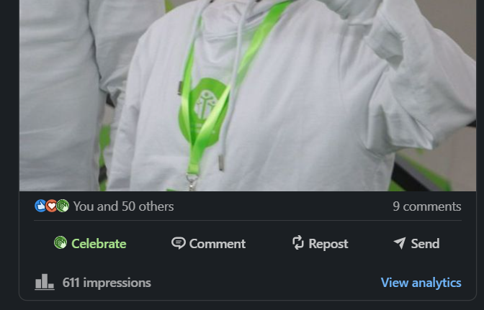

Original posts (3):
3. Received: 14 comments and 32 reactions .
https://www.linkedin.com/posts/atamjonraximov_linkedincompetition-activity-7366704365748785152-Q9i6?utm_source=share&utm_medium=member_desktop&rcm=ACoAAEWJaG4BfzzjZoOR5N1JVaFI6V85rvUjCeU
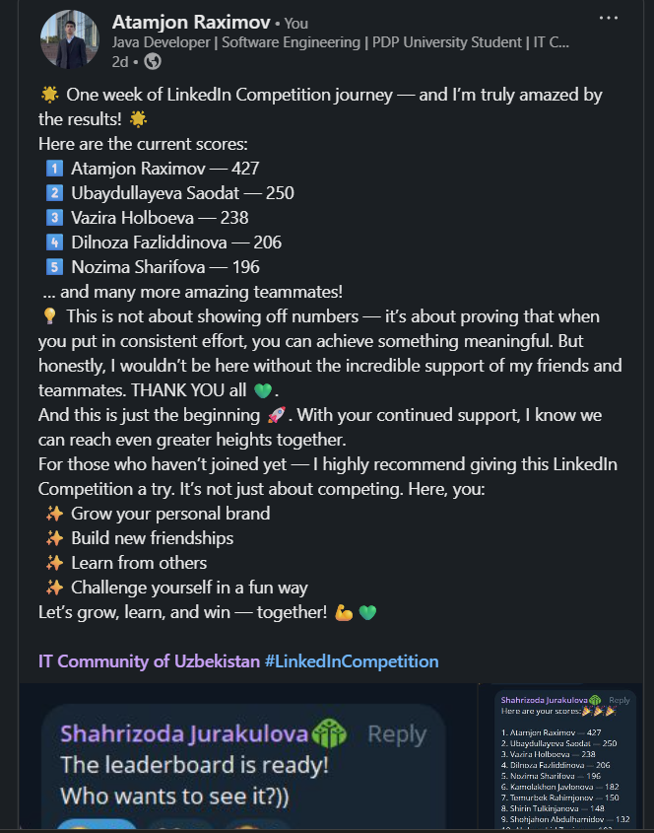

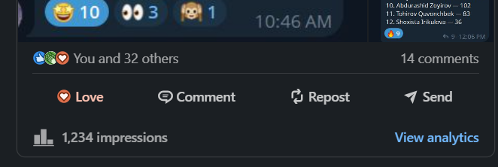

2. Reposts with meaningful comment: (1):
1. 17 reactions and 1 comments received
https://www.linkedin.com/posts/atamjonraximov_weve-reached-1000-volunteers-this-activity-7365287322826813440-070a?utm_source=share&utm_medium=member_desktop&rcm=ACoAAEWJaG4BfzzjZoOR5N1JVaFI6V85rvUjCeU
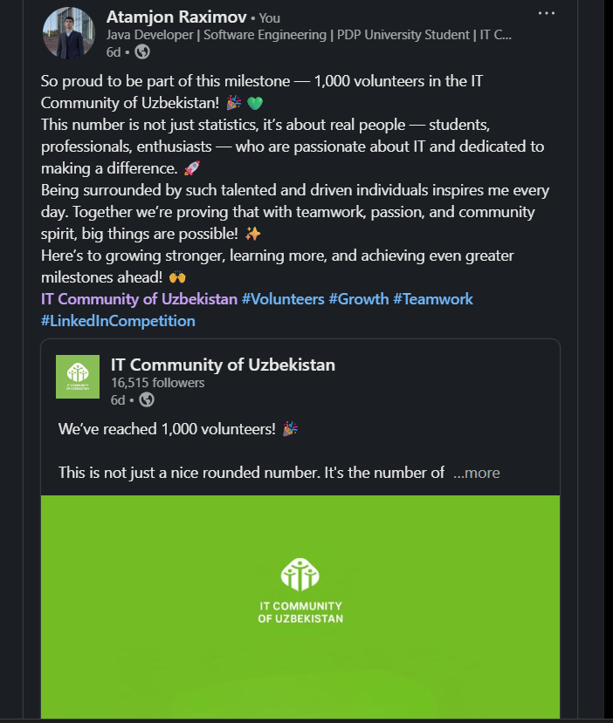

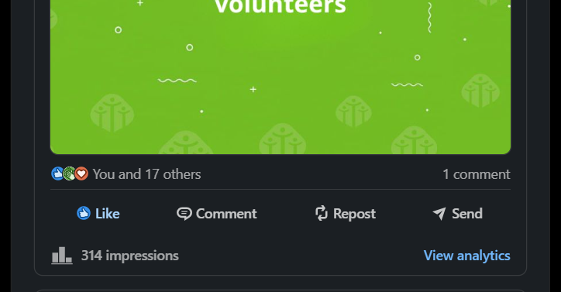

Reposts with meaningful comment: (2):
2. 6 reactions and 1 comments received
https://www.linkedin.com/posts/atamjonraximov_new-monday-vacancy-thread-every-monday-activity-7367038166291156992-QHC2?utm_source=share&utm_medium=member_desktop&rcm=ACoAAEWJaG4BfzzjZoOR5N1JVaFI6V85rvUjCeU
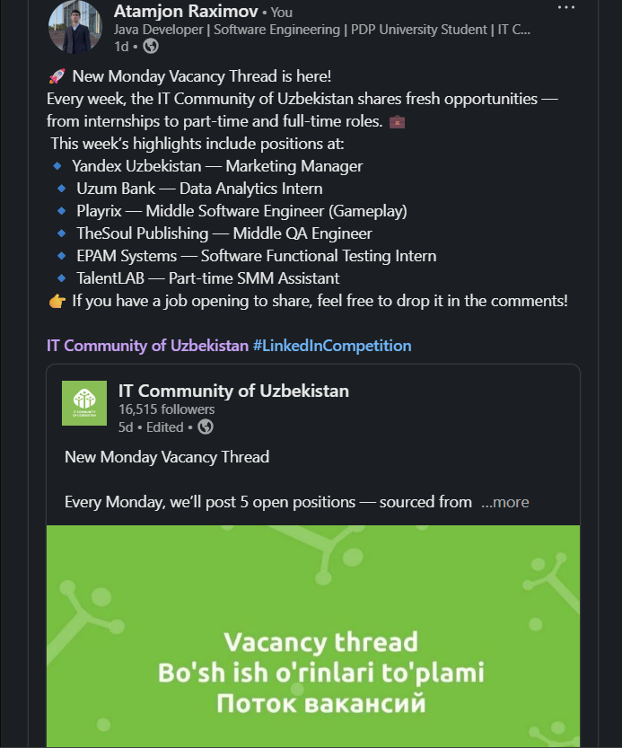

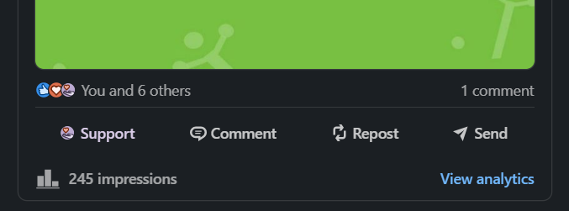

Reposts with meaningful comment: (3):
3. 3 reactions received
https://www.linkedin.com/posts/atamjonraximov_wanna-see-the-future-of-ai-photo-editing-activity-7367395120536530946-PKua?utm_source=share&utm_medium=member_desktop&rcm=ACoAAEWJaG4BfzzjZoOR5N1JVaFI6V85rvUjCeU
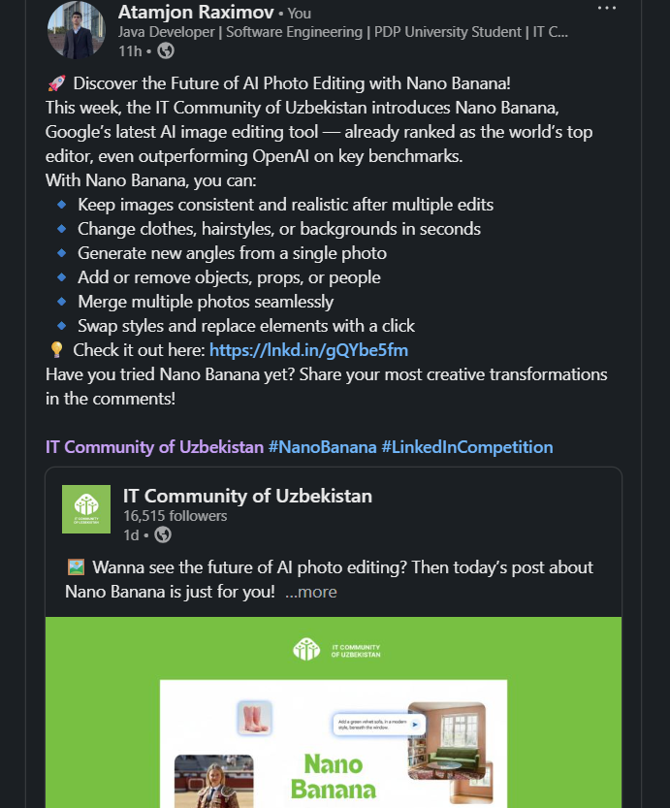

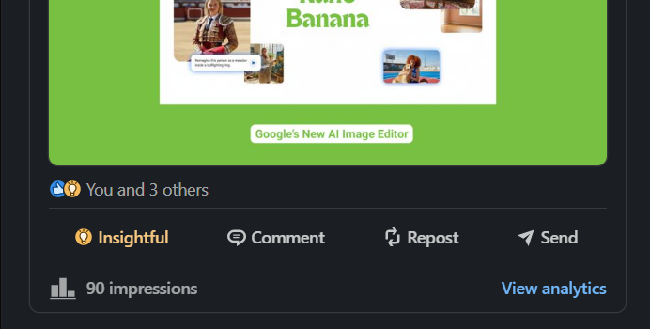

4. Comments on under IT Com (page) posts (1):
https://www.linkedin.com/feed/update/urn:li:activity:7365593781036900352?commentUrn=urn%3Ali%3Acomment%3A%28activity%3A7365593781036900352%2C7365664487422472193%29&dashCommentUrn=urn%3Ali%3Afsd_comment%3A%287365664487422472193%2Curn%3Ali%3Aactivity%3A7365593781036900352%29
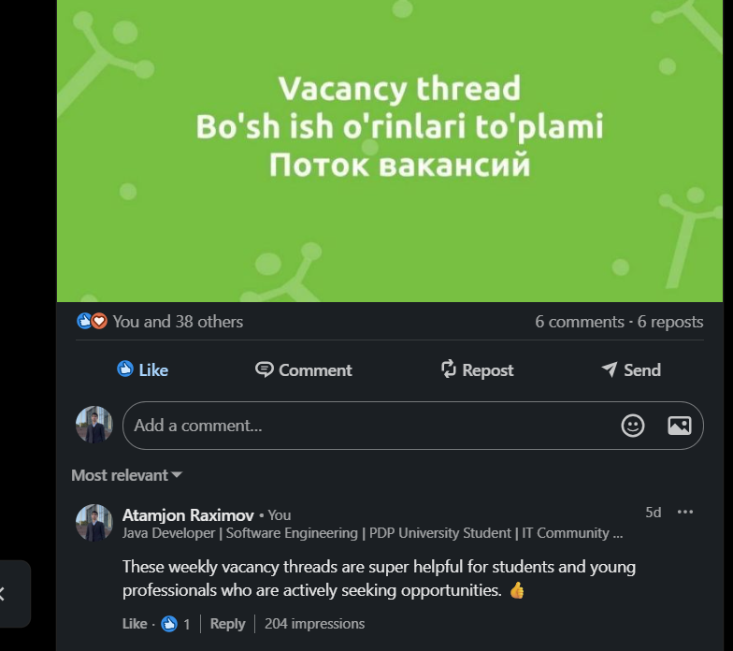

Comments on under IT Com (page) posts (2):
https://www.linkedin.com/feed/update/urn:li:activity:7367043954938142721?commentUrn=urn%3Ali%3Acomment%3A%28activity%3A7367043954938142721%2C7367125852892856320%29&dashCommentUrn=urn%3Ali%3Afsd_comment%3A%287367125852892856320%2Curn%3Ali%3Aactivity%3A7367043954938142721%29
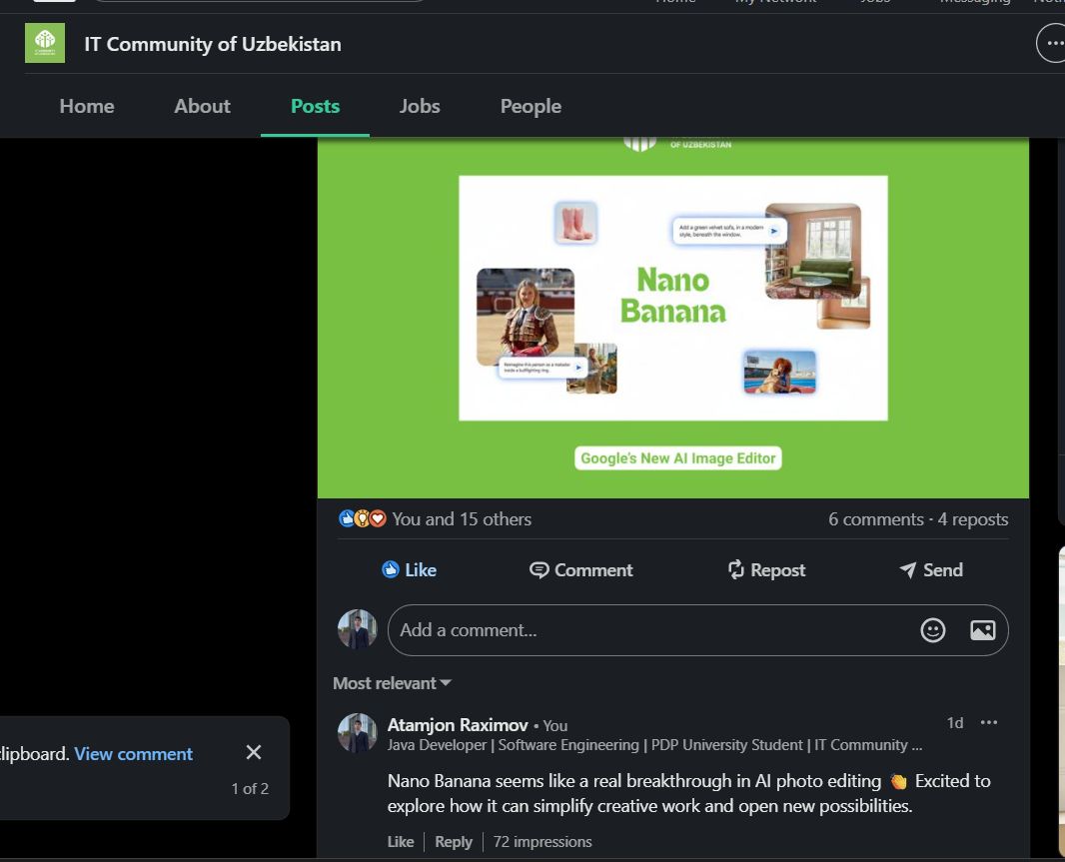

Comments on under IT Com (page) posts (3):
https://www.linkedin.com/feed/update/urn:li:activity:7367405715210022912?commentUrn=urn%3Ali%3Acomment%3A%28activity%3A7367405715210022912%2C7367424694297198592%29&dashCommentUrn=urn%3Ali%3Afsd_comment%3A%287367424694297198592%2Curn%3Ali%3Aactivity%3A7367405715210022912%29
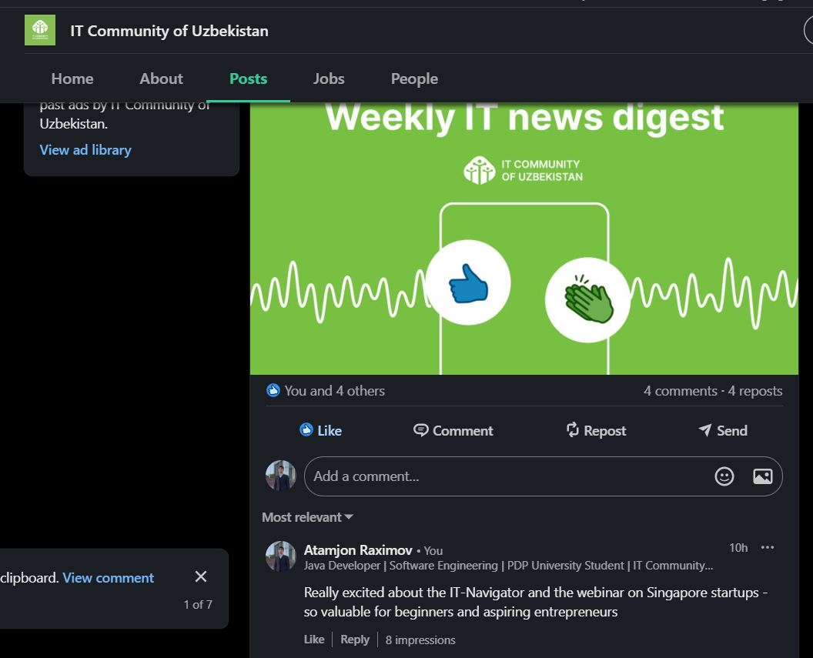

5. Comments in ITCom LinkedIn group (1):
https://www.linkedin.com/feed/update/urn:li:groupPost:9267750-7365368913192280064?commentUrn=urn%3Ali%3Acomment%3A%28groupPost%3A9267750-7365368913192280064%2C7366711313751900161%29&dashCommentUrn=urn%3Ali%3Afsd_comment%3A%287366711313751900161%2Curn%3Ali%3AgroupPost%3A9267750-7365368913192280064%29
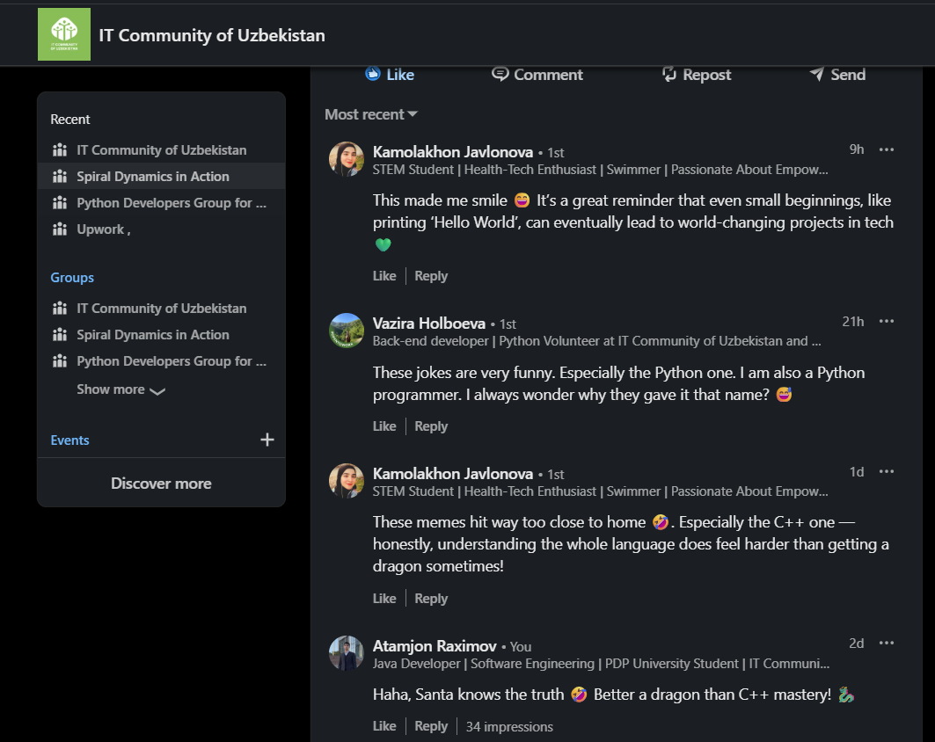

Comments in ITCom LinkedIn group (2):
https://www.linkedin.com/feed/update/urn:li:groupPost:9267750-7365596086415110144?commentUrn=urn%3Ali%3Acomment%3A%28groupPost%3A9267750-7365596086415110144%2C7366710127900495872%29&dashCommentUrn=urn%3Ali%3Afsd_comment%3A%287366710127900495872%2Curn%3Ali%3AgroupPost%3A9267750-7365596086415110144%29
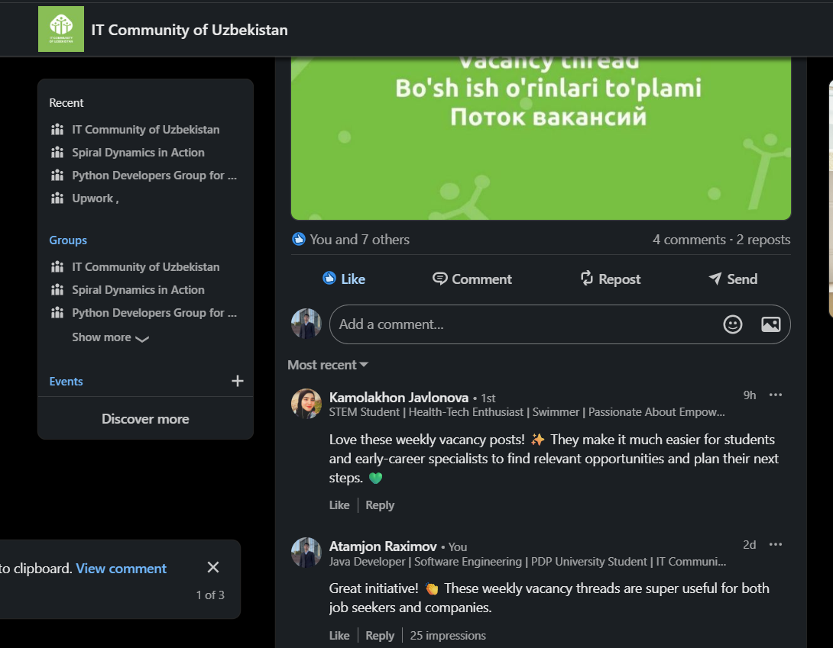

Comments in ITCom LinkedIn group (3):
https://www.linkedin.com/feed/update/urn:li:groupPost:9267750-7365963783208390656?commentUrn=urn%3Ali%3Acomment%3A%28groupPost%3A9267750-7365963783208390656%2C7366709648692899841%29&dashCommentUrn=urn%3Ali%3Afsd_comment%3A%287366709648692899841%2Curn%3Ali%3AgroupPost%3A9267750-7365963783208390656%29
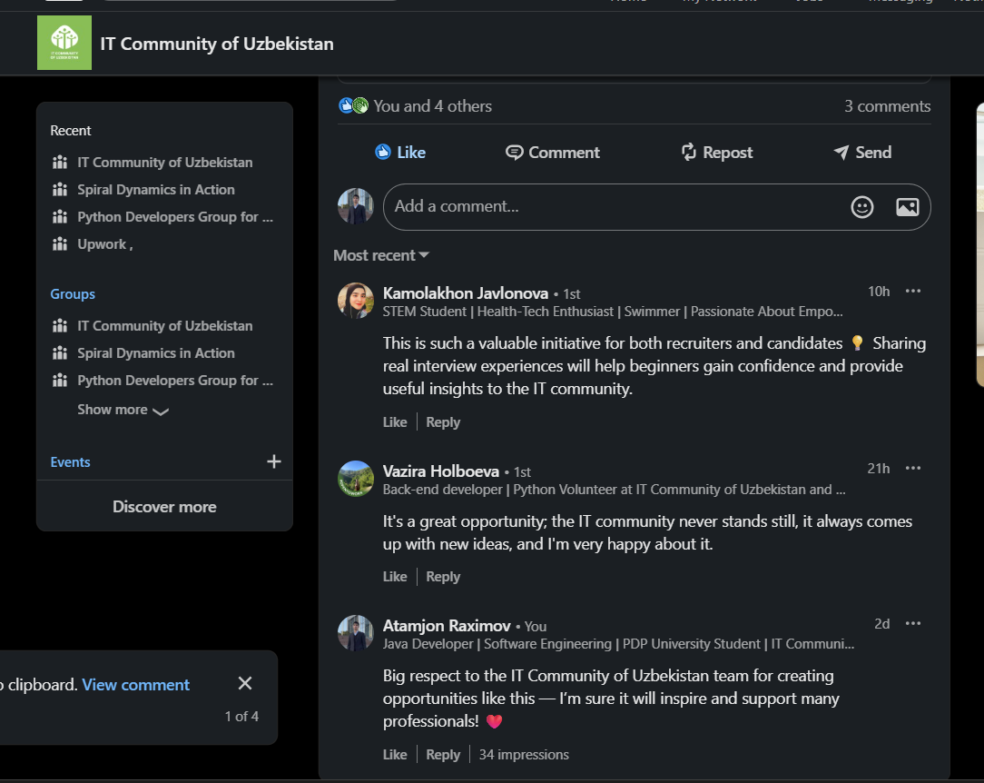

Comments in ITCom LinkedIn group (4):
https://www.linkedin.com/feed/update/urn:li:groupPost:9267750-7366685696083869696?commentUrn=urn%3Ali%3Acomment%3A%28groupPost%3A9267750-7366685696083869696%2C7366708929835331585%29&dashCommentUrn=urn%3Ali%3Afsd_comment%3A%287366708929835331585%2Curn%3Ali%3AgroupPost%3A9267750-7366685696083869696%29
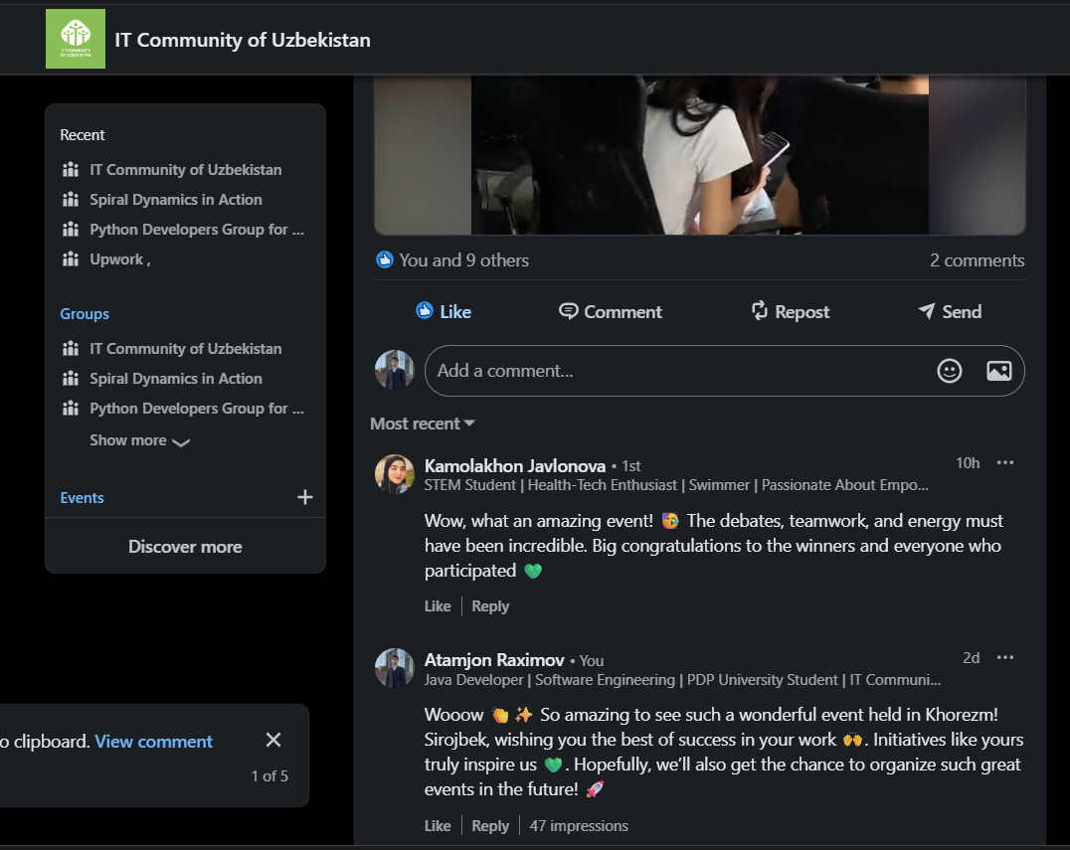

Comments in ITCom LinkedIn group (5):
https://www.linkedin.com/feed/update/urn:li:groupPost:9267750-7367044047376408577?commentUrn=urn%3Ali%3Acomment%3A%28groupPost%3A9267750-7367044047376408577%2C7367125951396069377%29&dashCommentUrn=urn%3Ali%3Afsd_comment%3A%287367125951396069377%2Curn%3Ali%3AgroupPost%3A9267750-7367044047376408577%29
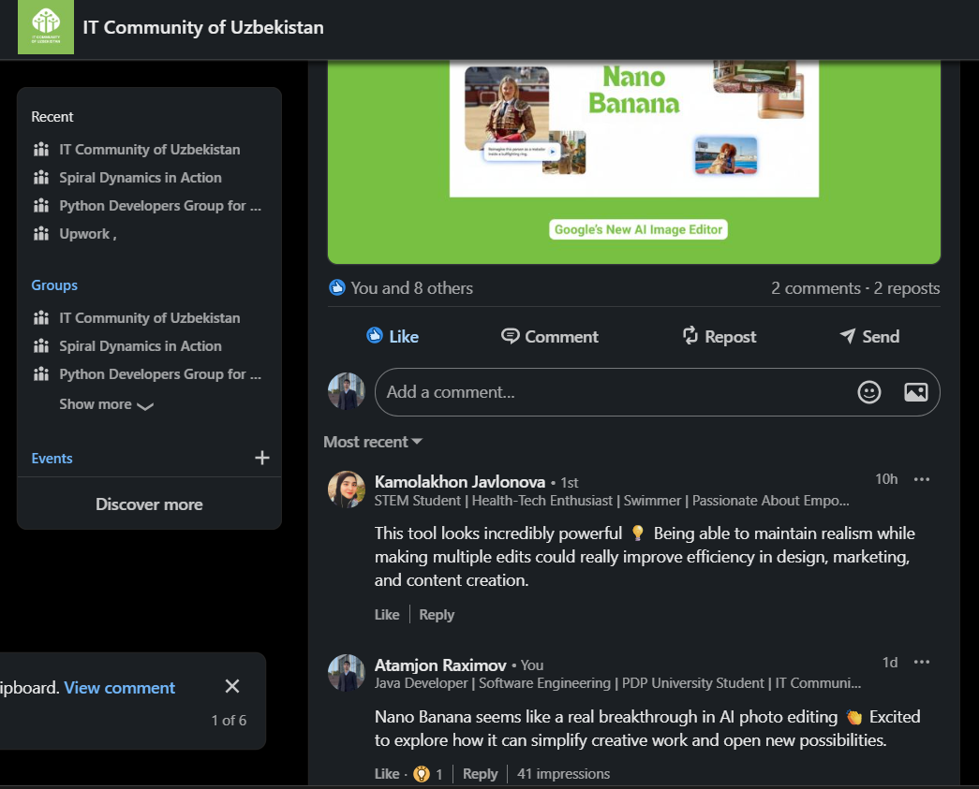

Comments in ITCom LinkedIn group (6):
https://www.linkedin.com/feed/update/urn:li:groupPost:9267750-7367406263766376449?commentUrn=urn%3Ali%3Acomment%3A%28groupPost%3A9267750-7367406263766376449%2C7367569600563003394%29&dashCommentUrn=urn%3Ali%3Afsd_comment%3A%287367569600563003394%2Curn%3Ali%3AgroupPost%3A9267750-7367406263766376449%29
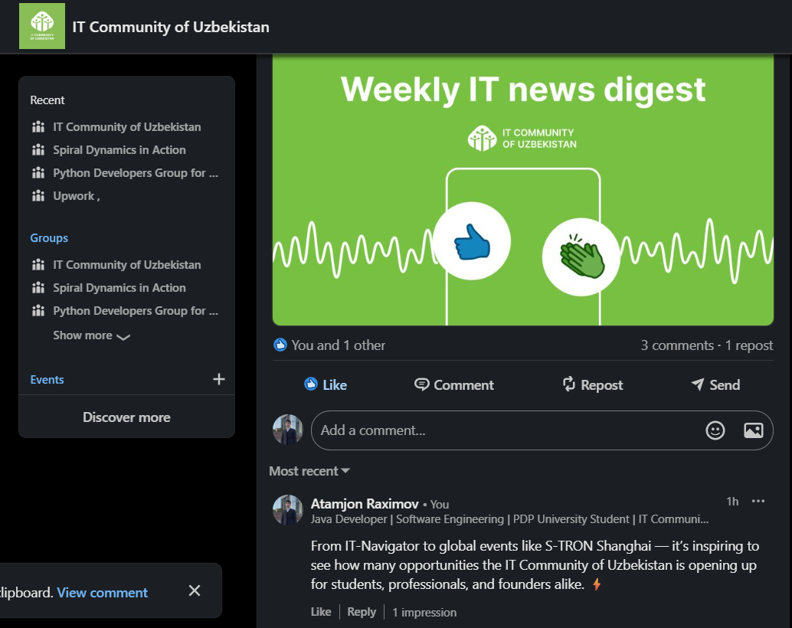

Comments in ITCom LinkedIn group (7):
https://www.linkedin.com/feed/update/urn:li:groupPost:9267750-7367406263766376449?commentUrn=urn%3Ali%3Acomment%3A%28groupPost%3A9267750-7367406263766376449%2C7367425233349152768%29&dashCommentUrn=urn%3Ali%3Afsd_comment%3A%287367425233349152768%2Curn%3Ali%3AgroupPost%3A9267750-7367406263766376449%29
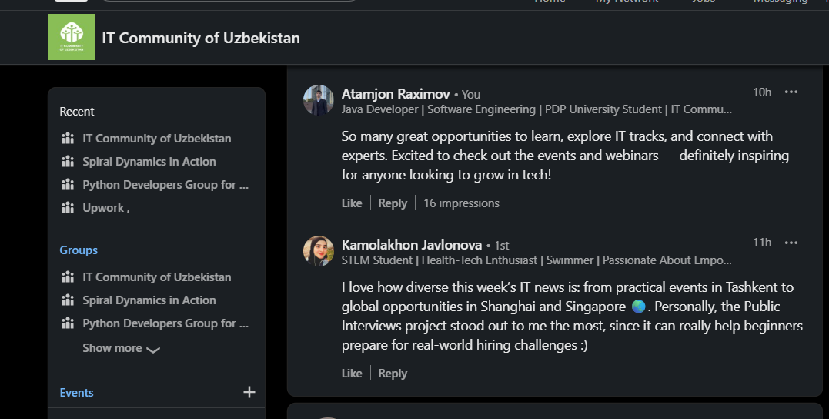

6. Comments under your competitors posts (1):
https://www.linkedin.com/feed/update/urn:li:activity:7365077067668865024?commentUrn=urn%3Ali%3Acomment%3A%28activity%3A7365077067668865024%2C7365228501823639553%29&dashCommentUrn=urn%3Ali%3Afsd_comment%3A%287365228501823639553%2Curn%3Ali%3Aactivity%3A7365077067668865024%29
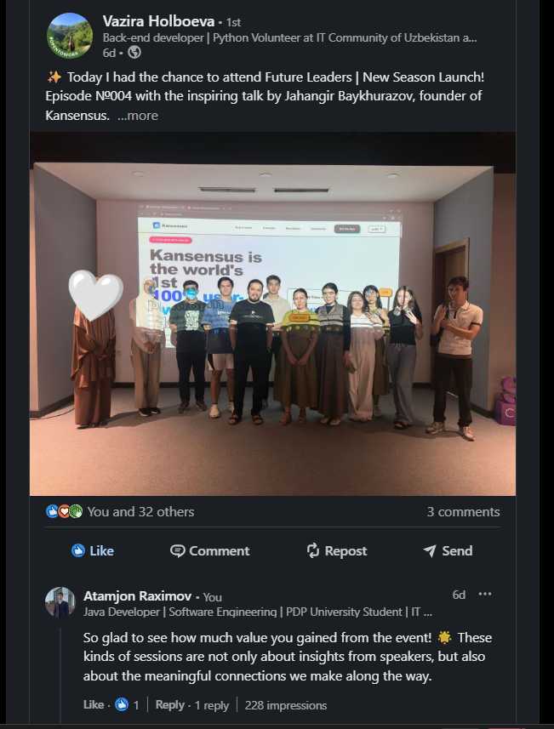

Comments under your competitors posts (2):
https://www.linkedin.com/feed/update/urn:li:activity:7365283245829124096?commentUrn=urn%3Ali%3Acomment%3A%28activity%3A7365283245829124096%2C7365286920731480064%29&dashCommentUrn=urn%3Ali%3Afsd_comment%3A%287365286920731480064%2Curn%3Ali%3Aactivity%3A7365283245829124096%29
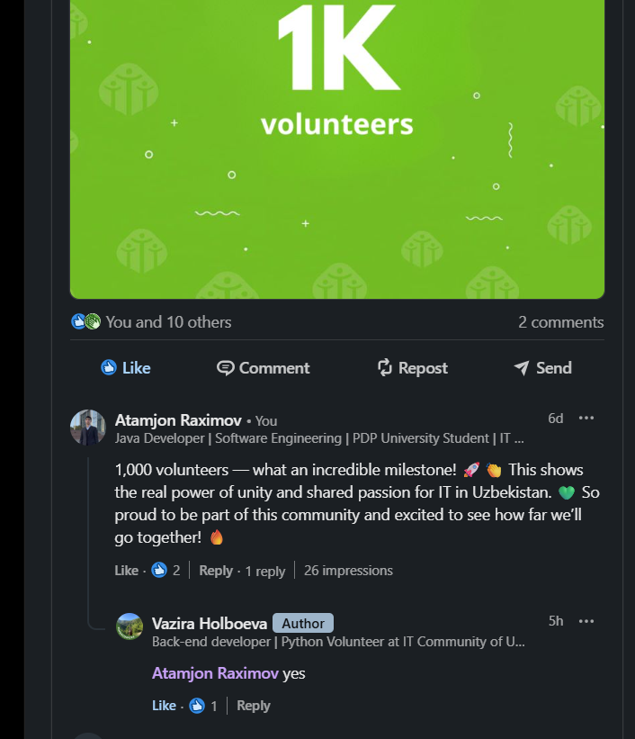

Comments under your competitors posts (3):
https://www.linkedin.com/feed/update/urn:li:ugcPost:7365361194120982528?commentUrn=urn%3Ali%3Acomment%3A%28ugcPost%3A7365361194120982528%2C7365662016163786752%29&dashCommentUrn=urn%3Ali%3Afsd_comment%3A%287365662016163786752%2Curn%3Ali%3AugcPost%3A7365361194120982528%29
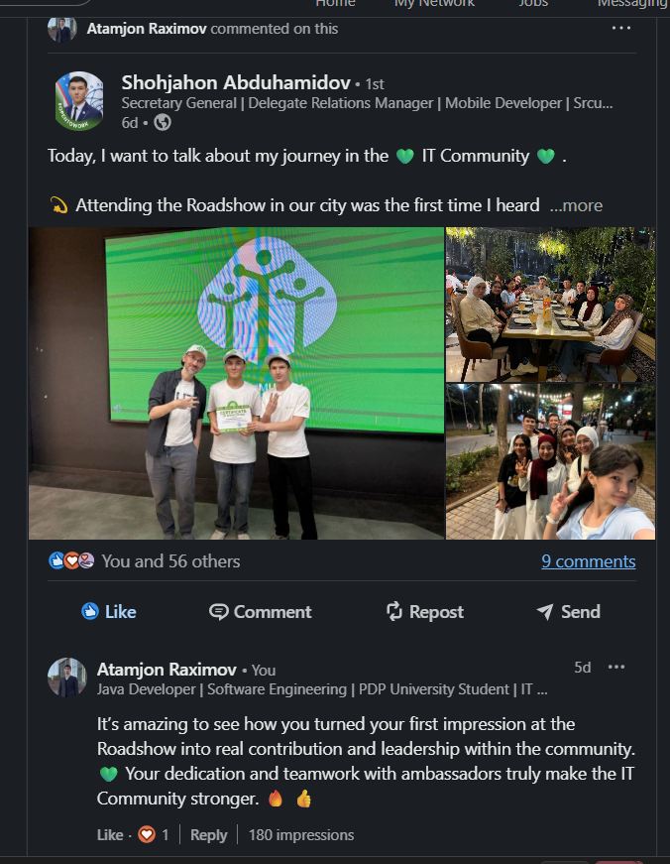

Comments under your competitors posts (4):
https://www.linkedin.com/feed/update/urn:li:activity:7365928282791256064?commentUrn=urn%3Ali%3Acomment%3A%28activity%3A7365928282791256064%2C7365967649429725185%29&dashCommentUrn=urn%3Ali%3Afsd_comment%3A%287365967649429725185%2Curn%3Ali%3Aactivity%3A7365928282791256064%29
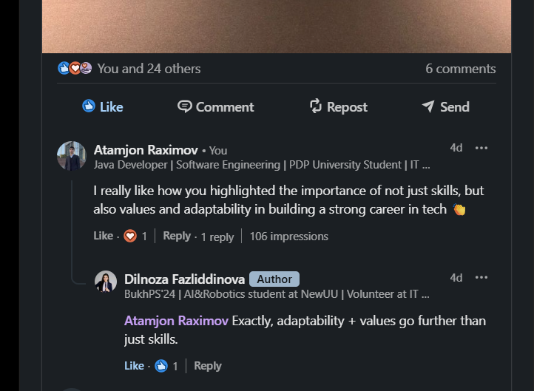

Comments under your competitors posts (5):
https://www.linkedin.com/feed/update/urn:li:activity:7365797502656094208?commentUrn=urn%3Ali%3Acomment%3A%28activity%3A7365797502656094208%2C7365971260628992000%29&dashCommentUrn=urn%3Ali%3Afsd_comment%3A%287365971260628992000%2Curn%3Ali%3Aactivity%3A7365797502656094208%29
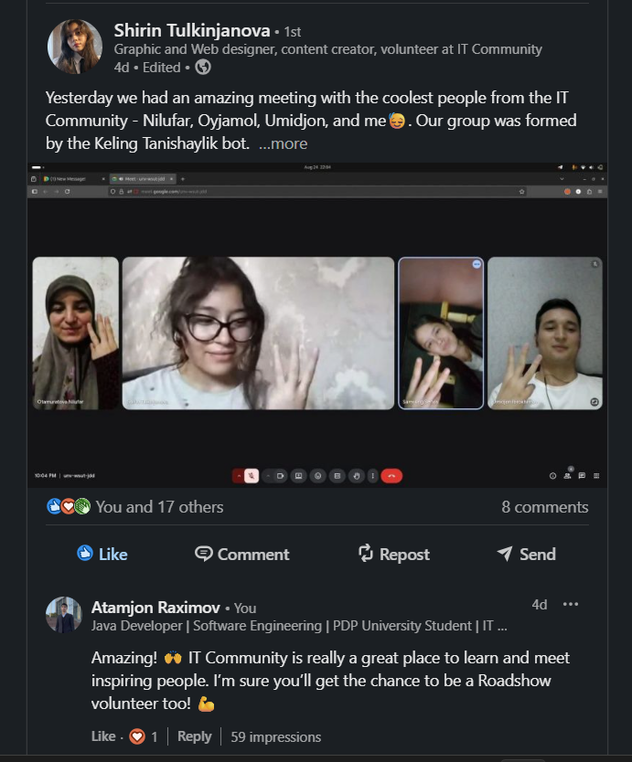

Comments under your competitors posts (6):
https://www.linkedin.com/feed/update/urn:li:activity:7365959667736326144?commentUrn=urn%3Ali%3Acomment%3A%28activity%3A7365959667736326144%2C7365974186982322176%29&dashCommentUrn=urn%3Ali%3Afsd_comment%3A%287365974186982322176%2Curn%3Ali%3Aactivity%3A7365959667736326144%29
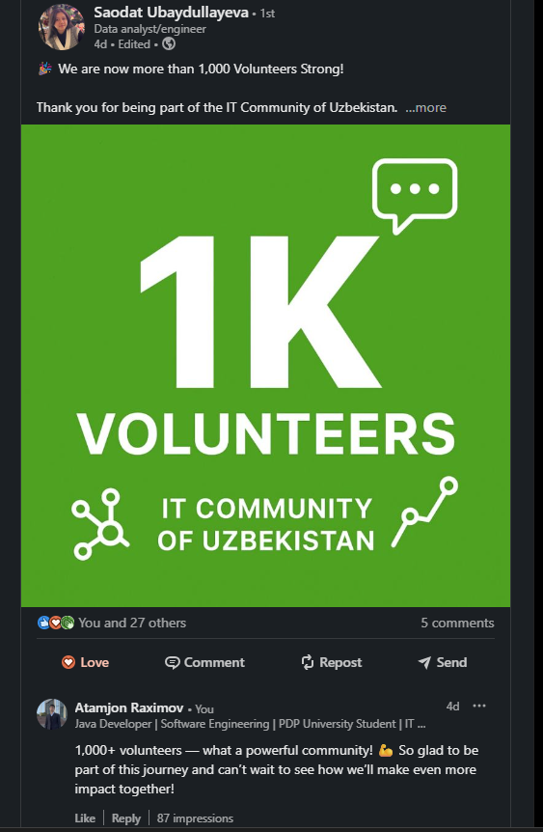

Comments under your competitors posts (7):
https://www.linkedin.com/feed/update/urn:li:activity:7366735193333829632?commentUrn=urn%3Ali%3Acomment%3A%28activity%3A7366735193333829632%2C7366786464455622656%29&dashCommentUrn=urn%3Ali%3Afsd_comment%3A%287366786464455622656%2Curn%3Ali%3Aactivity%3A7366735193333829632%29
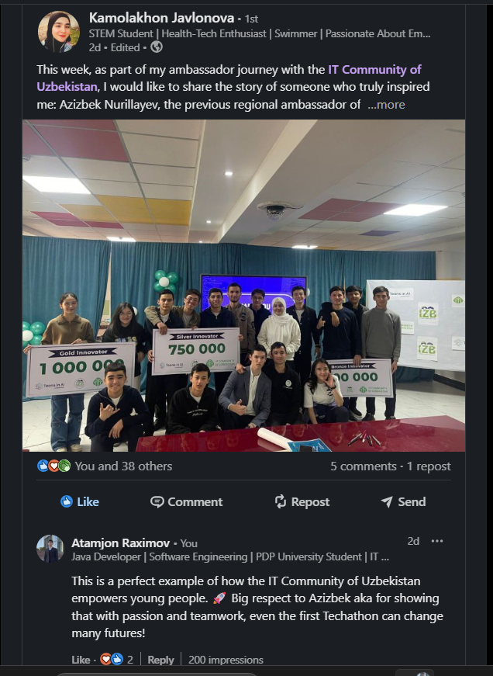

Comments under your competitors posts (8):
https://www.linkedin.com/feed/update/urn:li:activity:7367039974619160576?commentUrn=urn%3Ali%3Acomment%3A%28activity%3A7367039974619160576%2C7367041199951548417%29&dashCommentUrn=urn%3Ali%3Afsd_comment%3A%287367041199951548417%2Curn%3Ali%3Aactivity%3A7367039974619160576%29
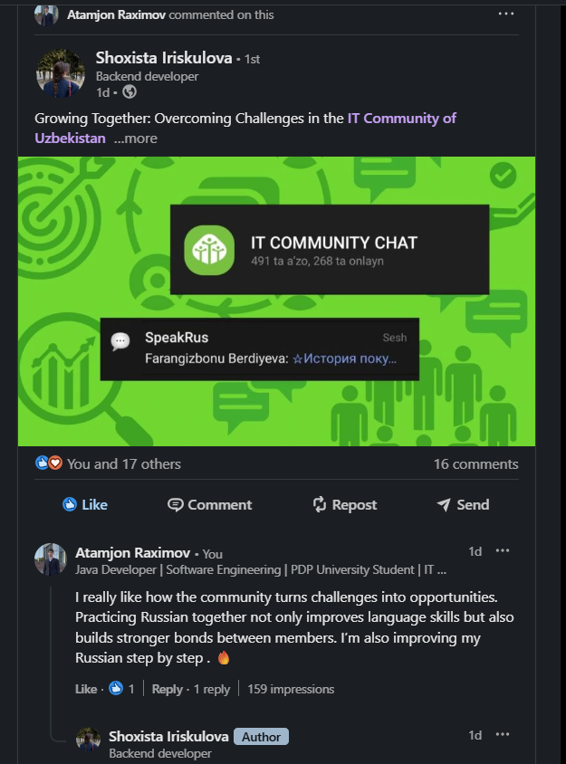

Comments under your competitors posts (9):
https://www.linkedin.com/feed/update/urn:li:activity:7367246004888223745?commentUrn=urn%3Ali%3Acomment%3A%28activity%3A7367246004888223745%2C7367251002288275456%29&dashCommentUrn=urn%3Ali%3Afsd_comment%3A%287367251002288275456%2Curn%3Ali%3Aactivity%3A7367246004888223745%29
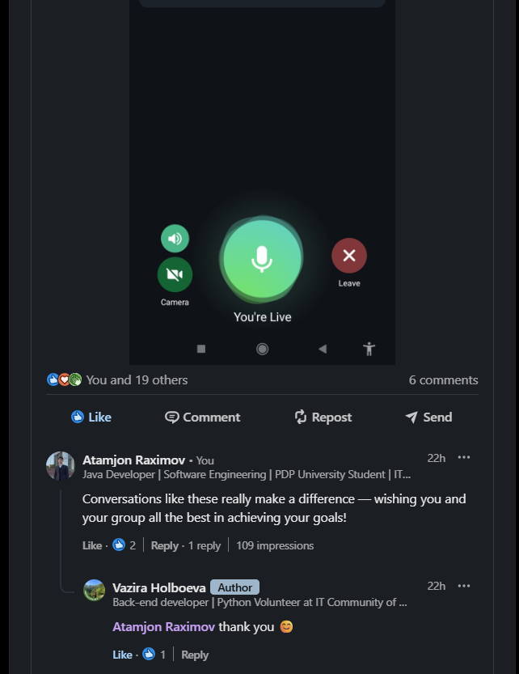

Comments under your competitors posts (10):
https://www.linkedin.com/feed/update/urn:li:activity:7367250812818903040?commentUrn=urn%3Ali%3Acomment%3A%28activity%3A7367250812818903040%2C7367396735410790400%29&dashCommentUrn=urn%3Ali%3Afsd_comment%3A%287367396735410790400%2Curn%3Ali%3Aactivity%3A7367250812818903040%29
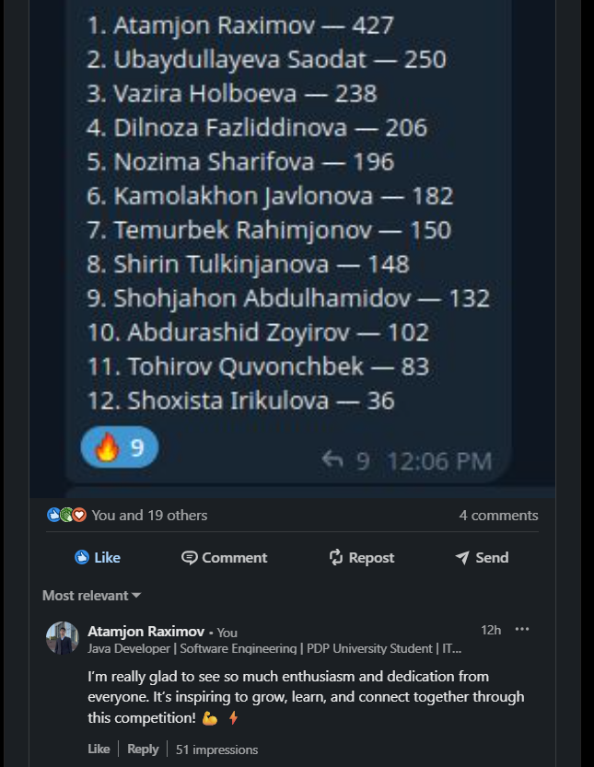

Comments under your competitors posts (11):
https://www.linkedin.com/feed/update/urn:li:activity:7367255483700690944?commentUrn=urn%3Ali%3Acomment%3A%28activity%3A7367255483700690944%2C7367397226970595328%29&dashCommentUrn=urn%3Ali%3Afsd_comment%3A%287367397226970595328%2Curn%3Ali%3Aactivity%3A7367255483700690944%29
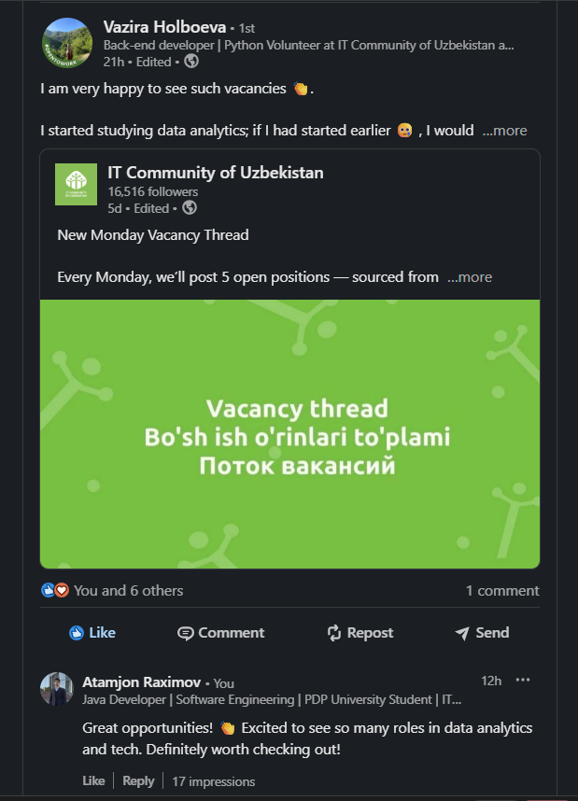

Comments under your competitors posts (12):
https://www.linkedin.com/feed/update/urn:li:activity:7367270847717236736?commentUrn=urn%3Ali%3Acomment%3A%28activity%3A7367270847717236736%2C7367397591916986368%29&dashCommentUrn=urn%3Ali%3Afsd_comment%3A%287367397591916986368%2Curn%3Ali%3Aactivity%3A7367270847717236736%29
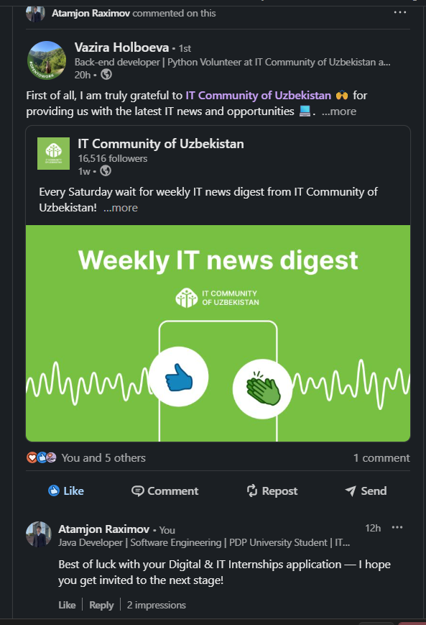

Comments under your competitors posts (13):
https://www.linkedin.com/feed/update/urn:li:activity:7365081358202826752?commentUrn=urn%3Ali%3Acomment%3A%28activity%3A7365081358202826752%2C7367398333268582400%29&dashCommentUrn=urn%3Ali%3Afsd_comment%3A%287367398333268582400%2Curn%3Ali%3Aactivity%3A7365081358202826752%29
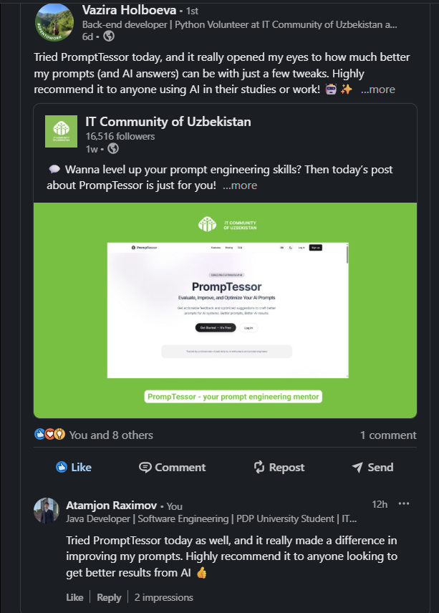

Comments under your competitors posts (14):
https://www.linkedin.com/feed/update/urn:li:activity:7367413348625182721?commentUrn=urn%3Ali%3Acomment%3A%28activity%3A7367413348625182721%2C7367414722847076355%29&dashCommentUrn=urn%3Ali%3Afsd_comment%3A%287367414722847076355%2Curn%3Ali%3Aactivity%3A7367413348625182721%29
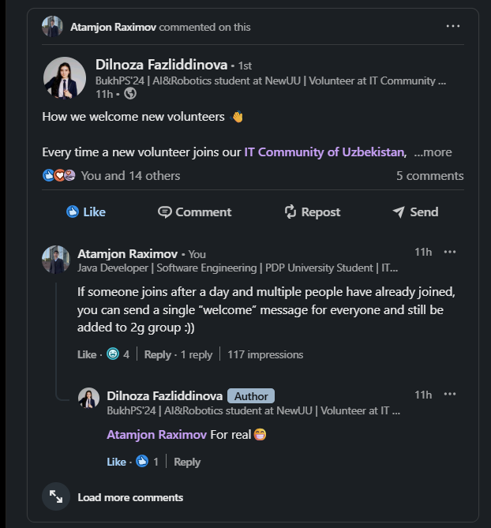

Comments under your competitors posts (15):
https://www.linkedin.com/feed/update/urn:li:activity:7367425590116704256?commentUrn=urn%3Ali%3Acomment%3A%28activity%3A7367425590116704256%2C7367481240360235008%29&dashCommentUrn=urn%3Ali%3Afsd_comment%3A%287367481240360235008%2Curn%3Ali%3Aactivity%3A7367425590116704256%29
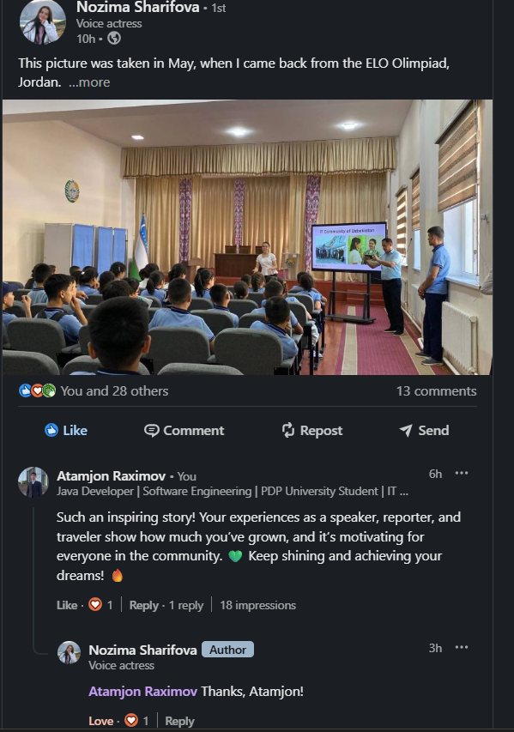

Comments under your competitors posts (16):
https://www.linkedin.com/feed/update/urn:li:activity:7367461787916533760?commentUrn=urn%3Ali%3Acomment%3A%28activity%3A7367461787916533760%2C7367481692975939584%29&dashCommentUrn=urn%3Ali%3Afsd_comment%3A%287367481692975939584%2Curn%3Ali%3Aactivity%3A7367461787916533760%29
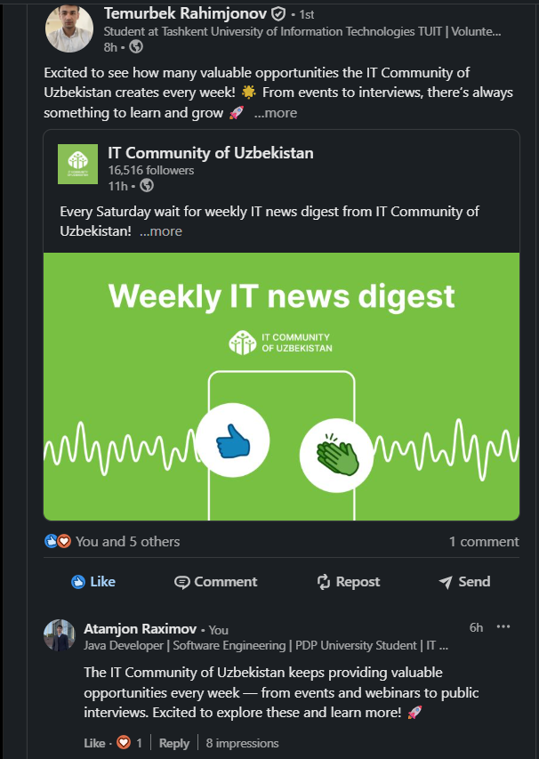

Comments under your competitors posts (17):
https://www.linkedin.com/feed/update/urn:li:ugcPost:7367470586366763009?commentUrn=urn%3Ali%3Acomment%3A%28ugcPost%3A7367470586366763009%2C7367482000951128064%29&dashCommentUrn=urn%3Ali%3Afsd_comment%3A%287367482000951128064%2Curn%3Ali%3AugcPost%3A7367470586366763009%29
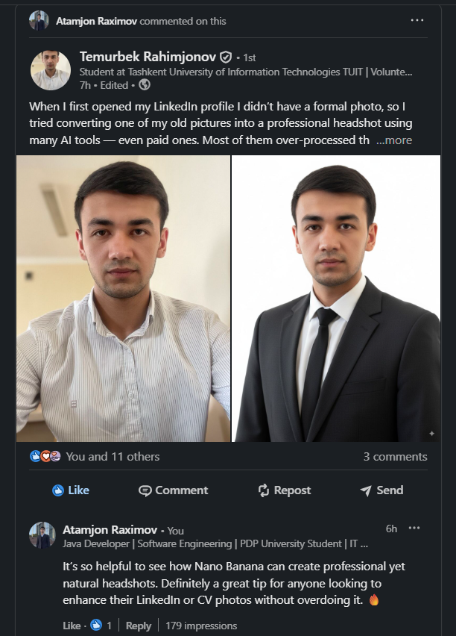

Comments under your competitors posts (18):
https://www.linkedin.com/feed/update/urn:li:activity:7367481518664949796?commentUrn=urn%3Ali%3Acomment%3A%28activity%3A7367481518664949796%2C7367482413859475456%29&dashCommentUrn=urn%3Ali%3Afsd_comment%3A%287367482413859475456%2Curn%3Ali%3Aactivity%3A7367481518664949796%29
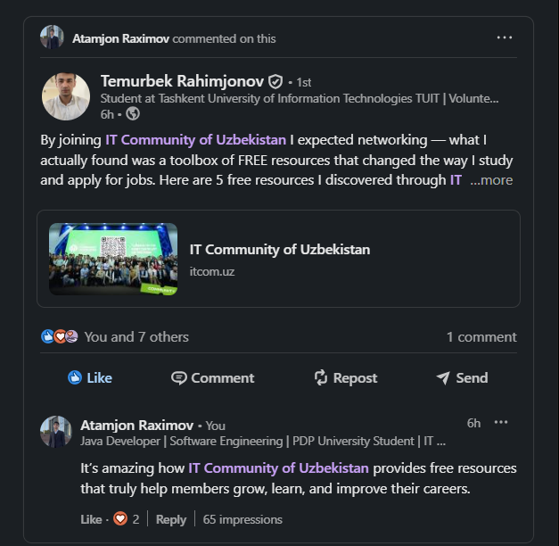

Comments under your competitors posts (19):
https://www.linkedin.com/feed/update/urn:li:activity:7367539105930407937?commentUrn=urn%3Ali%3Acomment%3A%28activity%3A7367539105930407937%2C7367540568584912896%29&dashCommentUrn=urn%3Ali%3Afsd_comment%3A%287367540568584912896%2Curn%3Ali%3Aactivity%3A7367539105930407937%29
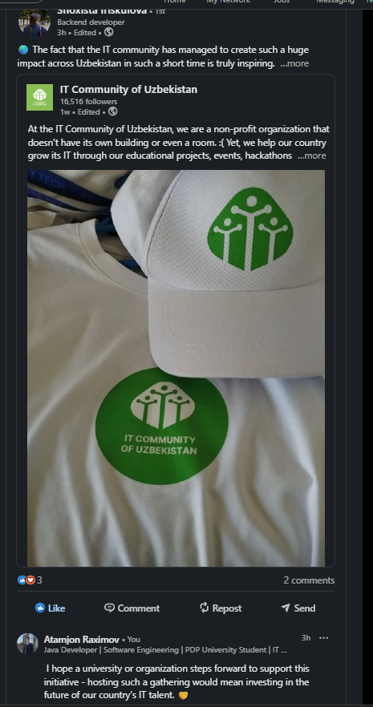

Comments under your competitors posts (20):
https://www.linkedin.com/feed/update/urn:li:ugcPost:7367238092765741056?commentUrn=urn%3Ali%3Acomment%3A%28ugcPost%3A7367238092765741056%2C7367569255652941824%29&dashCommentUrn=urn%3Ali%3Afsd_comment%3A%287367569255652941824%2Curn%3Ali%3AugcPost%3A7367238092765741056%29
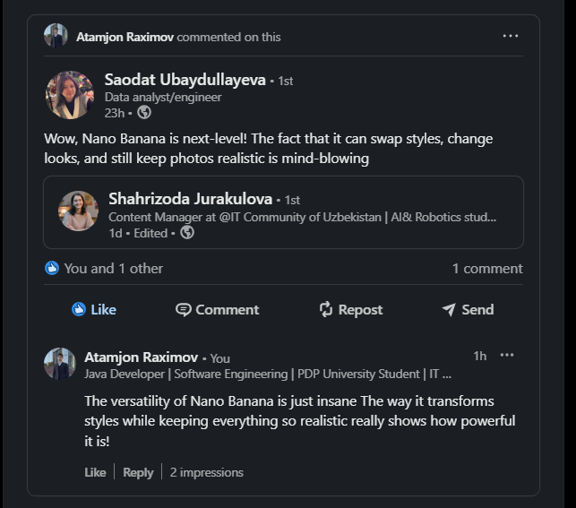

Comments under your competitors posts (21):
https://www.linkedin.com/feed/update/urn:li:activity:7367596232707436544?commentUrn=urn%3Ali%3Acomment%3A%28activity%3A7367596232707436544%2C7367604691762896896%29&dashCommentUrn=urn%3Ali%3Afsd_comment%3A%287367604691762896896%2Curn%3Ali%3Aactivity%3A7367596232707436544%29
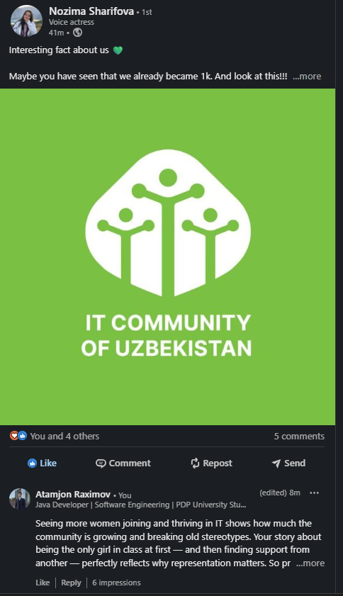

Comments under your competitors posts (22):
https://www.linkedin.com/feed/update/urn:li:activity:7367598654485868544?commentUrn=urn%3Ali%3Acomment%3A%28activity%3A7367598654485868544%2C7367605603956981760%29&dashCommentUrn=urn%3Ali%3Afsd_comment%3A%287367605603956981760%2Curn%3Ali%3Aactivity%3A7367598654485868544%29
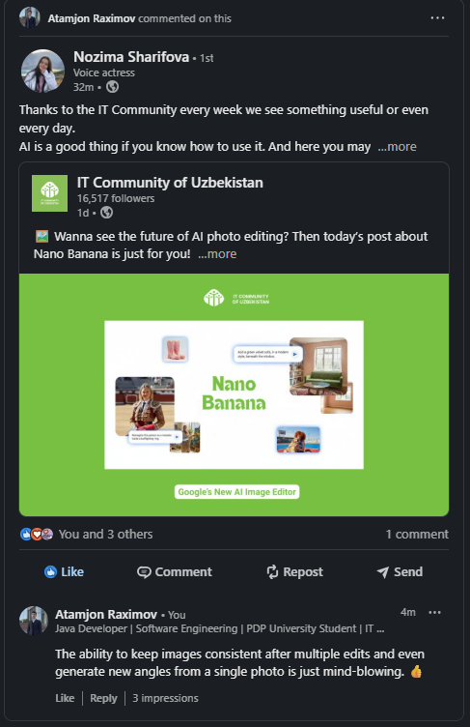

Comments under your competitors posts (23):
https://www.linkedin.com/feed/update/urn:li:activity:7367599668307865601?commentUrn=urn%3Ali%3Acomment%3A%28activity%3A7367599668307865601%2C7367606115477471232%29&dashCommentUrn=urn%3Ali%3Afsd_comment%3A%287367606115477471232%2Curn%3Ali%3Aactivity%3A7367599668307865601%29
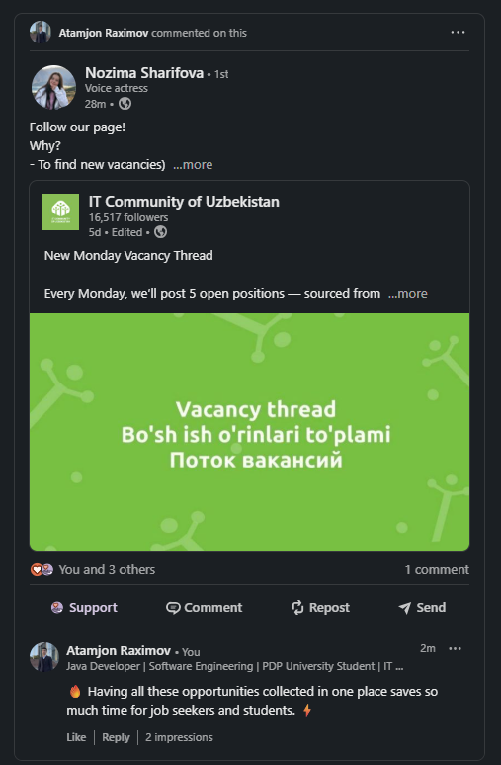

Comments under your competitors posts (24):
https://www.linkedin.com/feed/update/urn:li:activity:7367607255568928768?commentUrn=urn%3Ali%3Acomment%3A%28activity%3A7367607255568928768%2C7367607866700058624%29&dashCommentUrn=urn%3Ali%3Afsd_comment%3A%287367607866700058624%2Curn%3Ali%3Aactivity%3A7367607255568928768%29
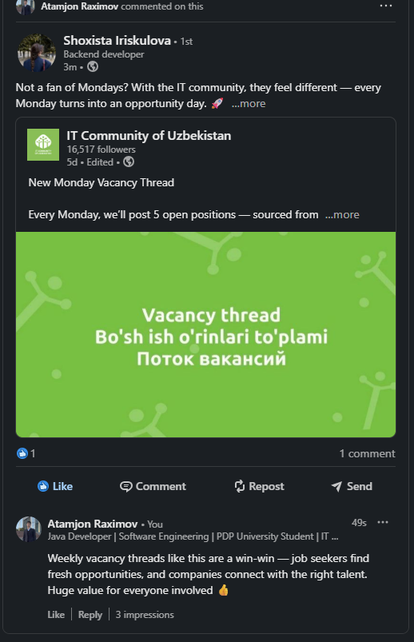

7. Reactions in our Linkedin group (1):
https://www.linkedin.com/feed/update/urn:li:activity:7365256624900399105?utm_source=share&utm_medium=member_desktop&rcm=ACoAAEWJaG4BfzzjZoOR5N1JVaFI6V85rvUjCeU
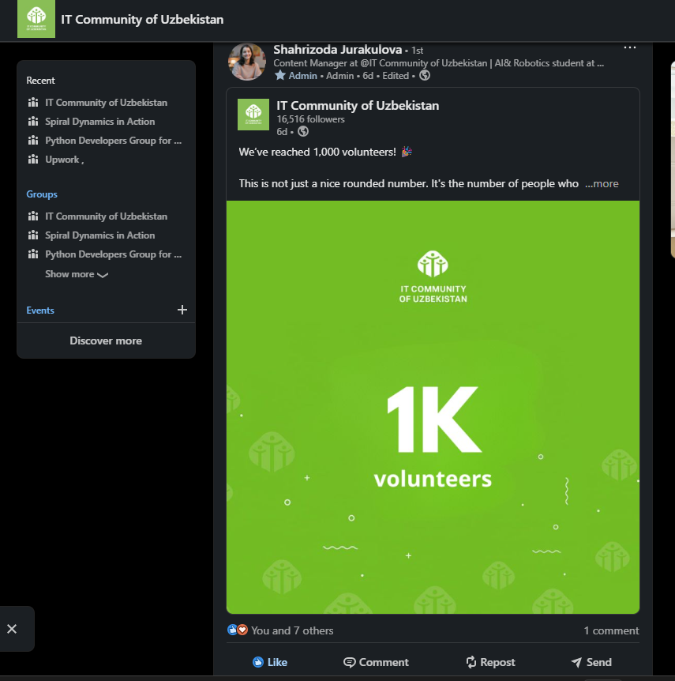

Reactions in our Linkedin group (2):
https://www.linkedin.com/feed/update/urn:li:activity:7365368914047840256?utm_source=share&utm_medium=member_desktop&rcm=ACoAAEWJaG4BfzzjZoOR5N1JVaFI6V85rvUjCeU
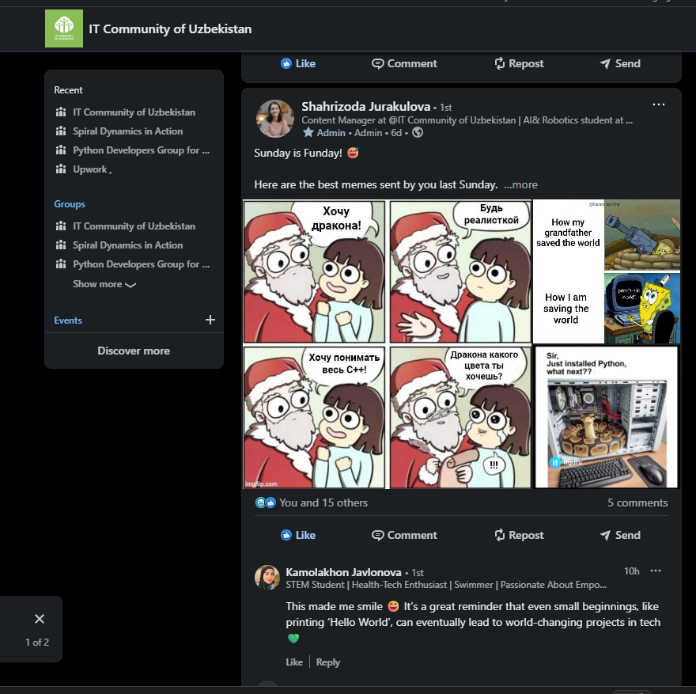

Reactions in our Linkedin group (3):
https://www.linkedin.com/feed/update/urn:li:activity:7365596087253893120?utm_source=share&utm_medium=member_desktop&rcm=ACoAAEWJaG4BfzzjZoOR5N1JVaFI6V85rvUjCeU
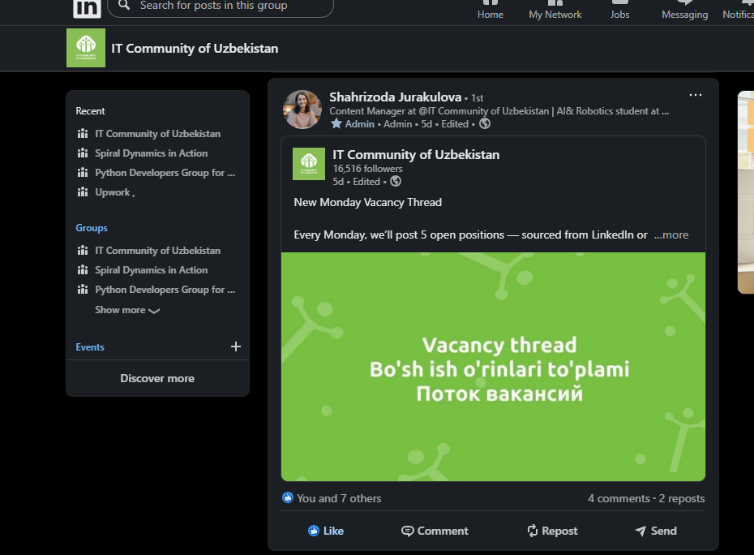

Reactions in our Linkedin group (4):
https://www.linkedin.com/feed/update/urn:li:activity:7365963783955017728?utm_source=share&utm_medium=member_desktop&rcm=ACoAAEWJaG4BfzzjZoOR5N1JVaFI6V85rvUjCeU
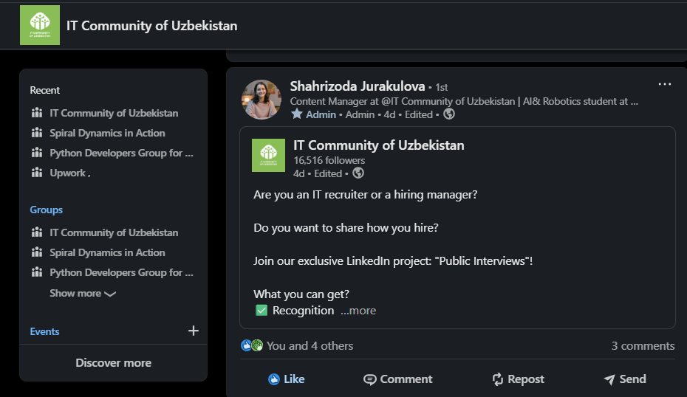

Reactions in our Linkedin group (5):
https://www.linkedin.com/feed/update/urn:li:activity:7366685697321164801?utm_source=share&utm_medium=member_desktop&rcm=ACoAAEWJaG4BfzzjZoOR5N1JVaFI6V85rvUjCeU
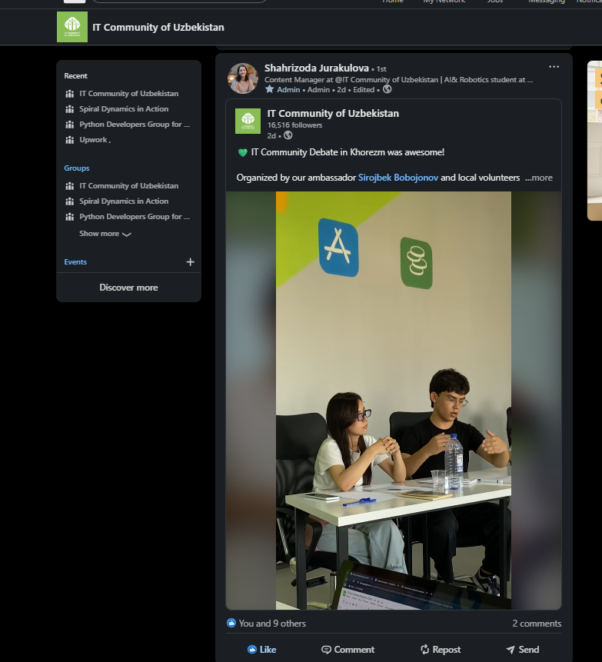

Reactions in our Linkedin group (6):
https://www.linkedin.com/feed/update/urn:li:activity:7367044048110407682?utm_source=share&utm_medium=member_desktop&rcm=ACoAAEWJaG4BfzzjZoOR5N1JVaFI6V85rvUjCeU
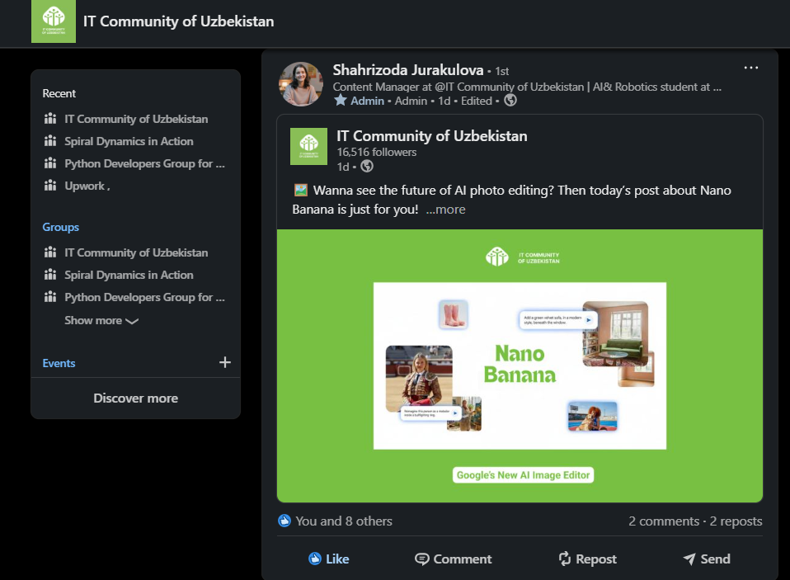

Reactions in our Linkedin group (7):
https://www.linkedin.com/feed/update/urn:li:activity:7367406264605196288?utm_source=share&utm_medium=member_desktop&rcm=ACoAAEWJaG4BfzzjZoOR5N1JVaFI6V85rvUjCeU

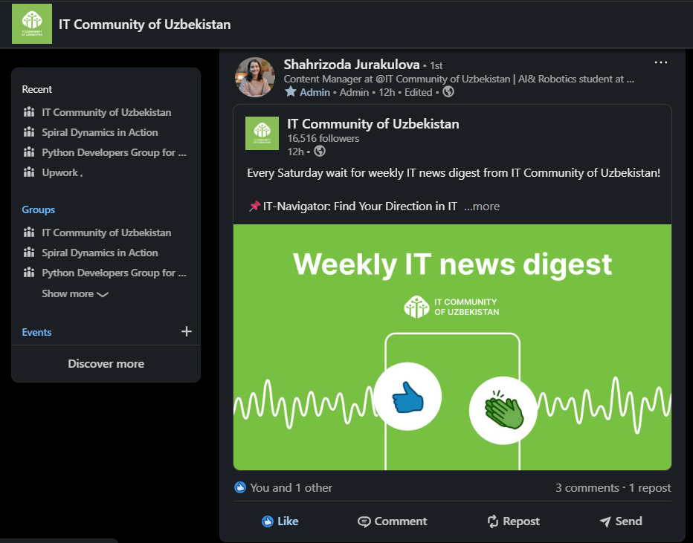

8. Reactions in our Linkedin page (1):
https://www.linkedin.com/posts/itcommunityuzb_new-monday-vacancy-thread-every-monday-activity-7365593781036900352-yMao?utm_source=share&utm_medium=member_desktop&rcm=ACoAAEWJaG4BfzzjZoOR5N1JVaFI6V85rvUjCeU
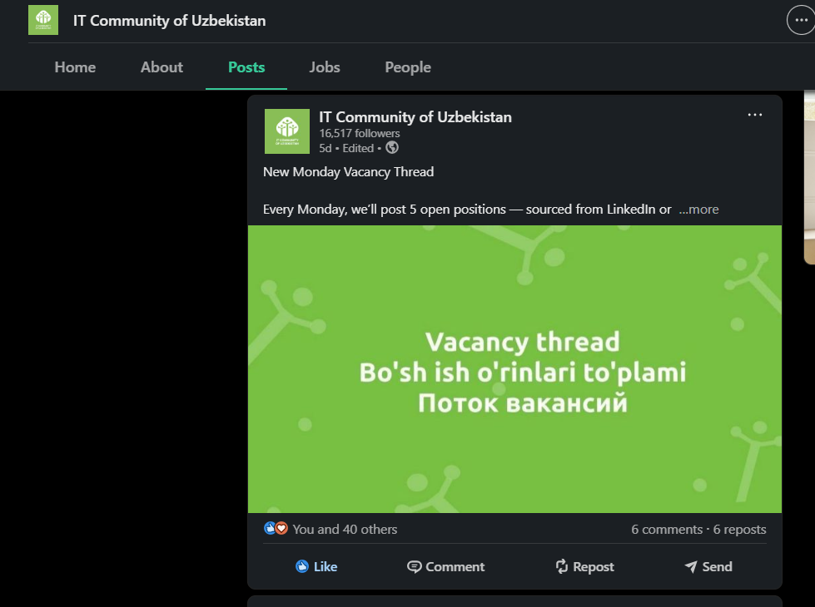

Reactions in our Linkedin page (2):
https://www.linkedin.com/posts/itcommunityuzb_wanna-see-the-future-of-ai-photo-editing-activity-7367043954938142721-naIG?utm_source=share&utm_medium=member_desktop&rcm=ACoAAEWJaG4BfzzjZoOR5N1JVaFI6V85rvUjCeU
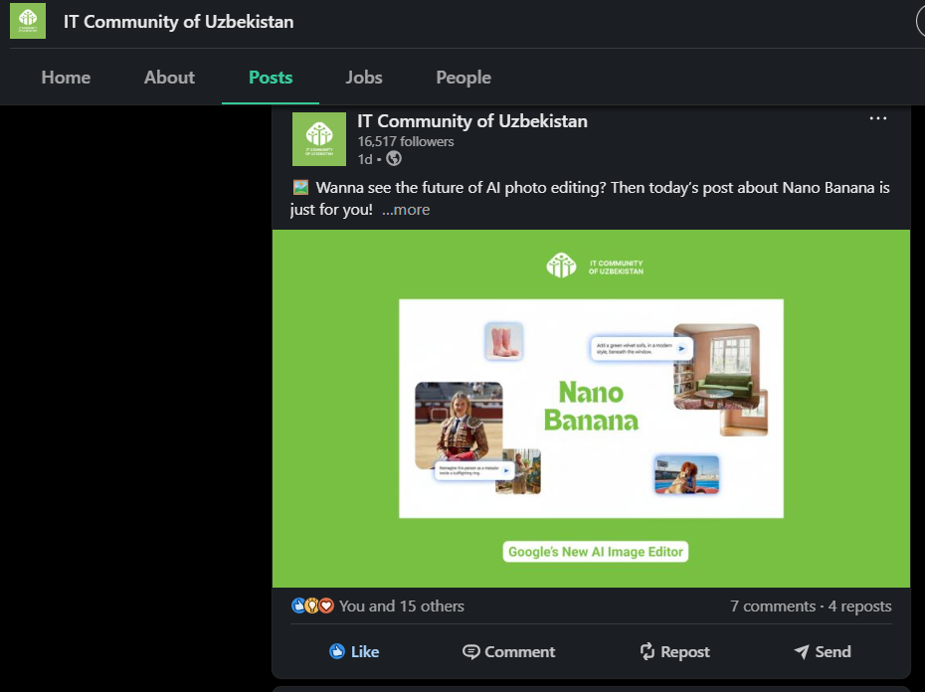

Reactions in our Linkedin page (3):
https://www.linkedin.com/posts/itcommunityuzb_every-saturday-wait-for-weekly-it-news-digest-activity-7367405715210022912-UDTq?utm_source=share&utm_medium=member_desktop&rcm=ACoAAEWJaG4BfzzjZoOR5N1JVaFI6V85rvUjCeU
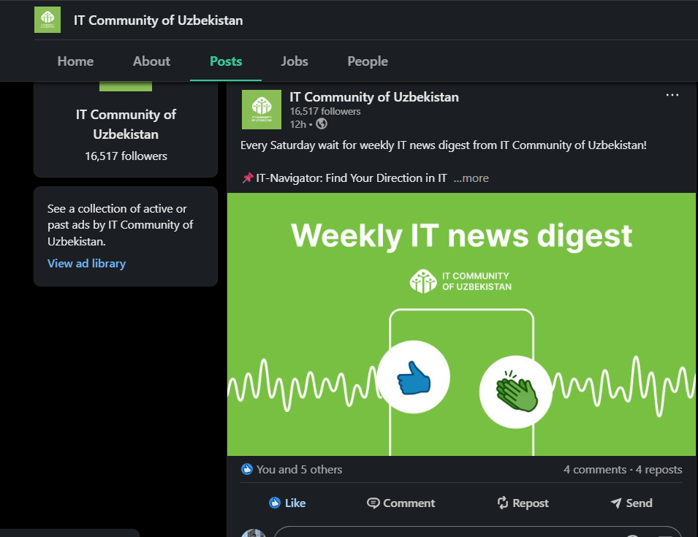

9. Reactions on your competitors posts (1):
https://www.linkedin.com/posts/vazira-holboeva_linkedincompetition-activity-7365077067668865024-JqCF?utm_source=share&utm_medium=member_desktop&rcm=ACoAAEWJaG4BfzzjZoOR5N1JVaFI6V85rvUjCeU
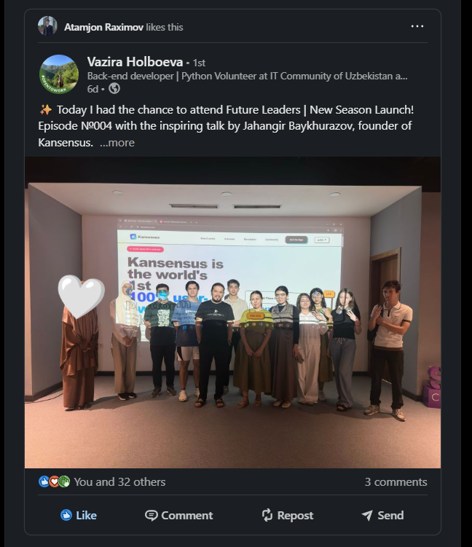

Reactions on your competitors posts (2):
https://www.linkedin.com/posts/shoxista-iriskulova-45523032a_itcommunity-linkedincompetition-activity-7365091367523373056-5liL?utm_source=share&utm_medium=member_desktop&rcm=ACoAAEWJaG4BfzzjZoOR5N1JVaFI6V85rvUjCeU
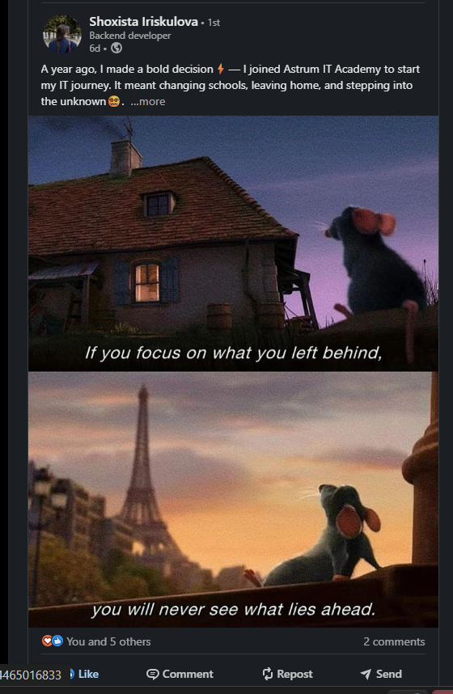

Reactions on your competitors posts (3):
https://www.linkedin.com/posts/kuvonchbek-tohirov-975458269_level-up-your-prompt-engineering-skills-ugcPost-7365048565930352640-me_L?utm_source=share&utm_medium=member_desktop&rcm=ACoAAEWJaG4BfzzjZoOR5N1JVaFI6V85rvUjCeU
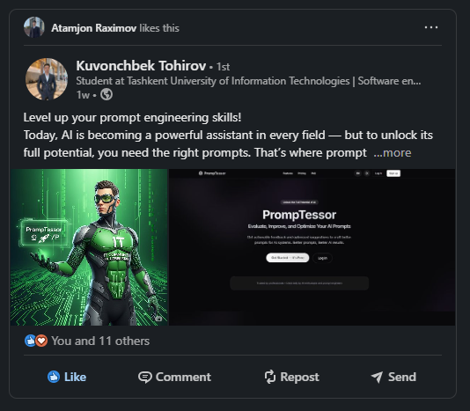

Reactions on your competitors posts (4):
https://www.linkedin.com/posts/vazira-holboeva_weve-reached-1000-volunteers-this-activity-7365283245829124096-SUhz?utm_source=share&utm_medium=member_desktop&rcm=ACoAAEWJaG4BfzzjZoOR5N1JVaFI6V85rvUjCeU
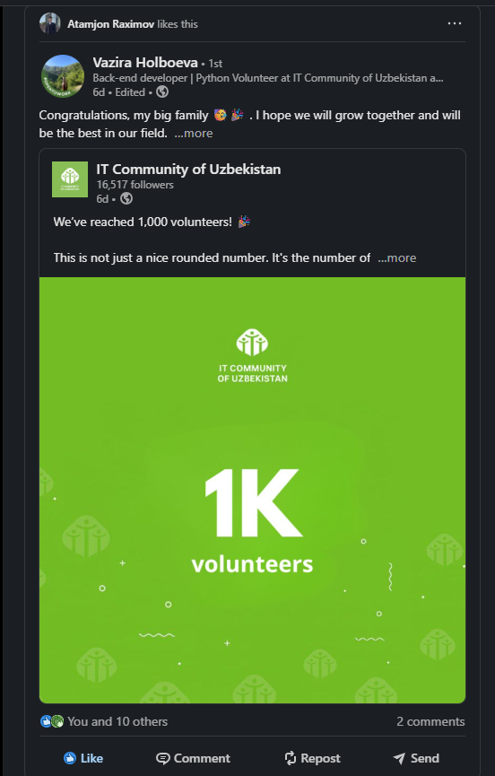

Reactions on your competitors posts (5):
https://www.linkedin.com/posts/shohjahon-abduhamidov_linkedincompetition-itcommunity-ugcPost-7365361194120982528-wGEu?utm_source=share&utm_medium=member_desktop&rcm=ACoAAEWJaG4BfzzjZoOR5N1JVaFI6V85rvUjCeU
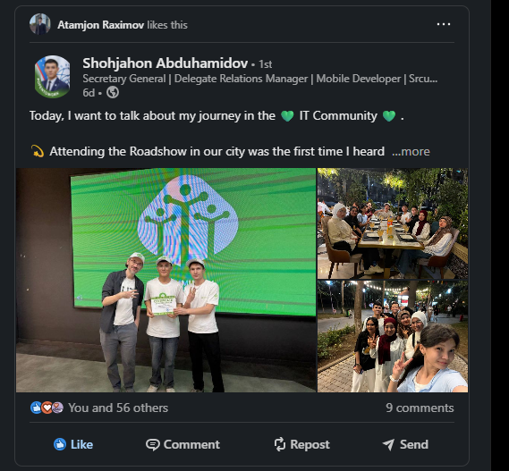

Reactions on your competitors posts (6):
https://www.linkedin.com/posts/shirin-tulkinjanova-1a12602ba_linkedincompetition-activity-7365797502656094208-EPBZ?utm_source=share&utm_medium=member_desktop&rcm=ACoAAEWJaG4BfzzjZoOR5N1JVaFI6V85rvUjCeU
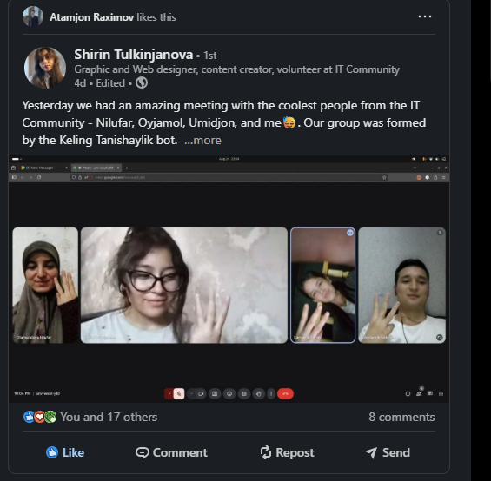

Reactions on your competitors posts (7):
https://www.linkedin.com/posts/dilnoza-fazliddinova-08a818340_linkedincompetition-activity-7365928282791256064-xDIj?utm_source=share&utm_medium=member_desktop&rcm=ACoAAEWJaG4BfzzjZoOR5N1JVaFI6V85rvUjCeU
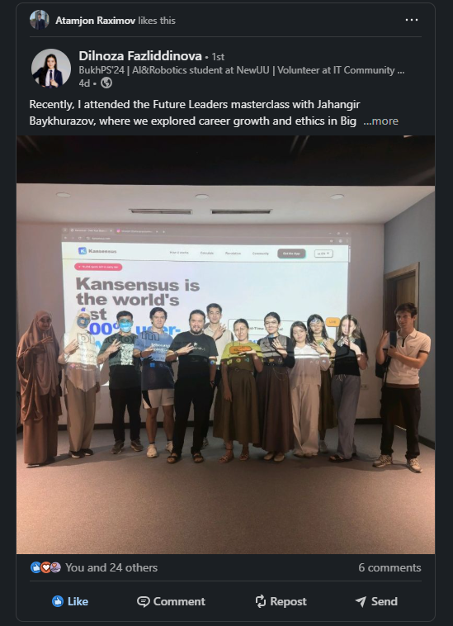

Reactions on your competitors posts (8):
https://www.linkedin.com/posts/saodat-ubaydullayeva_we-are-now-more-than-1000-volunteers-activity-7365959667736326144-eWEo?utm_source=share&utm_medium=member_desktop&rcm=ACoAAEWJaG4BfzzjZoOR5N1JVaFI6V85rvUjCeU
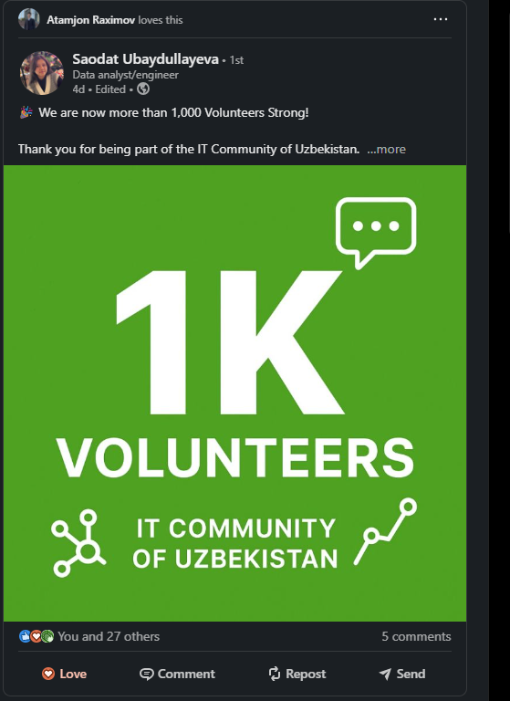

Reactions on your competitors posts (9):
https://www.linkedin.com/posts/vazira-holboeva_im-happy-to-share-that-ive-obtained-a-new-activity-7365766832860954625-XQpS?utm_source=share&utm_medium=member_desktop&rcm=ACoAAEWJaG4BfzzjZoOR5N1JVaFI6V85rvUjCeU
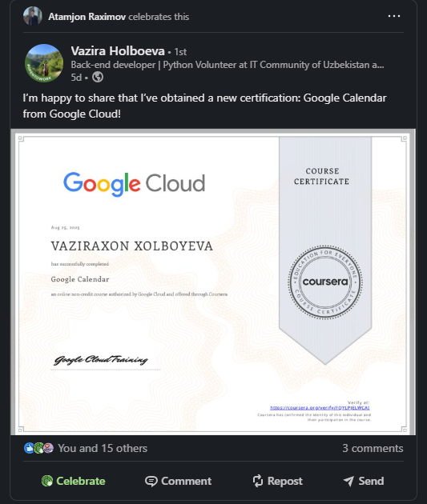

Reactions on your competitors posts (10):
https://www.linkedin.com/posts/kamolakhon-javlonova-b9b865319_itcommunityuzb-ambassadors-events-activity-7366735193333829632-26lR?utm_source=share&utm_medium=member_desktop&rcm=ACoAAEWJaG4BfzzjZoOR5N1JVaFI6V85rvUjCeU
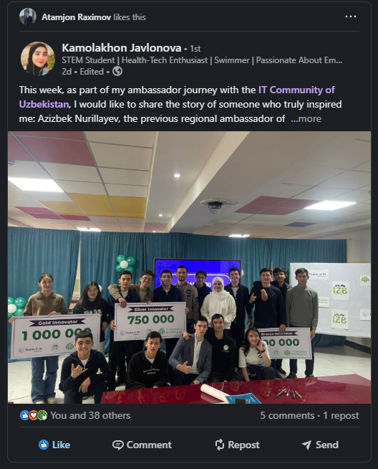

Reactions on your competitors posts (11):
https://www.linkedin.com/posts/nozima-sharifova-822a0527b_weve-reached-1000-volunteers-this-activity-7365425661458419712-k78X?utm_source=share&utm_medium=member_desktop&rcm=ACoAAEWJaG4BfzzjZoOR5N1JVaFI6V85rvUjCeU
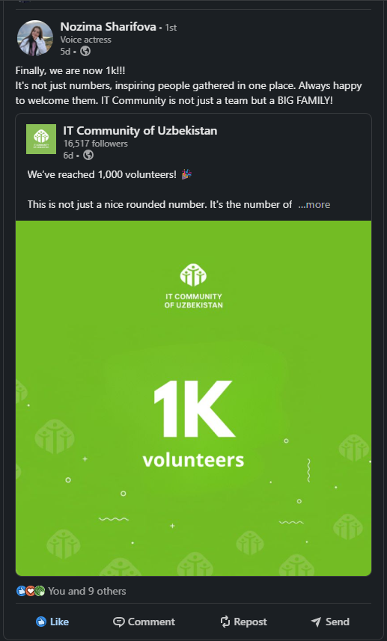

Reactions on your competitors posts (12):
https://www.linkedin.com/posts/shirin-tulkinjanova-1a12602ba_weve-reached-1000-volunteers-this-activity-7365318835094126592-OU2R?utm_source=share&utm_medium=member_desktop&rcm=ACoAAEWJaG4BfzzjZoOR5N1JVaFI6V85rvUjCeU
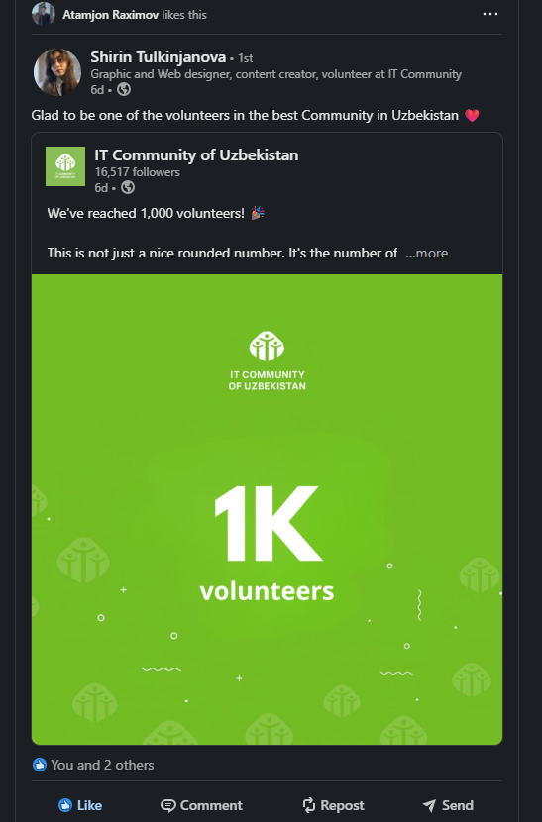

Reactions on your competitors posts (13):
https://www.linkedin.com/posts/shoxista-iriskulova-45523032a_itcommunityofuzbekistan-linkedincompetition-activity-7367039974619160576-mFKz?utm_source=share&utm_medium=member_desktop&rcm=ACoAAEWJaG4BfzzjZoOR5N1JVaFI6V85rvUjCeU
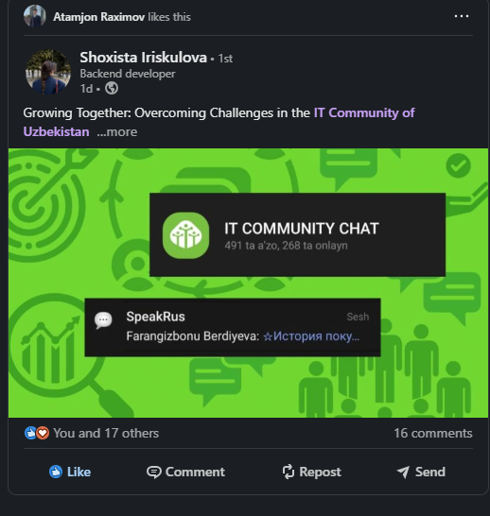

Reactions on your competitors posts (14):
https://www.linkedin.com/posts/kamolakhon-javlonova-b9b865319_linkedincompetition-nanobanana-ai-ugcPost-7367131865171771392-5hQ3?utm_source=share&utm_medium=member_desktop&rcm=ACoAAEWJaG4BfzzjZoOR5N1JVaFI6V85rvUjCeU
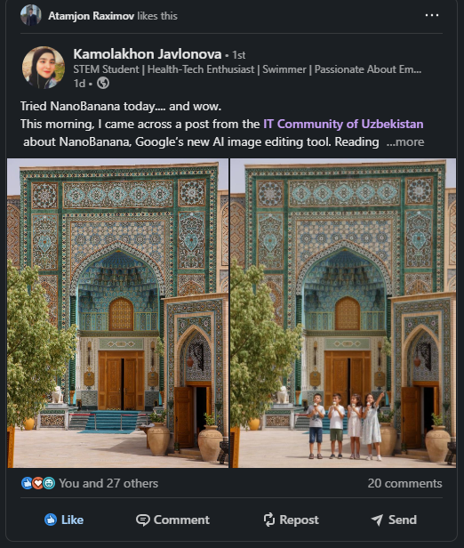

Reactions on your competitors posts (15):
https://www.linkedin.com/posts/vazira-holboeva_linkedincompetition-networking-activity-7367246004888223745-n5Yb?utm_source=share&utm_medium=member_desktop&rcm=ACoAAEWJaG4BfzzjZoOR5N1JVaFI6V85rvUjCeU
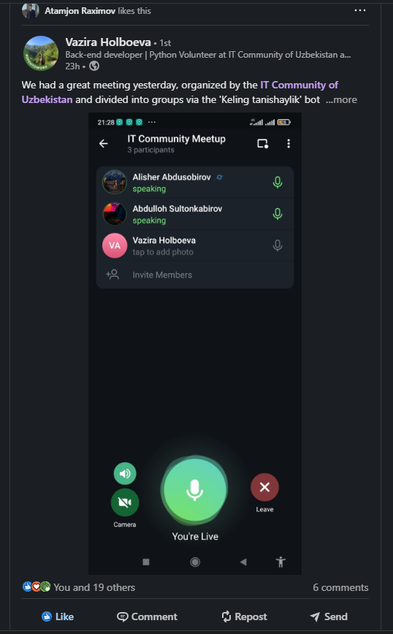

Reactions on your competitors posts (16):
https://www.linkedin.com/posts/saodat-ubaydullayeva_the-it-community-debate-in-khorezm-was-a-ugcPost-7367237426869661696-KoQn?utm_source=share&utm_medium=member_desktop&rcm=ACoAAEWJaG4BfzzjZoOR5N1JVaFI6V85rvUjCeU
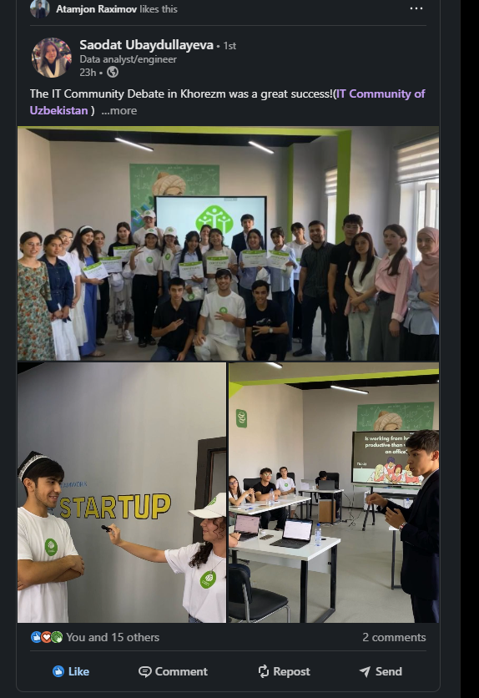

Reactions on your competitors posts (17):
https://www.linkedin.com/posts/vazira-holboeva_linkedincompetition-networking-activity-7367250812818903040-T1I9?utm_source=share&utm_medium=member_desktop&rcm=ACoAAEWJaG4BfzzjZoOR5N1JVaFI6V85rvUjCeU
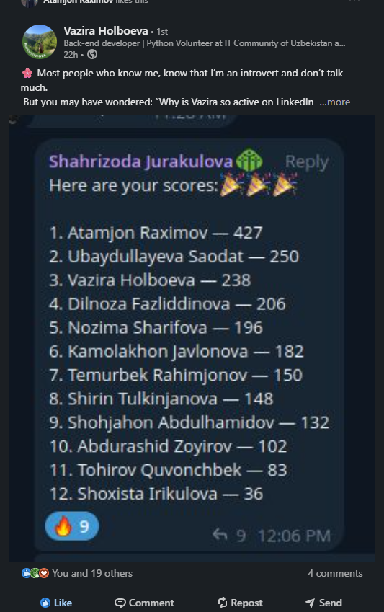

Reactions on your competitors posts (18):
https://www.linkedin.com/posts/vazira-holboeva_new-monday-vacancy-thread-every-monday-activity-7367255483700690944-r5em?utm_source=share&utm_medium=member_desktop&rcm=ACoAAEWJaG4BfzzjZoOR5N1JVaFI6V85rvUjCeU
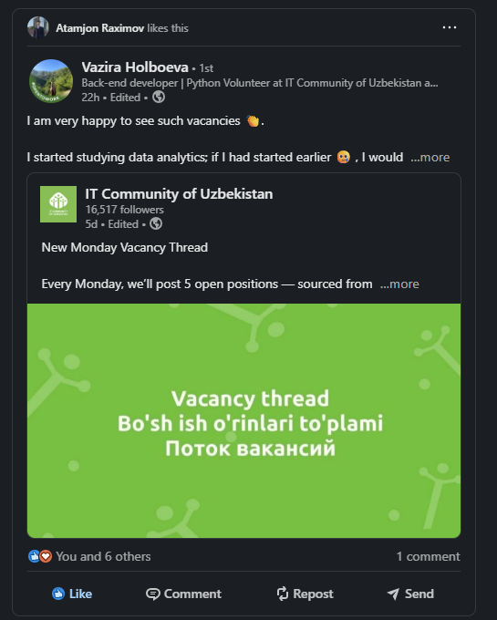

Reactions on your competitors posts (19):
https://www.linkedin.com/posts/vazira-holboeva_every-saturday-wait-for-weekly-it-news-digest-activity-7367270847717236736-2CZz?utm_source=share&utm_medium=member_desktop&rcm=ACoAAEWJaG4BfzzjZoOR5N1JVaFI6V85rvUjCeU
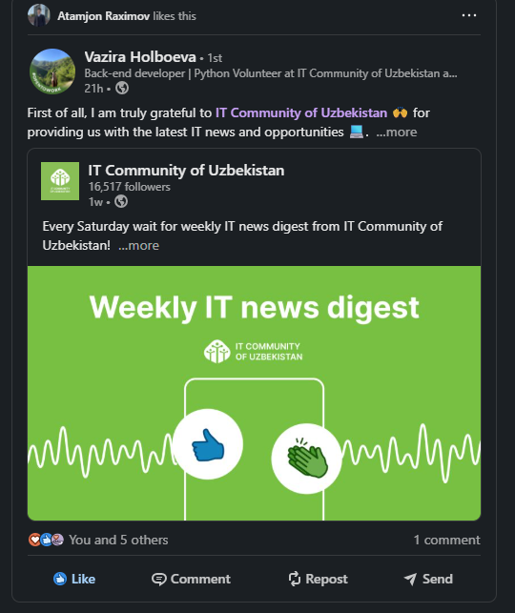

Reactions on your competitors posts (20):
https://www.linkedin.com/posts/vazira-holboeva_wanna-level-up-your-prompt-engineering-activity-7365081358202826752-XBIo?utm_source=share&utm_medium=member_desktop&rcm=ACoAAEWJaG4BfzzjZoOR5N1JVaFI6V85rvUjCeU
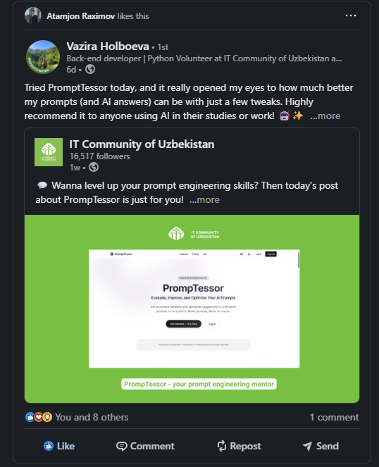

Reactions on your competitors posts (21):
https://www.linkedin.com/posts/dilnoza-fazliddinova-08a818340_how-we-welcome-new-volunteers-every-time-activity-7367413348625182721-ElDz?utm_source=share&utm_medium=member_desktop&rcm=ACoAAEWJaG4BfzzjZoOR5N1JVaFI6V85rvUjCeU
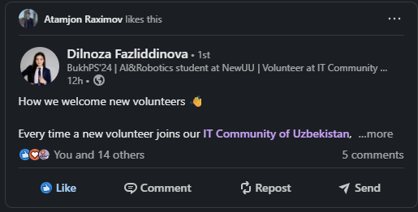

Reactions on your competitors posts (22):
https://www.linkedin.com/posts/nozima-sharifova-822a0527b_itcommunityofuzbekistan-linkedincompetition-activity-7367425590116704256-V70i?utm_source=share&utm_medium=member_desktop&rcm=ACoAAEWJaG4BfzzjZoOR5N1JVaFI6V85rvUjCeU
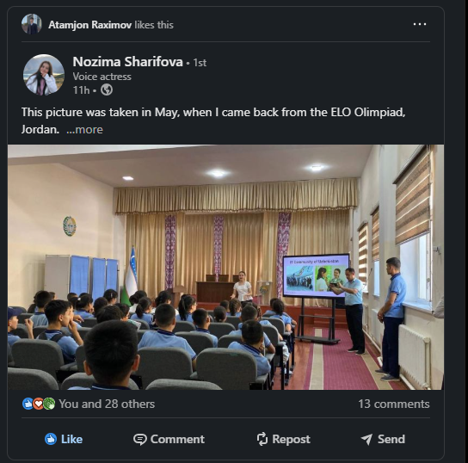

Reactions on your competitors posts (23):
https://www.linkedin.com/posts/temurbekrahimjonov_every-saturday-wait-for-weekly-it-news-digest-activity-7367461787916533760-s2g4?utm_source=share&utm_medium=member_desktop&rcm=ACoAAEWJaG4BfzzjZoOR5N1JVaFI6V85rvUjCeU
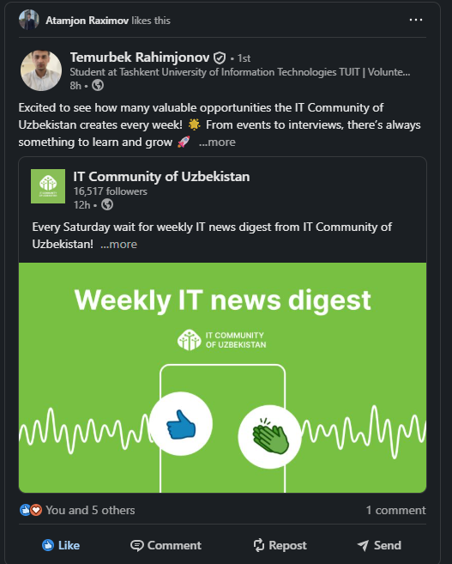

Reactions on your competitors posts (24):
https://www.linkedin.com/posts/temurbekrahimjonov_itcommunityofuzbekistan-ai-nanobanana-ugcPost-7367470586366763009-S65U?utm_source=share&utm_medium=member_desktop&rcm=ACoAAEWJaG4BfzzjZoOR5N1JVaFI6V85rvUjCeU
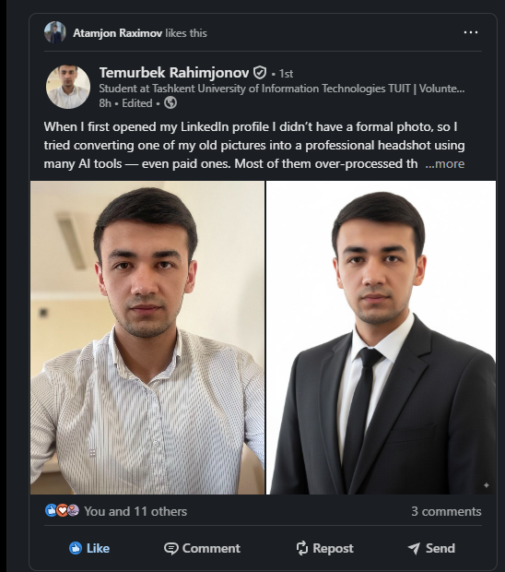

Reactions on your competitors posts (25):
https://www.linkedin.com/posts/temurbekrahimjonov_it-community-of-uzbekistan-activity-7367481518664949796-eobX?utm_source=share&utm_medium=member_desktop&rcm=ACoAAEWJaG4BfzzjZoOR5N1JVaFI6V85rvUjCeU
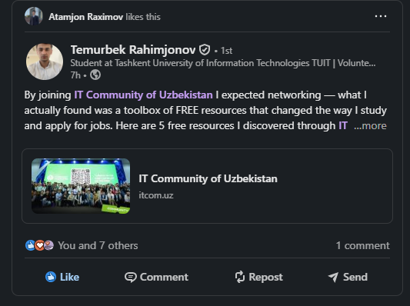

Reactions on your competitors posts (26):
https://www.linkedin.com/posts/shoxista-iriskulova-45523032a_at-the-it-community-of-uzbekistan-we-are-activity-7367539105930407937-Yuus?utm_source=share&utm_medium=member_desktop&rcm=ACoAAEWJaG4BfzzjZoOR5N1JVaFI6V85rvUjCeU
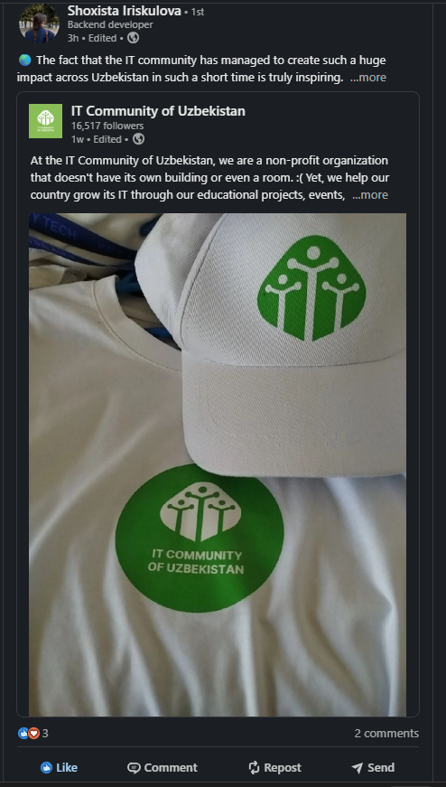

Reactions on your competitors posts (27):
https://www.linkedin.com/posts/nozima-sharifova-822a0527b_itcommunityofuzbekistan-linkedincompetition-activity-7367596232707436544-H6Y-?utm_source=share&utm_medium=member_desktop&rcm=ACoAAEWJaG4BfzzjZoOR5N1JVaFI6V85rvUjCeU
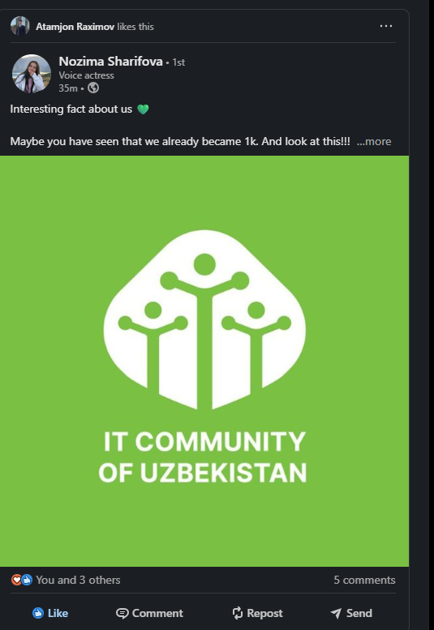

Reactions on your competitors posts (28):
https://www.linkedin.com/posts/nozima-sharifova-822a0527b_wanna-see-the-future-of-ai-photo-editing-activity-7367598654485868544-z59e?utm_source=share&utm_medium=member_desktop&rcm=ACoAAEWJaG4BfzzjZoOR5N1JVaFI6V85rvUjCeU
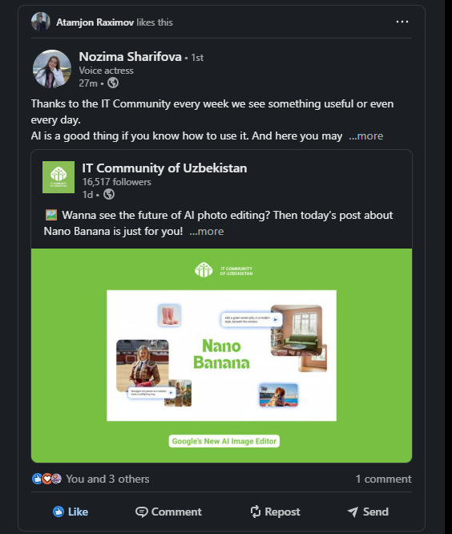

Reactions on your competitors posts (29):
https://www.linkedin.com/posts/nozima-sharifova-822a0527b_new-monday-vacancy-thread-every-monday-activity-7367599668307865601-SP5T?utm_source=share&utm_medium=member_desktop&rcm=ACoAAEWJaG4BfzzjZoOR5N1JVaFI6V85rvUjCeU
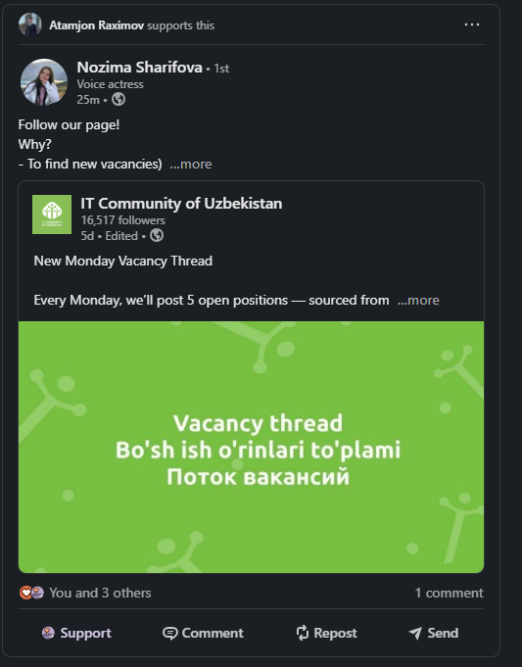

Reactions on your competitors posts (30):
https://www.linkedin.com/posts/shoxista-iriskulova-45523032a_new-monday-vacancy-thread-every-monday-activity-7367607255568928768-RE3o?utm_source=share&utm_medium=member_desktop&rcm=ACoAAEWJaG4BfzzjZoOR5N1JVaFI6V85rvUjCeU
