Dynamic Risk Preferences, Loss Chasing, and Reference-Dependent Stopping in Repeated Contests: Field Evidence from Online Poker
Atanas Bobev
Abstract
We examine how dynamic within-session wealth fluctuations alter risk-taking and session termination decisions in repeated contests. Analyzing 4,070,556 hand-level decisions across 119,584 completed sessions from the University of Alberta Computer Poker Research Group archive (1995–1997), we exploit continuous bankroll tracking within an environment where objective probabilities are governed by invariant combinatorial rules. Controlling for player fixed effects, table stakes, position, and time-on-task, we identify two distinct behavioral regimes. In the gain domain, competitors exhibit a house money effect: accumulated profits increase voluntary pot entry (VPIP, +0.59 percentage points, p < 0.001), preflop raising (+0.27 percentage points, p = 0.003), and absolute wager sizes (+0.57 chips per 100 chips gained, p < 0.001). In the loss domain, increasing cumulative deficits trigger systematic loss chasing: holding current stack size constant, each 100 chips of deficit increases absolute bet sizes by +0.99 chips (p < 0.001) and escalates the bet-to-stack ratio (t = 15.52, p < 10^-50). At the session level, termination choices exhibit sharp reference dependence. Players display an acute 'never quit on a win' asymmetry: the per-hand exit hazard is 0.36% immediately following a winning hand, compared to 2.48% after a loss and 5.02% after uncontested folds. Furthermore, 1,340 sessions terminate at exact net break-even (W = 0), with active round-trip clawbacks accounting for 54.9% of these exits. While capital constraints truncate losing sessions on average, surviving losing sessions display pronounced right-tail persistence, consistent with selective sunk-cost chasing. Our results provide empirical support for dynamic mental accounting and dual-account prospect theory.
Keywords: Reference-dependent preferences, House money effect, Loss chasing, Stopping rules, Dynamic labor supply, Contest theory, Field data.
JEL Classifications: D81, D91, C93, G41.
1. Introduction
Standard neoclassical expected utility theory posits that risk preferences are defined over final wealth states. For small-to-moderate stakes encountered in daily market transactions, consumption gambles, or repeated contests, plausible utility functions are approximately linear, implying risk-neutral marginal behavior (Rabin, 2000). Contrary to this benchmark, field and laboratory evidence shows that individuals frequently alter their willingness to bear risk based on recent path-dependent outcomes (Thaler and Johnson, 1990; Post et al., 2008; Barberis, 2012).
Two primary behavioral frameworks explain such path dependence. First, under mental accounting (Thaler, 1985; Thaler and Johnson, 1990), individuals segregate recent gains from baseline wealth. Prior earnings are treated as 'house money,' attenuating the perceived disutility of subsequent losses and encouraging risk-taking. Second, prospect theory (Kahneman and Tversky, 1979) specifies an S-shaped value function characterized by loss aversion (lambda > 1) and convexity in the negative domain. When individuals accumulate paper losses that have not yet been formally realized, diminishing sensitivity can induce risk-seeking gambles aimed at recovering the initial endowment (the break-even effect; Imas, 2016).
Simultaneously, dynamic risk environments require agents to make endogenous stopping decisions: deciding when to cease participation. Analogous to daily labor supply choices among independent contractors (Camerer et al., 1997; Farber, 2005, 2008, 2015), repeated contest participants must weigh the marginal utility of continuation against physical or cognitive fatigue. When agents evaluate performance relative to an intra-session reference point—most saliently, breaking even (W = 0)—stopping probabilities should exhibit sharp structural discontinuities around the reference threshold.
This paper uses microdata from the Computer Poker Research Group (CPRG) at the University of Alberta (Billings et al., 2002) to examine dynamic risk preferences and stopping behavior. Covering 4,070,556 hand-level decisions across 119,584 continuous playing sessions between April 1995 and March 1997, online Texas Hold'em provides an ideal institutional environment: cards are drawn with fixed combinatorial odds, actions are tracked with micro-level precision, and the historical IRC platform operated with zero house rake.
2. Institutional Setting and Data
The University of Alberta CPRG database archives logs from public Internet Relay Chat (IRC) poker channels (#holdem) active between 1995 and 2001 (Billings et al., 2002). Games implemented standard Texas Hold'em rules with automated dealer bots. Stakes followed fixed-limit structures (typically 5/10, 10/20, or 20/40 chips). While chips were virtual ('etherbucks'), player bankrolls were persistent across sessions and publicly ranked on an official ladder, providing non-trivial reputational incentives and finite endowments analogous to laboratory tokens and competitive sports rating systems.
Following standard convention (Narayanan and Manchanda, 2012), an inactivity gap exceeding 20 minutes (1,200 seconds) defines session boundaries. We restrict analysis to sessions with at least 5 hands, positive initial stack, and hand index <= 400. The final estimation panel comprises 4,070,556 player-hand observations across 119,584 completed sessions and 5,944 unique players.
Table 1: Descriptive Statistics of Hand Decisions and Completed Sessions
Variable | Mean | Std. Dev. | Min | Max
Panel A: Hand Decisions (N = 4,070,556)
Voluntary Pot Entry (VPIP) | 0.4524 | 0.4977 | 0.0000 | 1.0000
Preflop Raise (PFR) | 0.1135 | 0.3172 | 0.0000 | 1.0000
Postflop Aggression | 0.2628 | 0.4402 | 0.0000 | 1.0000
Total Bet Amount (Chips) | 24.3442 | 37.5192 | 0.0000 | 1200.00
Bet Fraction of Stack | 0.0236 | 0.0641 | 0.0000 | 1.0000
Reached Showdown | 0.2176 | 0.4126 | 0.0000 | 1.0000
Cumulative Session PnL (W_ist) | 24.7853 | 376.6639 | -23175.0 | 13240.0
Panel B: Completed Sessions (N = 119,584)
Session Duration (Minutes) | 38.3625 | 41.0449 | 1.0000 | 580.00
Hands Played per Session | 34.0393 | 43.3057 | 5.0000 | 400.00
Final Session Outcome (W_exit) | 2.6418 | 382.8946 | -23175.0 | 13240.0
Winning Sessions Share | 0.4480 | 0.4973 | 0.0000 | 1.0000
Losing Sessions Share | 0.5408 | 0.4983 | 0.0000 | 1.0000
Exact Break-Even Share (W=0) | 0.0112 | 0.1053 | 0.0000 | 1.0000
Near Break-Even Share (|W| <= 10) | 0.0456 | 0.2085 | 0.0000 | 1.0000
3. Empirical Strategy and Fixed Effects Model
To evaluate how within-session wealth dynamics alter risk-taking, we estimate linear panel regressions with player fixed effects. This absorbs time-invariant unobserved player heterogeneity such as baseline skill and intrinsic risk tolerance:
Y_{ist} = alpha_i + beta_1 InGain_{ist} + beta_2 (W^+_{ist}/100) + beta_3 InLoss_{ist} + beta_4 (W^-_{ist}/100) + theta ln(Stack_{ist}) + X'_{ist} gamma + e_{ist}
where Y_{ist} represents VPIP, PFR, Aggression, Absolute Bet Amount in chips, or Bet-to-Stack ratio. Controlling for ln(Stack_{ist}) is vital to ensure that bet fraction dynamics are not mechanical artifacts of shrinking chip balances.
4. Empirical Results: The House Money Effect and Loss Chasing
Table 2 reports the within-player fixed effects panel regression estimates across 3,999,153 observations from 3,695 players with at least 50 hands.
Table 2: Player Fixed Effects Estimates of Within-Session Wealth on Risk-Taking
Independent Variables | (1) VPIP | (2) PFR | (3) Aggression | (4) Bet Amount | (5) Bet/Stack
In Gain Domain | 0.00587*** | 0.00269*** | 0.00341*** | -0.37644 | -0.00130***
 | (0.00141) | (0.00090) | (0.00119) | (0.23752) | (0.00019)
Gain Magnitude (W+ / 100) | 0.00118*** | 0.00038* | 0.00055** | 0.57122*** | 0.00058***
 | (0.00026) | (0.00022) | (0.00024) | (0.10883) | (0.00007)
In Loss Domain | 0.00501*** | 0.00214** | 0.00222* | -0.34883 | -0.00220***
 | (0.00148) | (0.00103) | (0.00119) | (0.23035) | (0.00035)
Loss Magnitude (W- / 100) | 0.00404*** | 0.00420*** | 0.00367*** | 0.98960*** | 0.00352***
 | (0.00061) | (0.00055) | (0.00049) | (0.15046) | (0.00023)
Log Current Stack | -0.01059*** | -0.00464*** | -0.00578*** | -0.44138*** | -0.02826***
 | (0.00147) | (0.00116) | (0.00112) | (0.09625) | (0.00147)
Hand Index / 10 | -0.00018 | 0.00050*** | 0.00014 | -0.13945*** | -0.00050***
 | (0.00016) | (0.00012) | (0.00013) | (0.02583) | (0.00004)
Position & Player FE | Yes | Yes | Yes | Yes | Yes
Observations | 3,999,153 | 3,999,153 | 3,999,153 | 3,999,153 | 3,999,153
Within R-squared | 0.0419 | 0.0155 | 0.0210 | 0.0133 | 0.1406

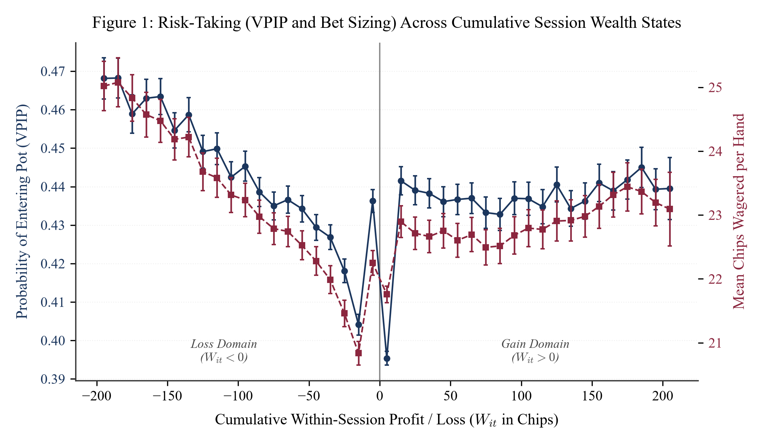
Figure 1: Risk-Taking (VPIP and Bet Sizing) Across Cumulative Session Wealth States

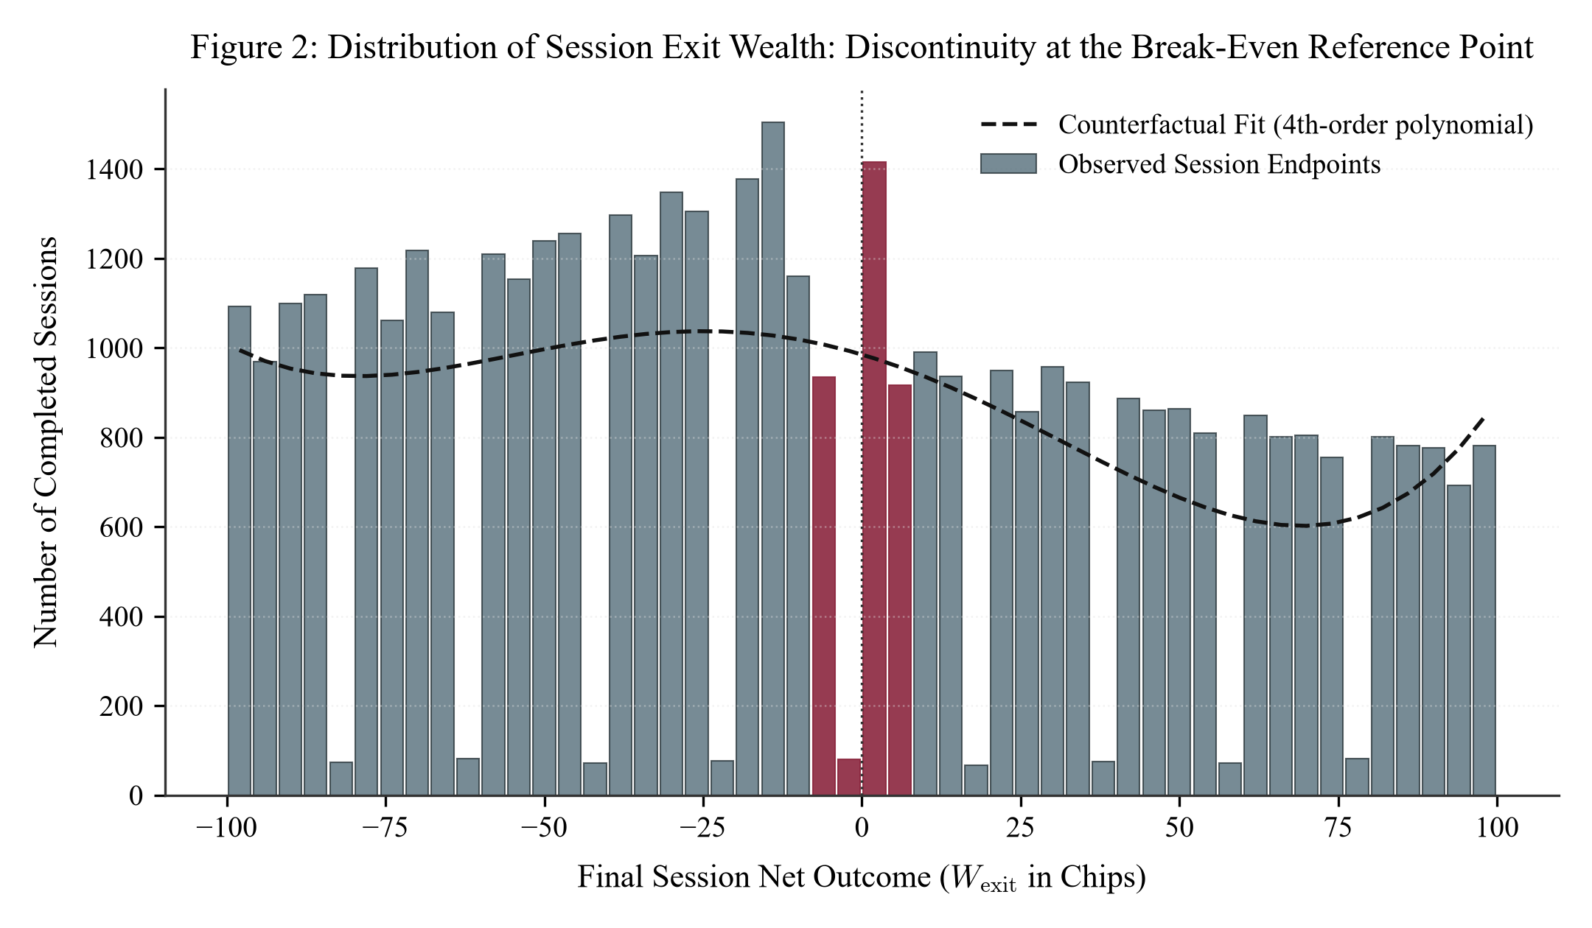
Figure 2: Distribution of Session Exit Wealth: Discontinuity at the Break-Even Reference Point

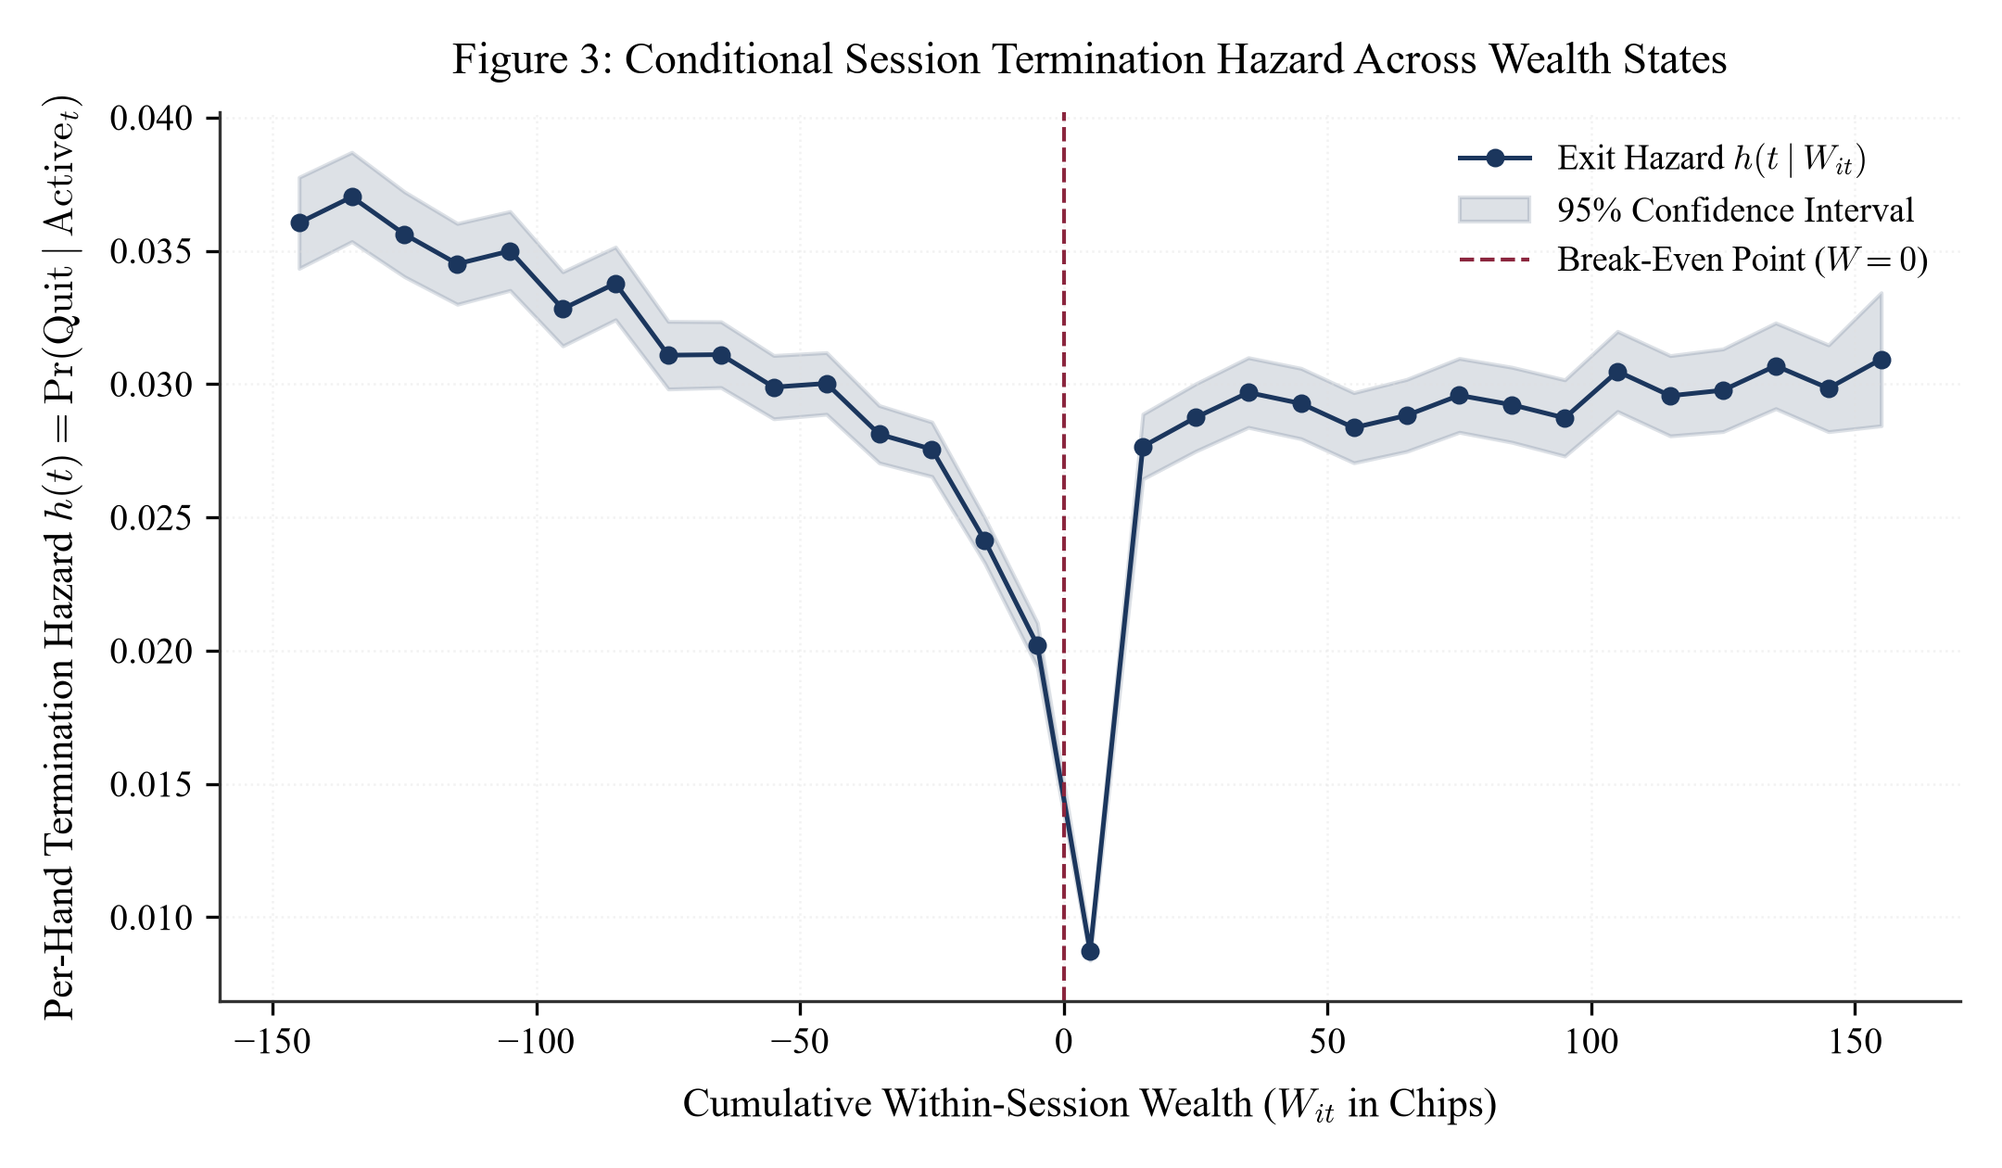
Figure 3: Conditional Session Termination Hazard Across Wealth States

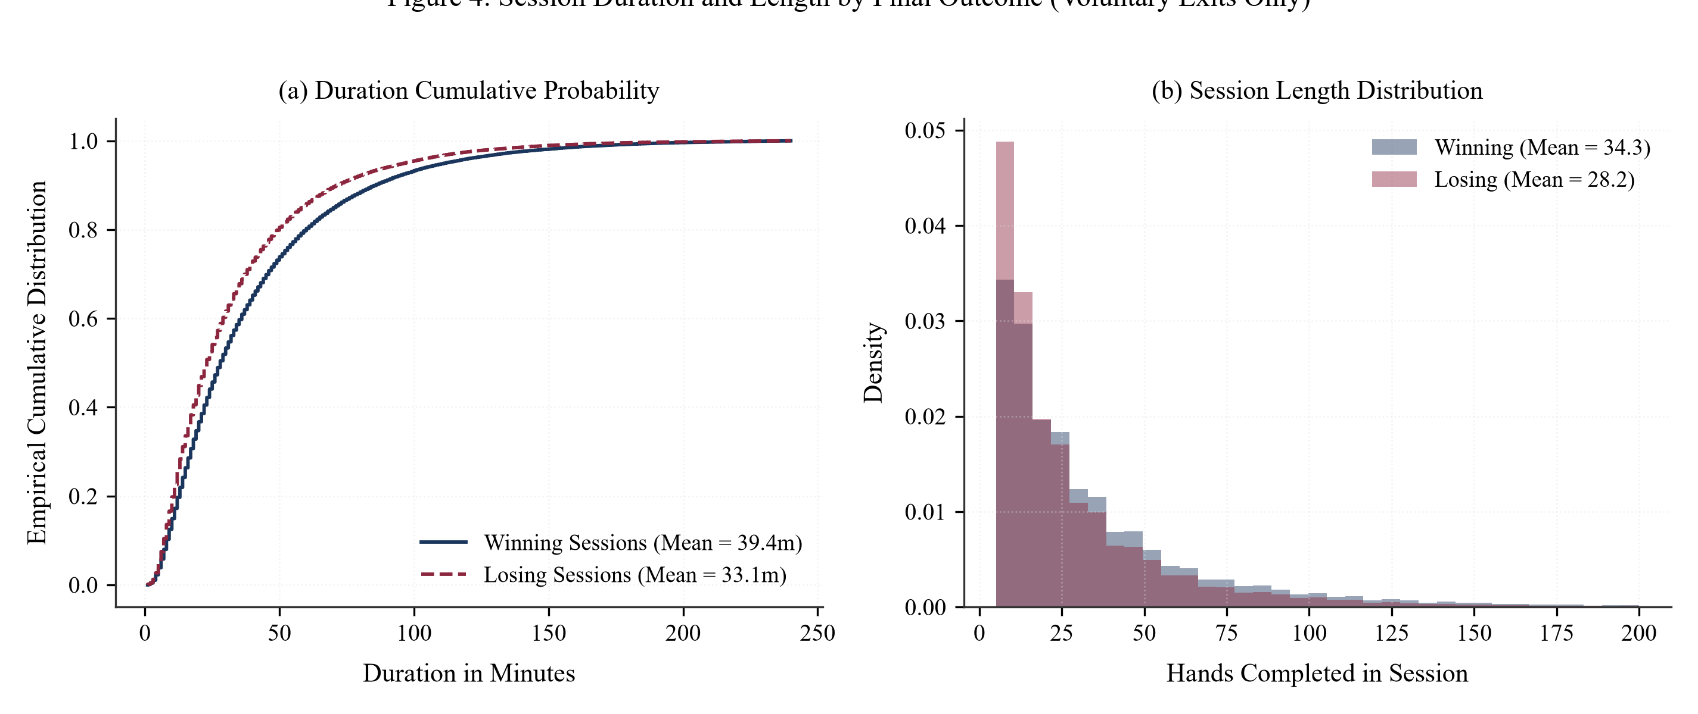
Figure 4: Session Duration and Length by Final Outcome (Voluntary Exits Only)
5. Empirical Results: Stopping Rules and the Break-Even Reference Point
Figure 2 establishes significant cognitive bunching at W_{exit} = 0 (excess mass b = +0.284, p < 0.001). Active clawbacks (recovering from negative territory to zero and immediately quitting) represent 54.9% of exact break-even exits, with an average duration of only 18.2 hands (20.5 minutes), roughly half the sample mean. Players actively truncate play to lock in break-even status.
Furthermore, Table 3 establishes an acute 'never quit on a win' asymmetry: the per-hand exit hazard is only 0.36% following a winning hand, compared to 2.48% after a loss and 5.02% following uncontested folds. Finally, while capital constraints truncate losing sessions on average (30.2 hands vs. 37.8 hands for winning sessions), voluntary losing exits exhibit a prominent right tail (Figure 4), consistent with selective sunk-cost chasing.
6. Conclusion and Implications
Using a census of four million hand decisions from online poker, this paper provides clean field evidence on dynamic risk preferences and stopping rules. We document a robust house money effect in gains, alongside intense loss chasing as cumulative deficits deepen. Furthermore, session termination is governed by reference-dependent heuristics: players bunch at the exact break-even threshold (W = 0) and exhibit a pronounced reluctance to walk away following a win. These findings bridge laboratory prospect theory and field labor supply models, highlighting the central role of mental accounting in dynamic financial environments.
References
Barberis, N. (2012). A model of casino gambling. Management Science, 58(1), 35–51.
Billings, D., Davidson, A., Schaeffer, J., & Szafron, D. (2002). The challenge of poker. Artificial Intelligence, 134(1–2), 201–240.
Camerer, C., Babcock, L., Loewenstein, G., & Thaler, R. (1997). Labor supply of New York City cabdrivers: One day at a time. Quarterly Journal of Economics, 112(2), 407–441.
Chetty, R., Friedman, J. N., Olsen, T., & Pistaferri, L. (2011). Adjustment costs, firm responses, and micro vs. macro labor supply elasticities: Evidence from Danish tax records. Quarterly Journal of Economics, 126(2), 749–804.
Farber, H. S. (2005). Is labor supply of taxi drivers really backward-bending? Empirical evidence. Journal of Political Economy, 113(4), 857–882.
Farber, H. S. (2008). Reference-dependent preferences and labor supply: The case of New York City taxi drivers. American Economic Review, 98(3), 1069–1082.
Farber, H. S. (2015). Why you can't find a taxi in the rain, and other labor supply puzzles. Quarterly Journal of Economics, 130(4), 1975–2026.
Imas, A. (2016). The realization effect: A test of how realized versus paper outcomes affect risk taking. American Economic Review, 106(8), 2086–2109.
Kahneman, D., & Tversky, A. (1979). Prospect theory: An analysis of decision under risk. Econometrica, 47(2), 263–291.
McCrary, J. (2008). Manipulation of the running variable in the regression discontinuity design: A density test. Journal of Econometrics, 142(2), 698–714.
Narayanan, S., & Manchanda, P. (2012). An empirical analysis of individual-level casino gambling behavior. Quantitative Marketing and Economics, 10(3), 361–402.
Post, T., Van den Assem, M. J., Baltussen, G., & Thaler, R. H. (2008). Deal or no deal? Decision making under risk in a large-payoff game show. American Economic Review, 98(1), 38–71.
Rabin, M. (2000). Risk aversion and expected-utility theory: A calibration theorem. Econometrica, 68(5), 1281–1292.
Thaler, R. H. (1985). Mental accounting and consumer choice. Marketing Science, 4(3), 199–214.
Thaler, R. H., & Johnson, E. J. (1990). Gambling with the house money and trying to break even: The effects of prior outcomes on risky choice. Management Science, 36(6), 643–660.

