**Buffmate Design Document**

By

**Atanas Marchev**

**Yosif Kiradzhiev**

**Table of Contents**

Planning 3

First Iteration Design 3

Food API 5

Running tracker 5

Second Iteration Design 6

Final Color Scheme 7

**Planning**

First things first, we decided what we wanted to have with this application. We stopped on a couple of features:

Calorie tracker – A view where you can input what you’ve eaten, show how much calories and what nutritional value it has, add it to the rest of the stuff you’ve inputted for the day and give some recommendations with the information. We wanted to use some APIs for the application, and this was one of the reasons why.

Running tracker – Using google maps’ API the application would track your daily runs and calculate how much you’ve ran. It also has a view where you can see your weekly runs.

Weight tracker – A place where you can input your weight and based on previous days give recommendations depending on set goal – for example: if you want to gain weight and you lost some from the previous day it will start off with some recommendations on what you can eat or do to gain back that weight.

An overview panel where you can see a quick overall of your activities.

**First Iteration Design**

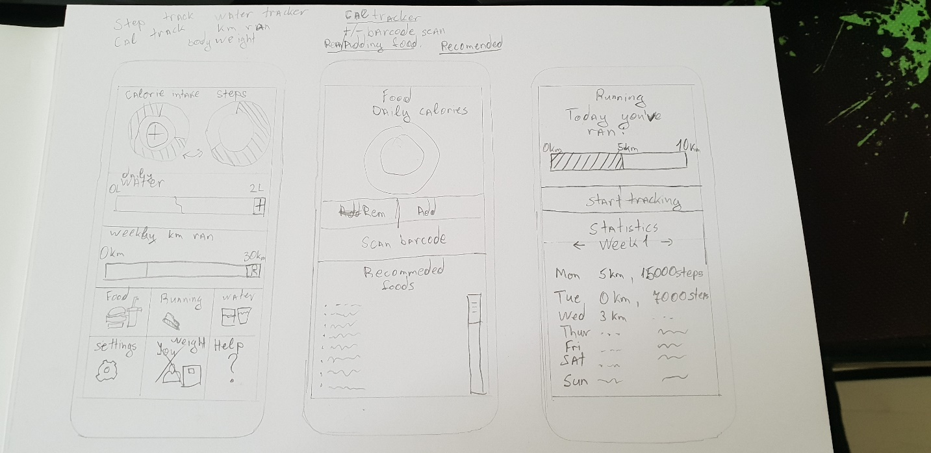As it was my first time in designing something this was horrifyingly wrong. I drew out what and where I wanted to put in the app and plopped some colors on top of it resulting in this:

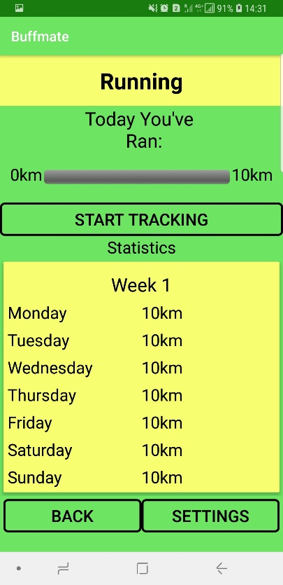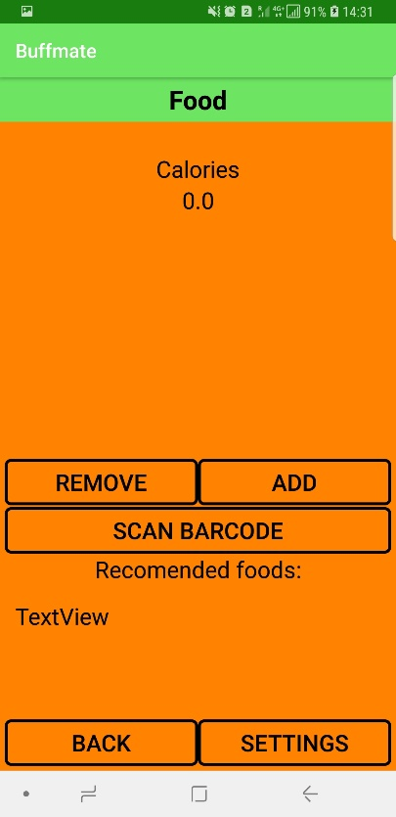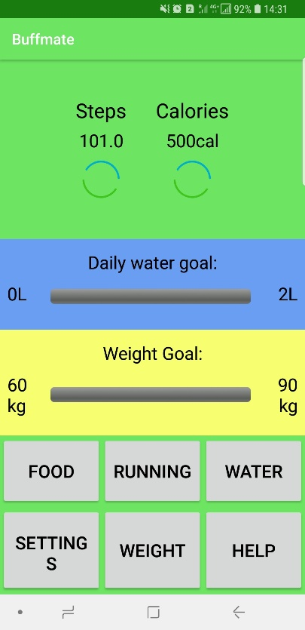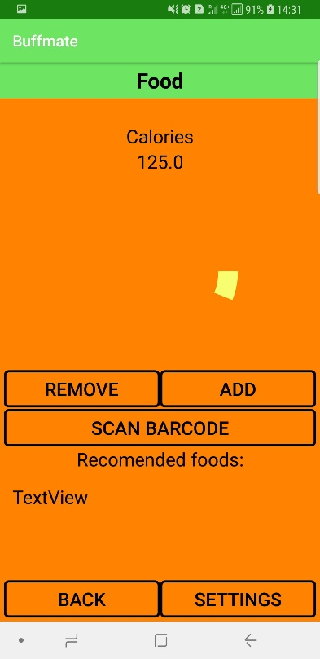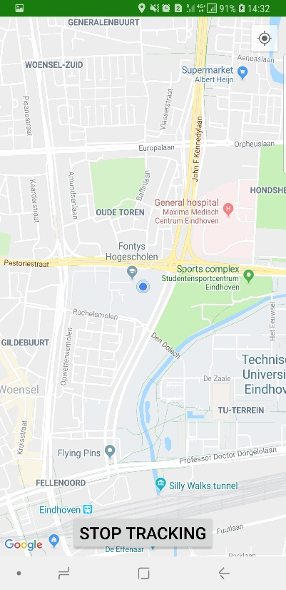

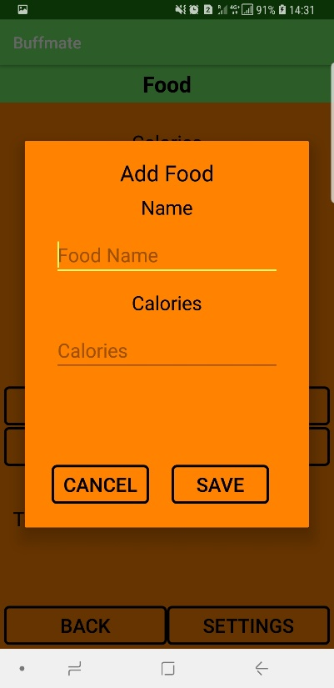

**Food API**

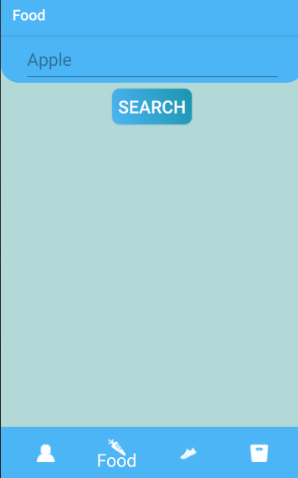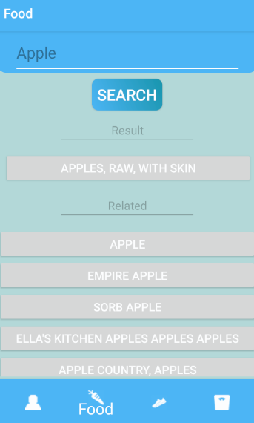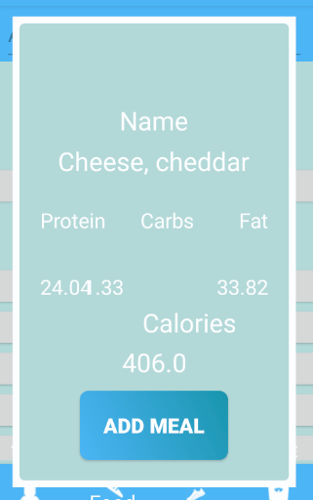Food Api needed to be added, so that the user can find the foods that they eat. So we registered in with an Api provider (), got the key and imported the functionality in the app. We used some Java Object to JSON conversion (the opposite as well) and some HTTP. For more details please check code.

**Running tracker**

For the running tracker I used Google’s API to get a map, knowledge from the workshops we had on using the device’s hardware and some documentation from android. First thing that happens when you open the app is that it asks you for permission for using the location of the device. After you start tracking your run your location appears on the map and it starts drawing lines between your previous and your current location. That way you can see where you have run, then the distance is added to the total distance you’ve ran. After you are done the application stores this information in one of the weekdays (depending on your calendar) and you can see it when you press the name of the weekday.

**Second Iteration Design**

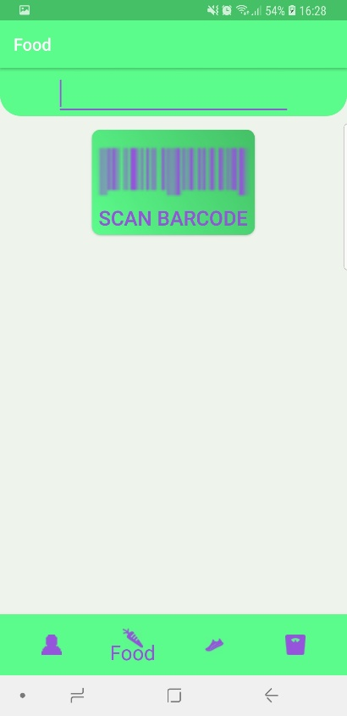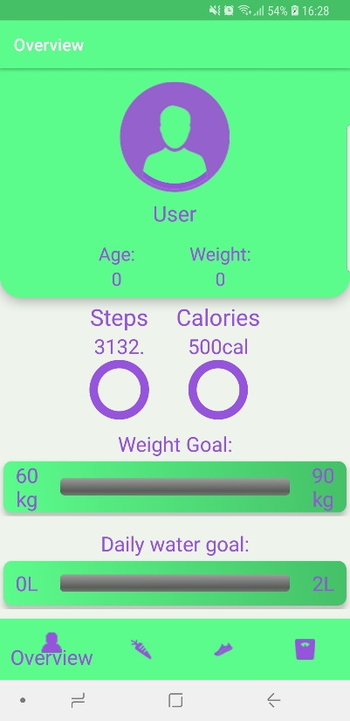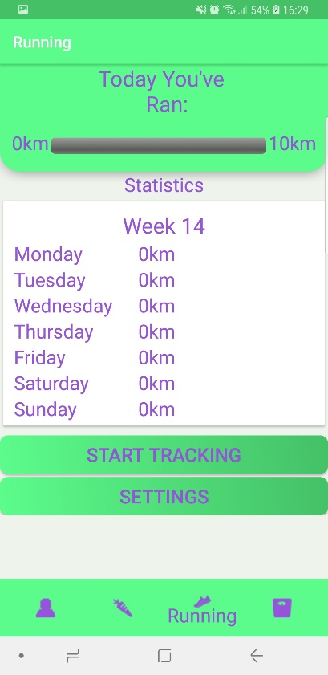Second try with the design: this time with Google’s android design guideline and Adobe’s color picker. As you can see the difference:

I used one main color and an Accent color for the text. I changed the navigation to a bottom navigation drawer.

**Final Color Scheme**

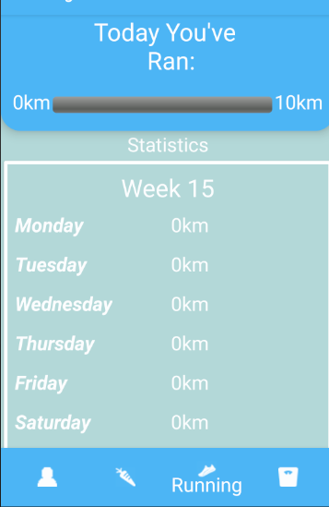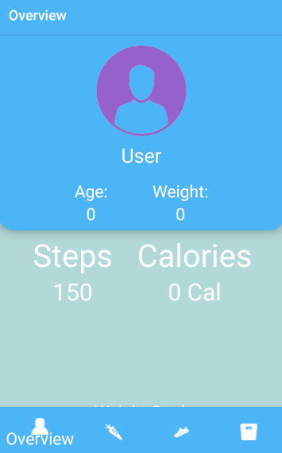 We have chosen a color scheme that we think fits the bill of our app very well.