

**Fire Will Kill Us All**

**Design Document**

Created by:

Atanas Marchev

Filippo Nardocci

Nikolay Ganev

Yosif Kiradzhiev

Stef van den Tempel

**Table of Contents**

**Class diagram 3**

**Sequence diagrams 3**

**Search grid 3**

**Spread fire 4**

**Get extinguisher 5**

**Class Diagram**

Due to the fact that our class diagram is too big to fit in an A4 paper there is a link to it right [here](https://drive.google.com/file/d/17s03ExqWLVnOcyKfhG9J5iTg6W90zC2B/view?usp=sharing).

**Sequence Diagrams**

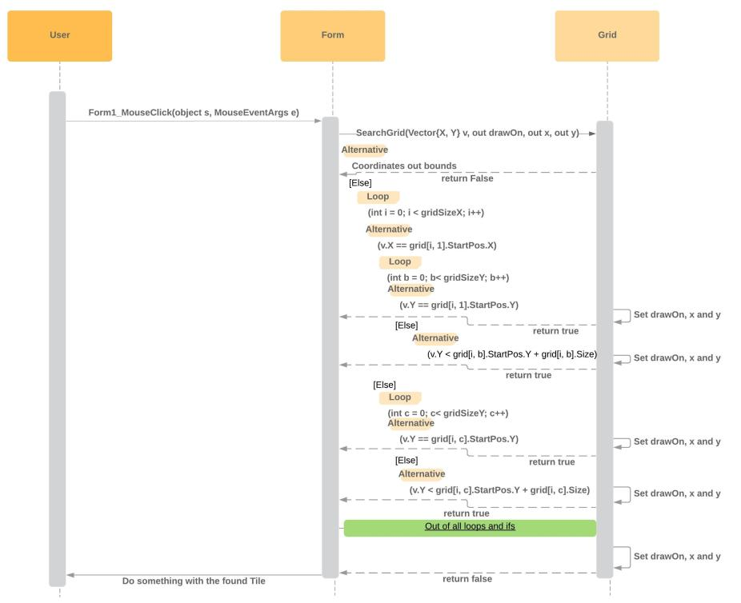**Search Grid**

**Spread Fire**

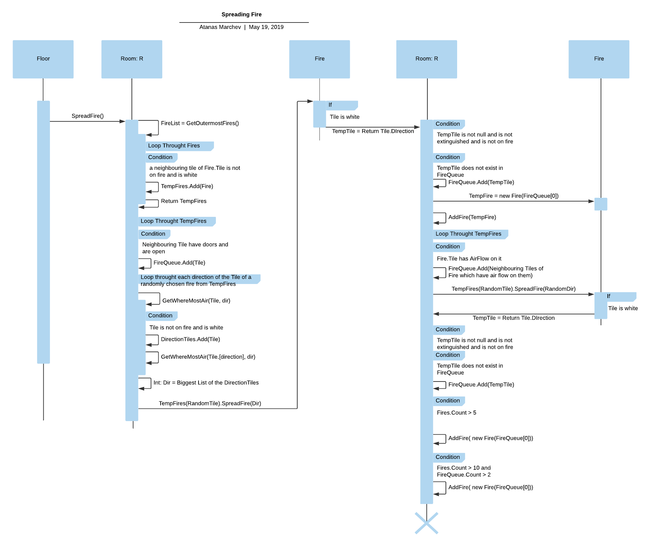

**Get Extinguisher**

