**Making of**

**Robed**

**By:** Atanas Marchev

**Table of Contents**

**Week 1 3**

**Week 2 3**

**Week 3 4**

**Week 4 5**

**Week 1**

Unfortunately, I was not present during the first week of university and I didn’t do much. I asked my groupmate what we were going to do and watched a few tutorials on Unity’s Basics. We talked about the game’s main goal and mood. We had some ideas – mainly we stopped on a silly, fun but challenging game that makes the player laugh.

**Week 2**

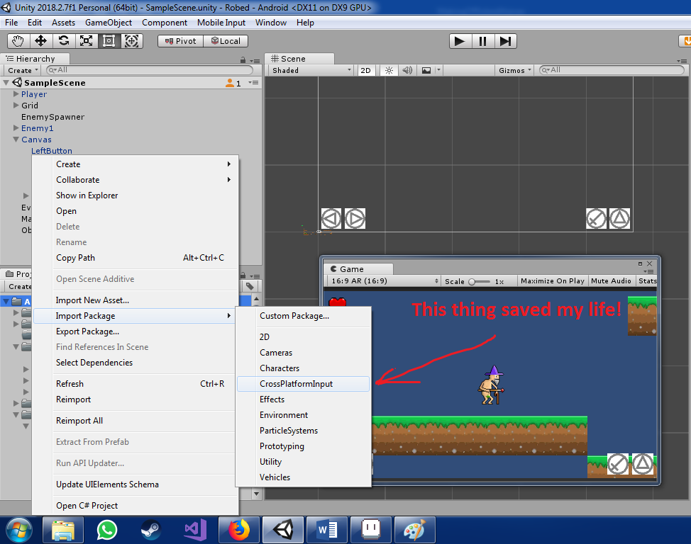During week 2 I had started catching up on our game and I started working on the buttons for Android. It was not very productive in the beginning because I was just starting to learn Unity for Android and my first tries were not successful. I watched a few videos and tried Making my own scripts but eventually I just did it with a package provided from Unity.

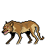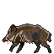After the buttons started working and my confidence grew I had to tackle harder problems and bigger challenges. So I drew placeholders for some enemies that we are probably never going to use :(.

**Week 3**

Week 3 was even more challenging and interesting: I had to do the Health bar and the according scripts to it!

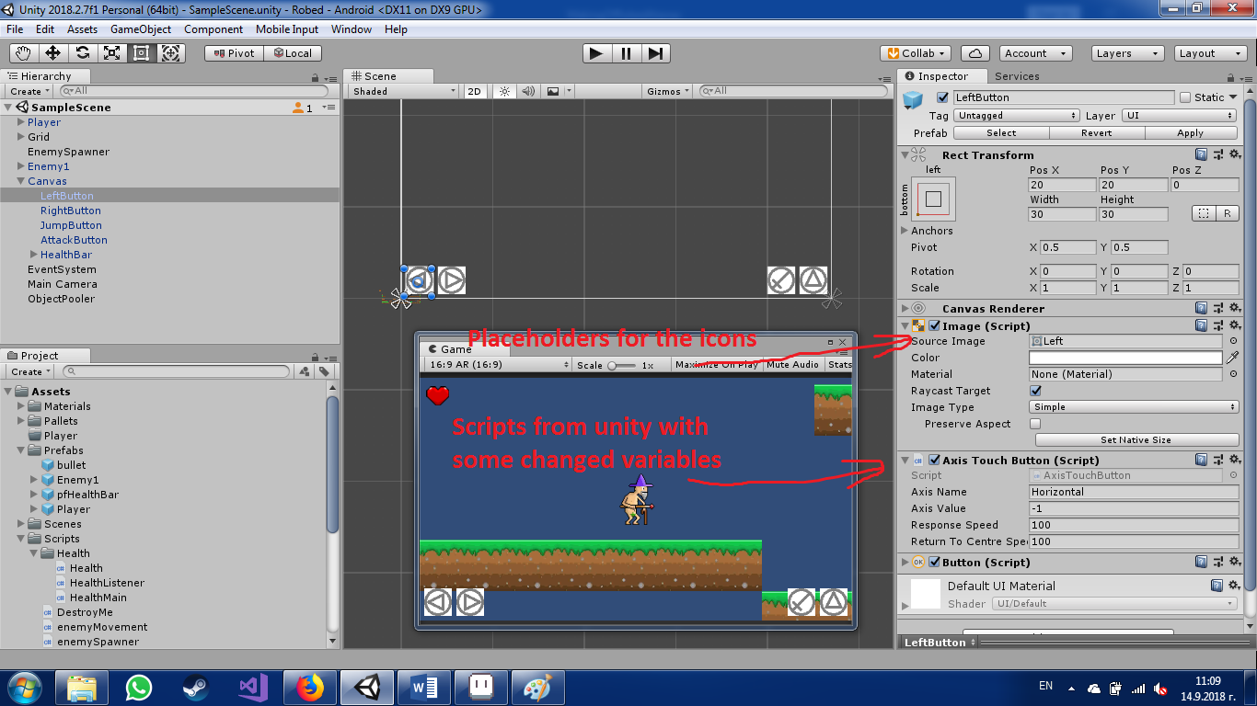Script took a couple of videos and some rummaging through Unity’s documentation, but I finished it faster than the buttons. I used events when our Player takes damage and with these events the health bar icon knew how much health to display on our Canvas.

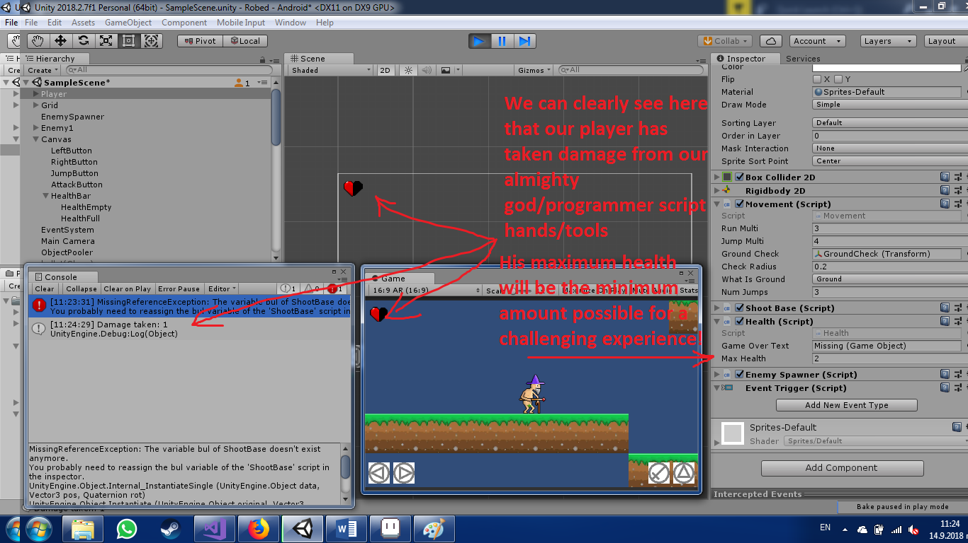

After having the health done I started drawing some more placeholders which I hope will make it to the prototype at least! And I made an animation for it!

We also talked about the MDA of the game and we both agreed that our main fun factor would be Challenge: the game is going to be challenging for the player because he will not have much room for error while playing. We will have a bright, flashy world will silly animations and funny monologues and dialogues. The mechanics for our character will consist of Moving left or right, jumping and shooting different kinds of magic spells. We will have different kinds of enemies and at least one boss fight and the occasional exploration part where you can find secret stuff.

**Week 4**

Week 4 was mostly graphics and looks. We started thinking about the first level and drawing it out. It’s idea was an introduction to the game and was set to be in the woods where Wizardo’s house is situated. I animated our evil wolf’s running and attack and I also changed his color. Unfortunately Word doesn’t run gifs so I can’t show you here.



I made a script for his attack inspired by this video by Blackthornprod: <https://www.youtube.com/watch?v=1QfxdUpVh5I>, he’s really good :).

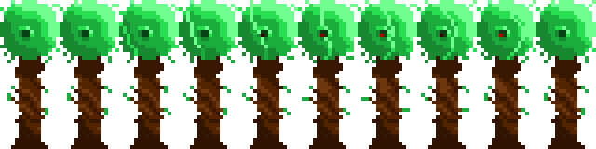I drew some trees for our level design and added some animation to them also:

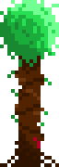If you look closely in the middle of the green part there is a small flash, that’s supposed to be some creepy eye peeping at you sometimes.

And one more which I tried to make so that it can be laid down as a tile and look alright no matter how many middle pieces you put there. I made sure that it can be fragmented in 3 parts which can be put together in different ways and still look okay.

I drew a fireball animation and our lovely naked wizard:

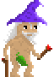C:\Users\koko\Documents\Assignments\GD\Robed\Robed_Game_Design\Fireball\FireballSpritesheet.png

I am yet to animate him.