**Robed Game Plan**

**Introduction**

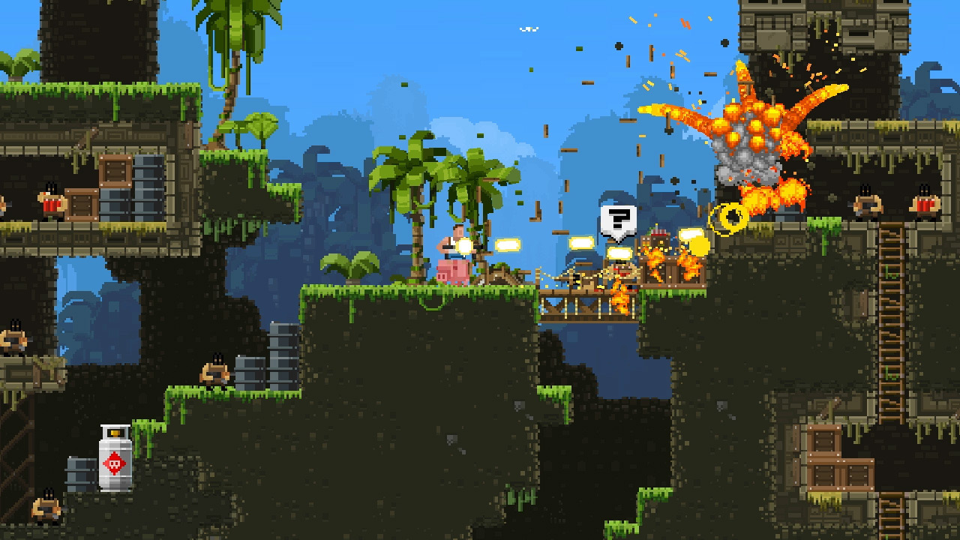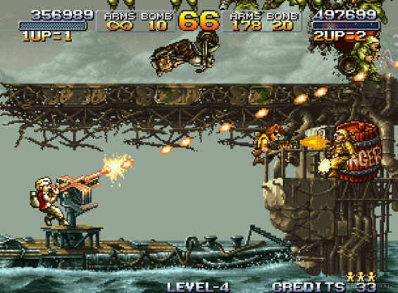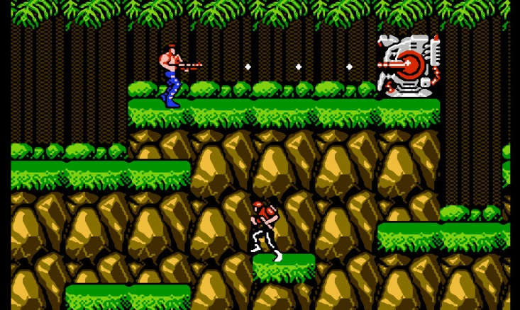The game that we would like to make is a 2d platformer inspired by Contra, Metal Slug and BroForce. We chose this combination due to the fact that we have some basic experience with unity 2d projects and we think that in the time provided we can create, and use the required resources. There will be different levels with several different themes which have their respective enemies. Enemies will have different behavioral patterns. You can change your character’s weapons which have different abilities.

**Overview**

The main character will be a naked wizard whose robe was stolen by an evil mutant moth. The main goal will be to get his robe back. He will traverse different levels while encountering animals and monsters who are being mind controlled by the mutant moth. With every level the moth eats more and more from the robe gaining more magic power and sending more powerful enemies at the wizard. At the end of each level he will face a boss. The passage to the next level is unlocked once the boss is defeated.

. 

(Wizardo The Wise Wicked Wizard)

**Mechanics**

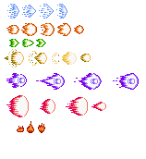Buffs - For the wizards weapons we will make different wands and staffs (buffs) that have different shooting pattern and damage. For example:

Character health – The playable character will have 2 hit points. The first hit will make him drop his walking cane (straighten his back) which will allow him to move faster. You can pick up another cane later, but it will be too heavy and it will break your characters back again, reducing movement speed. As for the enemies’ health, they will have different health points, weaker enemies have less health and stronger – more. For Example:

Boss fights – The bosses will have health bars, more health and different strategies to defeat them.

Movement – Two speeds in which the character moves (slower when holding his cane and faster when he has dropped it) and he can jump twice when he’s not holding his cane so he can reach bonus areas.

**Plan**

1. **Mood** 
   1. **Fun –** The hero will be a silly naked old man blowing up all sorts of wicked enemies. The game will have pop culture references.
   2. **Parody –** There will be exaggerated characters and levels, mockery and funny contradictions.
2. **Theme & vision**
   1. **General story –** After coming back from a mushroom picking adventureyou, Wizardo the wise wicked wizard, catchthe evil mutant-moth Mothew Smith stealing your magical robe. A robe created by the mystical underwater troglodytes weaved by their prime ministers back hair and covered with pollen from the rarest elvish flower – Plong which blooms in the deepest cave, under the highest mountain, every thousand years under the heat and light of lava from a volcano erupting at the same time. Unfortunately Mothew runs away and starts eating the robe slowly in his lair gaining its magical properties. You have to catch him before he eats your last pair of clothes.
3. **Genre** 
   1. **Shooter**
   2. **Side scroller**
   3. **Platformer**
4. **Design**
   1. **Interactive design**
      1. **Menu -** Simple menu with no more than 5 buttons
      2. **Buttons -** Buttons must be simple, with 1-2 colors and 1-2 words
   2. **Interface**
   3. **Prspective –** 2D(side scroller)
   4. **Characters** 
      1. **Playable characters -** Wizard
      2. **Enemies –** Monsters, wild animals
      3. **NPC‘s –** none
   5. **Levels** 
      1. **Conditions for completing a level –** kill a boss at the end of the level
      2. **Obsticals and traps –** holes, false floor, celling traps
   6. **Difficulty Level –** Single difficulty level
   7. **Single/Multiplayer –** Single player
5. **Story**
   1. **General Story-** A naked wizard on a quest to retrieve his robe.
   2. **Cutscenes/Cinematics**
6. **Gameplay** 
   1. **Basic description of the gameplay –** Move from left to right in the level. Kill enemies, avoid attacking enemies, pick up power ups for your weapon
   2. **Playable characters -** Wizard
   3. **Enemies –** Level 1 Forest(Boars, rabbits, wolves, Bear boss/monkey boss)

**/*4.1. Visual**

**4.1.1. Sprites**

**4.2. Sound*/**

**Inspirations:**

**Contra**

**Metal Slug**

**BroForce**

**References:**

1. Konami (1987). Contra. Retrieved 31.08.2018 from <https://www.getjar.com/categories/all-games/action-games/Contra-Classic-863522>.
2. SNK (1996). Metal Slug. Retrieved 31.08.2018 from <https://videochums.com/review/aca-neogeo-metal-slug>.
3. Free Lives (2015). Bro Force. Retrieved 31.08.2018 from <https://store.playstation.com/nl-nl/product/EP3643-CUSA03887_00-00000BROFORCEPS4>.
4. Bongwater-bandit (2016). Sprite fx – projectiles. Retrieved 31.08.2018 from <https://www.deviantart.com/bongwater-bandit/art/sprite-fx-projectiles-587001178>.
5. Pixerartmaker (2016). Health bar. Retrieved 31.08.2018 from <http://pixelartmaker.com/art/49e2498a414f221>.