**Military Tanks**

Military scientists are training battle tanks using artificial intelligence. The first lesson is to teach them to move across the (x,y) - plane. They give them a sequence of moves and observe whether the tanks get to the correct (x, y) position on the field. This sequence is represented by string, and the character at position i represents the tank’s **i**-th move.

There are several commands – R – moves right, L – moves left, U – moves up and D – moves down.

To help the scientists, you have to write a program that collects the learning results of the tanks.

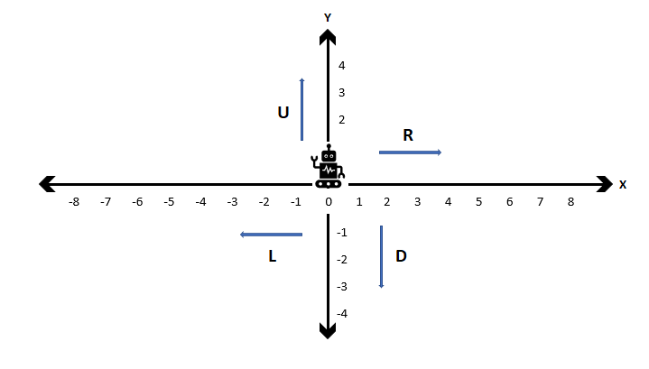

**Input**

Read from the standard input:

* There is one line of input, a string that contains tank's sequence of moves, represented by capital letters - R, L, D, U, no intervals:
* RLDULLR

**Output**

Print to the standard output:

* One line of output - tank's coordinates -> (-1, 0)
* Please note there is a **space** between the comma and the second coordinate.

**Sample Tests**

**Input**

DU

**Output**

(0, 0)

**Explanation**

The robot moves down at position (0, -1), and then up at (0, 0).

**Input**

LLRD

**Output**

(-1, -1)

**Explanation**

The robot moves left twice, so it goes to (-2, 0). Then it goes right once at (-1, 0) and after going down ends up at (-1, -1)