**Introduction**

The dataset which was wrangled and analyzed is the tweet archive of Twitter account @dog_rates also known as WeRateDogs. WeRateDogs is a Twitter account that rates people's dogs with humorous comment about the dog.

These rating ratings have a denominator value of 10 and numerator of values raging to 14. Some dogs were rated more than 10 because the account has over 4 million followers and has received international media coverage.

After cleaning the data, we were left 1976 rows of data to work with from 2356 records.

Insights And Visualizations

**Most used twitter Source as used by the account**

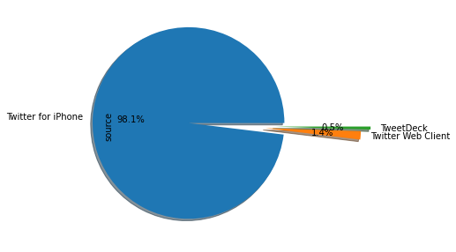

As it can be noticed from the visualization above, Twitter for iPhone ( 1938 ) has the highest of sources for Tweets followed by Tweet Web Client(28) and Tweet Deck ( 10 )

**‘**

**Analysis of the Common Dog Names**

It was observed from analysis that the Dog names has 912 unique names besides the unknown names that were recorded as ‘ None ’.

Of the 912 names , the 5 most common dog pet names are Penny, Oliver, Cooper, Lucy, Charlie

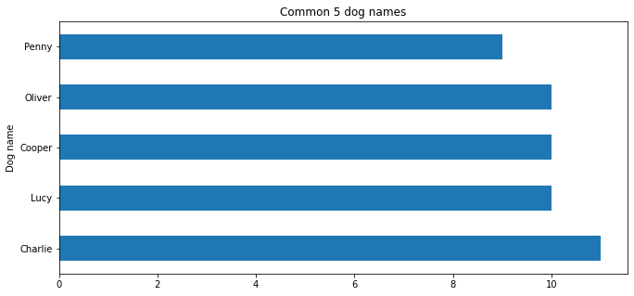

**Analyses of the Dog Stages**

Different dog stages were present in the dataset as Pupper, doggo, Floofer, Puppo.

### From analyses, it was discovered that besides None, Pupper has the highest percentage of Dog Stages at 10.7% and Floofer has the lowest at 0.4%.

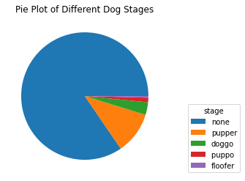

**Correlation Between Tweets with Favorite Counts and Retweet Counts**

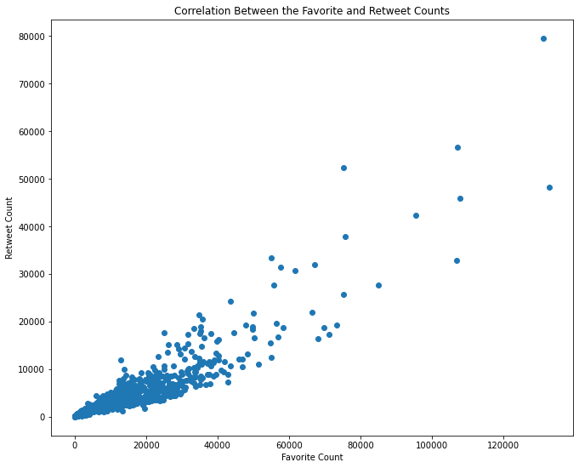

In checking for the correlation between Retweet Count and the favourite counts of Tweets it can be observed that they is a positive correlation between the two attributes.

**Dog Rating Distribution**

From the visualuasation below, it can be seen that most dogs rate within the range of (numerator value) 9 - 13 over (the denominator) value of 10

