|  |  |
| --- | --- |
| **Architetture dei Sistemi**  **Di Elaborazione** | Delivery date:  24th January 2023 |
| **Extra point #2**  **Max 2 points** | Expected delivery of extapoint2.zip must include:   * zipped project folder * this document compiled in pdf * Application note in pdf |
|  |  |

Purpose of Part 2: to enhance the Tamagotchi developed in the previous extra point with the KEIL **software debug** environment to emulate the behaviour of the LPC1768 and the LANDTIGER Board.

This part is evaluated to assign a maximum of 2 extra-points for qualified students taking the exam with a mark >= 18

**Improve your Tamagotchi!**

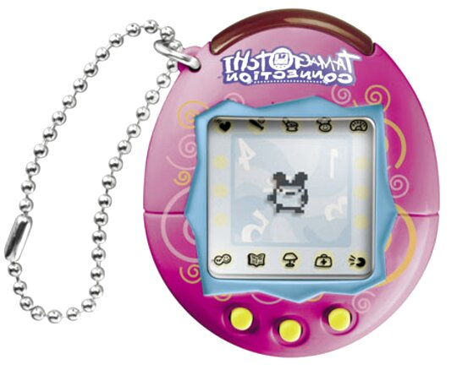

In Keil µVision, use the LANDTIGER **emulator** (or the actual board if you are able to have one) for implementing an improved version of your Tamagotchi.

Please deliver a zip folder with all the files of your project. At the end of the Keil project folder, please add “EMULATOR” if you developed it using the emulator or “BOARD” if you had the opportunity of developing the project on the actual board.

**Example**: extrapoint2_emulator.zip **or** extrapoint2_board.zip

Please attach any useful comments and your emulator configurations.

Your project will be evaluated according to your specification!!

|  |
| --- |
| Additional Comments (C-variable/defines defined in your code, e.g., scaling factors) : |
| The emulator configuration is not needed as this project was done and tested only on the board.  The license is needed as the size of the binary exceeds 32k.  The project is compiled with -O2 and C99 mode.  I also doubled the stack size from 200 bytes to 400 bytes to prevent stack overflow. |

**Application Note)**

You are required to produce an Application Note document **(MAXIMUM 1 PAGE)** regarding one (of your choice) of the new implemented features (aka Specifications).

An "Application Note" is a form of technical writing with the following purposes:

1. It has an instructional or tutorial style
2. It is targeted to a specific audience of users.
3. It is typically a focused description of how to do something, including an introduction to the topic as well as precise implementation details, results, and recommendations. It is more than just the repetition of information from part of a spec sheet.

For example: the writer should have done something with the information from a spec sheet, and describe how it was done or how ONE should do it.

1. It often includes references to other manuals, documents, or books where the user may gain more or related information. You can avoid adding references.

**Specification 1) Cuddles Animation**

You shall create a new way to interact with your Tamagotchi using the TouchScreen.

Touching the Tamagotchi shall now trigger a new animation.

This new animation:

* It lasts for 2 seconds.
* It is triggered only on the actual Tamagotchi.
* At the end, the cuddles increases the happiness level of one bar (of your scale).

An example of cuddles animation:

**Requirement 1:**

Note that images are only for explanation purposes.

**You are required to develop the cuddling feature.**

Cuddling is activated by pressing on the TouchScrenn present on the Landtiger.

The animation:

* It lasts for 2 seconds.
* It is triggered only on the actual Tamagotchi.

Touching the meal/snack menu, as well as the status levels or the Tamagotchi age on top of the screen should have no effect at all.

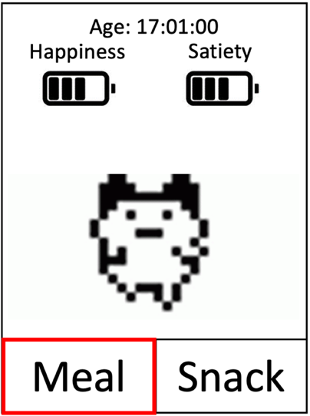

Area that triggers the cuddles animation.

* At the end, the cuddles increases the happiness level of one bar (of your scale).

**Specification 2) Sounds**

Each animation on your Tamagotchi shall now include a sound effect.

You are not requested to make complex sounds/music, it is enough to play some notes.

You should include sound/music to the following part of your project:

* **Click** of the Meal/Snack option.
* **Eating** (Meal/Snack) animation.
* **Death / run** away animation.
* **Cuddles** animation.



“Click”

**Requirement 2:**

Note that images are only for explanation purposes.

**You are required to develop a sound effect for all the major event/animation of your Tamagotchi.**

Sound/music don’t need to be excessively complex.

A single note is fine for the clicks and a couple of them is fine for the other animation (but you are free to experiment!).

For example:

* **Click** of the Meal/Snack option (a single note for representing the classical Windows “click” sound).
* **Eating** (Meal/Snack) animation (play 3 notes).
* **Death / run** away animation (play 5 notes).
* **Cuddles** animation (play 8 notes) .

**Specification 3) Volume**

With music/sound, it is common practice to develop the handling of the volume level.

As you can see for the following figure, a speaker icon with the following volume level can be added.

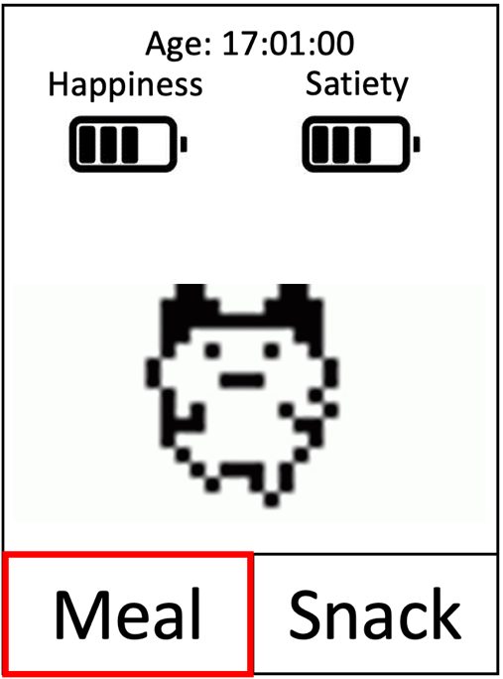

In this way, the volume level of the music can be controlled, from mute to the maximum level.

**Requirement 3:**

Note that images are only for explanation purposes.

**You are required to develop the handling of volume level.**

Volume level is sampled by reading the current analog value on the potentiometer every 50 ms.

When it is muted (lowest analog value), you are free to choose the image to show. For example:

or