Implementing sound effects on a LandTiger board

This document describes how to implement and play sound effects on a LandTiger board, this is achieved by writing a small library that uses two timers to write values to memory addresses relating to the speaker with frequencies and durations based on which note is being played.

The speaker uses a 10-bit value that represents the frequency to be played, to reproduce a full note it is needed to repeatedly feed a sampled sinusoid to this value. To control the pitch and volume of the note, the period and the amplitude of the sinusoid are changed, with a longer period corresponding to a lower pitch and a bigger amplitude corresponding to a higher volume. To write the sinusoid to the speaker address a timer is used, every time the timer is hit, a new point of the sinusoid is written, if the end of the sinusoid is reached, it is started from the beginning again. Thus, the timer value corresponds to the period we want the sinusoid to have, this is done with the following formula: $P=\frac{{TimerClkFreq}_{hz}}{{NoteFreq}_{hz}*NSamples}$

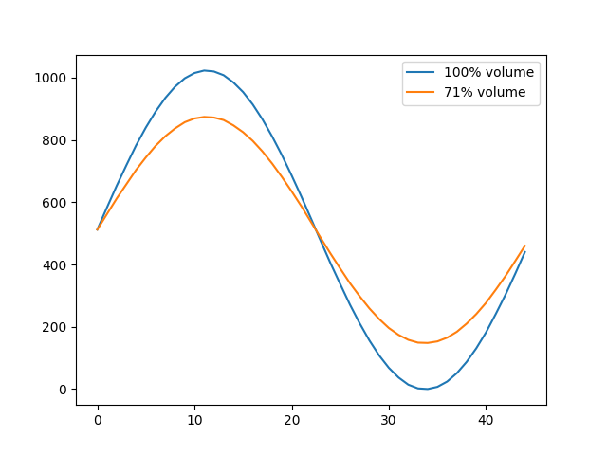Where the note’s frequency is taken from a lookup table of precalculated values, and the number of samples is the number of values in the sampled sinusoid. For the volume, it is needed to change the value of the sampled sinusoid to reduce its amplitude using the formula: $V^{'}=\frac{V*Volume}{100}+SinTable[0]$

Figure 1: example graph of volume adjustment

Where Volume is a value between 0 and 100, V is the value to adjust and SinTable is the sampled sinusoid centered in $\frac{2^{10}}{2}$ (512) because of the 10-bit limit of the speaker’s DACR[1].

To play a note however, this alone is not enough, since notes have duration, which depends on the BPM[2] of the song that’s being played. The formula for note duration for a quarter note given BPM is: ${NoteDur}_{ms}=\frac{1000}{\frac{bpm}{60}}$, this can be then multiplied or divided by powers of 2 to have whole notes, half notes, sixteenth notes, etc. This millisecond value needs to be converted to a timer value which can be done with: $T=\frac{{NoteDur}_{ms}}{1000}*{TimerClkFreq}_{hz}$

This is going to be the timer value needed for the timer that will drive the notes duration. This timer will adjust itself with the value needed for the current note to reproduce and will also set the other timer to the value needed using the formulas described for the period and amplitude for the sinusoid.

With this setup it is very simple to write some data structures to hold the various lengths and frequencies of the notes, then declare an array of the notes of the song that is intended to play and feed the values of the array to the timers to reproduce the notes.

It is necessary between notes to reset the values of the timers and disable them to make sure that the next note will play at the correct time and that there are no misfires which would lead to corrupt sounds. When silence needs to be played, the timer driving the sinusoid also needs to be stopped.

Figure : Arrays representing sound effects

1. Digital-Analog Converter Register
2. Beats Per Minute