Visuals.R

r3223084

2025-05-31

# Install required packages (run once)  
install.packages("ggplot2")

## Installing package into '/cloud/lib/x86_64-pc-linux-gnu-library/4.3'  
## (as 'lib' is unspecified)

install.packages("palmerpenguins")

## Installing package into '/cloud/lib/x86_64-pc-linux-gnu-library/4.3'  
## (as 'lib' is unspecified)

# Load libraries  
library(ggplot2)  
library(palmerpenguins)  
  
# Scatter plot: Flipper length vs Body mass, colored by species  
ggplot(data = penguins) +  
 geom_point(mapping = aes(x = flipper_length_mm, y = body_mass_g, color = species)) +  
 ggtitle("Penguins: Flipper Length vs Body Mass by Species") +  
 labs(subtitle = "Colored points represent different penguin species") +  
 annotate("text", x= 220, y = 3500, label = "The Gentoos are the largest!",  
 color = "purple", fontface = "bold", fontsize = 4.5, angle = 25)

## Warning in annotate("text", x = 220, y = 3500, label = "The Gentoos are the  
## largest!", : Ignoring unknown parameters: `fontsize`

## Warning: Removed 2 rows containing missing values or values outside the scale range  
## (`geom_point()`).

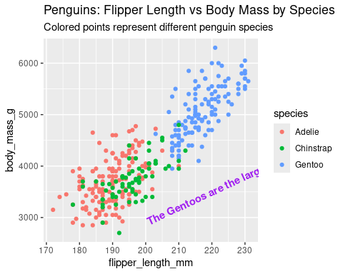

# Scatter plot: Flipper length vs Body mass, points shaped and colored by species  
ggplot(data = penguins) +  
 geom_point(mapping = aes(x = flipper_length_mm, y = body_mass_g, shape = species, color = species)) +  
 ggtitle("Penguins: Flipper Length vs Body Mass (Shape & Color by Species)") +  
 labs(subtitle = "Shape and color differentiate penguin species")

## Warning: Removed 2 rows containing missing values or values outside the scale range  
## (`geom_point()`).

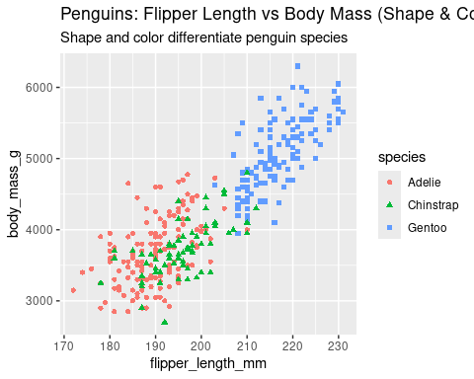

# Scatter plot: Flipper length vs Body mass, points with transparency based on species  
ggplot(data = penguins) +  
 geom_point(mapping = aes(x = flipper_length_mm, y = body_mass_g, alpha = species)) +  
 ggtitle("Penguins: Flipper Length vs Body Mass with Alpha by Species") +  
 labs(subtitle = "Transparency varies by species for visual distinction")

## Warning: Using alpha for a discrete variable is not advised.  
## Removed 2 rows containing missing values or values outside the scale range  
## (`geom_point()`).

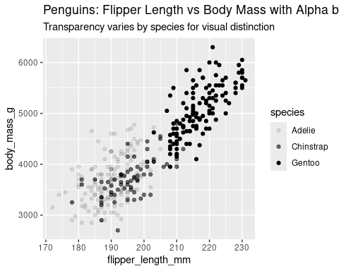

# Scatter plot with smooth trend line and points colored by species  
ggplot(data = penguins) +  
 geom_smooth(mapping = aes(x = flipper_length_mm, y = body_mass_g)) +  
 geom_point(mapping = aes(x = flipper_length_mm, y = body_mass_g, color = species)) +  
 ggtitle("Penguins: Body Mass vs Flipper Length with Trend Line") +  
 labs(subtitle = "Smoothed trend line overlaid on scatter plot")

## `geom_smooth()` using method = 'loess' and formula = 'y ~ x'

## Warning: Removed 2 rows containing non-finite outside the scale range (`stat_smooth()`).  
## Removed 2 rows containing missing values or values outside the scale range  
## (`geom_point()`).

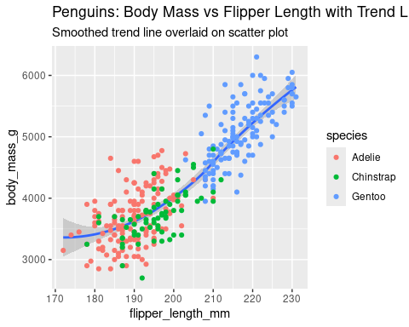

# Smooth lines showing trends by species with different line types  
ggplot(data = penguins) +  
 geom_smooth(mapping = aes(x = flipper_length_mm, y = body_mass_g, linetype = species)) +  
 ggtitle("Penguins: Trend Lines of Body Mass vs Flipper Length by Species") +  
 labs(subtitle = "Line type varies by species to show trends")

## `geom_smooth()` using method = 'loess' and formula = 'y ~ x'

## Warning: Removed 2 rows containing non-finite outside the scale range  
## (`stat_smooth()`).

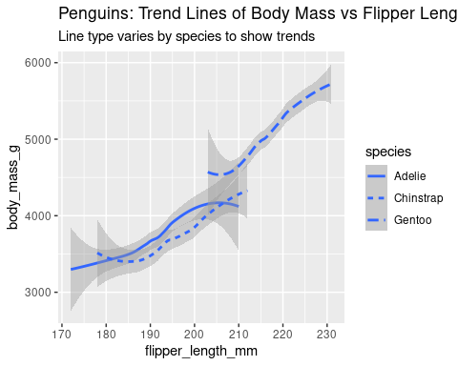

# Bar chart showing counts of diamonds by cut, filled by cut  
ggplot(data = diamonds) +  
 geom_bar(mapping = aes(x= cut, fill = cut)) +  
 ggtitle("Diamonds: Count by Cut") +  
 labs(subtitle = "Number of diamonds in each cut category")

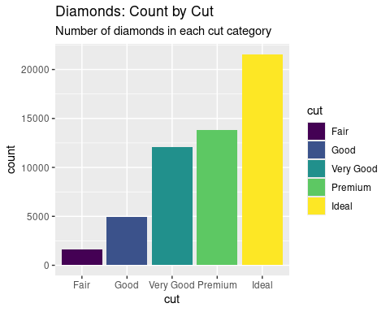

# Bar chart showing counts of diamonds by cut, filled by clarity  
ggplot(data = diamonds) +  
 geom_bar(mapping = aes(x= cut, fill = clarity)) +  
 ggtitle("Diamonds: Count by Cut Filled by Clarity") +  
 labs(subtitle = "Cut categories filled by clarity to show distribution")

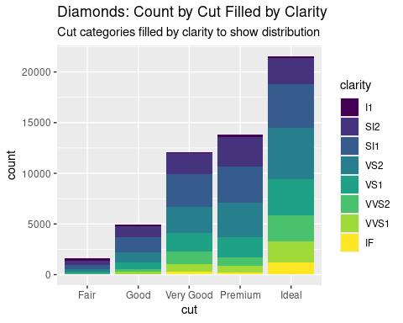

# Bar chart showing average price by cut, bars filled by cut  
ggplot(data = diamonds, aes(x = cut, y = price, fill = cut)) +  
 stat_summary(fun = mean, geom = "bar") +  
 ggtitle("Diamonds: Average Price by Cut") +  
 labs(subtitle = "Mean price of diamonds for each cut category")

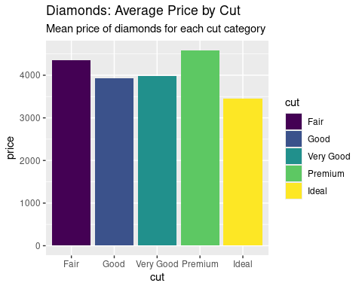

# Scatter plot faceted by species, colored by species  
ggplot(data = penguins) +  
 geom_point(mapping = aes(x = flipper_length_mm, y = body_mass_g, color = species)) +  
 facet_wrap(~species) +  
 ggtitle("Penguins: Flipper Length vs Body Mass Faceted by Species") +  
 labs(subtitle = "Separate panels for each species")

## Warning: Removed 2 rows containing missing values or values outside the scale range  
## (`geom_point()`).

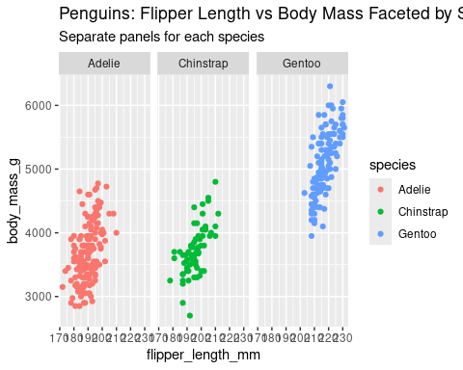

# Bar chart of diamond color counts, filled by cut, faceted by cut  
ggplot(data = diamonds) +  
 geom_bar(mapping = aes(x= color, fill = cut)) +  
 facet_wrap(~cut) +  
 ggtitle("Diamonds: Color Distribution Faceted by Cut") +  
 labs(subtitle = "Color frequency within each cut category")

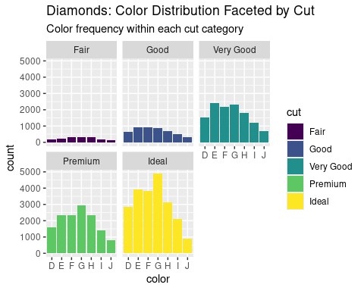

# Scatter plot faceted by sex and species, colored by species  
ggplot(data = penguins) +  
 geom_point(mapping = aes(x = flipper_length_mm, y = body_mass_g, color = species)) +  
 facet_grid(sex~species) +  
 ggtitle("Penguins: Flipper Length vs Body Mass Faceted by Sex and Species") +  
 labs(subtitle = "Panels arranged by sex (rows) and species (columns)")

## Warning: Removed 2 rows containing missing values or values outside the scale range  
## (`geom_point()`).

