Nama: Tan, William Marcelino Sugianto

NIM : 2602103936

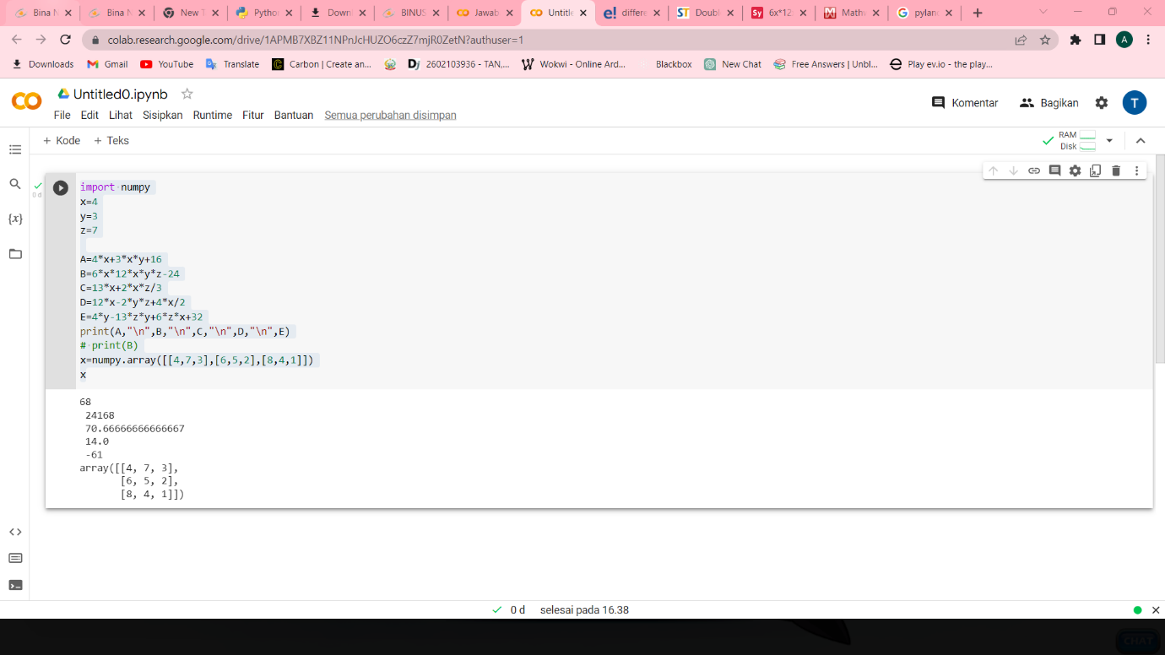Link : <https://colab.research.google.com/drive/1APMB7XBZ11NPnJcHUZO6czZ7mjR0ZetN?usp=sharing>