Nama : Tan, William Marcelino Sugianto

NIM : 2602103936

Link : <https://colab.research.google.com/drive/1RLGr9us6fcjqxivH0gDqgViWvxumD3Z4?usp=sharing>

Nomor 1

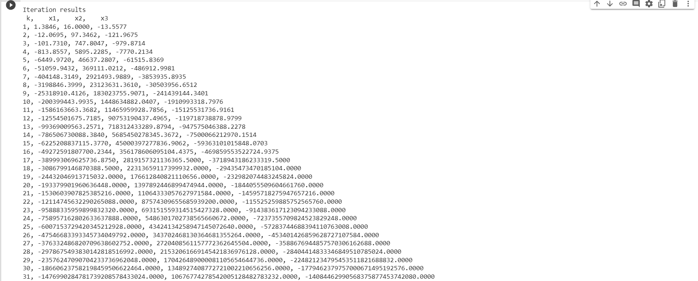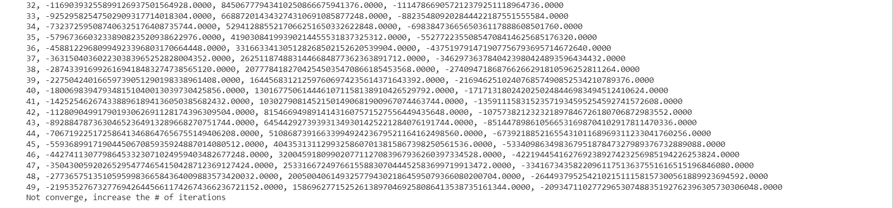

Nomor 2



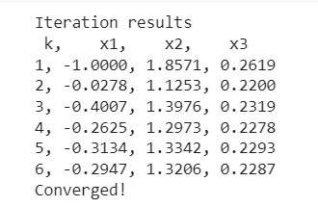



Nomor 3



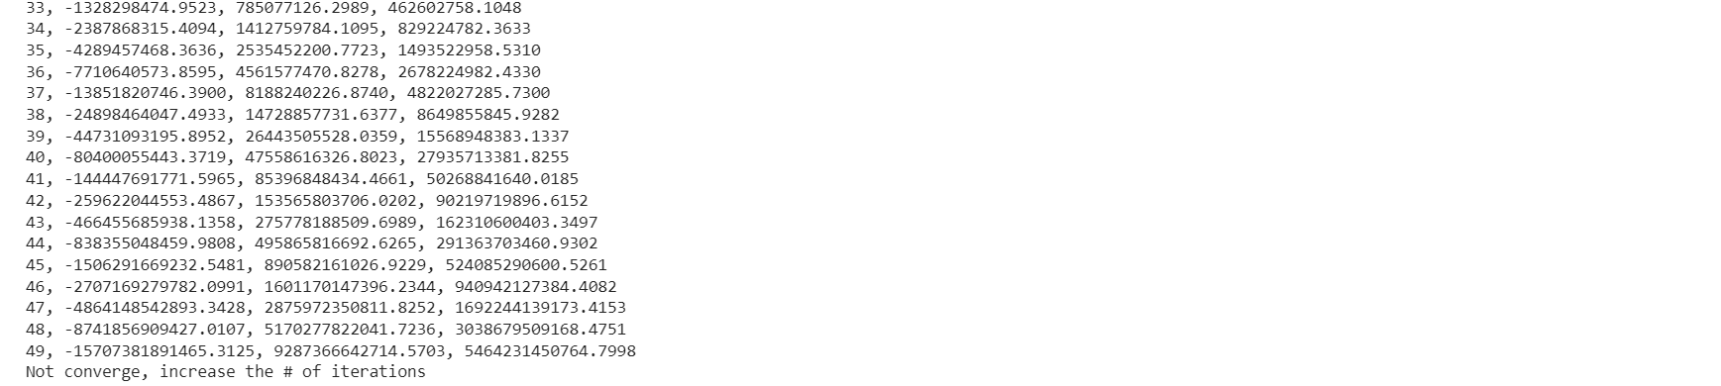

Nomor 4





