**DIGITAL MARKETING ASSIGNMENT**



BE-Computer Science and Engineering

Vivekanandha College of Technology for Women

Namakkal-637205

**NM id:**[A261AFC88B6748189C848E189F1150B3](https://github.com/Atcharahub/Atcharahub_A261AFC88B6748189C848E189F1150B3)   **Submitted by:**

ATCHARA HARIHARAN au613020104008

* **BRAND NAME:**

Health and Wellness

* **LOGO:**



**1.Create a blog or website using Blogspot and WordPress.**

Blogspot : https://atcharahariharan.blogspot.com/2023/09/mindfulnessmoments-wellness-wisdom.html

**2.Create a New Facebook Business Page and Post one social media poster**  Business Page Link:

https://www.facebook.com/profile.php?id=61552232031524&mibextid=ZbWKwL

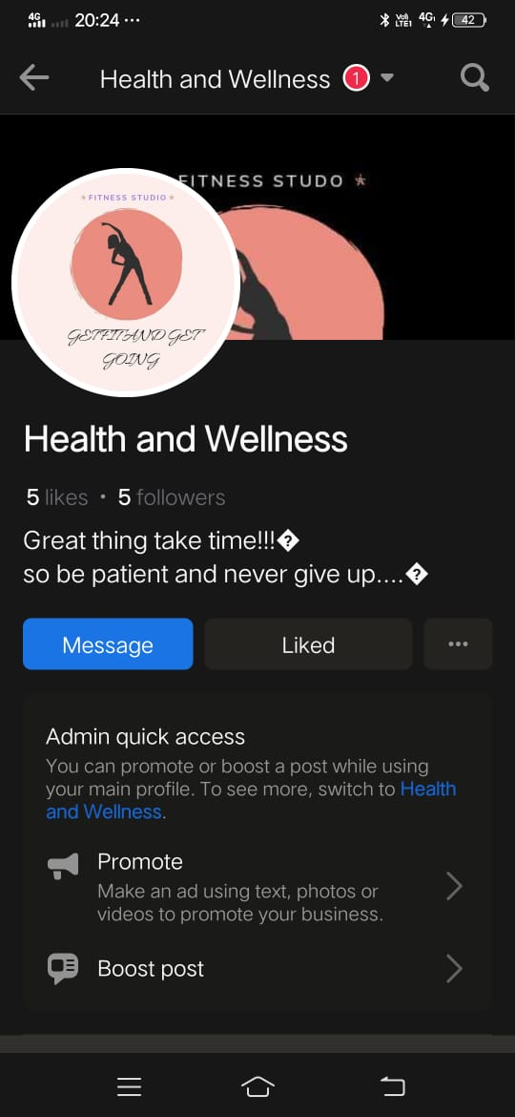

**3.Social media advertisement poster using Canva**



**4.E-mail newsletter using Mail Chimp or Canva**

