Postgraduate Project Summary

Title:
Targeting Gardnerella vaginalis Protein with Jatamansin Compound for the Treatment of Bacterial Vaginosis
Duration: 9 months (Individual research under Dr. S. J. Mohana)
Publication Details: Published in “Texila International Journal of Public Health”
ISSN: 2520-3134 DOI: 10.21522/TIJPH.2013.13.02.Art082
Received: 29 Jan 2025 Accepted: 03 Apr 2025 Published: 30 Jun 2025

Aim:
To identify a suitable therapeutic target protein in Gardnerella vaginalis associated with bacterial vaginosis and to evaluate phytochemical compounds with potential antibacterial activity using computational methods.
Objectives:
- Identify virulent and non-orthologous cytoplasmic proteins in G. vaginalis that can serve as viable drug targets.
- Model and validate the three-dimensional structure of the selected protein target.
- Screen and filter phytochemical compounds for drug-likeness and toxicity.
- Perform molecular docking and molecular dynamics (MD) simulation to identify the most stable ligand–protein complex.
Tools and Methods:
- Databases: NCBI, Uni Prot, PubChem, Dr. Duke’s Phytochemical & Ethnobotanical Database
- Target Identification: Virulent Pred, Blast2GO, Eco-Cyc
- Protein Modelling & Validation: HH-pred, Modeller, ModRefiner, PDB sum, Prank Web
- Docking & Interaction Analysis: PyRx (AutoDock Vina), UCSF Chimera, BIOVIA Discovery Studio
- ADME/Toxicity Analysis: Swiss ADME, Protox 3.0
- Simulation: GROMACS 2024.2 for molecular dynamics
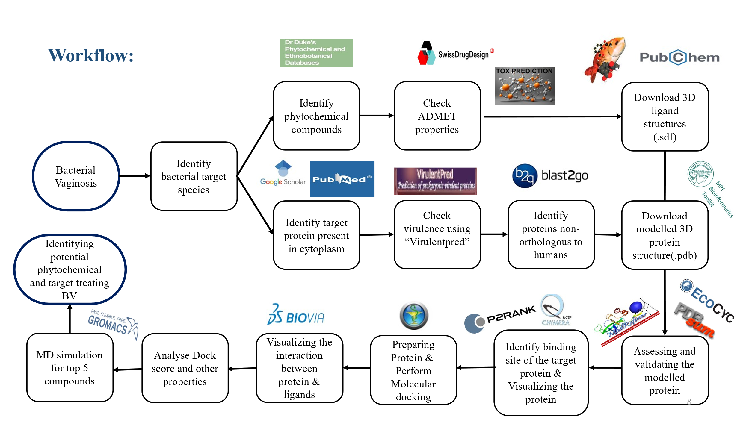
Results:
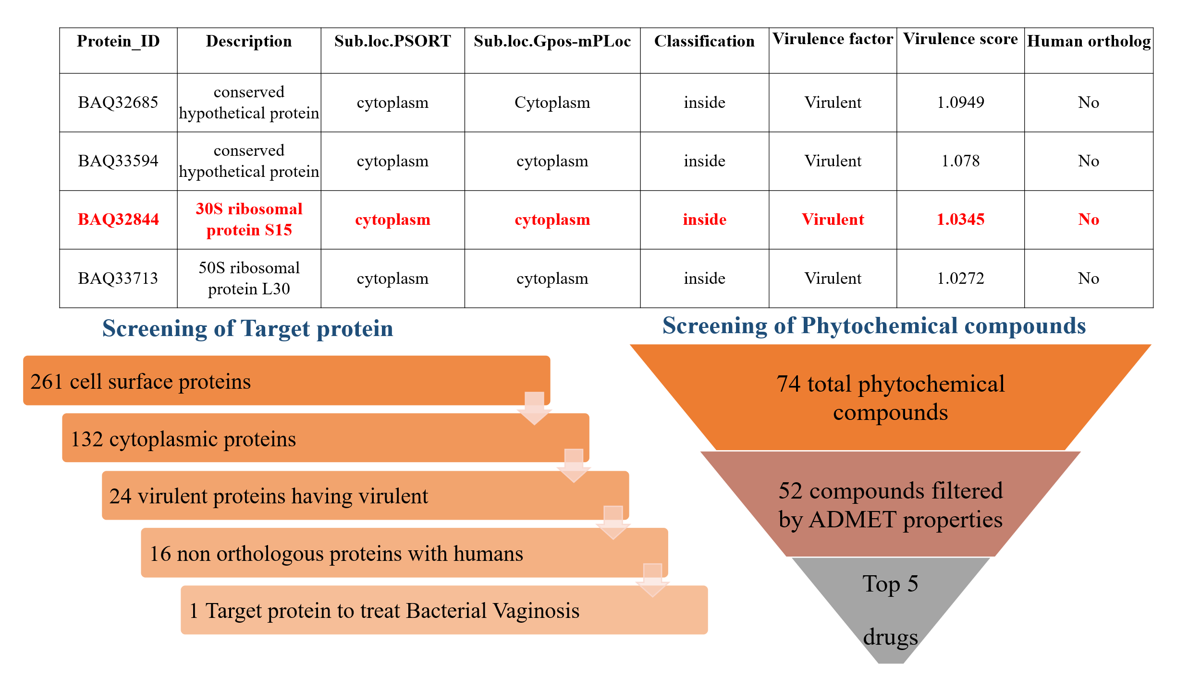
The 30S ribosomal protein S15 was identified as a key virulent, non-human-homologous cytoplasmic target essential for bacterial survival. Among the screened 74 phytochemicals, Jatamansin (from Nardostachys jatamansi) demonstrated the most stable binding with favourable docking scores and minimal structural fluctuation during molecular dynamics simulation, indicating strong inhibitory potential.
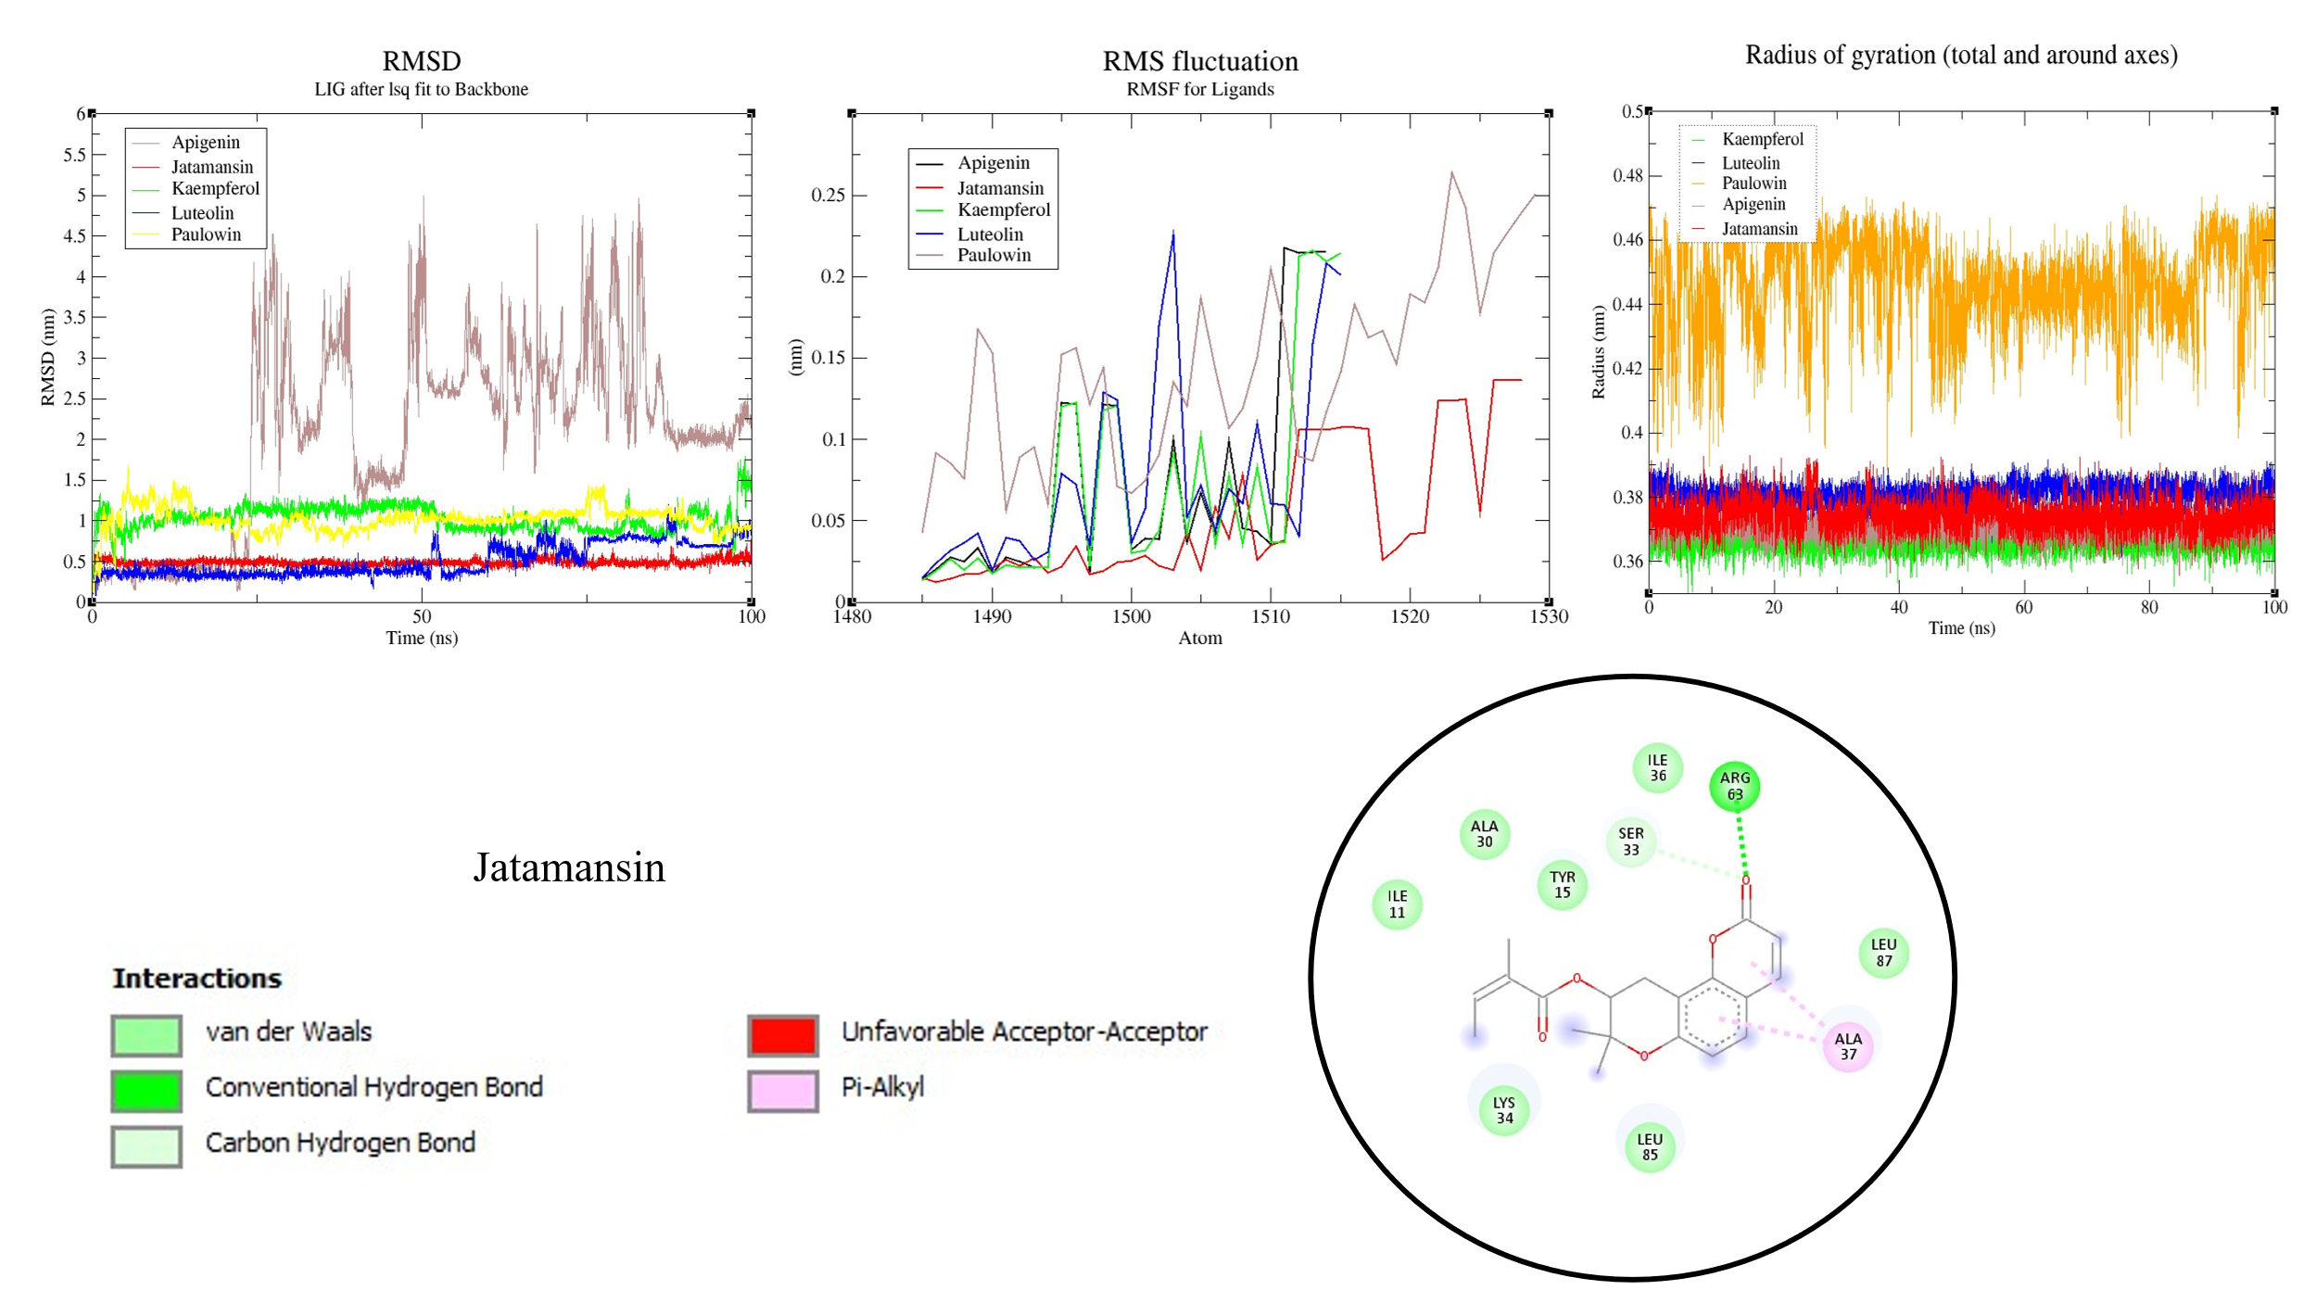
Conclusion:
The study revealed G. vaginalis 30S ribosomal protein S15 as a promising therapeutic target for bacterial vaginosis. Computational docking and simulation highlighted Jatamansin as a potent natural inhibitor exhibiting stable protein-ligand interactions. This research underscores the potential of phytochemical-based therapeutics and bioinformatics-driven approaches in the rational design of antibacterial agents.

