Undergraduate Project Summary

Title:
Virtual Screening Directed Towards Drug Repurposing for Combating Various Diseases
Duration: 6 months (Team of 3 students under Dr. G. Dicky John Davis)

Aim:
To repurpose existing bioactive compounds for identifying a single potential inhibitor effective against three distinct diseases — bacterial (Granville wilt), fungal (Tinea pedis), and cancer (Small Cell Lung Carcinoma) — through virtual screening and molecular docking techniques.

Objectives:
- To identify target proteins associated with each disease:
  - FtsZ protein for bacterial (Ralstonia solanacearum – Granville wilt)
  - Squalene Epoxidase for fungal (Tinea pedis)
  - EGFR for cancer (Small Cell Lung Carcinoma)
- To perform virtual screening of 300 phytochemical compounds (100 antibacterial, 100 antifungal, and 100 anticancer agents).
- To evaluate docking scores and interaction profiles to identify a common compound effective across all three targets.
- To analyze ADME properties and drug-likeness using in silico tools.
Tools and Methods:
- Databases: NCBI, PDB, Uni Prot, PubChem, ChemSpider
- Protein Modelling & Validation: I-TASSER, SWISS-MODEL, ProQ, MolProbity, PSVS
- Ligand Preparation: Marvin Sketch, Mol inspiration, Open Babel
- Docking & Visualization: AutoDock Vina (via UCSF Chimera), BIOVIA Discovery Studio
- Drug-likeness & ADME Analysis: SwissADME, PSAP
- Approach: Molecular docking of all 300 ligands against 3 proteins, ranking based on binding affinity and Lipinski rule compliance.
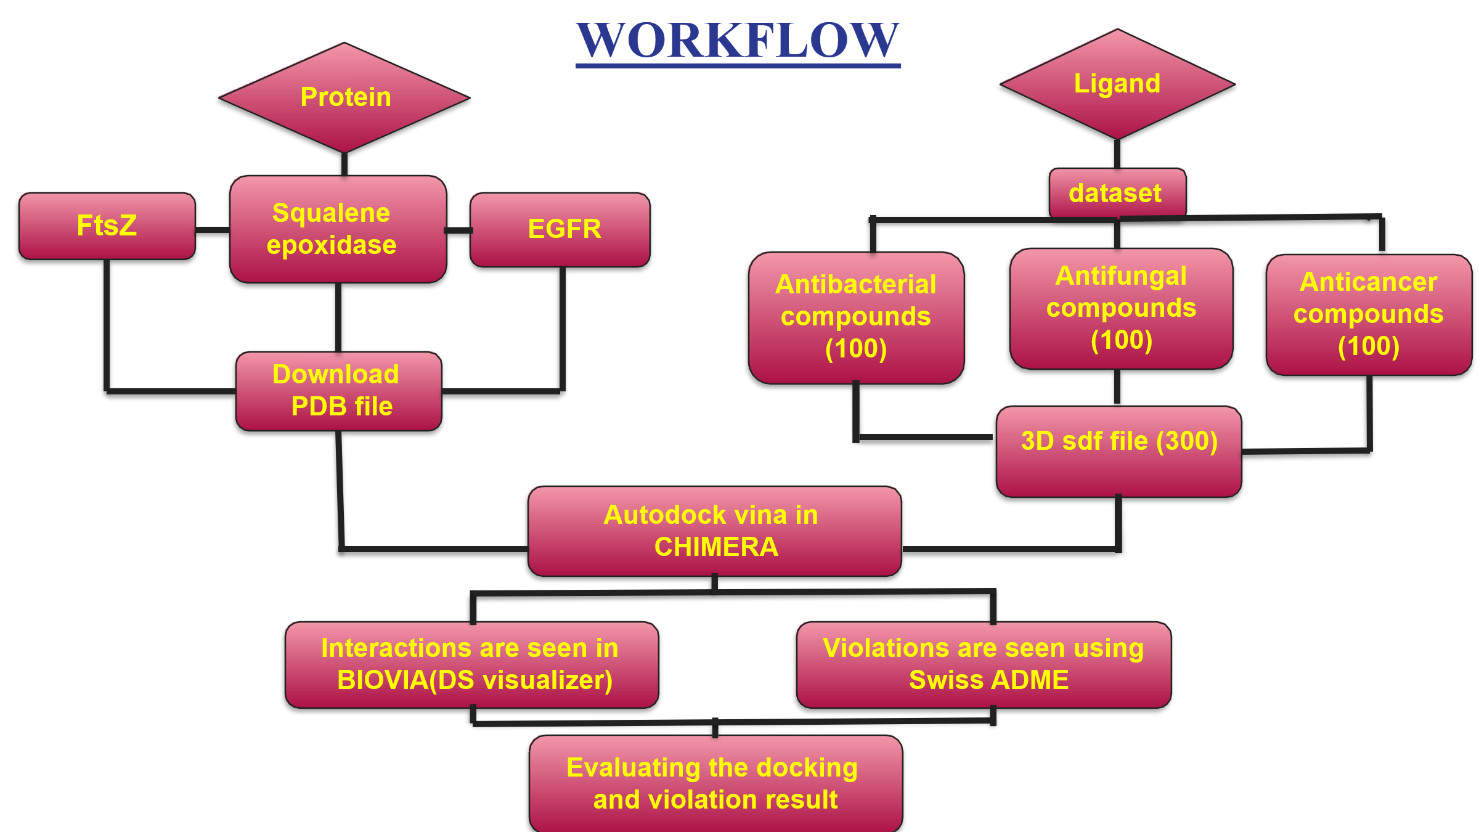
Results:
Out of 300 ligands screened across three targets, top-scoring compounds with minimal violations were shortlisted as potential inhibitors.
Docking and interaction analyses identified strong binding affinities for selected compounds, Among the screened compounds, Sanguinarine showed the best docking score and strongest binding interactions across all three target proteins (FtsZ, Squalene Epoxidase, and EGFR). It exhibited favourable hydrogen bonding and stability within the active sites of all targets.

Conclusion:
The study successfully identified Sanguinarine as a multi-target inhibitor with potential antibacterial, antifungal, and anticancer properties. The research highlights the effectiveness of virtual screening and drug repurposing strategies in accelerating multi-disease therapeutic discovery.

