Day 3 – Search Engine Mastery

1. Google Operators
Google Operators are special search commands that help filter search results and find specific information.
Example: site:gov.in cybersecurity (Searches only government websites in India.)
Examples:
- site: → Search within a specific domain (site:gov.in cybersecurity - (searches only government websites in India ))
- filetype: → Find specific file formats like PDF, Excel, etc. (filetype:pdf)--> This returns only PDF files related to Artificial Intelligence.
- intitle: → Search for keywords in page titles (intitle:"digital footprint")
- inurl: → Search for keywords in URLs (inurl:research)
- cache: → View Google’s cached version of a page
- “ “(Quotation Marks) : Searches for the exact phrase. (Eg: "artificial intelligence in defence")

2. Boolean Logic
Boolean Logic is a search method that uses logical operators like AND, OR, and NOT to combine or exclude keywords.

Operators:
- AND → shows results containing both keywords (Eg: cybersecurity AND malware)
- OR → shows results containing either keyword (Eg: drone OR UAV )
- NOT / - → removes a keyword from results (AI -games → removes gaming-related results)

3. Search Strategies
Search strategies are planned methods used to find accurate and relevant information quickly.

Some strategies include:
- Use simple and clear keywords
- Use quotation marks for exact phrases
- Use search operators like filetype, site, intitle
- Use trusted sources like edu, gov, org
- Combine multiple filters for better results

Example: site:gov.in filetype:pdf cybersecurity →This finds cybersecurity PDFs only from Indian government websites.

4. Search Intelligence
Search Intelligence means collecting useful information from publicly available sources using advanced search techniques. It is an important part of Open Source Intelligence (OSINT)."
Instead of searching randomly, analysts use Google operators and search strategies to quickly locate relevant documents.

Key Points:
- Identifying trusted sources like government and educational websites
- Removing irrelevant or fake information
- Using multiple operators together
- Understanding how search engines rank results

Example: site:gov filetype:pdf "climate change report"

Topic: Google Dorks Library (50 Queries)

1. Introduction
To create a library of 50 Google Dorks. Google Dorks are advanced Google search queries that use search operators to find specific publicly available information more efficiently than a normal Google search.
This practical focuses on four main categories:
- PDFs
- Excel Sheets
- Research Papers
- Government Documents

2. Google Dorks Library (50 Queries)

A. PDF Files (12 Queries)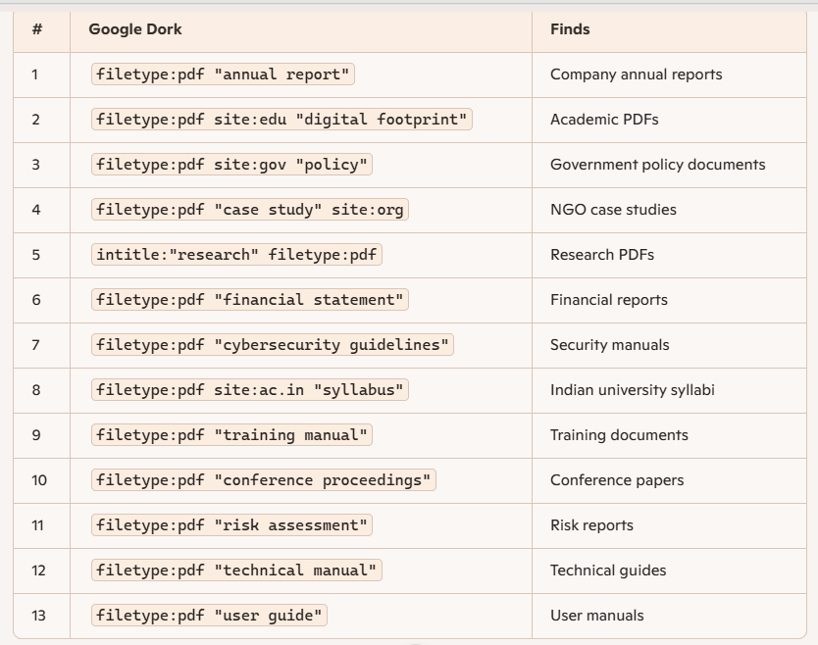

B. Excel Sheets (12 Queries)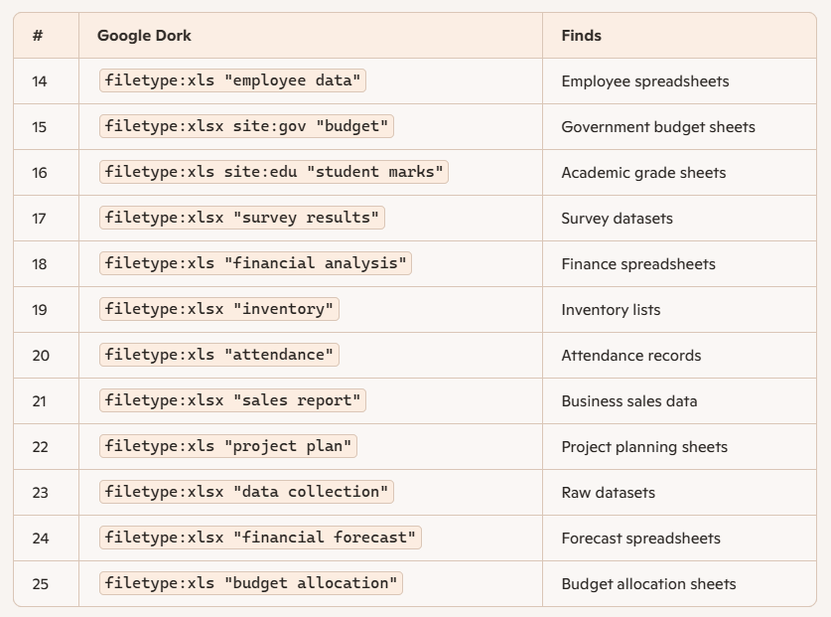

C. Research Papers (13 Queries)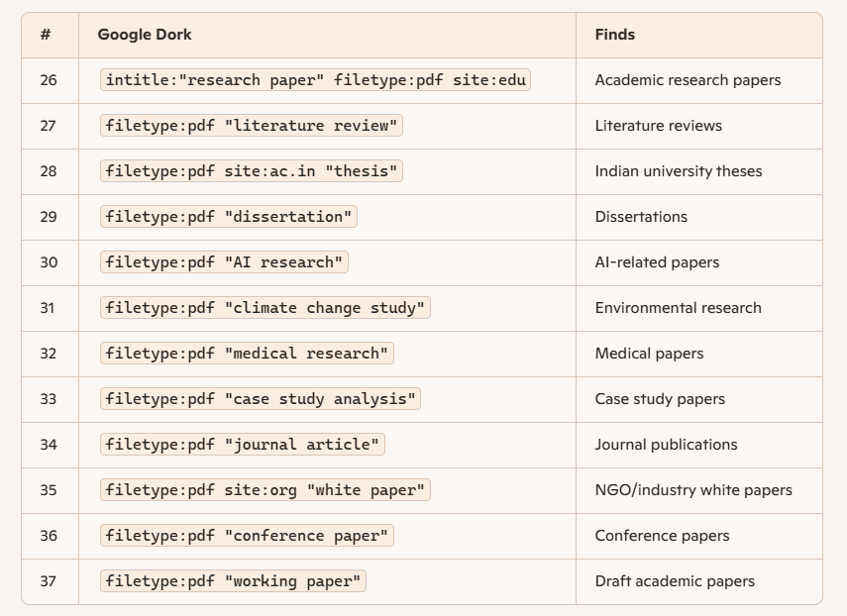

D. Government Documents (13 Queries)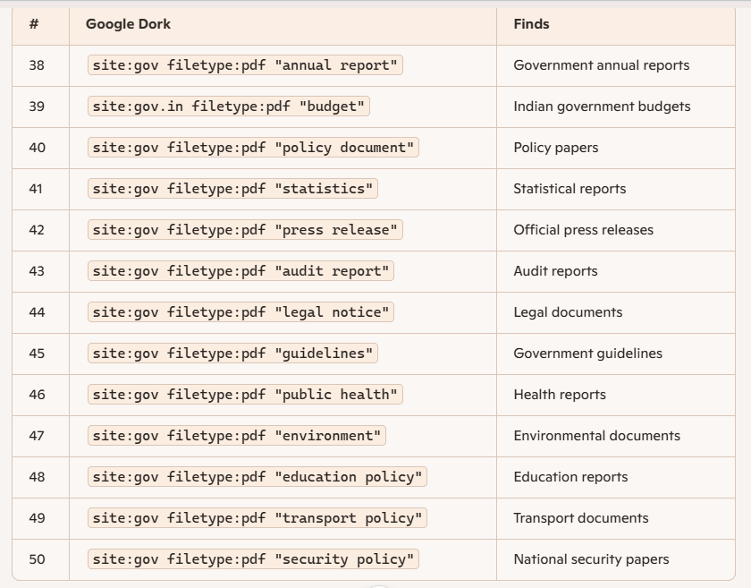

3. Outcome
A structured library of 50 Google Dorks was successfully created. These queries help in efficiently finding PDFs, Excel sheets, research papers, and government documents from reliable sources.

