

Sri Meenakshi Govt.Arts College for Women (A),

Madurai - 625 002

Department of Physics

Naan Mudhalvan Scheme

Domain : Sales Force Associate

Project Tile :A CRM Applicatin that helps to book a visa slot

Team ID;NM2023TMID05087

Submitted by

TEAM 1

Team Lead : Ms.P.Atchaya

Team Member 1 : Ms.T.Archana

Team Member 2: Ms. M.Asika

Team Member 3 : Ms.V.Arthika

Mentors : Dr. K. Vijaya Kumar & Dr. P. Indra Devi

April, 22 - 2023

**INTRODUCTION**

**1.1.OVER VIEW**

A CRM system manages all your contacts and aggregates lead and relation between customer information you to build to

access to important information to better understand customer behavior like purchase records and previous communications with contacts across different channels (chat, email, etc.). Customers won’t have to repeat their stories over and over to you, and you’ll be able to address issues with best practice and less effort for improved customer loyal ltapplications. It might be used by a government agency or a visa processing center to schedule and manage appointments with applicants. certain

.

**1.2 PURPOSE**

A visa slot management project is a system that is used to track and manage the availability of visa slots, which are appointments that are

agency or a visa processing center to schedule and manage appointments with applicants. c2 required for certain visa applications. It might be used by a government ertain visa applications. It might be used by a government agency or a visa processing center to schedule and m2222anage 22222appointments wit

**2. PROPLEM DEFINITION & DESIGN THINKING**

**2.1 EMPATHY MAP**

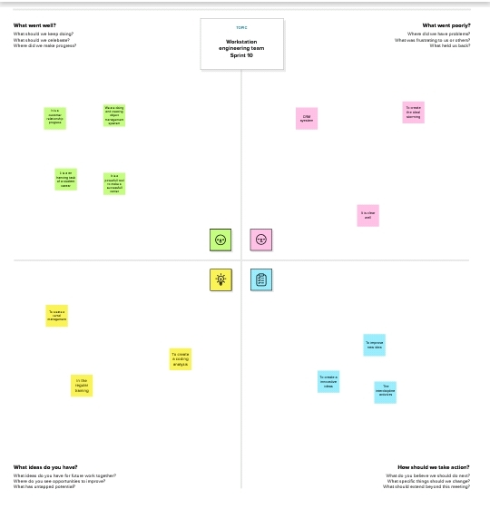

**BRAINSTORMING 2.2 IDEATION AND MAP**

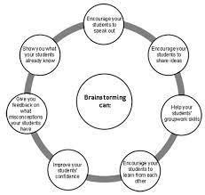

**3 RESUKT**

**3.1. DATA MODEL** ;

|  |  |  |  |  |  |  |  |
| --- | --- | --- | --- | --- | --- | --- | --- |
| OBJECT 1  Passport | |  |  | | --- | --- | | Field Label | Data Type | | Passport | Text | | Passport | Text | |
| OBJECT 2  Visa slots | |  |  | | --- | --- | | Field Label | Data Type | | Location | Text | | Visa slot Number | Text | |
| OBJECT 3  Payment | |  |  | | --- | --- | | Field Label | Data Type | | Payment Mode | Text | | Transaction id | Text | |
| OBJECT 4  Reschedule/cancel | |  |  | | --- | --- | | Field Label | Data Type | | Location | Text | | Cancel | Text | |

**3.2 Activity & Screenshot**

**Activity 1**

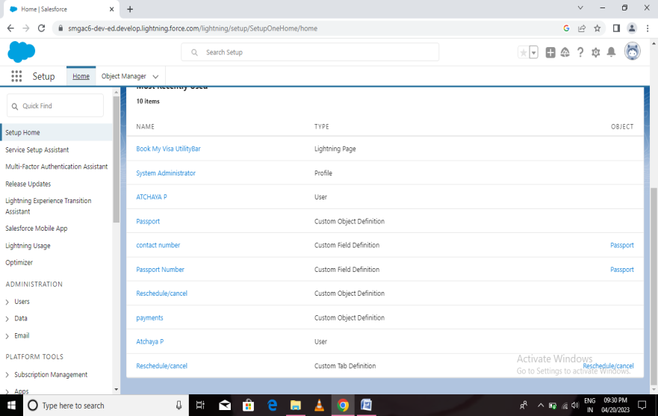

**Description;**

When you create an object, you are creating an instance of a class, therefore "instantiating" a class. The new operator requires a single, postfix argument: a call to a constructor. The name of the constructor provides the name of the class to instantiate. The constructor initializes the new object.

**Activity;2**

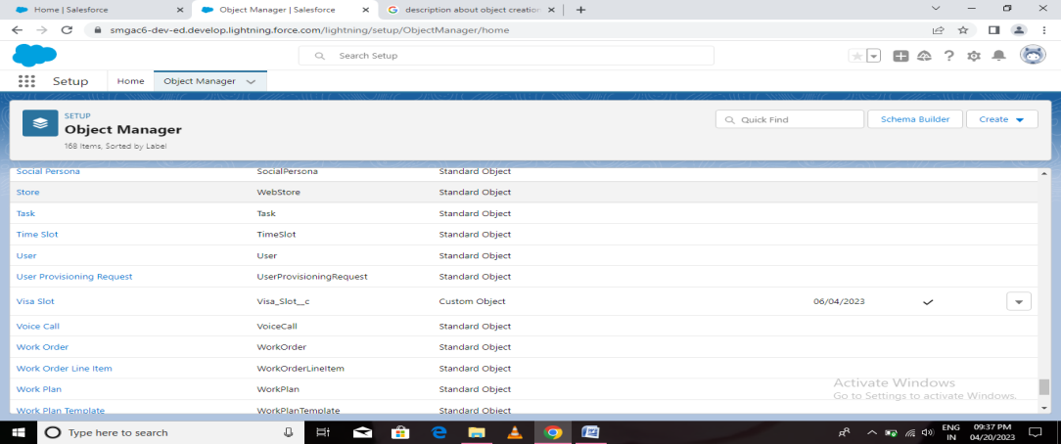

**Description;**

A user account is an identity created for a person in a computer or computing system. User accounts can also be created for machine entities, such as service accounts for running programs, system accounts for storing system files and processes, and root and administrator accounts for system administration

**Activity3**

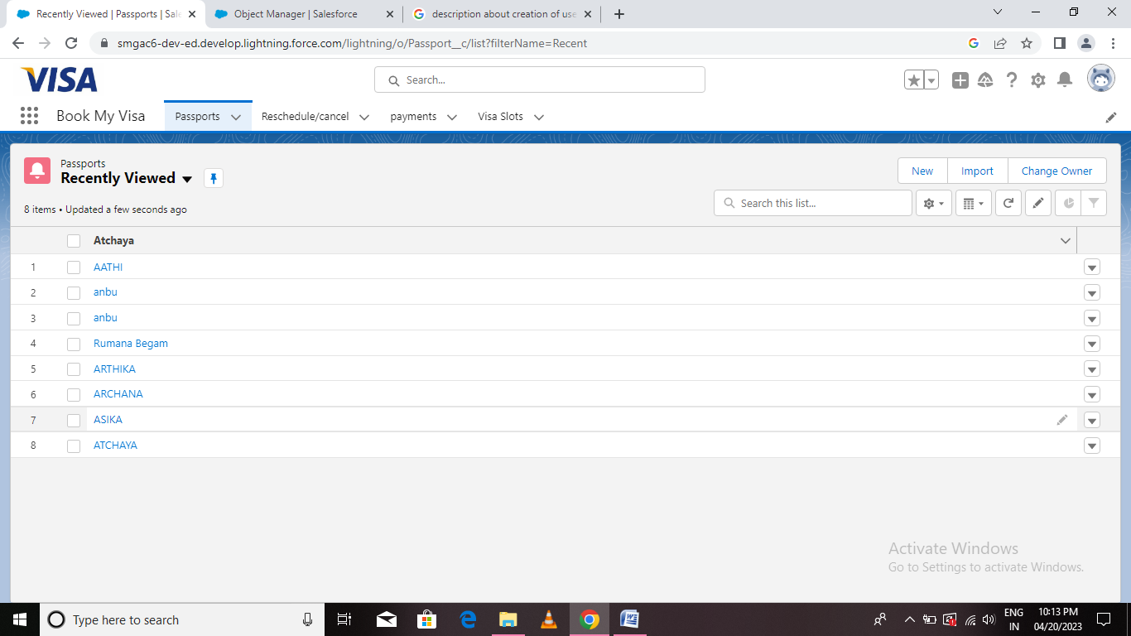

**Description;**

An app is a self-contained software package that allows users to perform specific tasks on a mobile or desktop device. Apps are pre-installed on your device or distributed via a proprietary app store such as the Apple App Store. Apps are typically written in different programming languages.

**Activity 4**

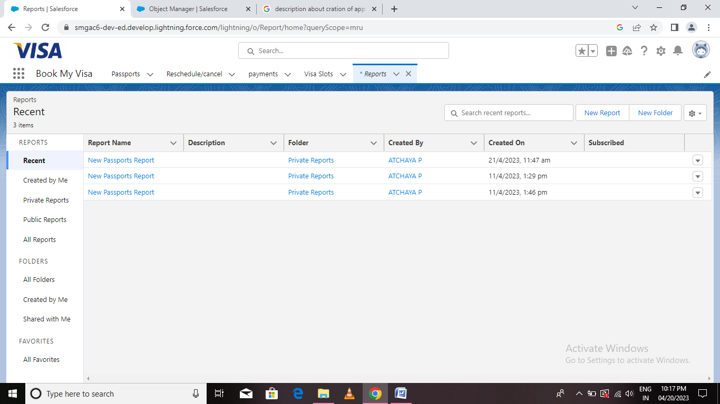

**Description**;

may be delivered orally, complete reports are almost always in the form of written documents. A report is a document that presents information in an organized format for a specific audience and purpose. Although summaries of reports

**4. TRAILHEAD PROFILE PUBLIC URL**

Team Lead-[; https://trailblazer.me/id/atchaya11](;%20https:/trailblazer.me/id/atchaya11)

## Team Member 1-[; https://trailblazer.me/id/archana181](;%20https:/trailblazer.me/id/archana181)

## Team Member 2-; <https://trailblazer.me/id/asika12>

Team Member 3[- https://trailblazer me/id/arthika000](-%20https:/trailblazer%20me/id/arthika000)

**5 ADVANTAGES AND DIS ADVANTAGES**;

**ADVANTAGES**

* CRM software is used to gather customer interactions in one central place to improve customer experience and satisfaction.
* CRM is one of the world’s fastest-growing industries, expected to grow at a rate of 14% between 2021 and 2027.
* The benefits of CRM include better customer retention, increased sales and detailed analytics.
* **This article is for small business owners and marketers who want to learn about the benefits of CRM software for small businesses.**

Customer relationship management (CRM) software has become a near-vital tool for businesses of a to any business, from organizing contacts to automating key tasks. It can also be a centralized, organized hub that enables consistent communication both with customers and within the organization. This is especially important as more organizations shift to remote work.

* with CRM implementation. ...

Poor communication. ... The CRM software market is currently one of the fastest-growing industries.

**DISADVANTAGES**

* CRM costs. One of the greatest challenges to CRM implementation is cost. ...
* Business culture. A lack of commitment or resistance to cultural change from people within the company can cause major difficulties
* Lack of leadership.

**6 APPLLICATION**

Using CRM software, organizations can collect and evaluate customer data. Based on the evaluation results, they can handle marketing campaigns, set prices of their products and services, and manage transactions. It also helps in maintaining good customer relationships.

**7 CONCLUSION**

From this study it can be concluded that the customer relationship management in Company is satisfactory. The company is using various CRM practices like custom ization of the product, maintaining interaction with the customers regularly and providing good quality product etc.

**8 FUTURE SCOPE**

The future of crm that is about which components will be able to plvot to meet the changing needs and trends- drivenby customer expectations.

Customers expect organizations to know a lot about them and expect to have conversations . The ultimate goal of the discipiline of customer relationship management ,and associated CRM systems is efficiency managing and improving business relationships