**WEEK-3**

**Spring Core and Maven**

**Exercise 1: Configuring a Basic Spring Application**

**Scenario:**

**Your company is developing a web application for managing a library. You need to use the Spring Framework to handle the backend operations.**

**Steps:**

1. **Set Up a Spring Project:**
   * **Create a Maven project named LibraryManagement.**
   * **Add Spring Core dependencies in the pom.xml file.**
2. **Configure the Application Context:**
   * **Create an XML configuration file named applicationContext.xml in the src/main/resources directory.**
   * **Define beans for BookService and BookRepository in the XML file.**
3. **Define Service and Repository Classes:**
   * **Create a package com.library.service and add a class BookService.**
   * **Create a package com.library.repository and add a class BookRepository.**
4. **Run the Application:**
   * **Create a main class to load the Spring context and test the configuration.**

**CODE:**

pom.xml

<project xmlns="http://maven.apache.org/POM/4.0.0"

xmlns:xsi="http://www.w3.org/2001/XMLSchema-instance"

xsi:schemaLocation="http://maven.apache.org/POM/4.0.0

http://maven.apache.org/xsd/maven-4.0.0.xsd">

<modelVersion>4.0.0</modelVersion>

<groupId>com.library</groupId>

<artifactId>LibraryManagement</artifactId>

<version>1.0-SNAPSHOT</version>

<dependencies>

<!-- Spring Core -->

<dependency>

<groupId>org.springframework</groupId>

<artifactId>spring-context</artifactId>

<version>5.3.31</version>

</dependency>

</dependencies>

</project>

applicationContext.xml

<?xml version="1.0" encoding="UTF-8"?>

<beans xmlns="http://www.springframework.org/schema/beans"

xmlns:xsi="http://www.w3.org/2001/XMLSchema-instance"

xsi:schemaLocation="http://www.springframework.org/schema/beans

http://www.springframework.org/schema/beans/spring-beans.xsd">

<bean id="bookRepository" class="com.library.repository.BookRepository"/>

<bean id="bookService" class="com.library.service.BookService">

<property name="bookRepository" ref="bookRepository"/>

</bean>

</beans>

BookRepository.java

package com.library.repository;

public class BookRepository {

public String getBookDetails() {

return "Book: Spring in Action by Craig Walls";

}

}

BookService.java

package com.library.service;

import com.library.repository.BookRepository;

public class BookService {

private BookRepository bookRepository;

// Setter for dependency injection

public void setBookRepository(BookRepository bookRepository) {

this.bookRepository = bookRepository;

}

public void displayBook() {

System.out.println(bookRepository.getBookDetails());

}

}

MainApp.java

package com.library;

import org.springframework.context.ApplicationContext;

import org.springframework.context.support.ClassPathXmlApplicationContext;

import com.library.service.BookService;

public class MainApp {

public static void main(String[] args) {

ApplicationContext context = new ClassPathXmlApplicationContext("applicationContext.xml");

BookService bookService = (BookService) context.getBean("bookService");

bookService.displayBook();

}

}

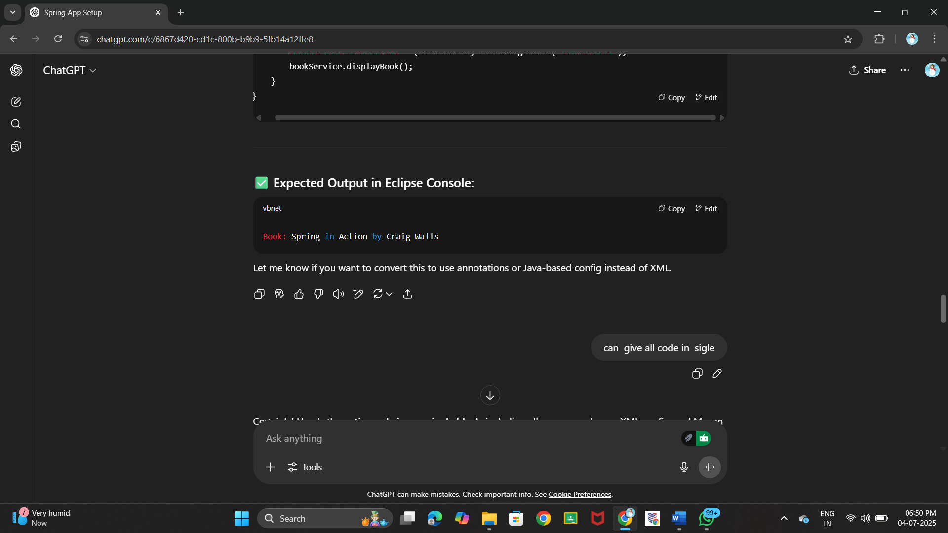**OUTPUT:**

**Exercise 2: Implementing Dependency Injection**

**Scenario:**

**In the library management application, you need to manage the dependencies between the BookService and BookRepository classes using Spring's IoC and DI.**

**Steps:**

1. **Modify the XML Configuration:**
   * **Update applicationContext.xml to wire BookRepository into BookService.**
2. **Update the BookService Class:**
   * **Ensure that BookService class has a setter method for BookRepository.**
3. **Test the Configuration:**
   * **Run the LibraryManagementApplication main class to verify the dependency injection.**

**CODE:**

pom.xml

<project xmlns="http://maven.apache.org/POM/4.0.0"

xmlns:xsi="http://www.w3.org/2001/XMLSchema-instance"

xsi:schemaLocation="http://maven.apache.org/POM/4.0.0

http://maven.apache.org/xsd/maven-4.0.0.xsd">

<modelVersion>4.0.0</modelVersion>

<groupId>com.library</groupId>

<artifactId>LibraryManagement</artifactId>

<version>1.0-SNAPSHOT</version>

<dependencies>

<!-- Spring Core Dependency -->

<dependency>

<groupId>org.springframework</groupId>

<artifactId>spring-context</artifactId>

<version>5.3.31</version>

</dependency>

</dependencies>

</project>

applicationContext.xml

<?xml version="1.0" encoding="UTF-8"?>

<beans xmlns="http://www.springframework.org/schema/beans"

xmlns:xsi="http://www.w3.org/2001/XMLSchema-instance"

xsi:schemaLocation="http://www.springframework.org/schema/beans

http://www.springframework.org/schema/beans/spring-beans.xsd">

<!-- BookRepository Bean -->

<bean id="bookRepository" class="com.library.repository.BookRepository"/>

<!-- BookService Bean with Setter Injection -->

<bean id="bookService" class="com.library.service.BookService">

<property name="bookRepository" ref="bookRepository"/>

</bean>

</beans>

BookRepository.java

package com.library.repository;

public class BookRepository {

public String getBookDetails() {

return "Book: Spring in Action by Craig Walls";

}

}

BookService.java

package com.library.service;

import com.library.repository.BookRepository;

public class BookService {

private BookRepository bookRepository;

// Setter method for Dependency Injection

public void setBookRepository(BookRepository bookRepository) {

this.bookRepository = bookRepository;

}

public void displayBook() {

System.out.println(bookRepository.getBookDetails());

}

}

LibraryManagementApplication.java

package com.library;

import org.springframework.context.ApplicationContext;

import org.springframework.context.support.ClassPathXmlApplicationContext;

import com.library.service.BookService;

public class LibraryManagementApplication {

public static void main(String[] args) {

ApplicationContext context = new ClassPathXmlApplicationContext("applicationContext.xml");

BookService bookService = (BookService) context.getBean("bookService");

bookService.displayBook();

}

}

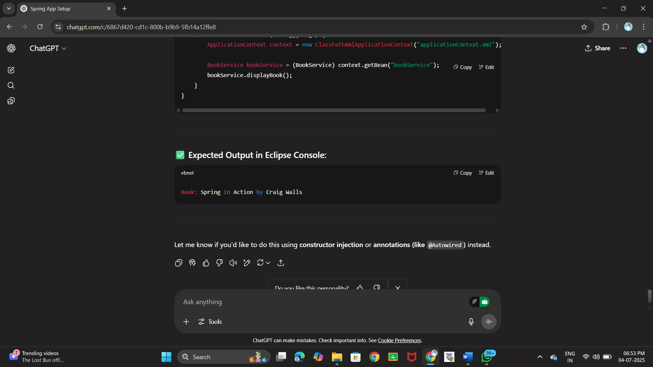**OUTPUT:**

**Exercise 4: Creating and Configuring a Maven Project**

**Scenario:**

**You need to set up a new Maven project for the library management application and add Spring dependencies.**

**Steps:**

1. **Create a New Maven Project:**
   * **Create a new Maven project named LibraryManagement.**
2. **Add Spring Dependencies in pom.xml:**
   * **Include dependencies for Spring Context, Spring AOP, and Spring WebMVC.**
3. **Configure Maven Plugins:**
   * **Configure the Maven Compiler Plugin for Java version 1.8 in the pom.xml file.**

**CODE:**

pom.xml

<project xmlns="http://maven.apache.org/POM/4.0.0"

xmlns:xsi="http://www.w3.org/2001/XMLSchema-instance"

xsi:schemaLocation="http://maven.apache.org/POM/4.0.0

http://maven.apache.org/xsd/maven-4.0.0.xsd">

<modelVersion>4.0.0</modelVersion>

<groupId>com.library</groupId>

<artifactId>LibraryManagement</artifactId>

<version>1.0-SNAPSHOT</version>

<properties>

<maven.compiler.source>1.8</maven.compiler.source>

<maven.compiler.target>1.8</maven.compiler.target>

</properties>

<dependencies>

<!-- Spring Context -->

<dependency>

<groupId>org.springframework</groupId>

<artifactId>spring-context</artifactId>

<version>5.3.31</version>

</dependency>

<!-- Spring AOP -->

<dependency>

<groupId>org.springframework</groupId>

<artifactId>spring-aop</artifactId>

<version>5.3.31</version>

</dependency>

<!-- Spring Web MVC -->

<dependency>

<groupId>org.springframework</groupId>

<artifactId>spring-webmvc</artifactId>

<version>5.3.31</version>

</dependency>

<!-- Servlet API (required for Spring MVC only at compile time) -->

<dependency>

<groupId>javax.servlet</groupId>

<artifactId>javax.servlet-api</artifactId>

<version>4.0.1</version>

<scope>provided</scope>

</dependency>

</dependencies>

<build>

<plugins>

<!-- Compiler Plugin for Java 8 -->

<plugin>

<groupId>org.apache.maven.plugins</groupId>

<artifactId>maven-compiler-plugin</artifactId>

<version>3.8.1</version>

<configuration>

<source>1.8</source>

<target>1.8</target>

</configuration>

</plugin>

</plugins>

</build>

</project>

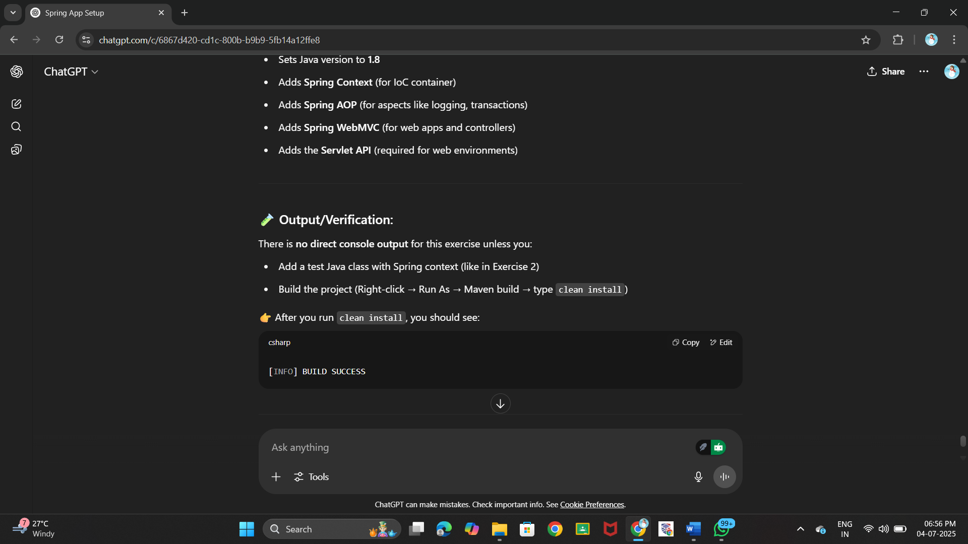**OUTPUT:**