**WEEK-1**

**Data Structures Algorithms**

**Exercise 2: E-commerce Platform Search Function**

**Main.java**

import java.util.Arrays;

import java.util.Comparator;

import java.util.Scanner;

class Product {

int productId;

String productName;

String category;

public Product(int productId, String productName, String category) {

this.productId = productId;

this.productName = productName;

this.category = category;

}

@Override

public String toString() {

return "Product[ID=" + productId + ", Name=" + productName + ", Category=" + category + "]";

}

}

public class Main {

public static Product linearSearch(Product[] products, String targetName) {

for (Product product : products) {

if (product.productName.equalsIgnoreCase(targetName)) {

return product;

}

}

return null;

}

public static Product binarySearch(Product[] products, String targetName) {

int low = 0;

int high = products.length - 1;

while (low <= high) {

int mid = (low + high) / 2;

int compare = products[mid].productName.compareToIgnoreCase(targetName);

if (compare == 0) {

return products[mid];

} else if (compare < 0) {

low = mid + 1;

} else {

high = mid - 1;

}

}

return null;

}

public static void main(String[] args) {

Scanner scanner = new Scanner(System.in);

Product[] products = {

new Product(1, "Laptop", "Electronics"),

new Product(2, "Shampoo", "Health"),

new Product(3, "Keyboard", "Electronics"),

new Product(4, "Chair", "Furniture")

};

Arrays.sort(products, Comparator.comparing(p -> p.productName.toLowerCase()));

System.out.print("Enter product name to search: ");

String searchName = scanner.nextLine();

Product resultLinear = linearSearch(products, searchName);

if (resultLinear != null) {

System.out.println("Linear Search Result: " + resultLinear);

} else {

System.out.println("Linear Search Result: Product not found.");

}

Product resultBinary = binarySearch(products, searchName);

if (resultBinary != null) {

System.out.println("Binary Search Result: " + resultBinary);

} else {

System.out.println("Binary Search Result: Product not found.");

}

scanner.close();

}

}

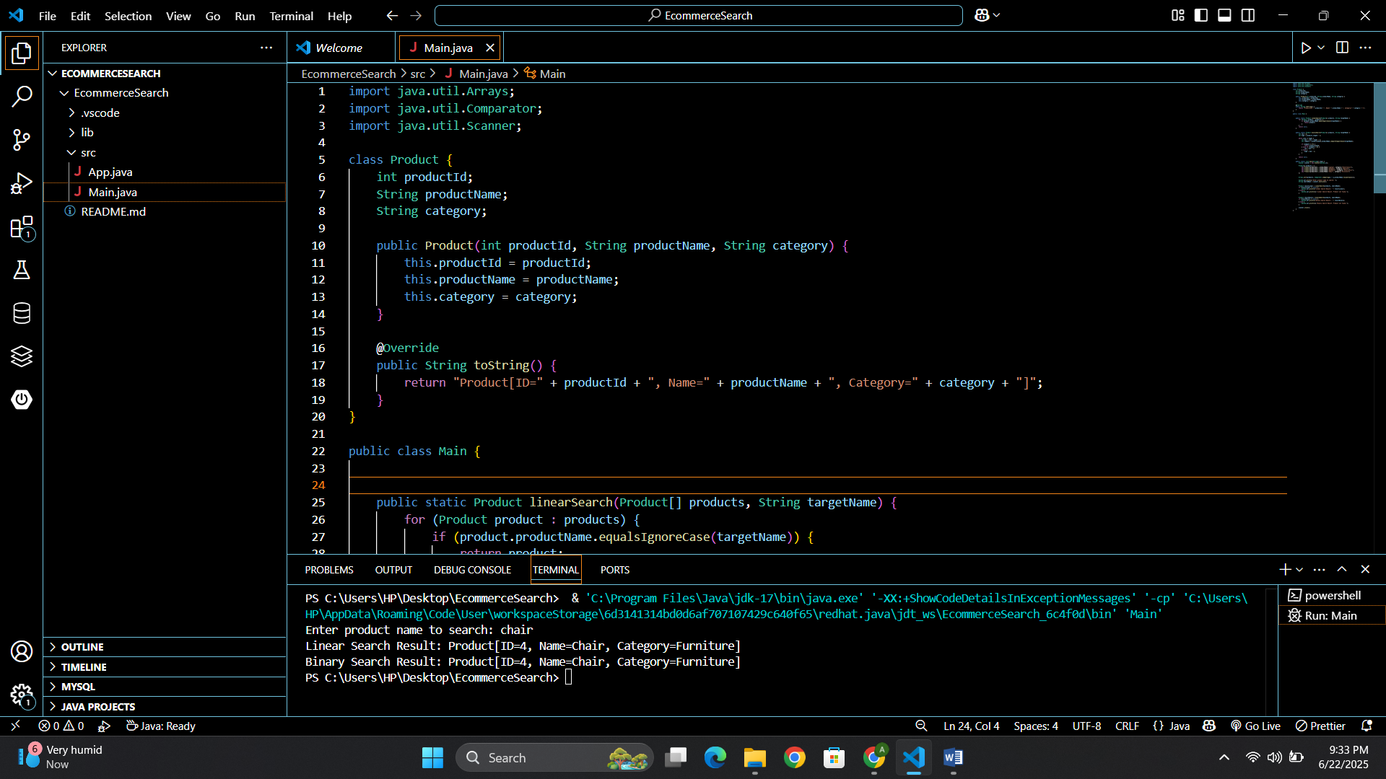

­

**Exercise 7: Financial Forecasting**

**Main.java**

import java.util.Scanner;

public class FinancialForecast {

public static double calculateFutureValue(double initialValue, double growthRate, int years) {

if (years == 0) {

return initialValue;

}

return calculateFutureValue(initialValue, growthRate, years - 1) * (1 + growthRate);

}

public static void main(String[] args) {

Scanner scanner = new Scanner(System.in);

System.out.print("Enter initial investment amount (INR): ");

double initialValue = scanner.nextDouble();

System.out.print("Enter annual growth rate (in %): ");

double ratePercent = scanner.nextDouble();

double growthRate = ratePercent / 100.0;

System.out.print("Enter number of years: ");

int years = scanner.nextInt();

double futureValue = calculateFutureValue(initialValue, growthRate, years);

System.out.printf("Future Value after %d years: INR %.2f%n", years, futureValue);

scanner.close();

}

}

