**Prerequisites**

**Appendix A:**

WHAT’S IN THIS APPENDIX

◆Installing the Anaconda distribution

◆Setting up a Python environment

◆Setting up Jupyter Notebook

In this appendix, you learn to install Anaconda Navigator on your computer, set up a Python

environment that includes several common machine learning libraries, and configure Jupyter Notebook.

Installing the Anaconda Distribution

Anaconda is a Python distribution (prebuilt and preconfigured collection of packages) that is commonly used for data science. The Anaconda distribution includes the Conda package manager in addition to the preconfigured Python packages and other tools. The Conda package manager can be used from the command line to set up Python environments and install additional packages that come with the default Anaconda distribution.

Anaconda Navigator is a GUI tool that is included in the Anaconda distribution and makes it easy to configure, install, and launch tools such as Jupyter Notebook. Although we use the Anaconda Navigator in this book, keep in mind that you can do everything through the command line using the conda command.

To begin the Anaconda Navigator installation process, visit <https://www.anaconda.com>

And On the Downloads page, locate the download link for a version that includes Python 3.7 or higher. Click the Download link to download the installer for your operating system. Locate the installer on your computer’s download folder and launch it to begin the installation process .

At some point in the installation process, you may be asked if you want to install an IDE such as Microsoft Visual Studio Code or JetBrain PyCharm . Installing an IDE is optional, and in this book we do not use any third-party IDE. If you want to install a third-partyIDE, you can do so either during the Anaconda distribution installation process or later from the Anaconda Navigator user interface.

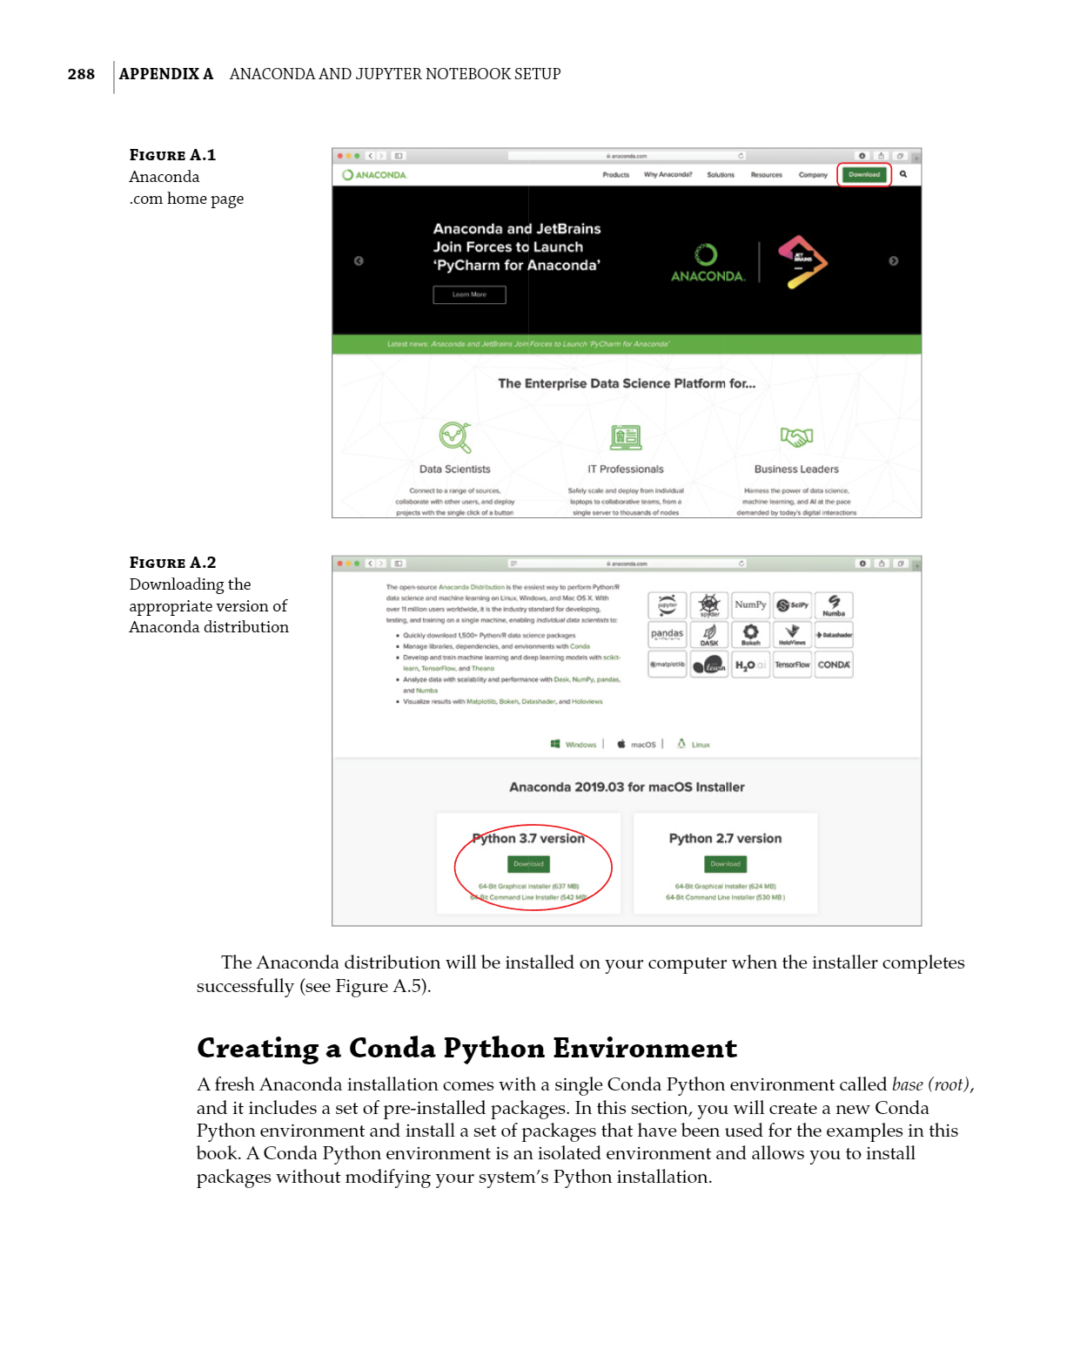

Anaconda and Jupyter Notebook Setup

Machine Learning for iOS Developers, First Edition. Abhishek Mishra.

© 2020 John Wiley & Sons, Inc. Published 2020 by John Wiley & Sons, Inc.

The Anaconda distribution will be installed on your computer when the installer completes successfully packages without modifying your system’s Python installation.

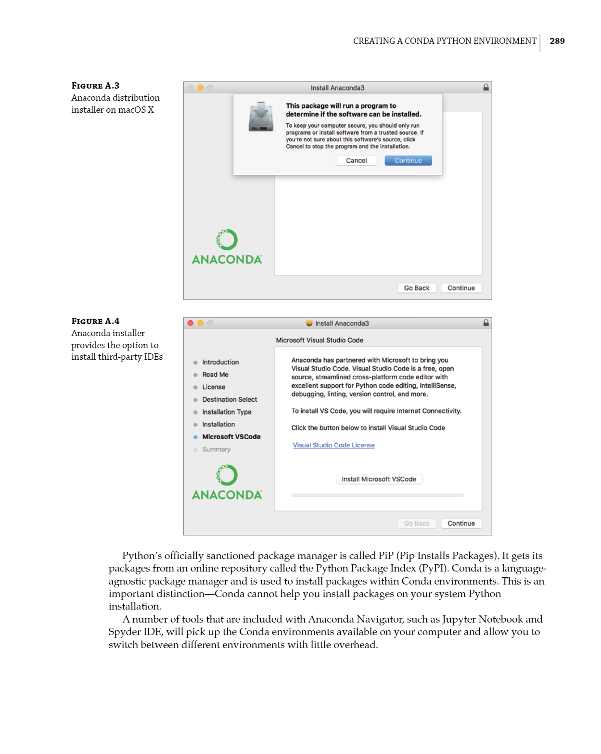

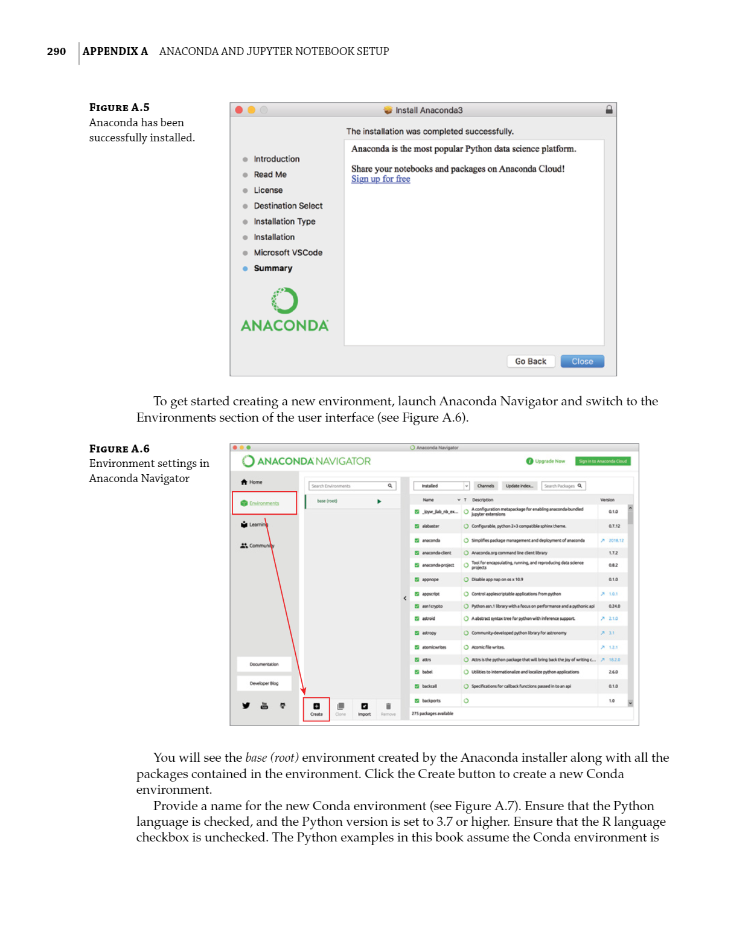



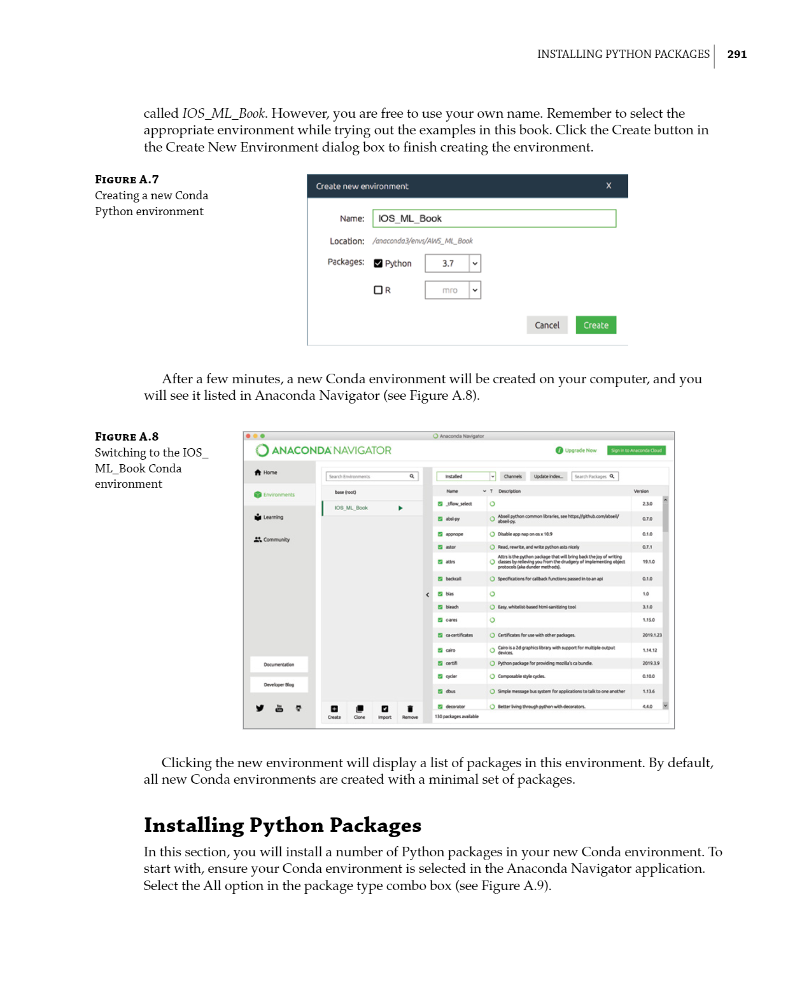

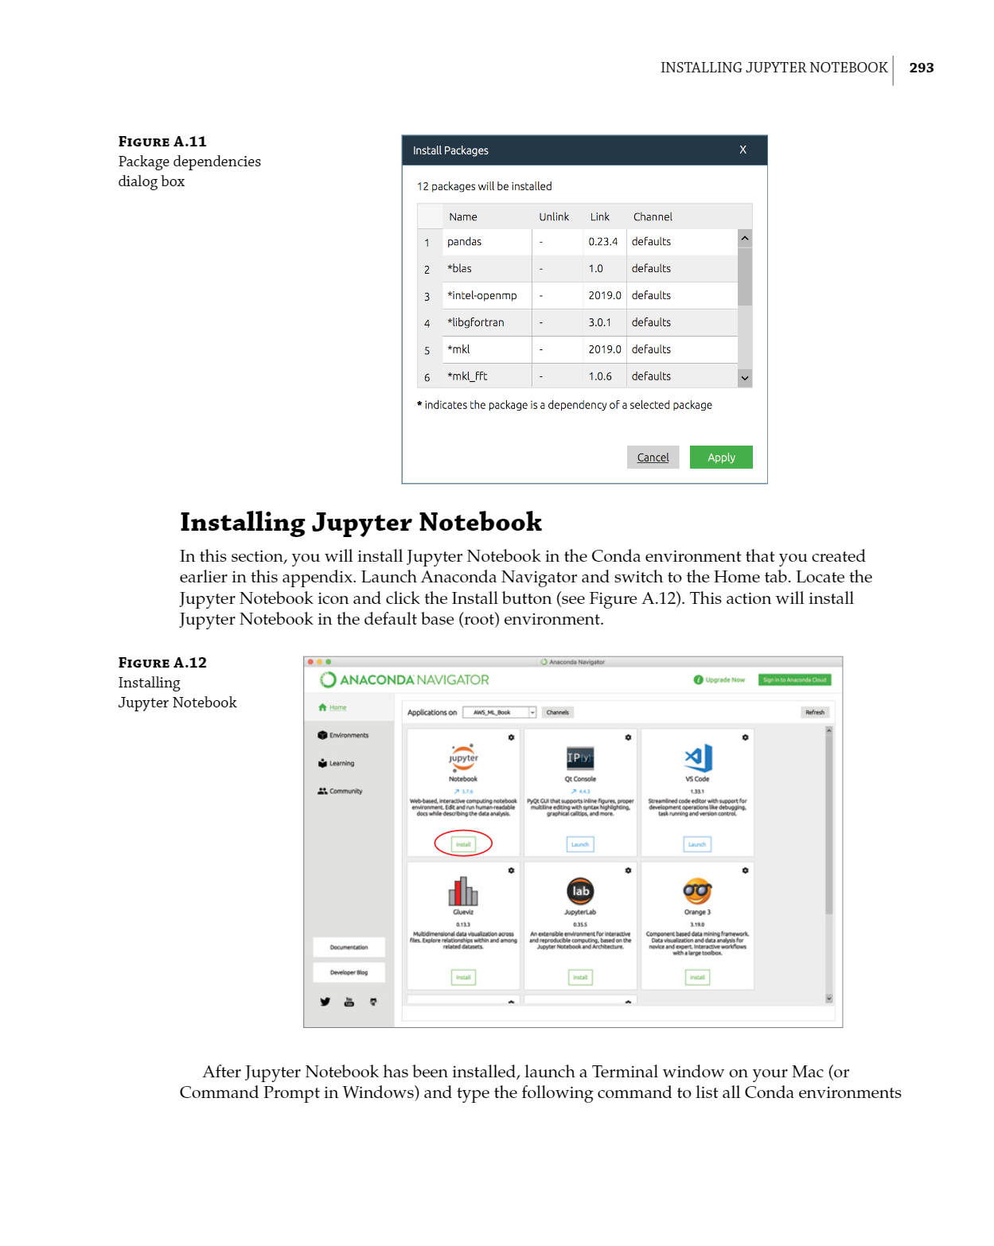

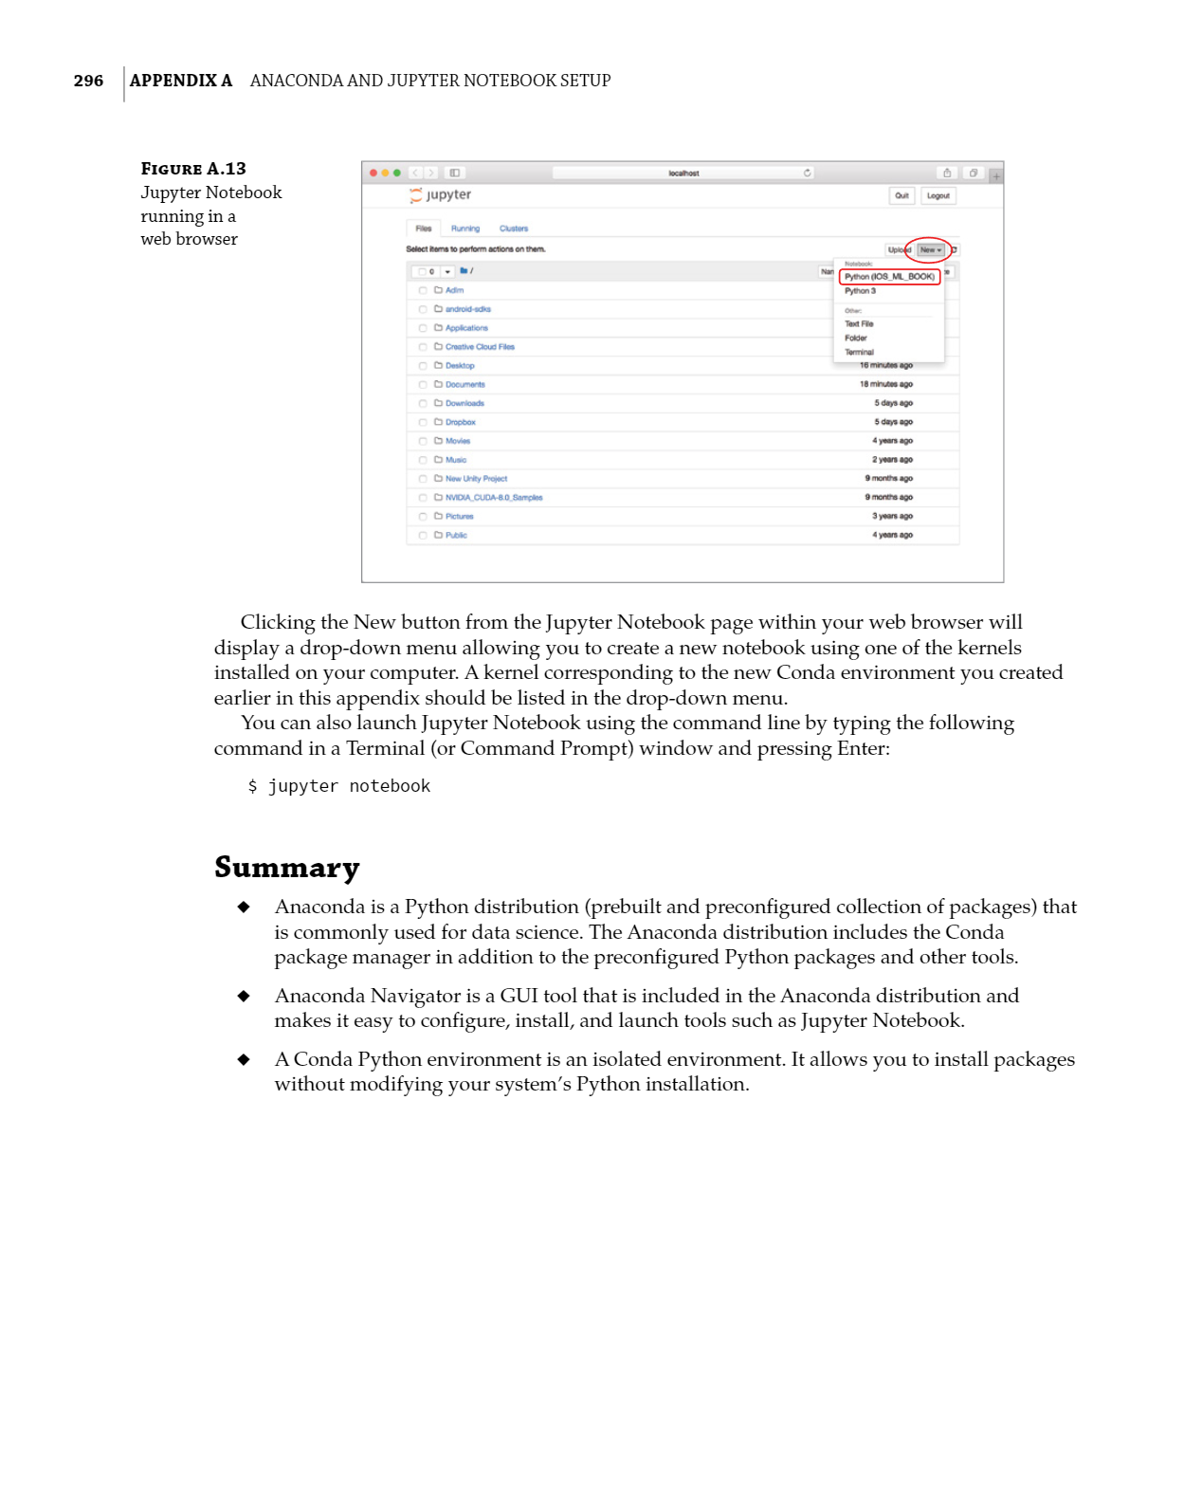

REQUIRE PACKAGES :

Sklearn :

Scikit-learns is a library in python that provides many unsupervised and supervised learning algorithms.

Numpy:

Numpy is a python package that stands for ‘numerical python’.it is the core library for scientific computing , which contains a powerful n-dimensional array object.

Pandas:

Pandas is a fast , powerful, flexible, and easy to use open source data analysis and manipulation tool, built on top of the python programming.

Matplotlib:

It provides an object –oriented API for embedding plots into applications using general purpose GUI toolkits.

Flask:

* Flask is a micro framework for python.
* Easy to code
* Easy to configure
* Flask won’t make any decisions for you, such as what database to use.
* Has an excellent documentation.
* RESTful
* Testable