Atchison Active 55 SMA 31 August 2025

|  |  |  |  |  |  |
| --- | --- | --- | --- | --- | --- |
|  | 3 Months | 6 Months | 1 Year | 2 Years (p.a.) | Since Inception (p.a.) |
| Atchison55ACTIVE | **3.5** | **4.77** | **9.39** | **10.24** | **10.9** |
| Peer Group | 3.51 | 4.73 | 8.74 | 9.15 | 9.14 |
| Inflation | -0.38 | 0.74 | 1.9 | 2.28 | 2.42 |
| Outperformance vs Peers | -0.01 | 0.04 | 0.65 | 1.09 | 1.76 |
| Outperformance vs Inflation | 3.88 | 4.03 | 7.49 | 7.96 | 8.49 |

Inception Date: 31 December 2022

Investment Objective

Outperform the FE AMI Mixed Asset – Balanced Peer Index, after underlying manager fees and before tax, over rolling seven-year periods.

Strategy Overview

Atchison Active 55 Portfolio is a Separately Managed Account (SMA), which is an all-inclusive diversified, multi-asset, investment portfolio professionally managed for you (the client) on behalf of a financial advisor. This portfolio is made up of 55% growth assets, and 45% defensive assets and uses a combination of passive ETFs and active managers. Asset classes include Australian Shares, Global Shares, Alternatives, Floating Rate, Long Duration, Real Assets and Cash.

|  |  |
| --- | --- |
| Key Details |  |
| Strategy Category | Multi Asset |
| Strategy Provider | Atchison |
| Benchmark | FE AMI Mixed Asset – Balanced Peer Index |
| Inception Date | 31 December 2022 |
| Investment Horizon | 7 Years |
| Risk Level (SRM) | Medium |
| Min Investment | 25k |
| Product Fee | Platform Specific - Refer to PDS |
| Underlying MER | 0.42% |
| Underlying Perf Fees | 0.07% |

Top 10 Share Exposures

|  |  |
| --- | --- |
| **Code** | **Name** |
| MSFT.NAS | MICROSOFT CORP |
| AAPL.NAS | APPLE INC |
| BHP-AU | BHP Group Limited |
| NVDA.NAS | NVIDIA CORP |
| CBA-AU | Commonwealth Bank of Australia |
| AMZN.NAS | AMAZON COM INC |
| META.NAS | META PLATFORMS INC CLASS A |
| CSL-AU | CSL Limited |
| LLY.NYS | ELI LILLY |
| GOOG.NAS | ALPHABET INC CLASS C |

Strategy Performance

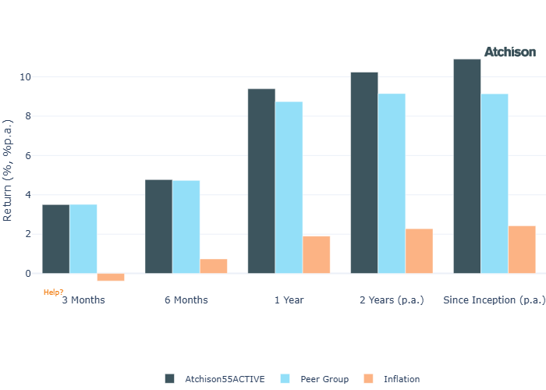

Cumulative Performance Since Inception

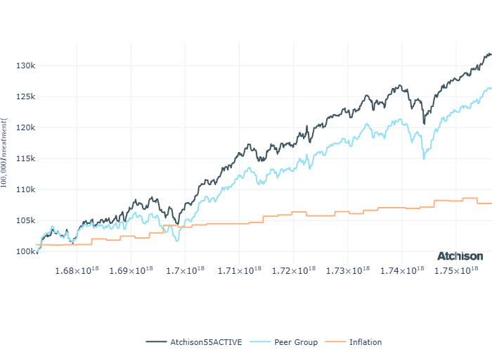

Portfolio Allocations

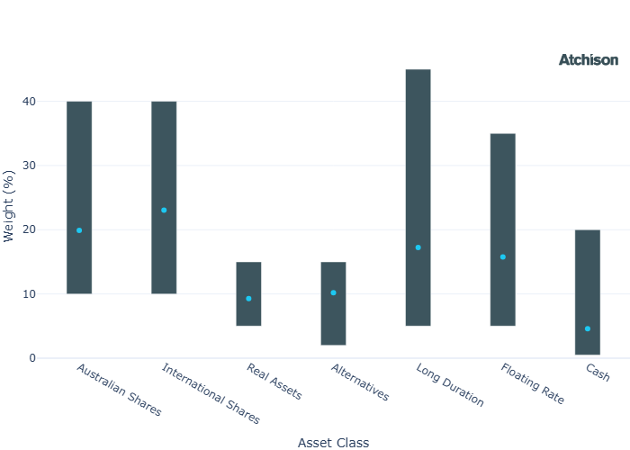

Asset Class Performance

|  |  |  |
| --- | --- | --- |
| **Period** | **1 Year** | **2 Years (p.a.)** |
| Australian Shares | 14.75 | 13.82 |
| International Shares | 13.3 | 16.39 |
| Real Assets | 6.63 | 9.9 |
| Alternatives | 10.41 | 9.73 |
| Long Duration | 3.4 | 4.26 |
| Floating Rate | 4.95 | 5.97 |
| Cash | 4.37 | 4.43 |

Inception Date: 31 December 2022

Portfolio Construction

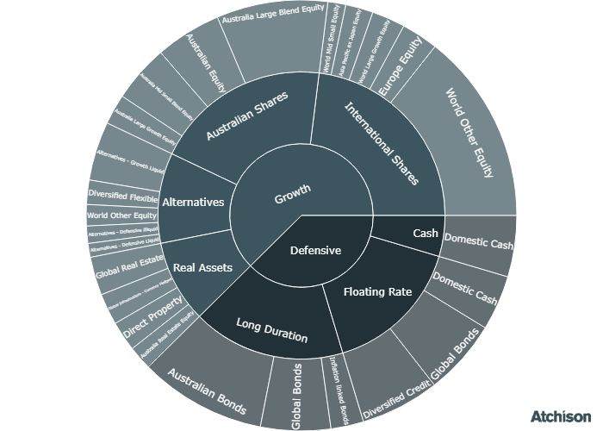

Correlations

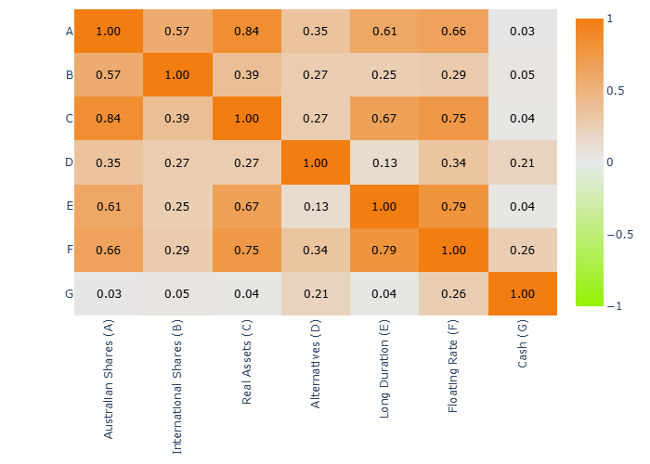

Historical Allocation Changes

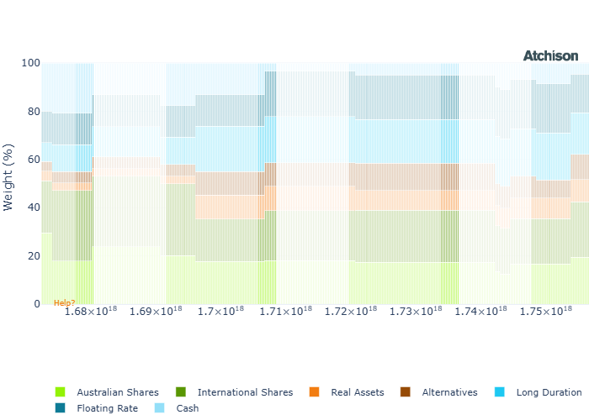

Underlying Current Manager Performance

|  |  |  |
| --- | --- | --- |
| **Strategy** | **1 Year** | **2 Years (p.a.)** |
| iShares ASX 200 | 14.79 | 14.72 |
| Merlon Conentated AusEq | 13.17 | 12.46 |
| Ausbil Aus Small | 43.63 | 34.48 |
| Invesco Aus Small | 21.67 | 17.83 |
| Greencape High Convic | 6.37 | 11.2 |
| Hyperion Aus Growth | 8.04 | 16.81 |
| Invesco WS Aus Share | 15.28 | 15.95 |
| **BM: Australian Shares** | **14.66** | **14.68** |
| iShares US 500 | 21.92 | 20.73 |
| iShares US 500 Hedged | 16.14 | 19.59 |
| VG Europe Eq | 18.45 | 15.52 |
| GQG Global Eq | -2.88 | 11.19 |
| Man GLG Asia | 26.79 | 18.43 |
| Fairlight Glob Small Mid | 8.02 | 10.47 |
| **BM: International Shares** | **20.47** | **18.75** |
| iShares AREIT | 12.62 | 18.67 |
| iShares GREIT | 0.21 | 7.72 |
| Alceon Aus Prop & Infra | 8.56 | 8.25 |
| CB RARE Infra Income H | 10.32 | 11.27 |
| **BM: Real Assets** | **5.5** | **9.96** |
| VE Global Listed P Private ETF | 19.99 | 23.92 |
| Talaria GE | 5.36 | 5.48 |
| P/E FX Alpha | -0.77 | -0.7 |
| Invesco Senior Secured | 5.15 | 5.99 |
| Pyford Global Abs | 8.48 | 8.31 |
| iShares Physical Gold | 40.92 | 28.72 |
| Barwon LPE | 6.33 | 15.85 |
| **BM: Alternatives** | **4.34** | **4.42** |
| iShares Aus Bond | 4.15 | 4.69 |
| iShares CPI Bond | 1.73 | 2.97 |
| iShares Globa Agg ESG | 2.37 | 4.19 |
| WA Aus Bond | 4.44 | 5.13 |
| Colchester Gov Bond | 2.91 | 3.56 |
| **BM: Duration** | **3.46** | **4.4** |
| VanEck FRN | 5.28 | 5.21 |
| iShares Enh Cash | 4.46 | 4.53 |
| Janus Div Credit | 6.81 | 7.04 |
| Daintree Core Inc | 6.07 | 7.26 |
| Bentham Global Inc | 2.74 | 6.79 |
| **BM: Floating** | **5.05** | **5.21** |
| iShares Cash | 4.35 | 4.41 |
| Cash | 4.34 | 4.42 |

Inception Date: 31 December 2022

Underlying investment manager returns are shown after fees and before tax

Market Update

August delivered broad gains across global equities and bonds, driven by actual and expected rate cuts.  
  
9 of 11 S&P/ASX 200 sectors advanced, with Materials and Consumer Discretionary leading gains. Meanwhile Health Care fell 13% due to a CSL sell-off following its spinoff announcement. Information Technology remained under pressure.  
  
Value, Equal Weight, and High Dividend each rose 6%. Growth lagged as the weakest performer year-to-date.  
  
Chinese equities outperformed, as onshore markets rebounded and narrowed the gap with offshore stocks.  
  
U.S. equities recorded a fourth consecutive month of gains, with the S&P 500 rising 2% in August, despite a sharp final-day sell-off. Market sentiment was supported by optimism around potential Federal Reserve rate cuts and continued strength in Big Tech.  
  
The rally broadened across market segments, with mid- and small-cap stocks outperforming large caps.  
  
Most sectors posted positive returns, led by Materials and Health Care; Health Care recovered losses from July. Utilities was the only sector to decline.  
  
European equities gained for the month, extending their positive run for the quarter. Sector leaders were Health Care (+4%+) and Consumer Staples (+3%+). Information Technology, Utilities, and Industrials posted modest losses of under 2%, not enough to offset the index’s overall gains.  
  
US fixed income indices all posted gains amid fluctuating yields and shifting rate expectations.  
  
The Reserve Bank of Australia and Reserve Bank of New Zealand each reduced key rates by 25bps..  
  
Commodities participated in the rally, led by Livestock. Precious Metals strengthened, with Gold reaching another record high, driven by renewed safe-haven demand.

Fine Print

Important Notice: This document is published by TAG Asset Consulting Group Pty Ltd, trading as Atchison Consultants, ABN 58 097 703 047, AFSL 230 846. Atchison Consultants distributes its investment solutions via platform and dealer groups (financial advisory groups).

Warning: Please be advised that past performance is not indicative of future performance. The returns discussed herein are based on model asset allocations and are for illustrative purposes only. Actual returns may differ due to variations in fees, timing of model change implementation, and the need to substitute individual holdings where reliable data was not available from our data providers. Any insights or recommendations provided in this document are intended for general advice purposes only and are based on our opinion of the investment merits of the financial products discussed, independent of the financial circumstances of any individual. Before proceeding with any investment based on the information provided, recipients must assess its suitability to their financial situation and consider seeking advice from an independent financial advisor.

Disclaimer: While care is taken to ensure the accuracy and completeness of the information presented herein, no warranties or representations are made as to its reliability. The content provided is derived from publicly available sources, or external data providers, which have not been independently verified by Atchison Consultants. Atchison Consultants, along with its directors, officers, employees, and agents, expressly disclaims any liability for errors, inaccuracies, or omissions in this document, as well as for any loss or damage that may arise from reliance on its contents. Readers are cautioned to verify all information independently before taking any actions based on this report.