Atchison Active Alternatives SMA 31 May 2025

|  |  |  |  |  |  |
| --- | --- | --- | --- | --- | --- |
|  | 3 Months | 6 Months | 1 Year | 2 Years (p.a.) | Since Inception (p.a.) |
| AtchisonAlts | **0.15** | **4.3** | **10.5** | **9.26** | **7.93** |
| Peer Group | -0.39 | -0.13 | 1.8 | 5.22 | 5.72 |
| Inflation | 1.2 | 1.5 | 2.21 | 3.1 | 2.87 |
| Outperformance vs Peers | 0.54 | 4.43 | 8.69 | 4.05 | 2.21 |
| Outperformance vs Inflation | -1.05 | 2.8 | 8.29 | 6.17 | 5.06 |

Inception Date: 31 December 2022

Investment Objective

Outperform the RBA Cash Rate, after underlying manager fees and before tax, over rolling five-year periods.

Strategy Overview

The Atchison Active Alternatives Portfolio offers an all-in-one solution for your alternative asset class exposure. This solution invests across a broad spectrum of liquid alternatives which may include, listed private equity, buy-write, commodities, hedge funds, currency alpha, macro discretionary, venture capital, risk mitigation, distressed and private credit.

|  |  |
| --- | --- |
| Key Details |  |
| Strategy Category | Alternatives |
| Strategy Provider | Atchison |
| Benchmark | RBA Cash Rate |
| Inception Date | 31 December 2022 |
| Investment Horizon | 10 Years |
| Risk Level (SRM) | High |
| Min Investment | 5k |
| Product Fee | Platform Specific - Refer to PDS |
| Underlying MER | 0.79% |
| Underlying Perf Fees | 0.09% |

Strategy Performance

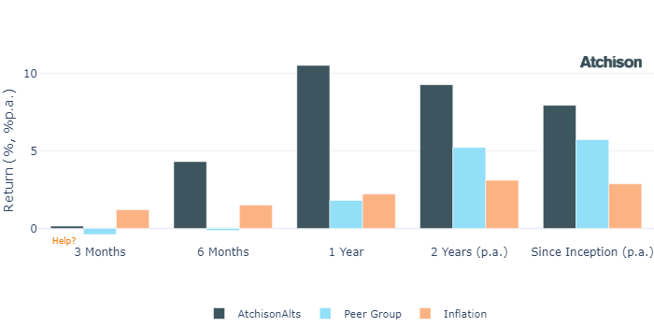

Cumulative Performance Since Inception

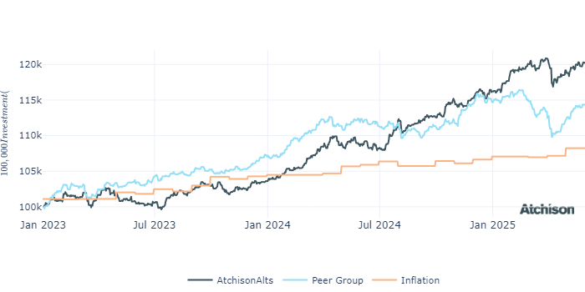

Portfolio Allocations

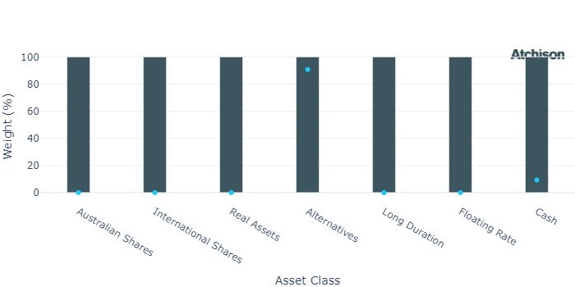

Portfolio Construction

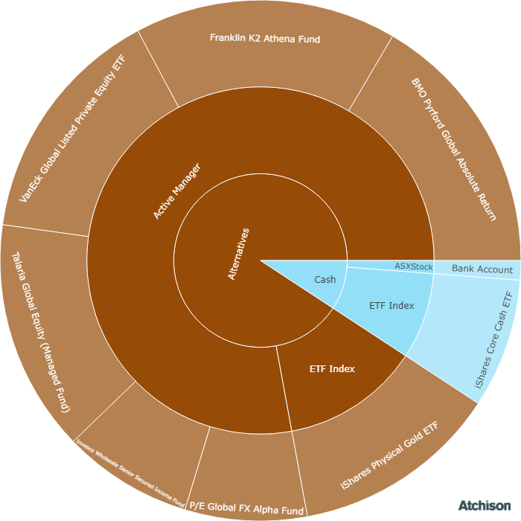

Correlations

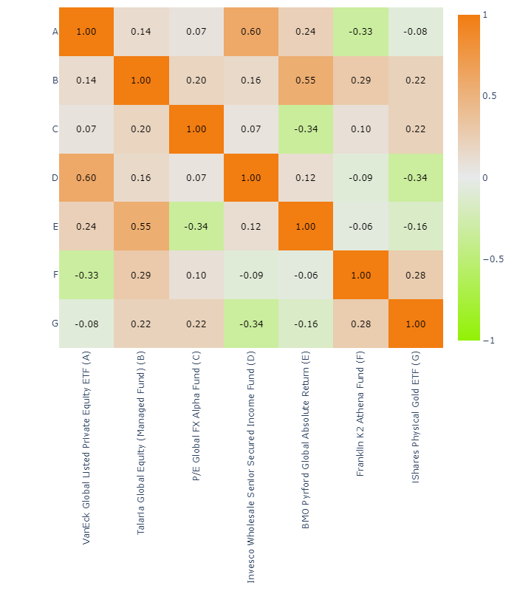

Underlying Manager Performance

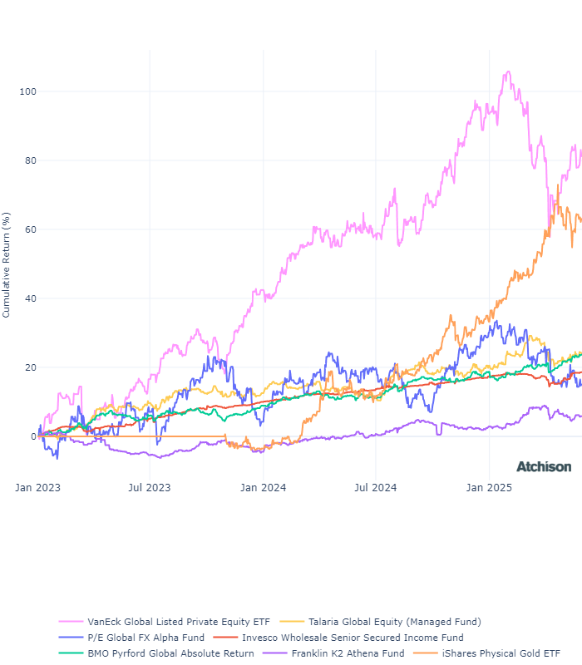

|  |  |  |
| --- | --- | --- |
| **Strategy** | **1 Year** | **2 Years (p.a.)** |
| VE Global Listed P Private ETF | 13.1 | 26.27 |
| Talaria GE | 10.41 | 6.76 |
| P/E FX Alpha | -2.09 | 2.32 |
| Invesco Senior Secured | 5.13 | 7.08 |
| Pyford Global Abs | 11.36 | 8.24 |
| K2 Athena | 4.49 | 5.66 |
| iShares Physical Gold | 44.82 | 27.65 |
| **BM: Alternatives** | **4.51** | **4.47** |
| iShares Cash | 4.56 | 4.46 |
| Cash | 4.51 | 4.47 |

Inception Date: 31 December 2022

Underlying investment manager returns are shown after fees and before tax

Market Update

Smaller companies outperformed their broader counterparts, with the Small Ordinaries rising 6%, whilst the ASX 200 advanced 4%<  
  
All sectors within the ASX 200 recorded gains. Information Technology led with a 20% jump, followed by Energy at 9%, while traditionally defensive sectors - Utilities, Consumer Staples, and Health Care lagged.  
  
All Australian factor indices ended the month in positive territory. Momentum, Equal Weight, and Growth factors outpaced others, whereas High Dividend and Value underperformed, echoing sector-level trends.  
  
China’s equity markets posted solid gains in May 2025, supported by tech earnings and fresh monetary easing, including rate and reserve ratio cuts. However, mixed economic data and external pressures, such as weaker U.S. exports, highlight ongoing structural and geopolitical challenges.  
  
U.S. equities staged a strong rebound in May, driven by renewed optimism over easing trade tensions. The S&P 500 rose 6%, marking its best May performance since 1990. Solid earnings from major technology firms also propelled the rally.   
  
Most sectors registered gains, led by Information Technology and Communication Services, which rose 11% and 10% respectively. Health Care was the notable underperformer.  
  
Risk appetite continued to improve, with Momentum, High Beta, and Growth factors leading for the second consecutive month, reflecting a continued rotation away from defensiveness.  
  
European equities maintained their positive trajectory, with the European Index gaining approximately 11% year-to-date, outperforming the U.S. market. This performance was supported by easing trade tensions and investor optimism.  
  
In May, the RBA cut rates for the second time this year, and delivered a dovish outlook, but Australian bond yields still rose, driven by global market forces including rising yields in the U.S. and Japan.  
  
U.S. Treasury yields rose sharply following a weak 20-year note auction and persistent fiscal concerns. As a result, the U.S. Treasury Bond Index declined by 1% in May, its first monthly loss of the year.  
  
Within commodities, Energy and Livestock were standout performers. Meanwhile, safe-haven demand for Gold was mixed, leading to slight underperformance in Precious Metals over the month.

Fine Print

Important Notice: This document is published by TAG Asset Consulting Group Pty Ltd, trading as Atchison Consultants, ABN 58 097 703 047, AFSL 230 846. Atchison Consultants distributes its investment solutions via platform and dealer groups (financial advisory groups).

Warning: Please be advised that past performance is not indicative of future performance. The returns discussed herein are based on model asset allocations and are for illustrative purposes only. Actual returns may differ due to variations in fees, timing of model change implementation, and the need to substitute individual holdings where reliable data was not available from our data providers. Any insights or recommendations provided in this document are intended for general advice purposes only and are based on our opinion of the investment merits of the financial products discussed, independent of the financial circumstances of any individual. Before proceeding with any investment based on the information provided, recipients must assess its suitability to their financial situation and consider seeking advice from an independent financial advisor.

Disclaimer: While care is taken to ensure the accuracy and completeness of the information presented herein, no warranties or representations are made as to its reliability. The content provided is derived from publicly available sources, or external data providers, which have not been independently verified by Atchison Consultants. Atchison Consultants, along with its directors, officers, employees, and agents, expressly disclaims any liability for errors, inaccuracies, or omissions in this document, as well as for any loss or damage that may arise from reliance on its contents. Readers are cautioned to verify all information independently before taking any actions based on this report.