Atchison Active Alternatives SMA 30 June 2025

|  |  |  |  |  |  |
| --- | --- | --- | --- | --- | --- |
|  | 3 Months | 6 Months | 1 Year | 2 Years (p.a.) | Since Inception (p.a.) |
| AtchisonAlts | **-0.76** | **3.13** | **10.8** | **9.15** | **7.53** |
| Peer Group | 2.28 | 0.31 | 3.37 | 5.04 | 5.77 |
| Inflation | 1.35 | 1.45 | 2.1 | 2.95 | 2.91 |
| Outperformance vs Peers | -3.04 | 2.83 | 7.43 | 4.12 | 1.76 |
| Outperformance vs Inflation | -2.11 | 1.69 | 8.69 | 6.21 | 4.61 |

Inception Date: 31 December 2022

Investment Objective

Outperform the RBA Cash Rate, after underlying manager fees and before tax, over rolling five-year periods.

Strategy Overview

The Atchison Active Alternatives Portfolio offers an all-in-one solution for your alternative asset class exposure. This solution invests across a broad spectrum of liquid alternatives which may include, listed private equity, buy-write, commodities, hedge funds, currency alpha, macro discretionary, venture capital, risk mitigation, distressed and private credit.

|  |  |
| --- | --- |
| Key Details |  |
| Strategy Category | Alternatives |
| Strategy Provider | Atchison |
| Benchmark | RBA Cash Rate |
| Inception Date | 31 December 2022 |
| Investment Horizon | 10 Years |
| Risk Level (SRM) | High |
| Min Investment | 5k |
| Product Fee | Platform Specific - Refer to PDS |
| Underlying MER | 0.79% |
| Underlying Perf Fees | 0.09% |

Strategy Performance

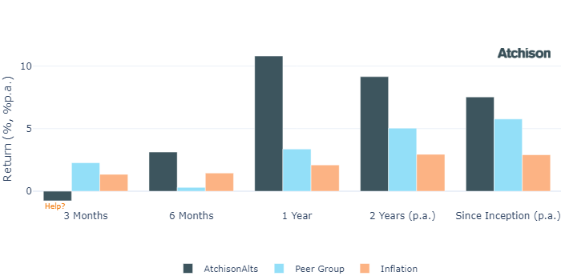

Cumulative Performance Since Inception

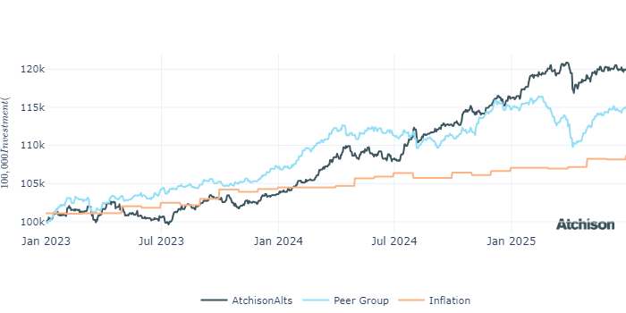

Portfolio Allocations

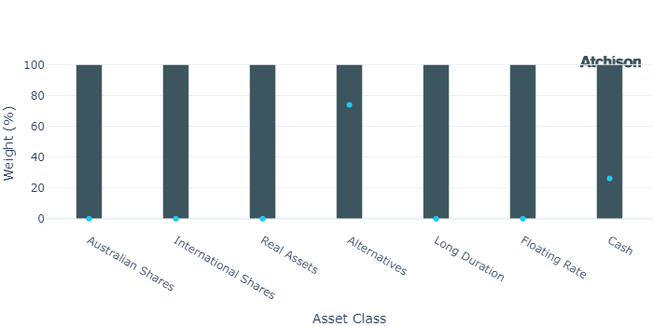

Portfolio Construction

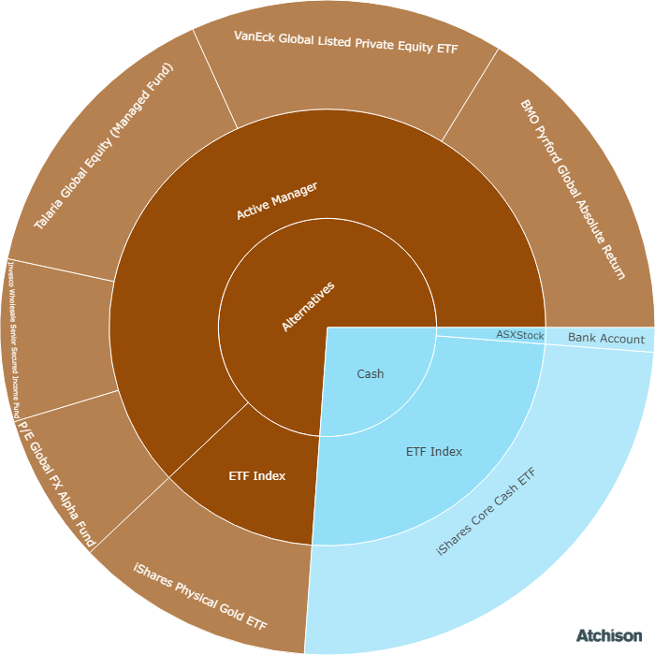

Correlations

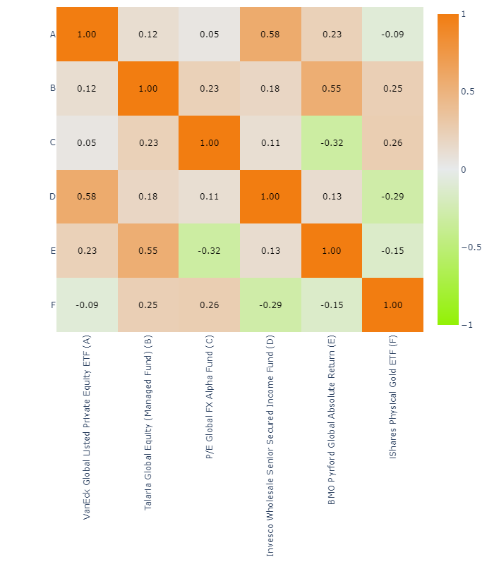

Underlying Manager Performance

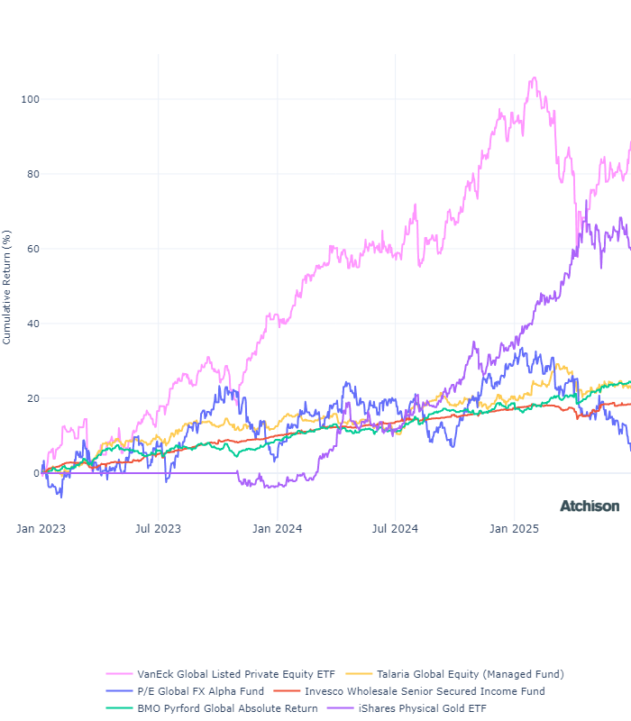

|  |  |  |
| --- | --- | --- |
| **Strategy** | **1 Year** | **2 Years (p.a.)** |
| VE Global Listed P Private ETF | 19.23 | 27.15 |
| Talaria GE | 10.58 | 5.8 |
| P/E FX Alpha | -11.19 | -0.51 |
| Invesco Senior Secured | 4.48 | 6.17 |
| Pyford Global Abs | 11.7 | 8.25 |
| iShares Physical Gold | 42.95 | 26.33 |
| **BM: Alternatives** | **4.51** | **4.49** |
| iShares Cash | 4.52 | 4.48 |
| Cash | 4.51 | 4.49 |

Inception Date: 31 December 2022

Underlying investment manager returns are shown after fees and before tax

Market Update

The Australian share market rose for the third consecutive month rising a modest +1.1% for the month but a stellar +16% since April and +10.2% for the 12 months to June 2025, after a +7.8% rise one year earlier and +9.6% in the year end June 2023. Performance during the year was mainly driven by technology and financial sectors.  
  
Australia’s economy grew 0.2% q-o-q in Q1 2025. While this fell short of the 0.4% market forecast, it marked the 14th consecutive quarter of expansion. OECD adjusted its GDP growth forecast for Australia in 2025 from 1.9% to 1.8%.  
  
Australian household net worth reached A$17.3 trillion in the March quarter, up from A$16.2 trillion a year earlier. Property remained the largest asset class at A$11.7 trillion, growing by 5.9% annually. Superannuation assets increased by 6.6% to A$4.14 trillion, while shares and equities rose by 8% to A$1.57 trillion.  
  
The World Bank left its forecast for China unchanged at 4.5% from January, saying Beijing still had monetary and fiscal space to support its economy and stimulate growth.  
  
President Trump has upended global trade with a series of on-again, off-again tariff hikes that have increased the effective U.S. tariff rate from below 3% to the mid-teens - its highest level in almost a century - and triggered retaliation by China and other countries.  
  
The US economy remained resilient in June, with equity markets hitting record highs amid easing geopolitical risks from the Iran-Israel ceasefire and a rollback of reciprocal tariffs. Expectations for 2–3 Fed rate cuts by year-end strengthened as inflation showed signs of moderation and financial conditions remained supportive.  
  
A weakening U.S. dollar has reinvigorated investor interest in Emerging Market assets. Notably, emerging market local currency debt experienced a resurgence, with bond funds recording eight consecutive weeks of inflows and returns exceeding 10% year-to-date.  
  
The eurozone's GDP is projected to grow by 0.9% in 2025, a downward revision from earlier forecasts, primarily due to heightened trade tensions and global uncertainty. Inflation is expected to average 2.0% in 2025, aligning with the European Central Bank's (ECB) target, before dipping to 1.6%.  
  
The US 10-year yield rose over the month as strong jobs data and sticky inflation reduced the likelihood of a July Fed rate cut, while fiscal concerns mounted following Senate approval of a $3.3 trillion deficit-financed tax bill.  
  
Australian government bond yields ended June slightly higher at the long end, while the 2-year yield eased as markets began to price in rate cuts in 2026 amid softening growth momentum. The yield curve steepened modestly, with RBA commentary remaining hawkish due to persistent services inflation and a tight labour market.  
  
Gold miners delivered 60% for the year. Gold is set to surpass metallurgical coal to become Australia's 3rd biggest resource export earner in 2025–2026.

Fine Print

Important Notice: This document is published by TAG Asset Consulting Group Pty Ltd, trading as Atchison Consultants, ABN 58 097 703 047, AFSL 230 846. Atchison Consultants distributes its investment solutions via platform and dealer groups (financial advisory groups).

Warning: Please be advised that past performance is not indicative of future performance. The returns discussed herein are based on model asset allocations and are for illustrative purposes only. Actual returns may differ due to variations in fees, timing of model change implementation, and the need to substitute individual holdings where reliable data was not available from our data providers. Any insights or recommendations provided in this document are intended for general advice purposes only and are based on our opinion of the investment merits of the financial products discussed, independent of the financial circumstances of any individual. Before proceeding with any investment based on the information provided, recipients must assess its suitability to their financial situation and consider seeking advice from an independent financial advisor.

Disclaimer: While care is taken to ensure the accuracy and completeness of the information presented herein, no warranties or representations are made as to its reliability. The content provided is derived from publicly available sources, or external data providers, which have not been independently verified by Atchison Consultants. Atchison Consultants, along with its directors, officers, employees, and agents, expressly disclaims any liability for errors, inaccuracies, or omissions in this document, as well as for any loss or damage that may arise from reliance on its contents. Readers are cautioned to verify all information independently before taking any actions based on this report.