Atchison Active Floating Rate SMA 30 September 2025

|  |  |  |  |  |  |
| --- | --- | --- | --- | --- | --- |
|  | 3 Months | 6 Months | 1 Year | 2 Years (p.a.) | Since Inception (p.a.) |
| AtchisonFloatingRate | **1.14** | **2.33** | **4.79** | **6.04** | **5.71** |
| Peer Group | 1.01 | 2.35 | 4.03 | 4.81 | 4.55 |
| Inflation | -0.01 | 1.34 | 2.05 | 2.08 | 2.64 |
| Outperformance vs Peers | 0.13 | -0.02 | 0.76 | 1.22 | 1.16 |
| Outperformance vs Inflation | 1.15 | 0.99 | 2.74 | 3.96 | 3.07 |

Inception Date: 31 December 2022

Investment Objective

Outperform the RBA Cash Rate, after underlying manager fees and before tax, over rolling three-year periods.

Strategy Overview

The Atchison Active Floating Rate Portfolio offers a bespoke solution as part of your defensive bond asset class allocation. Focusing on floating rate bank securities, asset backed securities and diversified credit strategies that pay a variable (or “floating” ) interest rate, typically with a duration of less than three years.

|  |  |
| --- | --- |
| Key Details |  |
| Strategy Category | Floating Rate |
| Strategy Provider | Atchison |
| Benchmark | RBA Cash Rate |
| Inception Date | 31 December 2022 |
| Investment Horizon | 3 Years |
| Risk Level (SRM) | Low to Medium |
| Min Investment | 5k |
| Product Fee | Platform Specific - Refer to PDS |
| Underlying MER | 0.37% |
| Underlying Perf Fees | 0.00% |

Strategy Performance

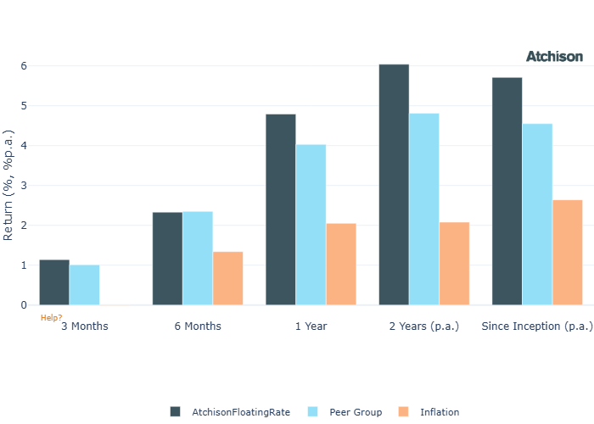

Cumulative Performance Since Inception

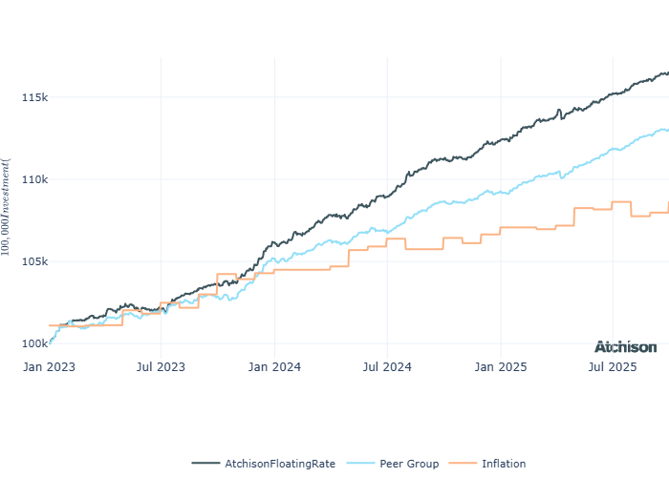

Portfolio Allocations

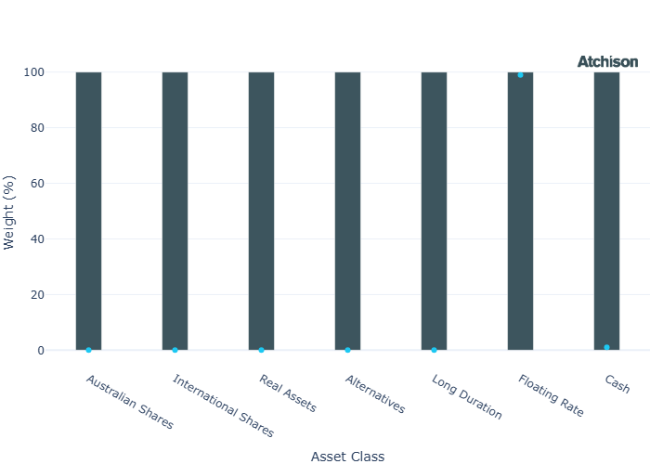

Portfolio Construction

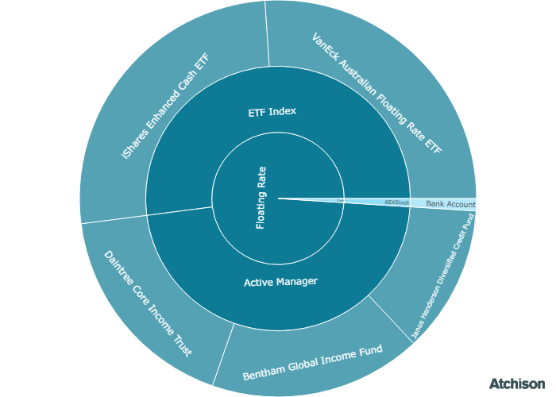

Correlations

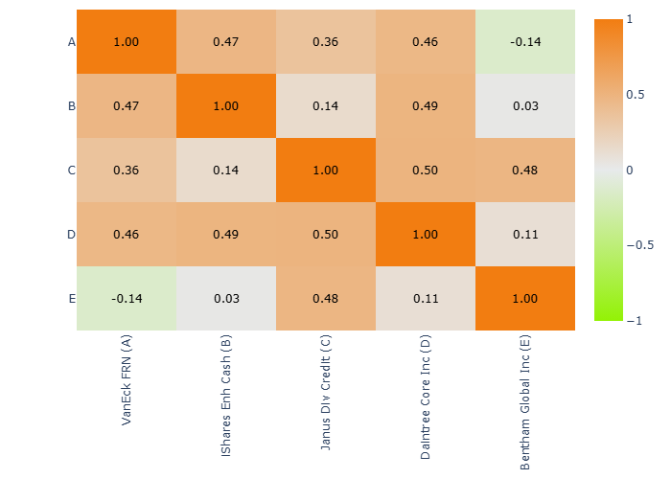

Underlying Manager Performance

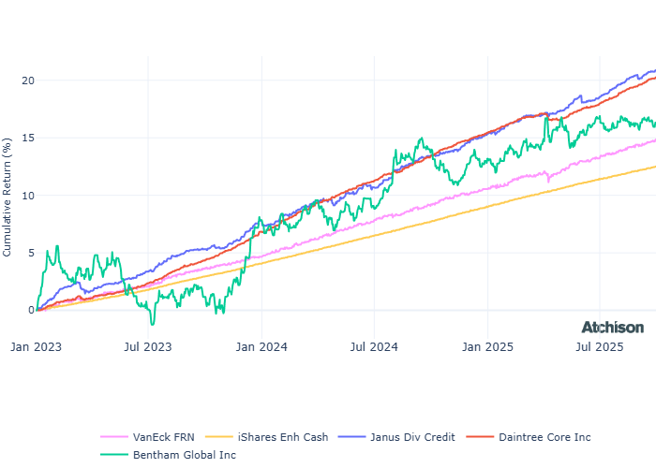

|  |  |  |
| --- | --- | --- |
| **Strategy** | **1 Year** | **2 Years (p.a.)** |
| VanEck FRN | 5.3 | 5.28 |
| iShares Enh Cash | 4.46 | 4.54 |
| Janus Div Credit | 6.56 | 7.12 |
| Daintree Core Inc | 6.09 | 7.35 |
| Bentham Global Inc | 2.17 | 7.15 |
| **BM: Floating** | **5.05** | **5.24** |
| Cash | 4.28 | 4.41 |

Inception Date: 31 December 2022

Underlying investment manager returns are shown after fees and before tax

Market Update

September saw global equities extend their rally, supported by the start of the U.S. easing cycle and improving growth sentiment. Bonds also gained as yields moved lower, particularly at the long end of the curve.  
  
The S&P/ASX 200 declined 0.8% in September, snapping its five-month winning streak. 9 out of 11 sectors reported losses with financials falling 1.4% detracting meaningfully given their index weight. Energy took the biggest fall returning -9.8% on the back of lower oil price.   
  
Materials stood out as the strongest performer on the ASX, rising 6.1% on the back of strength in gold and diversified miners.  
  
Emerging markets (+5.7%), particularly China (China Top 50 +6.7%), outperformed developed peers. Improving macro data and continued policy support underpinned performance.   
  
U.S. equities recorded a fifth consecutive month of gains. The S&P 500 posted its best September month in 15 years, gaining 3.7%, in what has historically been the worst month for stocks. This was supported by a Federal Reserve rate cut.  
  
Large cap equities outperformed mid and smalls in the US. Growth was the dominant factor outperforming value.  
  
Sector performance was split in September, with Technology leading the way, bouncing back from a negative August, advancing over 7.5%. Consumer Staples, Materials, and Energy all went negative, with Financials virtually flat at 0.1% in September.  
  
European equities advanced 1% for September continuing their positive run. However, german equities have been a drag for the quarter falling 1.2% behind political uncertainty.  
  
The Federal Reserve cut the federal funds rate by 25bps in September 2025, bringing it to the 4.00%–4.25% range, in line with expectations. It is the first reduction in borrowing costs since December.  
  
The RBA decided to leave the cash rate unchanged at 3.60 per cent at its September meeting. Bond indices were positive or neutral for the month.  
  
Commodites exteneded their rally. Gold reached record highs and copper saw a surge in prices. Rare earths performed well due to supply chain strain.

Fine Print

Important Notice: This document is published by TAG Asset Consulting Group Pty Ltd, trading as Atchison Consultants, ABN 58 097 703 047, AFSL 230 846. Atchison Consultants distributes its investment solutions via platform and dealer groups (financial advisory groups).

Warning: Please be advised that past performance is not indicative of future performance. The returns discussed herein are based on model asset allocations and are for illustrative purposes only. Actual returns may differ due to variations in fees, timing of model change implementation, and the need to substitute individual holdings where reliable data was not available from our data providers. Any insights or recommendations provided in this document are intended for general advice purposes only and are based on our opinion of the investment merits of the financial products discussed, independent of the financial circumstances of any individual. Before proceeding with any investment based on the information provided, recipients must assess its suitability to their financial situation and consider seeking advice from an independent financial advisor.

Disclaimer: While care is taken to ensure the accuracy and completeness of the information presented herein, no warranties or representations are made as to its reliability. The content provided is derived from publicly available sources, or external data providers, which have not been independently verified by Atchison Consultants. Atchison Consultants, along with its directors, officers, employees, and agents, expressly disclaims any liability for errors, inaccuracies, or omissions in this document, as well as for any loss or damage that may arise from reliance on its contents. Readers are cautioned to verify all information independently before taking any actions based on this report.