Atchison Active International Shares SMA 31 August 2025

|  |  |  |  |  |  |
| --- | --- | --- | --- | --- | --- |
|  | 3 Months | 6 Months | 1 Year | 2 Years (p.a.) | Since Inception (p.a.) |
| AtchisonIntShares | **5.16** | **2.93** | **13.46** | **16.7** | **19.42** |
| Peer Group | 4.56 | 3.72 | 14.76 | 14.44 | 17.37 |
| Inflation | -0.38 | 0.74 | 1.9 | 2.28 | 2.42 |
| Outperformance vs Peers | 0.6 | -0.78 | -1.3 | 2.26 | 2.05 |
| Outperformance vs Inflation | 5.54 | 2.2 | 11.56 | 14.42 | 17.0 |

Inception Date: 31 December 2022

Investment Objective

Outperform the FE AMI Equity – Global Peer Index, after underlying manager fees and before tax, over rolling five-year periods.

Strategy Overview

The Atchison Active International Shares Portfolio offers an all-in-one solution for your international shares, investing across, fund managers, low-cost ETF’s, investment styles, factors, sectors, and countries. The portfolio is continuously reviewed and adjusted to ensure it remains appropriately positioned to manage and take advantage of evolving investment and economic conditions.

|  |  |
| --- | --- |
| Key Details |  |
| Strategy Category | International Shares |
| Strategy Provider | Atchison |
| Benchmark | FE AMI Equity – Global Peer Index |
| Inception Date | 31 December 2022 |
| Investment Horizon | 10 Years |
| Risk Level (SRM) | High |
| Min Investment | 5k |
| Product Fee | Platform Specific - Refer to PDS |
| Underlying MER | 0.40% |
| Underlying Perf Fees | 0.04% |

Top 10 Share Exposures

|  |  |
| --- | --- |
| **Code** | **Name** |
| MSFT.NAS | MICROSOFT CORP |
| AAPL.NAS | APPLE INC |
| NVDA.NAS | NVIDIA CORP |
| AMZN.NAS | AMAZON COM INC |
| META.NAS | META PLATFORMS INC CLASS A |
| LLY.NYS | ELI LILLY |
| GOOG.NAS | ALPHABET INC CLASS C |
| ASML.AMS | ASML HOLDING NV |
| GOOGL.NAS | ALPHABET INC CLASS A |
| NOVO-B.CSE | NOVO NORDISK CLASS B |

Strategy Performance

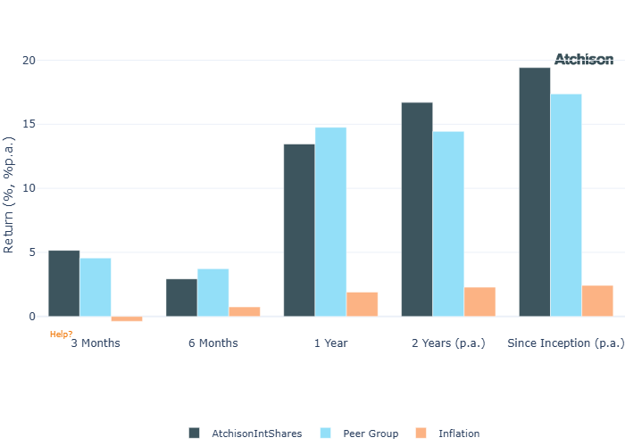

Cumulative Performance Since Inception

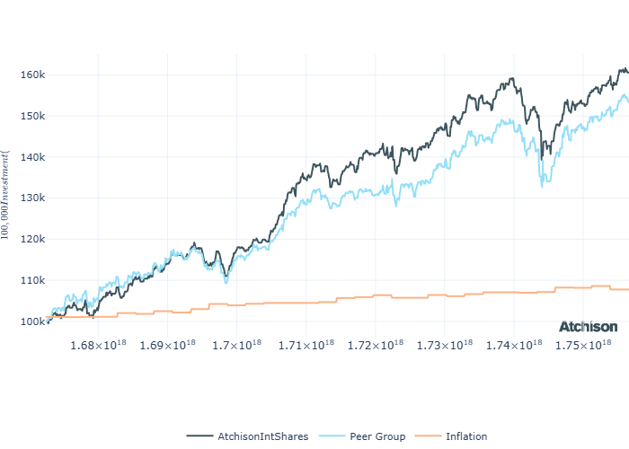

Portfolio Allocations

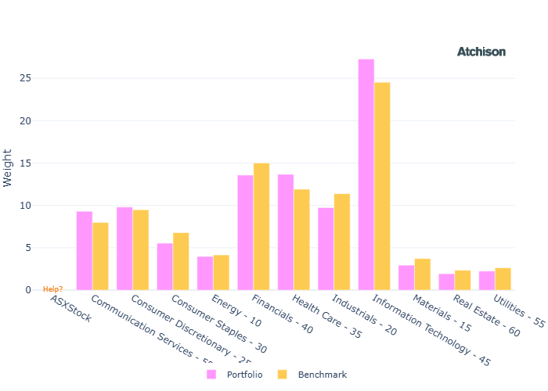

Portfolio Construction

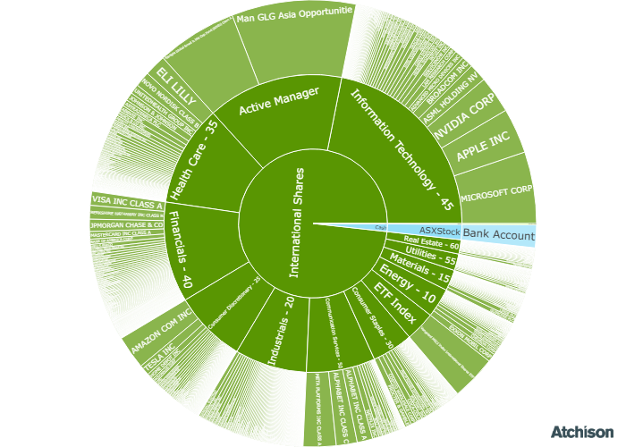

Correlations

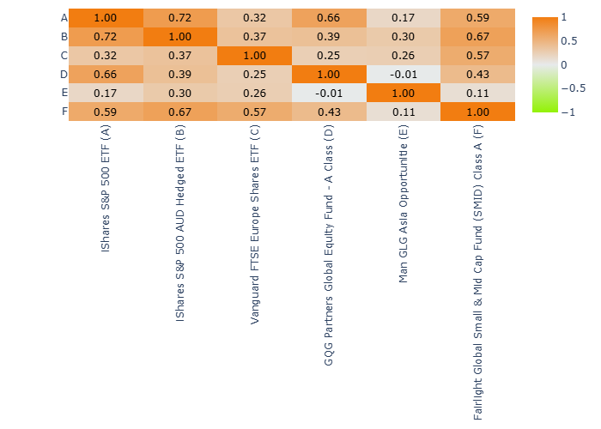

Underlying Manager Performance

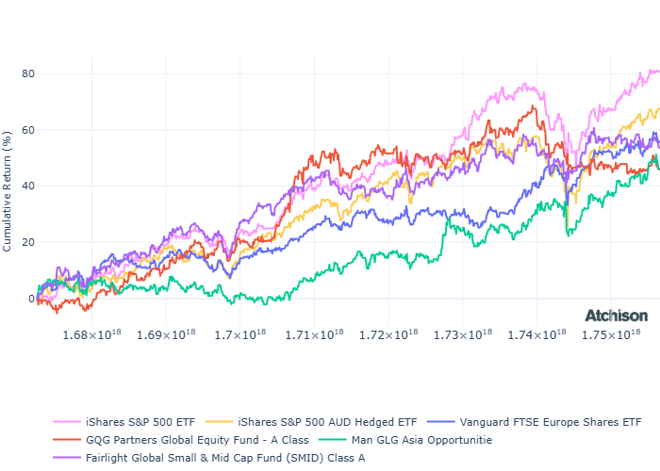

|  |  |  |
| --- | --- | --- |
| **Strategy** | **1 Year** | **2 Years (p.a.)** |
| iShares US 500 | 21.92 | 20.73 |
| iShares US 500 Hedged | 16.14 | 19.59 |
| VG Europe Eq | 18.45 | 15.52 |
| GQG Global Eq | -2.88 | 11.19 |
| Man GLG Asia | 26.79 | 18.43 |
| Fairlight Glob Small Mid | 8.02 | 10.47 |
| **BM: International Shares** | **20.47** | **18.75** |
| Cash | 4.34 | 4.42 |

Inception Date: 31 December 2022

Underlying investment manager returns are shown after fees and before tax

Market Update

August delivered broad gains across global equities and bonds, driven by actual and expected rate cuts.  
  
9 of 11 S&P/ASX 200 sectors advanced, with Materials and Consumer Discretionary leading gains. Meanwhile Health Care fell 13% due to a CSL sell-off following its spinoff announcement. Information Technology remained under pressure.  
  
Value, Equal Weight, and High Dividend each rose 6%. Growth lagged as the weakest performer year-to-date.  
  
Chinese equities outperformed, as onshore markets rebounded and narrowed the gap with offshore stocks.  
  
U.S. equities recorded a fourth consecutive month of gains, with the S&P 500 rising 2% in August, despite a sharp final-day sell-off. Market sentiment was supported by optimism around potential Federal Reserve rate cuts and continued strength in Big Tech.  
  
The rally broadened across market segments, with mid- and small-cap stocks outperforming large caps.  
  
Most sectors posted positive returns, led by Materials and Health Care; Health Care recovered losses from July. Utilities was the only sector to decline.  
  
European equities gained for the month, extending their positive run for the quarter. Sector leaders were Health Care (+4%+) and Consumer Staples (+3%+). Information Technology, Utilities, and Industrials posted modest losses of under 2%, not enough to offset the index’s overall gains.  
  
US fixed income indices all posted gains amid fluctuating yields and shifting rate expectations.  
  
The Reserve Bank of Australia and Reserve Bank of New Zealand each reduced key rates by 25bps..  
  
Commodities participated in the rally, led by Livestock. Precious Metals strengthened, with Gold reaching another record high, driven by renewed safe-haven demand.

Fine Print

Important Notice: This document is published by TAG Asset Consulting Group Pty Ltd, trading as Atchison Consultants, ABN 58 097 703 047, AFSL 230 846. Atchison Consultants distributes its investment solutions via platform and dealer groups (financial advisory groups).

Warning: Please be advised that past performance is not indicative of future performance. The returns discussed herein are based on model asset allocations and are for illustrative purposes only. Actual returns may differ due to variations in fees, timing of model change implementation, and the need to substitute individual holdings where reliable data was not available from our data providers. Any insights or recommendations provided in this document are intended for general advice purposes only and are based on our opinion of the investment merits of the financial products discussed, independent of the financial circumstances of any individual. Before proceeding with any investment based on the information provided, recipients must assess its suitability to their financial situation and consider seeking advice from an independent financial advisor.

Disclaimer: While care is taken to ensure the accuracy and completeness of the information presented herein, no warranties or representations are made as to its reliability. The content provided is derived from publicly available sources, or external data providers, which have not been independently verified by Atchison Consultants. Atchison Consultants, along with its directors, officers, employees, and agents, expressly disclaims any liability for errors, inaccuracies, or omissions in this document, as well as for any loss or damage that may arise from reliance on its contents. Readers are cautioned to verify all information independently before taking any actions based on this report.