

Strategic Partnership   
with KeyInvest

July 2025

Contents

1. Introduction & Present State
2. Strategic Benefits
3. About KeyInvest
4. Key Partners
5. Conclusion
6. Appendix

Introduction & Present State

KeyInvest proposes a strategic partnership with {insert platform provider} to broaden access to its investment menu and offer the third investment stream of Investment Bonds, as they emerge as a core solution for wealth transfer estate planning, and investment outside of superannuation.

As the advice landscape adapts to a shifting regulatory and market environment, platform providers are under increasing pressure to increase the service offering, remain competitive and respond to client demands. Division 296 and the forecast $3.5 trillion intergenerational wealth transfer are accelerating the need for tax-effective, estate-focused products that can be accessed outside of the super and non-super streams currently available on the platform.

This presents an opportunity for the platform to be positioned to capture the estimated $240 billion of assets seeking new investment structures and present the compelling solution of investment bonds, while gaining an additional revenue stream for the platform through a free-sharing scheme including admin fees.

KeyInvest is uniquely positioned to support this partnership. A member-owned mutual with over 147 years of heritage, KeyInvest holds a Highly Recommended Lonsec rating and is dual-regulated by APRA and ASIC.

Adding KeyInvest’s investment products to your platform’s Approved Product List (APL) and entering into a strategic parentship will unlock new distribution channels, deliver new revenue opportunities, and offer a streamlined and compliant solution for platforms, advisers and investors.

Platforms that act will lead the market in offering a complete investment solution spanning super, non-super and tax-effective structures.

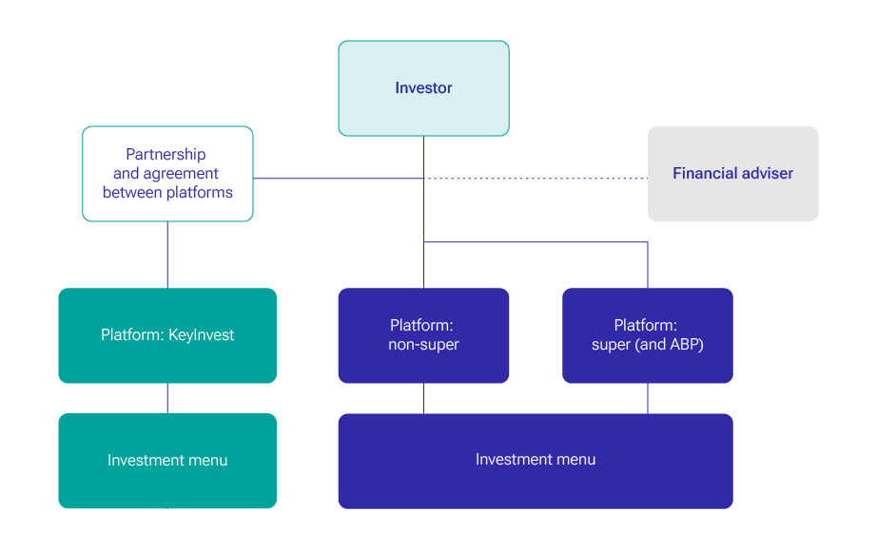

Strategic Benefits

By collaborating with KeyInvest, platforms will be further empowering current and new advisers with access to compliant, tax-optimised investment vehicles.

This will position your platform as a forward-thinking platform who considers the future of the wealth management sector and the challenges they are faced with in the intergenerational transfer and post-super strategies, alongside further benefits including:

|  |
| --- |
| Fee Structure  Fee structures are designed surrounding a fee-sharing model to align incentives. A volume-based fee rebate applies, rewarding strong inflows and platform engagement to drive long-term value for all parties. |
| Accelerating Market Inflows  KeyInvest has strategically partnered with trusted capital raising specialists including The Inside Network, and Capital Outcomes, to amplify market reach, enhance adviser engagement, and accelerate inflows through targeted campaigns. |
| Asset Capture Strategy Positioning platforms to capture and a share in the estimated $240 billion of assets seeking new investment structures. |
| Enhanced Tax Efficiency Access to investment solutions with favourable tax treatment that can improve after tax-returns. |
| Improved Estate Planning   * Tools and structures that facilitate seamless intergenerational wealth transfer and estate management. * Intergenerational inheritances expected to increase from $52 billion in 2018 to $3.5 trillion (est.) by 2038. * An estimated 80% of wealth will be passed to those aged 50+ years. * Building strong relationships with the next generation. * Investment bonds can be used to transfer wealth to their family, how they wish and provide an extra layer of protection, whilst being tax effective environment. |
| Simplified Wealth Management  Consolidated platform solutions that integrate investment management with tax and estate planning benefits. |
| Long-Term Wealth Growth Solutions designed to support sustainable growth aligned with clients’ financial goals and  life events. |
| Tailored Client Solutions Investment options that reflect diverse client needs and risk profiles, supporting personalised financial planning. |
| Refined and Tailored Investment Offering Enhancing the platform investment menu with carefully selected high-quality portfolios. |
| Addition of Investment Sophistication  Incorporation of KeyInvest’s investment menu adds depth and sophistication to the investment platform investment menu, elevating client offerings. |
| Enhanced Client Outcome Tools Provides additional tools to help advisers guide clients toward optimal financial outcomes. |
| Strong Revenue Upside with Minimal Operational Impact Generates increased revenue from advice fees and investment management, with little to no added operational expenditure. |
| Increased Funds Under Management (FUM) Drives growth in FUM through expanded distribution, and marketing of the platform and its offering. |
| Supports Enduring Adviser-Client Relationships  Facilitates long-term engagement aligned the focus of platforms to drive adviser-led relationships, aided by the 10-year Investment Bond holding period. |
| Minimal Impact on Risk Management Maintains existing risk controls with little to no incremental risk exposure. |
| Marketing and Outreach Through marketing and outreach efforts, including strategic input from Capital Outcomes and The Inside Network, platform providers benefit from coordinated education campaigns, high-impact product roadshows, and adviser presentations that strengthen market positioning and boost adoption. |
| Alignment to Core Values Do the right thing, put clients first, lead with exceptional ideas, commit to diversity and inclusion, and  give back. |

**About KeyInvest**

**Supporting the unique financial needs of our customers**

KeyInvest is an independent, member-owned mutual friendly society, established in 1878 as IOOFSA. With a proud 147+ year legacy, we exist to serve over 50,000 members with tax-effective wealth management solutions tailored to their unique financial needs.

We are dually regulated by APRA (as a life insurer) and ASIC (as a financial product provider), underpinned by robust governance, compliance, and culture frameworks.

With offices in Adelaide, Sydney, and Melbourne, we are uniquely positioned to help advisers and platforms deliver intergenerational wealth solutions. In 2023, we became the first friendly society in Australia to raise additional Tier 1 Capital—supporting our strategic investment in non-bank lender Keystone Capital Ltd.

KeyInvest remains focused on innovation, with new product launches planned to meet the evolving needs of investors.

**Key Partners**

**Atchison**

KeyInvest has entered into a partnership with Atchison, a leading asset consulting and investment management firm, that focuses on delivering tailored portfolio solutions to financial advisers, superannuation funds, charities, and foundations across Australia.

As KeyInvest’s dedicated investment manager, Atchison plays a key role in ensuring our investment menu remains robust, forward-thinking, and aligned to the evolving needs of adviser and investors.

**The services within the Atchison partnership include:**

* Strategic participation on KeyInvest’s investment committees.
* Comprehensive due diligence and research of underlying investment options.
* Construction and stress-testing of tailored portfolios, including managed account offerings.
* Ongoing support to ensure compliance with regulatory requirements and governance standards.

Over the past 18 months, KeyInvest has conducted a thorough review of its investment suite with the support of Atchison, with a singular focus of delivering a best-in-class menu of tax-effective, estate-focused investment options accessible through our platform relationships.

This partnership strengthens KeyInvest’s ability to deliver meaningful, differentiated solutions to platform providers, advisers, and clients and enhances estate planning capabilities, broadening investment choice, and driving sustained growth in FUM.

**Capital Outcomes & The Inside Network**

KeyInvest has established a powerful partnership with two of the most respected voices, Capital Outcomes and The Inside Network.

Capital Outcomes is a public relations, marketing and creative firm specialising in financial services, and The Inside Network is a dedicated community of investment professionals connecting through events programs, publications and educational channels.

Together, we will deliver an integrated marketing, communications and distribution strategy that includes key initiatives such as:

* The development and execution of an integrated and cohesive marketing, communication and distribution strategy to engage the adviser and direct investor segments.
* Leverage earned media opportunities through strategic interviews with mainstream and trade financial media, alongside timely fund performance updates and thought leadership.
* Development and execution of high-quality content including thought leadership articles, videos and podcasts to boost awareness of KeyInvest CEO, and enhance the overall credibility of the firm.
* Facilitating and participating in industry-wider symposiums discussing investment strategies, the positioning of KeyInvest’s investment menu and accessibility through the platform.
* Facilitation of education webinars targeting The Inside Networks adviser database of 12,000 plus.
* Leverage KeyInvest’s extensive database of 1,100 advisers and 3,300 existing bondholders to accelerate platform adoption and consider other investment solutions through targeted email campaigns and personalised communications.
* Utilisation of industry recognised achievements including KeyInvest’s Highly Recommended research rating with Lonsec is expected to have great appeal with external dealer groups and advisers.
* Digital marketing campaigns include webinars, social media engagement, and online educational content focusing on the implications of Division 296 tax legislation and Investment Bond benefits.
* Ongoing adviser engagement initiatives to build advocacy and drive organic referral flows.

Conclusion

As the financial landscape continues to evolve, platform providers are under increasing pressure to respond to changing client demands, regulatory shifts, and the need for broader investment options.

The impending introduction of Division 296 and the $3.5 trillion intergenerational wealth transfer confirms the urgency for platforms to offer tax-effective, estate-focused investment solutions that go beyond traditional super and non-super streams.

By entering into a strategic partnership with KeyInvest and adding the investment menu onto the APL, the platform is strongly positioned to lead the shift as advisers become more compliant, look at streamlining processes and including relevant investment solutions into their portfolios.

This strategic partnership unlocks an additional revenue stream, broadens your platform’s investment menu, and supports advisers in delivering better long-term outcomes for clients.

With 147-years of heritage, APRA regulation, and a Highly Recommended Lonsec rating, KeyInvest brings proven credibility, operational excellence, and a strong commitment to innovation. Supported by expert partners including Atchison, Capital Outcomes, and The Inside Network, we are uniquely positioned to drive engagement, scale, and impact.

Together, we can capture a meaningful share of the $240 billion in assets seeking new investment structures, and build a sustainable, future-ready solution for advisers and investors alike.

We look forward to progressing this opportunity with you.

Appendix

* 1. Proposed Division 296 Tax Legislation

Introduced as part of the Treasury Laws Amendment (Better Targeted Superannuation Concessions and Other Measures) Bill 2023 (The Bill).

Additional 15% tax rate: Individuals with total superannuation balances (being the combined value across all superannuation accounts, whether in accumulation and pension phase) exceeding $3 million on 30 June 2026 will face an additional tax of 15% on earnings.

Earnings: Earnings include the unrealised capital growth and income incurred by a member at each   
30 June.

Non-Indexed threshold: The $3 million threshold is unindexed.

Per person limit: The tax applies per individual, not per fund or couple. For instance, an SMSF with 2 members could have up to $6 million ($3 million per member) without being impacted.

The Bill is likely to impact 80,000 investors with super balances of at least $3 million (equating to a minimum of $240 billion), however the Federal Finance Department estimated the average super balance of these account holders was $5.8 million in 2023, suggesting the pool of assets is closer to $500 billion. Therefore, there is potentially $250 billion in super assets that need to find a new home. In addition, these super account holders will need to consider allocating capital on a forward basis to ensure that they don’t exceed the $3 million cap; this will create opportunities for additional capital flows, on an ongoing basis.

Modelling of Division 296: Tax payable on balances ranging from $2 million to $7 million.

Post Division 296 – Scenario Outcomes

|  |  |  |  |  |
| --- | --- | --- | --- | --- |
| Balance | Total Tax – Super | Total Tax - Super  & INV BOND | Total Tax –  Pension & Super | Total Tax -Super/Pension/INV BOND |
| $2,000,000 | $19,500.00 | $19,500.00 |  |  |
| $2,500,000 | $24,375.00 | $24,375.00 | $4,875.00 | $4,875.00 |
| $3,000,000 | $29,250.00 | $29,742.11 | $9,750.00 | $10,242.11 |
| $3,500,000 | $39,000.00 | $32,671.71 | $14,625.00 | $16,101.32 |
| $4,000,000 | $48,750.00 | $38,530.92 | $24,375.00 | $21,960.53 |
| $4,500,000 | $58,500.00 | $44,390.13 | $34,125.00 | $27,819.74 |
| $5,000,000 | $68,250.00 | $50,249.34 | $43,875.00 | $33,678.95 |
| $5,500,000 | $78,000.00 | $56,108.55 | $53,625.00 | $39,538.16 |
| $6,000,000 | $87,750.00 | $61,967.76 | $63,375.00 | $45,397.37 |
| $6,500,000 | $97,500.00 | $67,826.97 | $73,125.00 | $51,256.58 |
| $7,000,000 | $107,250.00 | $73,686.18 | $82,875.00 | $57,115.79 |

|  |  |
| --- | --- |
| Assumptions: | 1. Effective Tax Rate of 18% (this is the actual average effective tax rate for 2022-2024) 2. Modelled on Vanguard Balanced Indexed 3. The full Transfer Balance Cap is used in Pension Phase 4. Div 296 is legislated with a $3m cap. |
|  |
|  |