Atchison Dynamic ETF 70 SMA 31 May 2025
 | 3 Months | 6 Months | 1 Year | 2 Years (p.a.) | Since Inception (p.a.)
Atchison70ETF | 1.94 | 2.55 | 11.59 | 11.76 | 11.71
Peer Group | 1.29 | 1.66 | 9.77 | 10.13 | 10.3
Inflation | 1.2 | 1.5 | 2.21 | 3.1 | 2.87
Outperformance vs Peers | 0.65 | 0.89 | 1.82 | 1.63 | 1.41
Outperformance vs Inflation | 0.75 | 1.04 | 9.38 | 8.66 | 8.84
Inception Date: 31 December 2022

Investment Objective
Outperform the FE AMI Mixed Asset – Growth Peer Index, after underlying manager fees and before tax, over rolling five-year periods.

Strategy Overview
Atchison Dynamic ETF 70 Portfolio is a Separately Managed Account (SMA), which is an all-inclusive diversified, multi-asset, low-cost ETF investment portfolio professionally managed for you (the client) on behalf of a financial advisor. This portfolio is 70% growth assets, and 30% defensive assets. Asset classes include Australian Shares, Global Shares, Alternatives, Floating Rate, Long Duration, Real Assets and Cash.
Key Details
Strategy Category | Multi Asset
Strategy Provider | Atchison
Benchmark | FE AMI Mixed Asset – Growth Peer Index
Inception Date | 31 December 2022
Investment Horizon | 8 Years
Risk Level (SRM) | Medium
Min Investment | 25k
Product Fee | Platform Specific - Refer to PDS
Underlying MER | 0.15%
Underlying Perf Fees | 0.00%
Top 10 Share Exposures
Code | Name
BHP-AU | BHP Group Limited
CBA-AU | Commonwealth Bank of Australia
CSL-AU | CSL Limited
NAB-AU | National Australia Bank Limited
ANZ-AU | ANZ Group Holdings Limited
WBC-AU | Westpac Banking Corporation
WDS-AU | Woodside Energy Group Ltd
MSFT.NAS | MICROSOFT CORP
AAPL.NAS | APPLE INC
WES-AU | Wesfarmers Limited
Strategy Performance
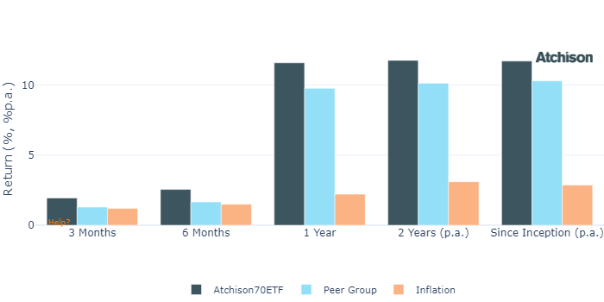
Cumulative Performance Since Inception
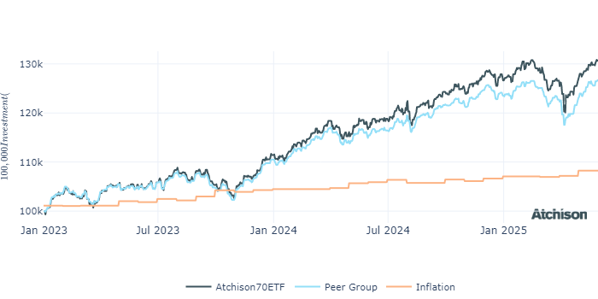
Portfolio Allocations
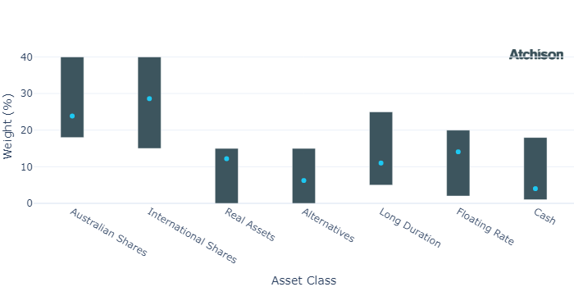
Asset Class Performance
Period | 1 Year | 2 Years (p.a.)
Australian Shares | 12.43 | 12.27
International Shares | 15.28 | 16.82
Real Assets | 10.43 | 11.43
Alternatives | 6.73 | 3.31
Long Duration | 5.01 | 2.94
Floating Rate | 5.06 | 5.42
Cash | 4.55 | 4.46
Inception Date: 31 December 2022
Portfolio Construction
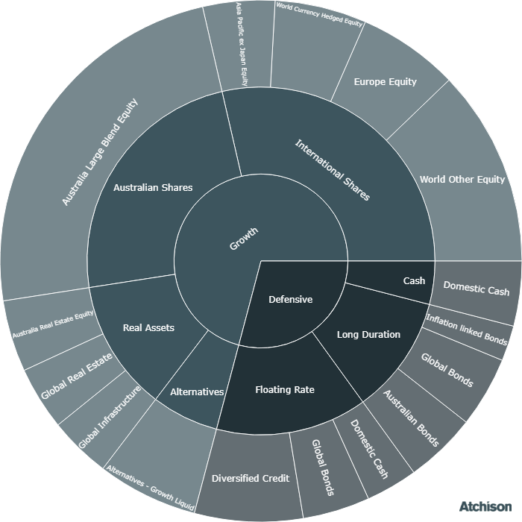
Correlations
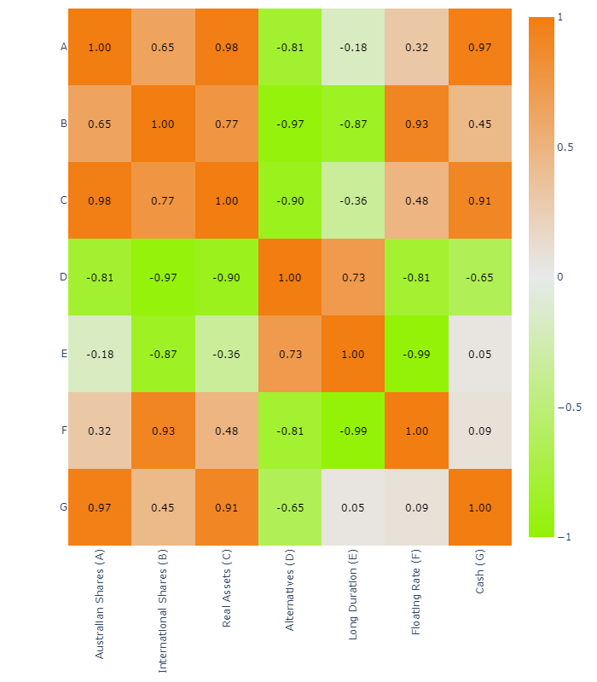
Historical Allocation Changes
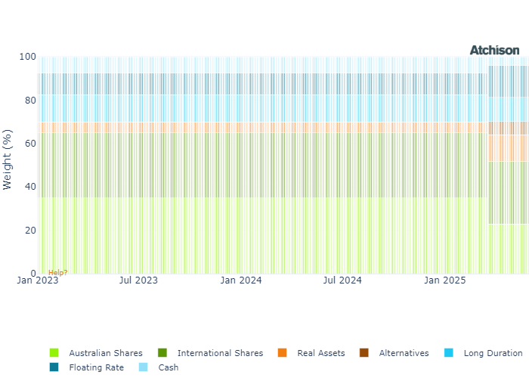
Underlying Current Manager Performance
Strategy | 1 Year | 2 Years (p.a.)
iShares ASX 200 | 13.19 | 12.98
BM: Australian Shares | 13.24 | 13.01
VG MSCI World Hedged | 12.44 | 17.62
iShares US 500 | 17.81 | 20.63
VG Europe Eq | 16.98 | 16.13
iShares Japan | 14.37 | 14.75
VG Asia ex Japan | 16.74 | 12.81
BM: International Shares | 17.73 | 18.52
VG Global Infra | 17.94 | 11.53
iShares AREIT | 10.46 | 16.67
iShares GREIT | 7.71 | 7.47
BM: Real Assets | 8.55 | 8.58
iShares Physical Gold | 44.82 | 27.65
BM: Alternatives | 4.51 | 4.47
iShares Aus Bond | 6.47 | 3.63
iShares CPI Bond | 2.32 | 1.33
iShares Globa Agg ESG | 5.3 | 3.36
BM: Duration | 5.96 | 3.54
VanEck FRN | 5.26 | 5.34
BetaShares Hybrids | 4.92 | 6.12
iShares Enh Cash | 4.64 | 4.6
BM: Floating | 5.12 | 5.25
iShares Cash | 4.56 | 4.46
Cash | 4.51 | 4.47
Inception Date: 31 December 2022
Underlying investment manager returns are shown after fees and before tax

Market Update
Smaller companies outperformed their broader counterparts, with the Small Ordinaries rising 6%, whilst the ASX 200 advanced 4%<
All sectors within the ASX 200 recorded gains. Information Technology led with a 20% jump, followed by Energy at 9%, while traditionally defensive sectors - Utilities, Consumer Staples, and Health Care lagged.
All Australian factor indices ended the month in positive territory. Momentum, Equal Weight, and Growth factors outpaced others, whereas High Dividend and Value underperformed, echoing sector-level trends.
China’s equity markets posted solid gains in May 2025, supported by tech earnings and fresh monetary easing, including rate and reserve ratio cuts. However, mixed economic data and external pressures, such as weaker U.S. exports, highlight ongoing structural and geopolitical challenges.
U.S. equities staged a strong rebound in May, driven by renewed optimism over easing trade tensions. The S&P 500 rose 6%, marking its best May performance since 1990. Solid earnings from major technology firms also propelled the rally.
Most sectors registered gains, led by Information Technology and Communication Services, which rose 11% and 10% respectively. Health Care was the notable underperformer.
Risk appetite continued to improve, with Momentum, High Beta, and Growth factors leading for the second consecutive month, reflecting a continued rotation away from defensiveness.
European equities maintained their positive trajectory, with the European Index gaining approximately 11% year-to-date, outperforming the U.S. market. This performance was supported by easing trade tensions and investor optimism.
In May, the RBA cut rates for the second time this year, and delivered a dovish outlook, but Australian bond yields still rose, driven by global market forces including rising yields in the U.S. and Japan.
U.S. Treasury yields rose sharply following a weak 20-year note auction and persistent fiscal concerns. As a result, the U.S. Treasury Bond Index declined by 1% in May, its first monthly loss of the year.
Within commodities, Energy and Livestock were standout performers. Meanwhile, safe-haven demand for Gold was mixed, leading to slight underperformance in Precious Metals over the month.

Fine Print
Important Notice: This document is published by TAG Asset Consulting Group Pty Ltd, trading as Atchison Consultants, ABN 58 097 703 047, AFSL 230 846. Atchison Consultants distributes its investment solutions via platform and dealer groups (financial advisory groups).

Warning: Please be advised that past performance is not indicative of future performance. The returns discussed herein are based on model asset allocations and are for illustrative purposes only. Actual returns may differ due to variations in fees, timing of model change implementation, and the need to substitute individual holdings where reliable data was not available from our data providers. Any insights or recommendations provided in this document are intended for general advice purposes only and are based on our opinion of the investment merits of the financial products discussed, independent of the financial circumstances of any individual. Before proceeding with any investment based on the information provided, recipients must assess its suitability to their financial situation and consider seeking advice from an independent financial advisor.

Disclaimer: While care is taken to ensure the accuracy and completeness of the information presented herein, no warranties or representations are made as to its reliability. The content provided is derived from publicly available sources, or external data providers, which have not been independently verified by Atchison Consultants. Atchison Consultants, along with its directors, officers, employees, and agents, expressly disclaims any liability for errors, inaccuracies, or omissions in this document, as well as for any loss or damage that may arise from reliance on its contents. Readers are cautioned to verify all information independently before taking any actions based on this report.

