Atchison Dynamic ETF 98 SMA 31 March 2026
 | 3 Months | 6 Months | 1 Year | 2 Years (p.a.) | 3 Years (p.a.) | Since Inception (p.a.)
Atchison98ETF | -4.44 | -2.55 | 10.56 | 10.1 | 12.6 | 13.03
Peer Group | -3.18 | -2.39 | 7.71 | 6.65 | 9.53 | 10.29
Inflation | -0.02 | 0.78 | 3.68 | 3.02 | 3.19 | 2.95
Outperformance vs Peers | -1.26 | -0.16 | 2.84 | 3.45 | 3.06 | 2.74
Outperformance vs Inflation | -4.42 | -3.34 | 6.88 | 7.08 | 9.41 | 10.08
Inception Date: 31 December 2022

Investment Objective
Outperform the FE AMI Mixed Asset – Aggresive Peer Index, after underlying manager fees and before tax, over rolling ten-year periods.

Strategy Overview
Atchison Dynamic ETF 70 Portfolio is a Separately Managed Account (SMA), which is an all-inclusive diversified, multi-asset, low-cost ETF investment portfolio professionally managed for you (the client) on behalf of a financial advisor. This portfolio is 98% growth assets, and 2% defensive assets. Asset classes include Australian Shares, Global Shares, Alternatives, Floating Rate, Long Duration, Real Assets and Cash.
Key Details
Strategy Category | Multi Asset
Strategy Provider | Atchison
Benchmark | FE AMI Mixed Asset – Aggressive Peer Index
Inception Date | 31 December 2022
Investment Horizon | 10 Years
Risk Level (SRM) | High
Min Investment | 25k
Product Fee | Platform Specific - Refer to PDS
Underlying MER | 0.15%
Underlying Perf Fees | 0.00%
Top 10 Share Exposures
Code | Name
BHP-AU | BHP Group Limited
CBA-AU | Commonwealth Bank of Australia
WDS-AU | Woodside Energy Group Ltd
AAPL.NAS | APPLE INC
NAB-AU | National Australia Bank Limited
MSFT.NAS | MICROSOFT CORP
ANZ-AU | ANZ Group Holdings Limited
WBC-AU | Westpac Banking Corporation
NVDA.NAS | NVIDIA CORP
TLS-AU | Telstra Group Limited
Strategy Performance
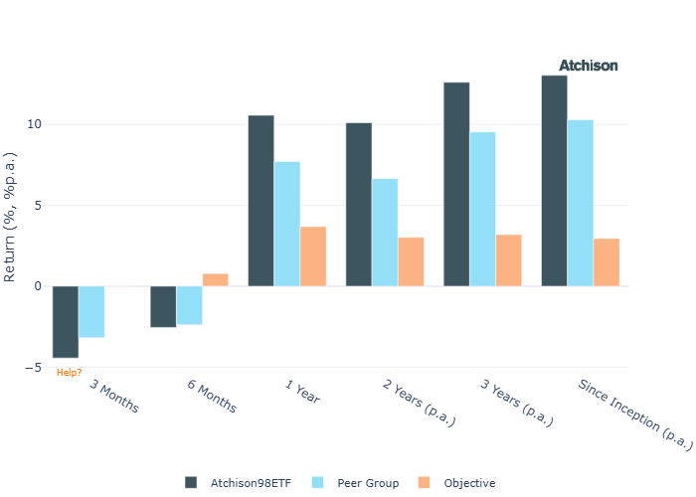
Cumulative Performance Since Inception
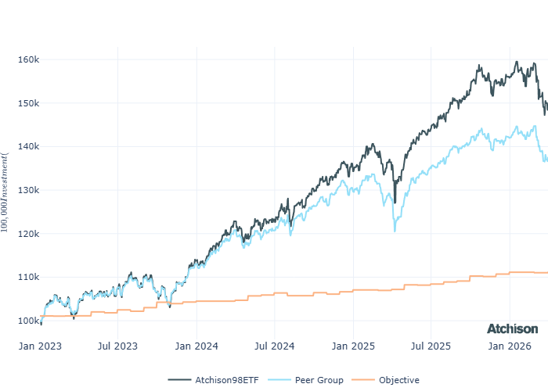
Portfolio Allocations
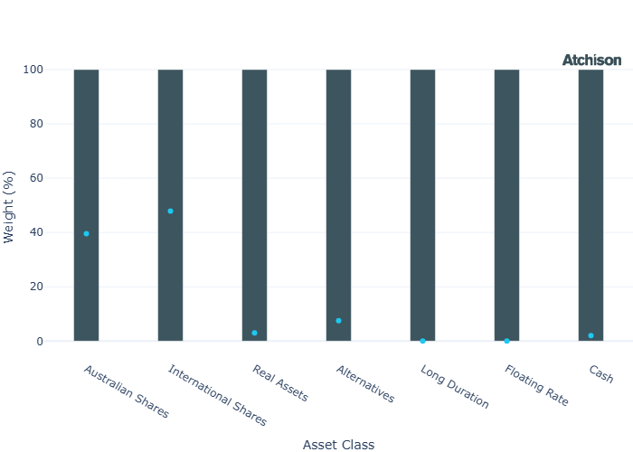
Asset Class Performance
Period | 1 Year | 3 Years (p.a.)
Australian Shares | 11.13 | 9.07
International Shares | 8.57 | 13.88
Real Assets | 7.78 | 9.44
Alternatives | 22.12 | 19.11
Long Duration | 0.0 | inf
Floating Rate | 0.0 | inf
Cash | 3.87 | 4.22
Inception Date: 31 December 2022
Portfolio Construction
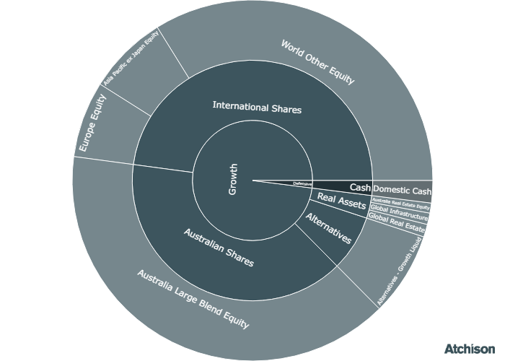
Correlations
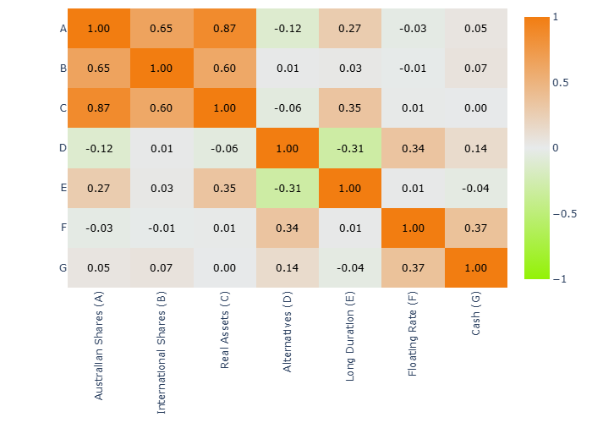
Historical Allocation Changes
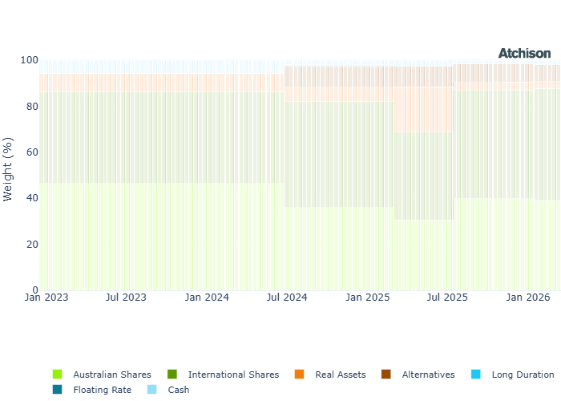
Underlying Current Manager Performance
Strategy | 1 Year | 3 Years (p.a.)
iShares ASX 200 | 11.66 | 9.45
BM: Australian Shares | 11.66 | 9.45
iShares US 500 | 6.83 | 16.85
iShares US 500 Hedged | 15.37 | 16.05
VG Europe Eq | 6.74 | 11.8
iShares Japan | 15.07 | 14.16
VG Asia ex Japan | 17.55 | 12.87
VG All ex US Shares | 13.31 | 13.29
BM: International Shares | 7.61 | 14.91
iShares AREIT | -3.39 | 7.11
iShares GREIT | 7.53 | 6.01
iShares Glob Infra H | 16.64 | 10.92
BM: Real Assets | 3.44 | 5.47
VE Global Listed P Private ETF | -22.11 | 9.98
iShares Physical Gold | 34.27 | 28.39
BS Energy ETF | 40.6 | 17.24
BM: Alternatives | 3.86 | 4.24
iShares Cash | 3.87 | 4.23
Cash | 3.86 | 4.24
Inception Date: 31 December 2022
Underlying investment manager returns are shown after fees and before tax

Market Update
The ASX200 lifted 4% for the month of February. Sector dynamics drove the divergence, with Financials and Materials within the S&P/ASX 200 each climbing close to 9%. In contrast, Health Care fell sharply and Information Technology remained under pressure, now significantly below its July 2025 peak amid concerns around AI disruption.
The ASX 20 advanced about 8%, while smaller companies lagged and both the ASX Small Ordinaries and NZX SmallCap indices declined.
South Korea led regional markets once again, with the Korea BMI advancing roughly 20% for the month and around 52% year-to-date.
U.S. equities faced headwinds in February, as heightened scrutiny around AI-related capital spending and its implications for corporate profitability weighed on large-cap technology companies. The S&P 500 recorded its third weekly decline.
Sector performance among large caps was uneven, reflecting a pullback in enthusiasm for major technology companies and a move toward more defensive positioning. Utilities delivered the strongest gains, while Communication Services and Consumer Discretionary sectors declined.
Factor strategies largely produced positive results, with quality, dividend and low-volatility approaches outperforming. Value-oriented strategies also exceeded growth-focused approaches during the month.
In Europe, most sectors delivered positive returns, with Communication Services and Real Estate producing particularly strong gains, while Financials was the only sector to decline during the month.
Australian 10-year government bond yields eased to 4.29%, while expectations for domestic monetary easing expected later in 2026.
U.S. 10-year Treasury yields declined to 4.21%, with interest rate markets increasingly assigning a greater probability to a third Federal Reserve rate reduction later in the year.
Recent escalation in the Middle East has increased geopolitical uncertainty and reintroduced energy supply risk into market pricing. Investors are assessing whether higher oil prices could reignite inflation, slow growth, or both.
We maintain, meaningful exposure to global infrastructure, structural allocation to energy stocks, dedicated gold allocation, high-quality fixed income, active currency hedging.

Fine Print
Important Notice: This document is published by TAG Asset Consulting Group Pty Ltd, trading as Atchison Consultants, ABN 58 097 703 047, AFSL 230 846. Atchison Consultants distributes its investment solutions via platform and dealer groups (financial advisory groups).

Warning: Please be advised that past performance is not indicative of future performance. The returns discussed herein are based on model asset allocations and are for illustrative purposes only. Actual returns may differ due to variations in fees, timing of model change implementation, and the need to substitute individual holdings where reliable data was not available from our data providers. Any insights or recommendations provided in this document are intended for general advice purposes only and are based on our opinion of the investment merits of the financial products discussed, independent of the financial circumstances of any individual. Before proceeding with any investment based on the information provided, recipients must assess its suitability to their financial situation and consider seeking advice from an independent financial advisor.

Disclaimer: While care is taken to ensure the accuracy and completeness of the information presented herein, no warranties or representations are made as to its reliability. The content provided is derived from publicly available sources, or external data providers, which have not been independently verified by Atchison Consultants. Atchison Consultants, along with its directors, officers, employees, and agents, expressly disclaims any liability for errors, inaccuracies, or omissions in this document, as well as for any loss or damage that may arise from reliance on its contents. Readers are cautioned to verify all information independently before taking any actions based on this report.

