
September 2024

Recommended Fund Review

Fairlight Global Small & Mid Cap Fund
APIR: PIM7802AU

FUND
The Fairlight Global Small & Mid Cap Fund (the “Fund”) is managed by Fairlight and was incepted in November 2018. Fairlight invests in small-mid cap Global equities with a focus on quality and growth.

It employs a long only, low turnover, concentrated portfolio construction process (average 30-40 stocks). The Fund is structured as an open-ended unlisted registered managed investment scheme.

INVESTMENT OBJECTIVE
The Fund aims to outperform the MSCI World SMID Cap NR Index AUD (‘the Benchmark’) after all fees and expenses over a rolling seven-year period by investing in a portfolio of ex-Australian global companies.
The Fund is a quality/growth oriented, actively managed fund that invests in small-mid cap ex-Australian global listed companies in the market cap spectrum of US$500mn-$40bn.

GOVERNANCE AND COMPLIANCE
Responsible Entity
The Trust Company (‘Perpetual’, ‘the RE’) is the Responsible Entity of the Fairlight Global Small & Mid Cap Fund. Pleasingly the RE is not a related party.

Compliance
The Responsible Entity’s Compliance Committee is responsible for overall compliance as part of its function in forming long-term alliances and supporting a stable of investment management businesses.

FUNDS UNDER MANAGEMENT
- Global Small & Mid Cap Fund - $1.6bn

The Manager has indicated a capacity limit of US$4bn on Fund and as such there is plenty of headroom for growth. This is the only Fund that the manager is responsible for. Over 90% of the money invested is retail with only roughly $80mn invested across two institutional mandates.
PRODUCT FEATURES

- Management Fee = 1.30% p.a.
- Performance Fee = 15% (Hurdle and High Watermark included)
- AFC = 1.75%
- Buy/Sell Spread = 0.25%/0.25%
- Risk Level = High

The total fee load is high in an absolute sense and on a peer-relative basis it is deemed to be above the median of fundamental small- cap peers.

INVESTIBLE STATUS
The Fund is open to wholesale and retail investors, available on platforms. Plenty of capacity remaining for investment.

BUSINESS
Fairlight is an Australian based International Equities Manager. Established in November 2018 by Nicholas Cregan, they offer one strategy, which is the Fairlight Global Small & Mid Cap Fund. Fairlight is 50% employee owned with the remaining 50% stake held by Perennial. Perennial provides back-office support and is responsible for the distribution of the Fund.

INVESTMENT TEAM

The Investment team is led by Nicholas Cregan who has ultimate decision-making authority. Cregan is supported by three portfolio managers and one quantitative analyst. Whilst the team is small for the size of the universe, we are cognisant of the robust quality screens that are used to narrow the universe to a much more manageable level. As such, the team is considered to be sufficiently resourced.

Track record and co-tenure amongst the team is on the lower end compared to peers, however, recent additions are considered highly capable and welcome resources. Pleasingly Nicholas Cregan and Will Dowd have a long working relationship having worked together at Evand & Partners before Fairlight.

Remuneration and Incentives
Pleasing all PMs are equity holders in the business and have a profit share arrangement. In addition to this they are all significantly co-invested in the Fund. Whilst there is no direct performance bonus based on the outperformance of the Fund, the equity structure and co-investment is seen as sufficient and the co-PMs are considered to be adequately aligned with investors.

Key Person Risk
A departure of Nicholas Cregan would be a considerable loss for the Fund and would trigger a re-assessment of the investment case. However, his considerable equity in the business and being a founder makes this an unlikely event.

INVESTMENT PHILOSOPHY AND PROCESS

Investable Universe

The Fund seeks ideas from the global investment universe excluding Australian listed companies. The Fund will invest in companies between a market cap of US$500mn-$40bn. However, the manager has indicated that their “sweet spot” is companies in the single digit billions of market cap. The Fund is benchmarked against the MSCI World SMID AUD (Net) Index.

Philosophy

The Manager employs a quality centric philosophy. Primarily the manager aims to identify high quality growth, stable compounders and turnaround/special situations. The focus on quality is considered highly portable to the small & mid-cap universe where capital preservation tends to be more important.

Idea Generation

Fairlight utilise a number of quality screens based on ROIC, business cycle, ratios, ESG and single points of failure. This narrows their universe to 200-300 companies and is a valuable source of ideas. The Manager also utilises research trips as a source of ideas, often having someone in the team located overseas for 6 months at a time. This extensive use of travel is seen as highly valuable and helps decrease potential information asymmetries between an Australian based international equities manager and global based managers.

Research Process

The Manager will break up potential investments into three different opportunity types with different return profiles. These first of which are High Quality Growth, characterised by companies that generate sustained earnings growth and either require little capital to operate or those who can deploy growth capital at high rates of return. The second bucket is Stable compounders which are businesses that generate modest revenue growth, stable cash-flows and have opportunities to extend margins. The final bucket and low risk turnarounds and special situations which tend to be contrarian in nature and require some refocus to unlock the inherent quality in the business.

The Manager follows a four-stage process. Stage one is the initial screening and allocation, followed by stage two where the analysts conduct a rapid due diligence that is two days and aims to reduce the emotional bias of being too attached to a company, they have spent a lot of time on. A discussion takes place on the investment merit and if successful it will move to stage three where a deep due diligence is conducted. In the deep due diligence, the team conduct research trips, meetings with management and detailed forecasting and industry analysis. This is followed by another discussion between the team before it moves to the final stage being portfolio construction.

The Manager has been automating a lot of their process and has partnered with Calibre to build out fundamental research models on their system. This is seen as a competitive edge and a highly useful addition to their approach.

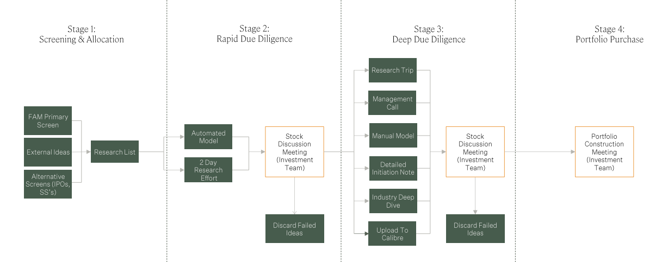

Portfolio Construction

The Portfolio will hold 30-40 companies, 40% of which will be “High Growth Quality”, 40% will be “Stable Compounders” and 15% will be “Turnaround & Special Situation” with the remaining in cash.
The individual stock weighting follows an assessment of the stocks conviction rating and discount to intrinsic value. Pleasingly the manager also pays high attention to cross-correlations between positions and adjusts accordingly.

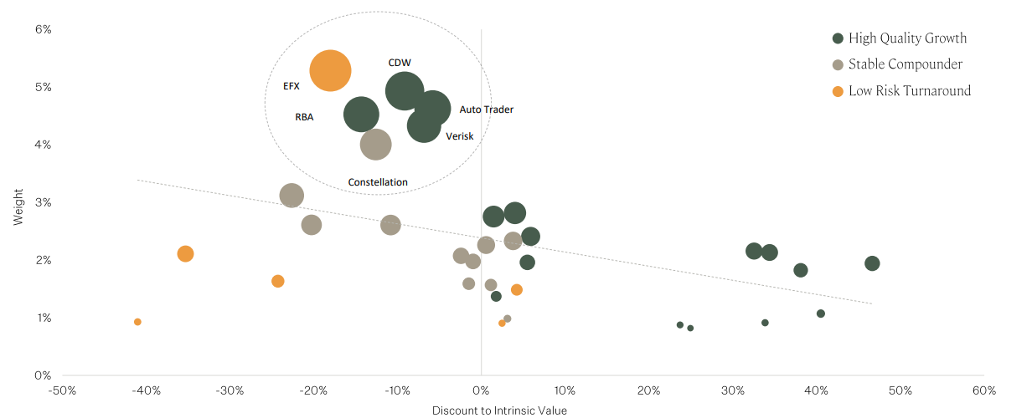

Risk Management

The Manager is relatively unconstrained in terms of positioning and managing the Fund. There are few risk limits in place, however, this is consistent with the high conviction design. The Manager is limited to Developed Markets only which is viewed positively given the flow of information in emerging market small & mid-caps can be asymmetric.

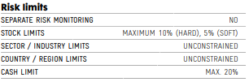

PORTFOLIO CHARACTERISTICS

Portfolio Turnover

The Fund’s turnover is typically 25% annually. The manager is active in adding and trimming names, however, actual name turnover is low, which is expected given the managers approach to quality and stable compounding. The Manager does have a deep bench of names that are approved in terms of investment case, however, are not at the right valuation. Turnover on the bench is around 20% per year.

Liquidity

Small cap stocks have the potential to be less liquid, however, the Fund invests at the larger end of small’s and has some mid-cap exposures.

Leverage

This Fund does not employ leverage.

PERFORMANCE – 30/09/2024

Performance Opinion
The Fund has outperformed over one-, three- and five-year periods. The Fund is expected to perform through cycles with its distinct approach to quality. The manager separates stocks into three different buckets that have different levels of risk and return drivers.
A global small-cap manager enhances diversification in a multi-manager portfolio by providing exposure to different geographies, currencies and reducing the reliance on domestic economic factors. Additionally, the sector composition and growth profile of global small caps differ from those of domestic small caps, improving the portfolio's return potential while mitigating risk.
Atchison supports active management in the small-cap space, emphasising that its unique market dynamics and complexities make it well-suited for active strategies. Atchison also notes that the asymmetric flow of information in this segment further reinforces the advantages of an active approach.

CONCLUSION
- The Fund is led by a highly capable and experienced PM. Pleasingly this is the only strategy Fairlight, and the team are responsible for and as such there are no distractions. Perennial look after back office and distribution which takes pressure off the team.
- No capacity concerns at current levels with AUD$1.6bn invested in the Fund. The manager has indicated a US$4bn capacity target and as such there is plenty of headroom for growth.
- The investment approach is deemed to be thorough and repeatable with a clear philosophy and target companies. Their internal systems and research & development partnership with Calibre is viewed as a competitive edge.
- Fees are high in an absolute sense and on the higher end of small cap fundamental peers. Consequence of investing in an Australian based Global equities manager.
- Investment case here is based on a high-quality portfolio of companies that will complement domestic small/mid cap exposure in a multi manager portfolio. Non-Austrlian portfolio provides the diversification benefit and reduces liquidity issues while maintaining exposure to the small cap factor.



Atchison Consultants
Level 4, 125 Flinders Lane,
Melbourne Vic 3000
P: +61 (0) 3 9642 3835
enquiries@atchison.com.au
www.atchison.com.au
ABN: 58 097 703 047
AFSL Number: 230846
To obtain further information,
please contact:

Kev Toohey
Principal
P: +61 3 9642 3835
E: kev@atchison.com.au

Nick Hatzis
Analyst
P: +61 433 717 504
E: nick@atchison.com.au

