
September 2024

Recommended Fund Review

Talaria Global Equity Strategy
APIR: TLRH-AU

FUND
The Talaria Global Equity Strategy (the “Fund”) is managed by Talaria and was incepted in October 2005. Talaria is an alternatives manager that utilises a cash-secured put strategy to invest in stocks or generate income.

It employs a long only, low turnover, concentrated portfolio construction process (average 25-40 stocks). The Fund is structured as an open-ended unlisted registered managed investment scheme.

INVESTMENT OBJECTIVE
The Fund’s investment strategy seeks to increase the certainty of international equity returns for investors. Talaria aims to deliver on its objective through generating income, capturing less of the downside and lower volatility.
The Fund is a quality/value oriented, actively managed fund that invests in large cap global listed companies through writing cash-secured puts.

GOVERNANCE AND COMPLIANCE
Responsible Entity
Australian Unity Funds Management Limited (“the RE’) is the Responsible Entity of the Talaria Global Equity Strategy. Pleasingly the RE is not a related party.

Compliance
The Responsible Entity’s Compliance Committee is responsible for overall compliance as part of its function in forming long-term alliances and supporting a stable of investment management businesses.

FUNDS UNDER MANAGEMENT
- Talaria Global Equity Strategy $2.5bn

The Manager has indicated a capacity limit of $5bn on Fund and as such there is plenty of headroom for growth. This is the only Fund that the manager is responsible for.
PRODUCT FEATURES

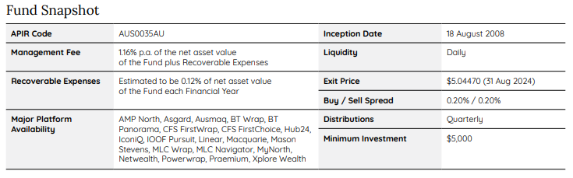

The management fee is considered high, however, the absence of a performance fee results in a total fee load that is lower than peers. A portfolio that sits in the alternatives bucket with daily liquidity is also a positive.

INVESTIBLE STATUS
The Fund is open to wholesale and retail investors, available on platforms. Plenty of capacity remaining for investment.

BUSINESS
Talaria is an Australian based alternative investment manager founded in 2005. Talaria is 70% employee owned with the remaining 30% owned by The Wingate Group. Talaria are a one strategy shop solely focused on running the Talaria Global Equity Strategy.

INVESTMENT TEAM

The investment team is lead by co-CIOs, Chad Padowitz and Hugh Selby Smith, who both have extensive experience in markets and are capable stewards of the Fund. Providing support is a team of five analysts. Whilst the analyst team is experienced the relative co-tenure is less than peers with some changes and additions in recent years. The team operate a number of screens to help narrow the universe to a more manageable level and thus is considered adequately resourced.

Remuneration and Incentives
Pleasing co-CIOs are equity holders in the business and have a profit share arrangement. In addition to this they are all significantly co-invested in the Fund.

Analyst team are paid a combination of salary and performance based bonus based on short and long term incentives. These include stock recommendations, performance of the fund and growth in assets.

Key Person Risk
Due to the lower co-tenure amongst the broader team a departure of Chad Padowitz or Hugh Shelby Smith would be a considerable loss for the Fund and would trigger a re-assessment of the investment case. However, their considerable equity in the business helps mitigate concerns.

INVESTMENT PHILOSOPHY AND PROCESS

Investable Universe

The Fund seeks ideas from the global investment universe excluding Australian listed companies and will invest in companies above a market cap of US$5bn. The investment universe is large cap developed equities; however, it can invest in emerging market stocks using ADRs only. The Fund is benchmarked against the MSCI World ex-Aus Indes SA Net Dividends Reinvested.

Philosophy

The Manager aims to deliver superior risk adjusted returns with a consistent income stream from option writing. The underlying positions will reflect quality at a reasonable price with the manager believing companies with strong free cash flows will deliver more sustainable and consistent returns.

The Managers investment philosophy revolves around the inherent bias of people to pay more for insurance. Thus the sale of put options will produce a consistent and attractive income stream.

Idea Generation

Talaria utilises several quality-based screens reflecting their proprietary “seven metrics”. This takes the universe from 2500 companies to 220. The filters are run monthly with a focus on new names. This is a pragmatic way to narrow the universe to a more manageable level.

Research Process

The roughly 220 stocks that come through the screening process are divided amongst the team where they make an initial assessment. In the initial assessment phase, the analysts are looking for reasons that it may not be investable which helps them prioritise a research list of roughly 80 names.

The Fundamental research phase includes a deep dive into the companies’ fundamentals with a focus on looking at normalised free cash flow. The manager is assessing the track record and consistency of the company. ESG is integrated into the research, however, it is skewed towards governance with the manager keeping a keen interest in the quality of management and their capital allocation practices.

Financial metric analysis and valuation principles feature heavily and result on the portfolio having a skew towards quality and value.

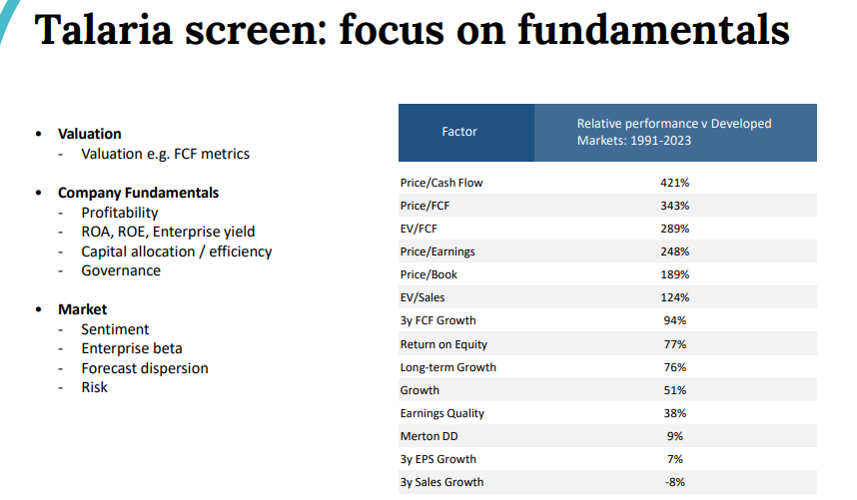

Portfolio Construction

The Manager will not buy any stocks on market. When a stock has been agreed upon by the team it will enter the portfolio through option sales. The team will write put options at a strike price roughly 3-5% below the current market price with 1-3 months to expiration. Stock weights are determined based on conviction and the estimated rate of return. This portfolio construction process means the manager may miss some stocks that run up and are above the strike price of their options at expiration.

When exiting positions the manager will write call options to facilitate the sale of stocks. However, the manager has allowed two exceptions to this rule which are if the stock has run up quickly or something significant has change in the fundamentals of the business. In the occurrence of either of these situations the manager will sell the stock on market.

The final portfolio will comprise 25-40 stocks with a large cap quality/value bias.

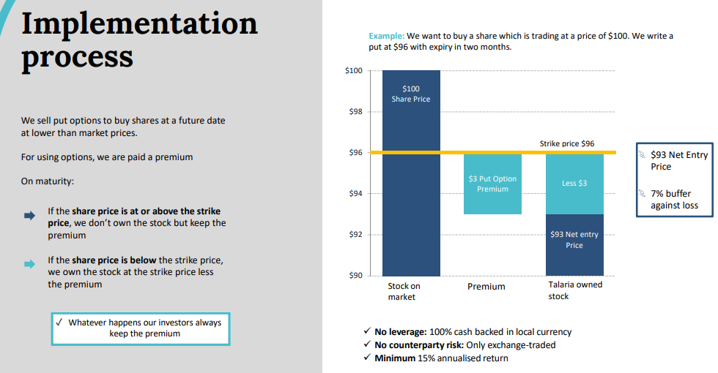

Risk Management

The Manager is relatively unconstrained in terms of positioning and managing the Fund. There are few risk limits in place, however, this is consistent with the high conviction design. The Manager is limited to Developed Markets only, although, can invest in emerging markets through ADRs. Whilst the manager has a single stock limit of 10%, they indicated that internally they view their limit as 6% and will view a stock going above that as a trim indicator.

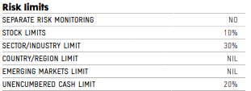

PORTFOLIO CHARACTERISTICS

Portfolio Turnover

The Fund’s turnover is typically 30-40% annually. The manager is active in adding and trimming names, however, actual name turnover is low.

Liquidity

The Fund invests in large cap global stocks and as such there are no liquidity concerns.

Leverage

The put options are fully cash backed and the call options are fully equity backed thus the manager is not exposed to leverage.

PERFORMANCE – As at 31/08/2024
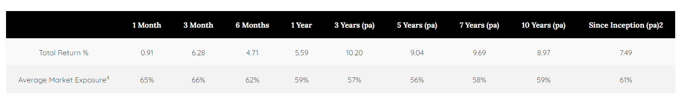
Performance Opinion
The strategy will provide a consistent income stream and insulation in times of market stress. The Fund has outperformed in all down markets on a rolling three-year basis. This is due to the managers philosophy of people paying more for insurance is more fruitful when markets are trending down. However, the Fund will lag in rising markets compared to traditional equity peers and in the long run is expected to have a low growth profile.
The Fund will have less volatility than traditional equity managers providing a smoother return profile. In addition to this the strategy has a low correlation to the NASDAQ and traditional equity managers.
This low volatility, low correlation and downside protection means the Fund will blend well in a multi manager portfolio that has a reasonable exposure to equity managers. Will provide insulation and diversification.

CONCLUSION
- Single strategy shop is viewed favourably and means the team has sole focus on the strategy. The
- The Fund is led by two highly capable CIOs who have amassed a significant working relationship together. Have support from a five-person analyst team. The team is considered to be adequately resourced.
- The process is differentiated in the form of option premiums and consistent income stream with no on market purchases. Pragmatic rules allowing on market selling in times of extreme market circumstances.
- The strategy provides relatively low-cost access to the alternatives space.
- The investment case here revolves around the diversification and income insulation this fund will provide in combination with traditional equity managers. Will blend best with a portfolio that has a relatively high growth allocation.



Atchison Consultants
Level 4, 125 Flinders Lane,
Melbourne Vic 3000
P: +61 (0) 3 9642 3835
enquiries@atchison.com.au
www.atchison.com.au
ABN: 58 097 703 047
AFSL Number: 230846
To obtain further information,
please contact:

Kev Toohey
Principal
P: +61 3 9642 3835
E: kev@atchison.com.au

Nick Hatzis
Analyst
P: +61 433 717 504
E: nick@atchison.com.au

