Atchison Active 55 SMA 30 November 2025
 | 3 Months | 6 Months | 1 Year | 2 Years (p.a.) | Since Inception (p.a.)
Atchison55ACTIVE | 0.95 | 4.48 | 7.03 | 10.97 | 10.28
Peer Group | 1.78 | 5.35 | 7.34 | 10.43 | 8.99
Inflation | 2.52 | 2.33 | 3.79 | 3.02 | 3.16
Outperformance vs Peers | -0.83 | -0.87 | -0.32 | 0.54 | 1.3
Outperformance vs Inflation | -1.57 | 2.15 | 3.23 | 7.95 | 7.13
Inception Date: 31 December 2022

Investment Objective
Outperform the FE AMI Mixed Asset – Balanced Peer Index, after underlying manager fees and before tax, over rolling seven-year periods.

Strategy Overview
Atchison Active 55 Portfolio is a Separately Managed Account (SMA), which is an all-inclusive diversified, multi-asset, investment portfolio professionally managed for you (the client) on behalf of a financial advisor. This portfolio is made up of 55% growth assets, and 45% defensive assets and uses a combination of passive ETFs and active managers. Asset classes include Australian Shares, Global Shares, Alternatives, Floating Rate, Long Duration, Real Assets and Cash.
Key Details
Strategy Category | Multi Asset
Strategy Provider | Atchison
Benchmark | FE AMI Mixed Asset – Balanced Peer Index
Inception Date | 31 December 2022
Investment Horizon | 7 Years
Risk Level (SRM) | Medium
Min Investment | 25k
Product Fee | Platform Specific - Refer to PDS
Underlying MER | 0.42%
Underlying Perf Fees | 0.07%
Top 10 Share Exposures
Code | Name
MSFT.NAS | MICROSOFT CORP
AAPL.NAS | APPLE INC
BHP-AU | BHP Group Limited
NVDA.NAS | NVIDIA CORP
GOOG.NAS | ALPHABET INC CLASS C
AMZN.NAS | AMAZON COM INC
CBA-AU | Commonwealth Bank of Australia
GOOGL.NAS | ALPHABET INC CLASS A
LLY.NYS | ELI LILLY
META.NAS | META PLATFORMS INC CLASS A
Strategy Performance
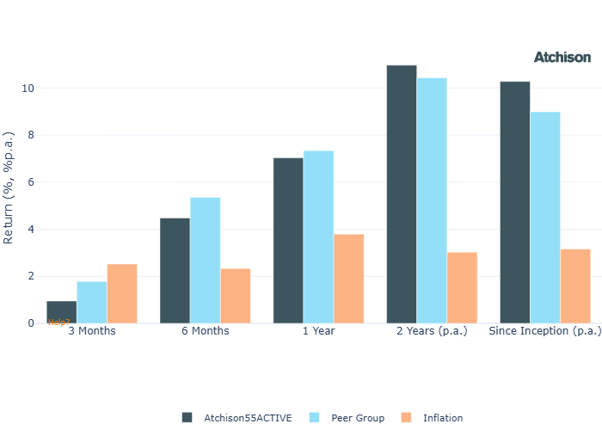
Cumulative Performance Since Inception
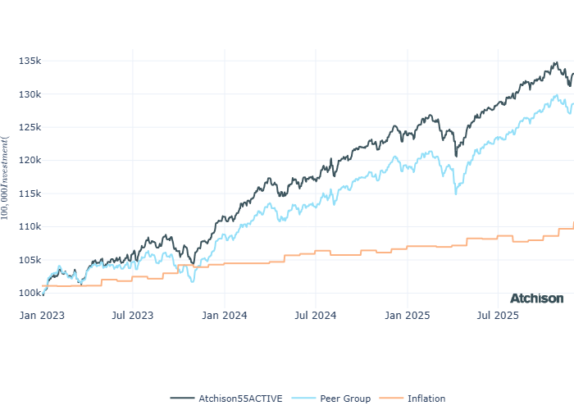
Portfolio Allocations
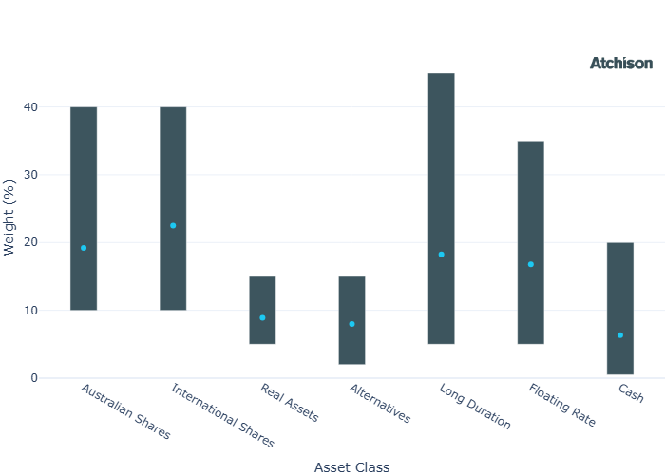
Asset Class Performance
Period | 1 Year | 2 Years (p.a.)
Australian Shares | 5.19 | 13.46
International Shares | 10.44 | 18.98
Real Assets | 5.42 | 12.03
Alternatives | 10.22 | 11.23
Long Duration | 4.03 | 4.46
Floating Rate | 4.95 | 5.82
Cash | 4.15 | 4.36
Inception Date: 31 December 2022
Portfolio Construction
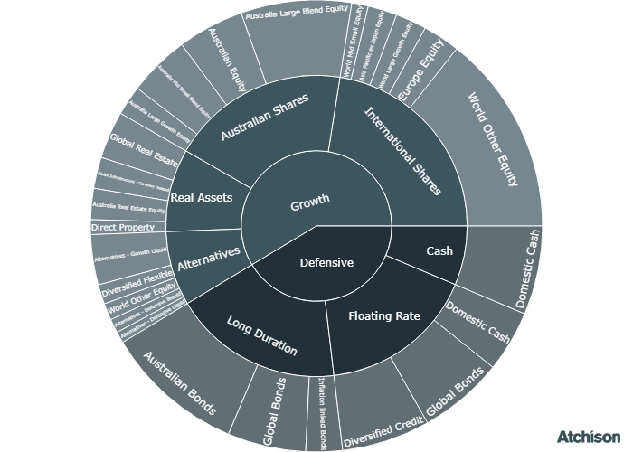
Correlations
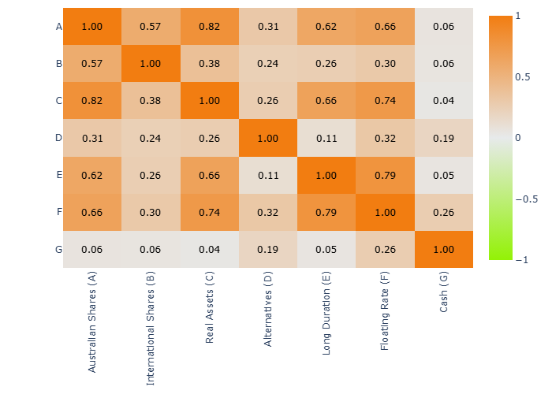
Historical Allocation Changes
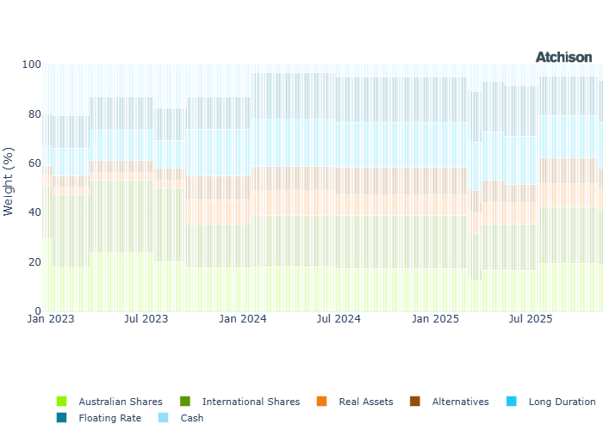
Underlying Current Manager Performance
Strategy | 1 Year | 2 Years (p.a.)
iShares ASX 200 | 5.49 | 14.02
Merlon Concentrated AusEq | 8.55 | 15.63
Ausbil Aus Small | 25.28 | 33.88
Invesco Aus Small | 11.99 | 18.87
Greencape High Convic | -3.85 | 10.3
Hyperion Aus Growth | -17.35 | 9.91
Invesco WS Aus Share | 5.13 | 14.54
BM: Australian Shares | 5.4 | 13.96
iShares US 500 | 14.65 | 24.91
iShares US 500 Hedged | 13.49 | 22.24
VG Europe Eq | 26.37 | 18.37
GQG Global Eq | -6.17 | 11.82
Man GLG Asia | 28.09 | 23.58
Fairlight Glob Small Mid | -5.98 | 5.49
BM: International Shares | 18.49 | 22.78
iShares AREIT | -0.72 | 17.44
iShares GREIT | 0.56 | 9.45
Alceon Aus Prop & Infra | 7.67 | 9.33
CB RARE Infra Income H | 15.17 | 14.82
BM: Real Assets | 2.81 | 10.87
VE Global Listed P Private ETF | -5.91 | 15.72
Talaria GE | 6.37 | 6.31
P/E FX Alpha | -5.76 | 1.9
Invesco Senior Secured | 3.88 | 5.3
Pyford Global Abs | 8.13 | 9.06
iShares Physical Gold | 56.37 | 43.81
Barwon LPE | -1.27 | 11.49
BM: Alternatives | 4.12 | 4.35
iShares Aus Bond | 4.28 | 4.63
iShares CPI Bond | 2.92 | 3.59
iShares Globa Agg ESG | 3.53 | 4.43
WA Aus Bond | 4.4 | 5.18
Colchester Gov Bond | 4.6 | 3.97
BM: Duration | 3.91 | 4.68
VanEck FRN | 5.01 | 5.22
iShares Enh Cash | 4.28 | 4.48
Janus Div Credit | 6.21 | 6.95
Daintree Core Inc | 5.44 | 6.93
Bentham Global Inc | 4.34 | 6.62
BM: Floating | 4.84 | 5.17
iShares Cash | 4.13 | 4.34
Cash | 4.12 | 4.35
Inception Date: 31 December 2022
Underlying investment manager returns are shown after fees and before tax

Market Update
Australia’s S&P/ASX 200 retreated 3 percent, while New Zealand’s S&P/NZX 50 also finished the month slightly lower.
The weakness in the S&P/ASX 200 was driven primarily by Financials, which fell 7 percent. Information Technology performed even more poorly, sliding 12 percent. By contrast, Health Care and Consumer Staples were relative bright spots, each advancing 2 percent.
For the month, low volatility as a factor stood out as the only index to deliver a positive return. Growth and Momentum factors, however, were among the weakest performers.
Chinese equities dipped in November as early-month gains faded. Weak manufacturing and services data, ongoing property-sector strain, and softer domestic demand weighed on market sentiment.
The S&P500 finished muted for the month up 0.13%. Sector performance among large-caps was mixed. Health Care delivered an exceptional 9 percent return. Information Technology fell 4 percent amid renewed worries about an AI-driven valuation bubble, although it recovered strongly toward month end.
Mid and small-capitalisation stocks outperformed, with midcaps rising 2 percent and smallcaps gaining 3 percent.
Factor performance shifted from the previous month, with Low Volatility and Dividend strategies outperforming High Beta, while Value led Growth.
Europe delivered a subdued but positive outcome in November, edging up 1 percent. Health Care stood out as the strongest performing sector, rising 6 percent over the month. At the opposite end, Information Technology declined 4 percent as concerns about stretched valuations weighed on sentiment.
Fixed income markets generally remained under pressure. After leaving the cash rate unchanged in early November, the Reserve Bank of Australia is now viewed as more likely to tighten than ease, particularly following stronger than expected inflation data.
Most major fixed income indices advanced. U.S. Treasuries firmed as markets priced in a higher likelihood of rate cuts, with the 10-year yield dipping below 4 percent.
Crude oil, fell 4 percent, while gold continued its strong run, rising a further 5 percent to take its year to date gain to 57 percent.

Fine Print
Important Notice: This document is published by TAG Asset Consulting Group Pty Ltd, trading as Atchison Consultants, ABN 58 097 703 047, AFSL 230 846. Atchison Consultants distributes its investment solutions via platform and dealer groups (financial advisory groups).

Warning: Please be advised that past performance is not indicative of future performance. The returns discussed herein are based on model asset allocations and are for illustrative purposes only. Actual returns may differ due to variations in fees, timing of model change implementation, and the need to substitute individual holdings where reliable data was not available from our data providers. Any insights or recommendations provided in this document are intended for general advice purposes only and are based on our opinion of the investment merits of the financial products discussed, independent of the financial circumstances of any individual. Before proceeding with any investment based on the information provided, recipients must assess its suitability to their financial situation and consider seeking advice from an independent financial advisor.

Disclaimer: While care is taken to ensure the accuracy and completeness of the information presented herein, no warranties or representations are made as to its reliability. The content provided is derived from publicly available sources, or external data providers, which have not been independently verified by Atchison Consultants. Atchison Consultants, along with its directors, officers, employees, and agents, expressly disclaims any liability for errors, inaccuracies, or omissions in this document, as well as for any loss or damage that may arise from reliance on its contents. Readers are cautioned to verify all information independently before taking any actions based on this report.

