Euree Balanced Portfolio 31 December 2025
 | 3 Months | 6 Months | 1 Year | 2 Years (p.a.) | Since Inception (p.a.)
Euree_Balanced | 1.08 | 4.51 | 9.67 | 10.78 | 11.13
Peer Group: FE Balanced | 0.71 | 4.08 | 8.14 | 8.68 | 9.19
Objective: CPI + 3% p.a. | 1.57 | 4.08 | 6.96 | 6.26 | 6.78
Outperformance vs Peers | 0.37 | 0.43 | 1.53 | 2.1 | 1.94
Outperformance vs Inflation | -0.49 | 0.43 | 2.71 | 4.52 | 4.36
Inception Date: 22 August 2023

Investment Objective
The Fund will invest in a mixture of asset classes to form a multi-asset portfolio with the aim to earn Investors a return of CPI +3% p.a. after management fees (before performance fees) and before tax, over rolling 7-year periods.

Strategy Overview
The Fund will use a combination of strategic asset allocation taking into account long term projections on asset class performance, short term dynamic asset allocation tilts,and passive and active investment managment to provide returns and mitigate risk in the medium term.
Key Details
Strategy Category | Multi Asset
Strategy Provider | Euree
Benchmark | The Fund will invest in a mixture of asset classes to form a multi-asset portfolio with the aim to earn Investors a return of CPI +3% p.a. after management fees (before performance fees) and before tax, over rolling 7-year periods.
Inception Date | 22 August 2023
Investment Horizon | 7 Years
Risk Level (SRM) | Medium to High
Min Investment | 10k
Product Fee | nan
Underlying MER | 0.95%
Underlying Perf Fees | nan
Top 10 Share Exposures
Code | Name
QRI-AU | Qualitas Real Estate Income Fund
BHP-AU | BHP Group Limited
CBA-AU | Commonwealth Bank of Australia
NAB-AU | National Australia Bank Limited
ANZ-AU | ANZ Group Holdings Limited
WBC-AU | Westpac Banking Corporation
CSL-AU | CSL Limited
WDS-AU | Woodside Energy Group Ltd
WES-AU | Wesfarmers Limited
MSFT.NAS | MICROSOFT CORP
Strategy Performance
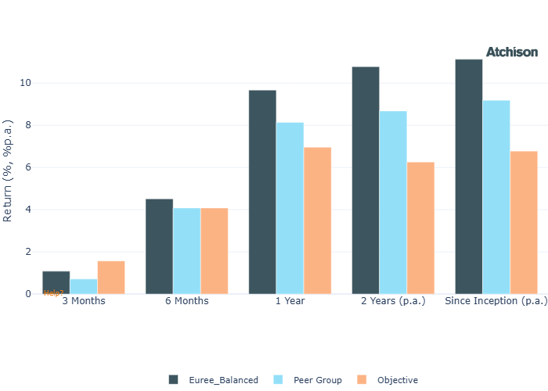
Cumulative Performance Since Inception
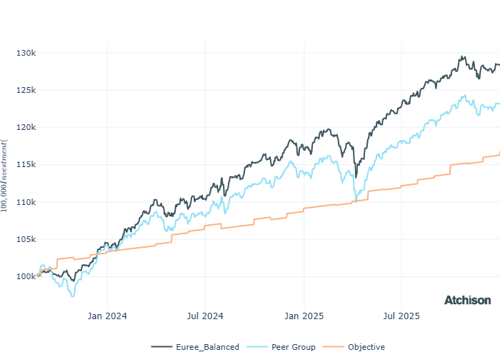
Portfolio Allocations
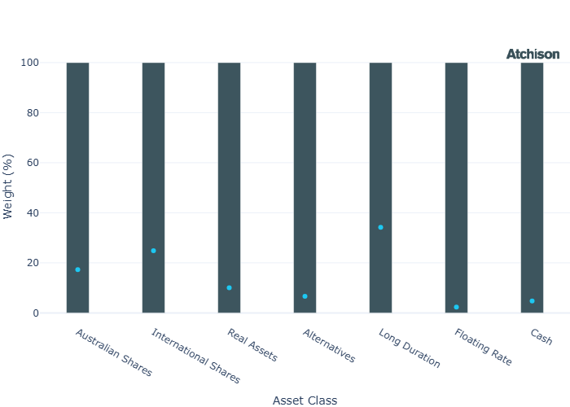
Asset Class Performance
Period | 1 Year
Australian Shares | 8.77
International Shares | 13.99
Real Assets | 11.91
Alternatives | 24.26
Long Duration | 2.05
Floating Rate | 5.63
Cash | 4.04
Inception Date: 22 August 2023
Portfolio Construction
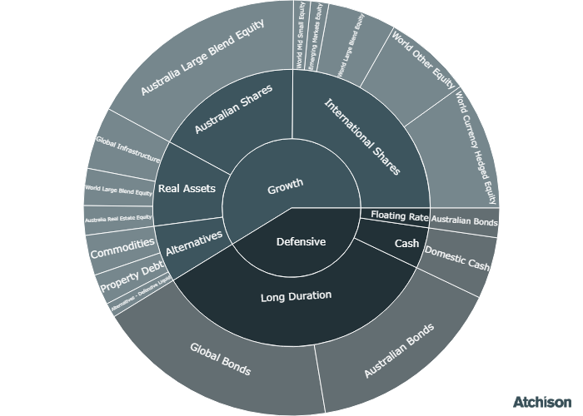
Correlations
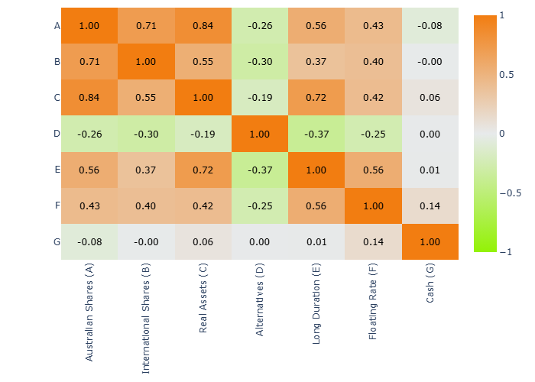
Historical Allocation Changes
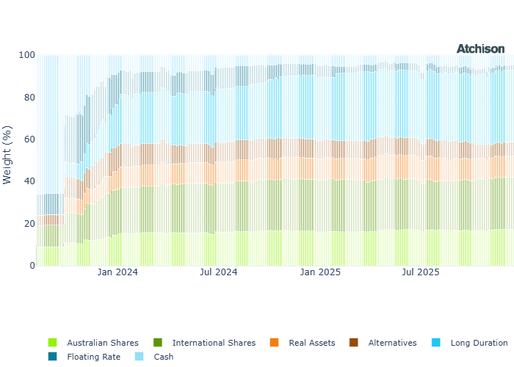
Underlying Current Manager Performance
Strategy | 1 Year | 3 Years (p.a.)
iShares ASX 200 | 10.26 | 10.03
Merlon Concentrated AusEq | 9.19 | 7.84
BM: Australian Shares | 10.32 | 10.02
VG MSCI World | 12.89 | 15.08
VG MSCI World Hedged | 19.29 | 16.09
iShares Japan | 16.42 | 11.81
Capital Group New H | 15.48 | 13.43
Fidelity EM | 16.37 | 8.31
CapGroup New Persp | 11.93 | 13.5
VG Int Smalls | 12.23 | 10.95
VE Global Quality Eq | 8.12 | 13.5
VG Global Value Eq | 18.08 | 13.01
BM: International Shares | 14.29 | 14.57
VG AREIT | 7.93 | 11.95
VanEck Glb Infra H | 11.92 | 9.41
RARE Infra Income | 17.09 | 10.36
Euree AREIT | 9.27 | 10.76
BM: Real Assets | 7.02 | 7.34
ETFS Physical Gold | 54.32 | 29.67
Janus Gbl Multi Strat | 7.56 | 3.33
Qualitas Prop Inc | 2.87 | 7.89
BM: Alternatives | 4.06 | 3.39
iShares Aus Bond | 2.97 | 3.03
VG Global Agg | 4.33 | 3.63
iShares Global Bond | 2.61 | 3.13
iShares Aus Bond | 0.93 | 2.39
BM: Duration | 3.65 | 3.4
Janus Tactical Inc | 5.63 | 4.58
BM: Floating | 4.77 | 3.97
iShares Cash | 4.07 | 3.38
Inception Date: 22 August 2023
Underlying investment manager returns are shown after fees and before tax

Market Update
The S&P/ASX 200 generated a total return of 10% over the year, extending its run to three consecutive years of double-digit performance. Market leadership came from smaller capitalisation stocks, with the Small Ordinaries Index climbing 25% and the Emerging Companies Index surging 39%.
Sector outcomes across the Australian market were uneven despite broad participation. Nine of the eleven S&P/ASX 200 sectors finished higher, led by a 35% rally in Materials. In contrast, Health Care endured a sharp 24% decline, and Information Technology reversed last year’s strength, falling 21%.
The largest detractors over the year included CSL, WiseTech Global, and Xero.
China’s CSI 300 rose 21% over the year, supported by policy easing, state-backed buying, and strength in financials, consumer staples, and industrials, despite ongoing property and growth challenges.
The S&P 500 delivered 18% for the year, the technology-heavy Nasdaq delivered 21% for the year. US aerospace and defence names were the biggest winners, along with unloved semiconductor companies including Intel and Micron Technology.
Sector performance across the large-cap universe was uniformly positive. Communication Services were up 34%, followed by Information Technology, which rose 24% over the year.
Expectations of Federal Reserve rate cuts also helped extend market gains beyond mega-caps, supporting improved performance across mid- and small-capitalisation stocks.
Several European markets performed strongly over the past 12 months, including Spain, up 50%, Italy, up 33%, and Germany, up 23%. Performance was supported by strength in European banks, while Germany benefited primarily from aerospace and defence stocks.
Economists expect persistent inflation to force the RBA into multiple rate hikes this year, potentially starting as early as February, amid resilient demand, tight labour markets, and rising housing costs.
In the US, markets anticipate further rate cuts in 2026, bringing rates down from their current range of 3.5%–3.75%, towards 3%.
Commodity performance was mixed. Gold rose 64% over the year, while silver outperformed with gains of 145%. In contrast, crude oil and Brent prices continued to struggle, declining around 20%.

Fine Print
Important Notice: This document is published by TAG Asset Consulting Group Pty Ltd, trading as Atchison Consultants, ABN 58 097 703 047, AFSL 230 846. Atchison Consultants distributes its investment solutions via platform and dealer groups (financial advisory groups).

Warning: Please be advised that past performance is not indicative of future performance. The returns discussed herein are based on model asset allocations and are for illustrative purposes only. Actual returns may differ due to variations in fees, timing of model change implementation, and the need to substitute individual holdings where reliable data was not available from our data providers. Any insights or recommendations provided in this document are intended for general advice purposes only and are based on our opinion of the investment merits of the financial products discussed, independent of the financial circumstances of any individual. Before proceeding with any investment based on the information provided, recipients must assess its suitability to their financial situation and consider seeking advice from an independent financial advisor.

Disclaimer: While care is taken to ensure the accuracy and completeness of the information presented herein, no warranties or representations are made as to its reliability. The content provided is derived from publicly available sources, or external data providers, which have not been independently verified by Atchison Consultants. Atchison Consultants, along with its directors, officers, employees, and agents, expressly disclaims any liability for errors, inaccuracies, or omissions in this document, as well as for any loss or damage that may arise from reliance on its contents. Readers are cautioned to verify all information independently before taking any actions based on this report.

