Euree Balanced Portfolio 20 February 2026
 | 3 Months | 6 Months | 1 Year | 2 Years (p.a.) | Since Inception (p.a.)
Euree_Balanced | 0.64 | 3.63 | 8.21 | 10.52 | 11.06
Peer Group | 0.18 | 3.86 | 6.83 | 8.5 | 9.09
Inflation | 1.26 | 3.2 | 6.53 | 6.05 | 6.47
Outperformance vs Peers | 0.46 | -0.22 | 1.38 | 2.02 | 1.97
Outperformance vs Inflation | -0.62 | 0.43 | 1.68 | 4.47 | 4.59
Inception Date: 22 August 2023

Investment Objective
The Fund will invest in a mixture of asset classes to form a multi-asset portfolio with the aim to earn Investors a return of CPI +3% p.a. after management fees (before performance fees) and before tax, over rolling 7-year periods.

Strategy Overview
The Fund will use a combination of strategic asset allocation taking into account long term projections on asset class performance, short term dynamic asset allocation tilts,and passive and active investment managment to provide returns and mitigate risk in the medium term.
Key Details
Strategy Category | Multi Asset
Strategy Provider | Euree
Benchmark | The Fund will invest in a mixture of asset classes to form a multi-asset portfolio with the aim to earn Investors a return of CPI +3% p.a. after management fees (before performance fees) and before tax, over rolling 7-year periods.
Inception Date | 22 August 2023
Investment Horizon | 7 Years
Risk Level (SRM) | Medium to High
Min Investment | 10k
Product Fee | nan
Underlying MER | 0.95%
Underlying Perf Fees | nan
Top 10 Share Exposures
Code | Name
QRI-AU | Qualitas Real Estate Income Fund
BHP-AU | BHP Group Limited
CBA-AU | Commonwealth Bank of Australia
NAB-AU | National Australia Bank Limited
ANZ-AU | ANZ Group Holdings Limited
WBC-AU | Westpac Banking Corporation
CSL-AU | CSL Limited
WDS-AU | Woodside Energy Group Ltd
WES-AU | Wesfarmers Limited
NEM-AU | Newmont Corporation
Strategy Performance
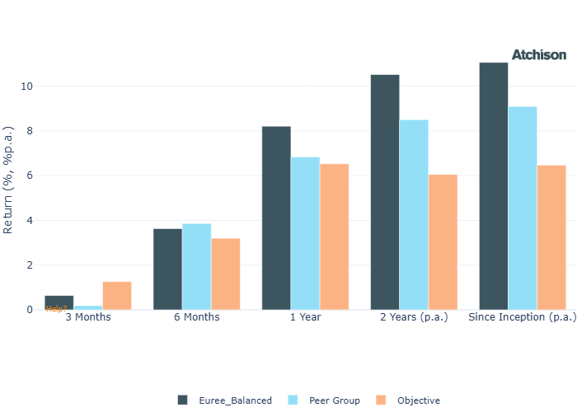
Cumulative Performance Since Inception
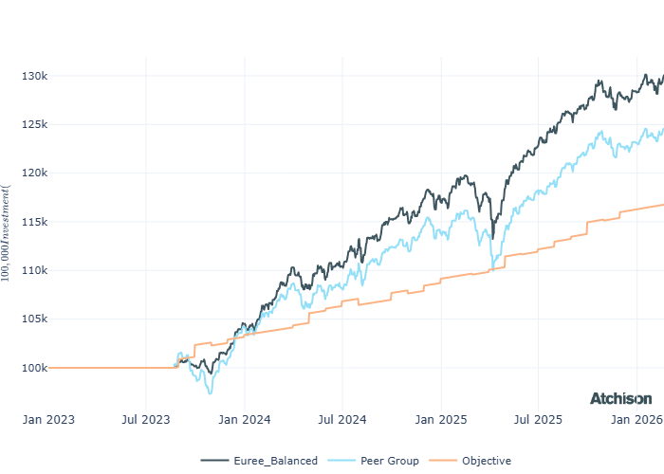
Portfolio Allocations
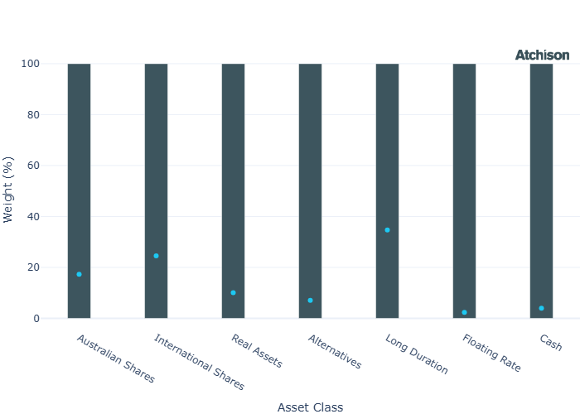
Asset Class Performance
Period | 1 Year
Australian Shares | 6.3
International Shares | 9.46
Real Assets | 8.3
Alternatives | 28.95
Long Duration | 2.58
Floating Rate | 5.92
Cash | 3.92
Inception Date: 22 August 2023
Portfolio Construction
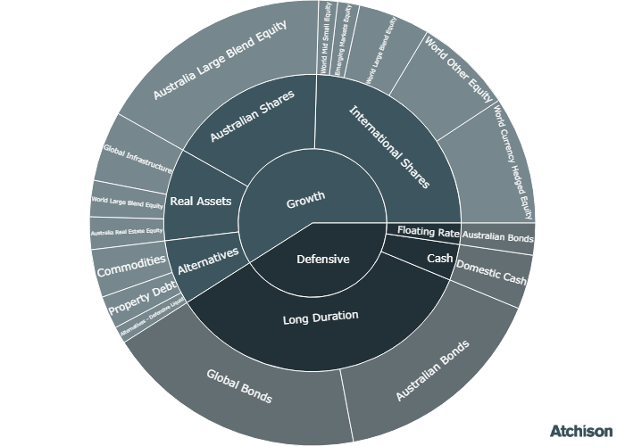
Correlations
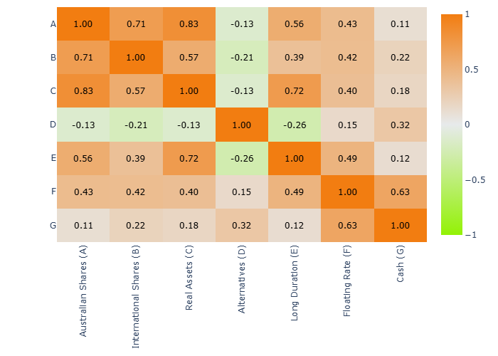
Historical Allocation Changes
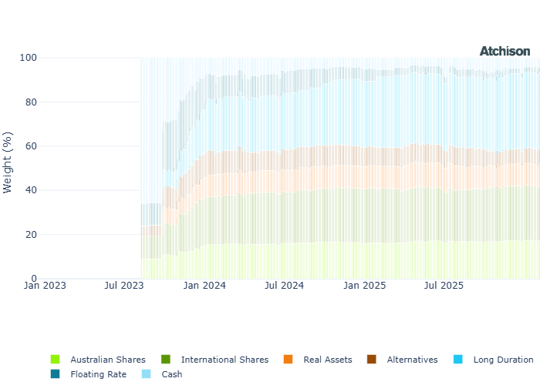
Underlying Current Manager Performance
Strategy | 1 Year | 3 Years (p.a.)
iShares ASX 200 | 7.41 | 9.71
Merlon Concentrated AusEq | 6.99 | 9.56
BM: Australian Shares | 7.37 | 9.72
VG MSCI World | 5.98 | 20.29
VG MSCI World Hedged | 16.04 | 19.0
iShares Japan | 15.92 | 17.15
Capital Group New H | 12.3 | 16.27
Fidelity EM | 20.52 | 9.39
CapGroup New Persp | 5.62 | 18.59
VG Int Smalls | 8.88 | 14.4
VE Global Quality Eq | 2.37 | 21.72
VG Global Value Eq | 11.43 | 16.48
BM: International Shares | 9.67 | 19.24
VG AREIT | 0.93 | 10.04
VanEck Glb Infra H | 13.49 | 8.13
RARE Infra Income | 16.23 | 9.93
Euree AREIT | 2.22 | 9.7
BM: Real Assets | 5.4 | 5.42
ETFS Physical Gold | 64.65 | 39.04
Janus Gbl Multi Strat | 8.5 | 4.55
Qualitas Prop Inc | 3.73 | 10.13
BM: Alternatives | 3.96 | 4.21
iShares Aus Bond | 3.1 | 2.76
VG Global Agg | 4.46 | 2.9
iShares Global Bond | 3.29 | 2.59
iShares Aus Bond | 1.67 | 2.06
BM: Duration | 3.56 | 2.96
Janus Tactical Inc | 5.85 | 5.73
BM: Floating | 5.14 | 5.15
iShares Cash | 3.96 | 4.19
Inception Date: 22 August 2023
Underlying investment manager returns are shown after fees and before tax

Market Update
Australian equities began the year on a strong footing, with the S&P/ASX 200 rising 2% in January. Sector returns were mixed, with Energy and Materials the standout performers, rising 11% and 9% respectively, supported by stronger oil and copper prices.
In contrast, Information Technology extended its weakness into 2026, falling 9%.
Most factor indices recorded gains, led by Momentum and Value, each up 3%, while Low Volatility edged down 1%.
The CSI300 finished marginally in the red for the month down -0.2%, as strength in policy-supported technology and industrial names was offset by ongoing weakness in property-related sectors and subdued consumer sentiment.
The S&P 500 recovered to reach record highs, ending January up 1%.
Market gains broadened beyond mega-caps, with mid- and small-cap indices advancing 4% and 6%, signalling a wider participation in the rally.
Sector leadership rotated toward cyclicals, with Energy and Materials rising 14% and 9%, while factor performance favoured dividend and value strategies over momentum.
In Europe, Information Technology led gains in January, rising 11% driven by strong semiconductor stocks such as Besi and ASM International. Utilities climbed nearly 8%, while Consumer Discretionary lagged, falling 8%.
In January 2026, the Reserve Bank of Australia lifted the official cash rate by 25 basis points to 3.85 per cent in response to persistent inflationary pressures, marking the first rate increase in over two years.
US inflation remained elevated, leading markets to price a more hawkish Federal Reserve outlook, supporting the US dollar and weighing on rate-sensitive assets.
Gold and silver continued their rally as investors sought exposure to hard assets. Silver performed strongly but saw a sharp one-day pullback late in the month (which has continued into February) as higher rate expectations weighed on precious metals.

Fine Print
Important Notice: This document is published by TAG Asset Consulting Group Pty Ltd, trading as Atchison Consultants, ABN 58 097 703 047, AFSL 230 846. Atchison Consultants distributes its investment solutions via platform and dealer groups (financial advisory groups).

Warning: Please be advised that past performance is not indicative of future performance. The returns discussed herein are based on model asset allocations and are for illustrative purposes only. Actual returns may differ due to variations in fees, timing of model change implementation, and the need to substitute individual holdings where reliable data was not available from our data providers. Any insights or recommendations provided in this document are intended for general advice purposes only and are based on our opinion of the investment merits of the financial products discussed, independent of the financial circumstances of any individual. Before proceeding with any investment based on the information provided, recipients must assess its suitability to their financial situation and consider seeking advice from an independent financial advisor.

Disclaimer: While care is taken to ensure the accuracy and completeness of the information presented herein, no warranties or representations are made as to its reliability. The content provided is derived from publicly available sources, or external data providers, which have not been independently verified by Atchison Consultants. Atchison Consultants, along with its directors, officers, employees, and agents, expressly disclaims any liability for errors, inaccuracies, or omissions in this document, as well as for any loss or damage that may arise from reliance on its contents. Readers are cautioned to verify all information independently before taking any actions based on this report.

