

January 2024

APL Inclusion – Australian Equities

Invesco Wholesale Australian Share Fund – Class A
APIR: CNA0811AU

Summary
The Invesco Wholesale Australian Share Fund – Class A is a systematic equity fund with a target tracking error between 1-3%. Offering active exposure to Australian equities at a competitive cost, the fund has demonstrated consistent performance since inception. Its inclusion on the APL is being considered as it provides an opportunity for Atchison to diversify away from the dominance of passive strategies in large-cap exposure while maintaining a focus on cost efficiency.

APL Fit
The Invesco Wholesale Australian Share Fund provides an attractive addition to the APL as a cost-effective, systematic equity strategy designed to capture factor premia and deliver consistent long-term returns. The fund’s quantitative approach diversifies large-cap Australian equity exposure by offering an active alternative to traditional passive strategies, while maintaining a competitive fee structure.
Its systematic methodology, backed by a highly experienced investment team and extensive global resources, ensures disciplined implementation and minimises reliance on subjective decision-making. This approach aligns well with Atchison’s objective of balancing performance potential with cost efficiency, making it a valuable complement to existing large-cap equity offerings within the APL.
Fund Overview
- Manager: Invesco Australian Equities Team
- Fund Inception Date: 30 April 1991
- Firmwide Assets Under Management: $2.3tr (as at 31/12/2024)
  - Wholesale Australian Share Fund: $351mn
- Investment Strategy: The Manager applies a systematic approach aimed at harvesting factor premia to deliver long term excess returns.
- Benchmark: S&P ASX 300 Accumulatipon Index.

BUSINESS
Invesco Ltd. Is a large multinational investment management company headquartered in Atlanta, Georgia, with offices in over 20 countries. Invesco is listed on the New York Stock Exchange and is a constituent of the S&P 500 (NYSE: IVZ) with a market cap of US$8bn. The business is well established with a track record across investment markets and geographies.
This Fund is part of the Invesco Quantitative Strategies (IQS) which is the quantitative sleeve of Invesco that manages $47b globally. The local IQS team actively manage $9.6b across multiple strategies. The Australian strategies include the Wholesale Australian Share Fund as well as a Smaller Companies strategy.

Team
The team is highly experienced, with strong prior co-tenure and deep technical expertise in quantitative strategies. It consists of Neil Lahy, Ritchard Longmire, Andre Roberts, and Richard Tsai, all of whom joined the firm in 2018 after managing Australian quantitative equity portfolios together at BlackRock for a decade until 2016. The team is further strengthened by Nicole Schnuderl, who has been with Invesco since 2005 and has managed the Australian equity strategy in Melbourne for over ten years.

This core group is supported by a larger global team, providing extensive resources and a proven long-term track record. While Atchison places less emphasis on the team due to the strategy’s quantitative nature, the individuals are regarded as highly capable, with the requisite expertise to effectively implement and refine the underlying model.

Process
The team utilises a quantitative model that is driven by three major factors – ‘Price and Earnings Momentum’, ‘Quality’ and ‘Value’. The Manager's approach centres on identifying proprietary factors and taking a longer-term view, aiming to capture a combination of factors with superior explanatory power across the economic cycle. The model primarily operates systematically, with limited room for overrides, which are carefully utilised in response to short-term events such as corporate actions to maintain alignment with longer-term signals. The process is logical, repeatable, and market-aware with a clear Factor Model Map. Research outcomes are robust, and they are continuously introducing effective signals. Atchison view positively the high barrier to entry for research projects required to enter the model.

Fees and operational considerations
- Management Fee: 0.22% p.a. (includes rebate – product price is 44 bps)
- Performance Fee: Nil.
- Liquidity: Daily applications and redemptions.
- Capacity: The Fund invests across the ASX 300 in a systematic and benchmark aware manner. Given the nature of the strategy, capacity is not considered to be a concern.
- Minimum Investment: $20,000
- Responsible Entity: Invesco Australia Limited (Related party RE)

Performance – 30/11/2024
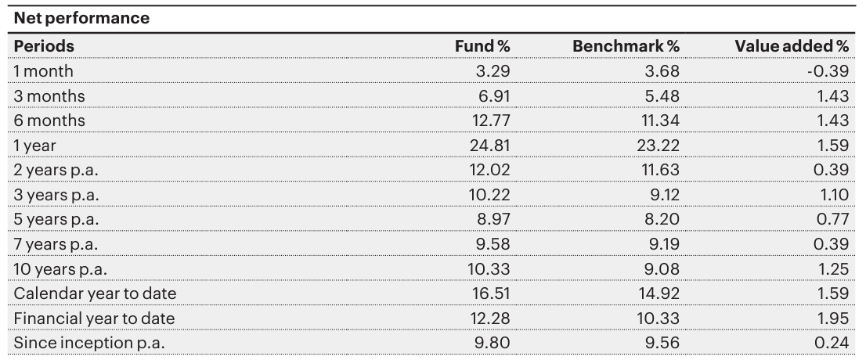
The Fund has consistently produced alpha net of fees across all time periods. Atchison have a high degree of confidence in the model’s ability to produce index plus returns through the market cycle. The Fund provides an attractive alternative to relying on passive ETF exposure to the market and allows for a cost-effective active market exposure.

