

January 2025

APL Inclusion – Alternative Investments

Munro Global Growth Fund
APIR: MUA0002AU

Summary
The Munro Global Growth Fund (the "Fund") is an actively managed, benchmark-unaware, long, short global equities strategy designed to deliver long-term capital appreciation by identifying and investing in structural growth trends. The Fund is expected to maintain a net exposure between 50-100% with a gross exposure of 50-150% (200% limit). Atchison believe classifying this as a growth alternative will enhance the exiting APL and provide a more compelling risk/return offering for inclusion into client portfolios.

APL Fit
The Munro Global Growth Fund offers a compelling addition to the alternatives sleeve of the APL, providing diversified exposure through its absolute return, long-short strategy. By combining long positions in quality/growth opportunities with short positions targeting overvalued or declining companies, the fund generates returns less correlated to traditional equity benchmarks. The Fund has an expected beta of 0.7. This complements the existing alternative APL offerings by enhancing “growth” potential and reducing overall portfolio volatility.

The Fund’s absolute return target, strong downside protection, and low correlation with traditional equity managers make it well-suited for classification as an alternatives product. Its active use of leverage and ability to generate returns in both rising and falling markets position it as a versatile tool for navigating diverse market environments.

Inclusion within the alternatives sleeve enhances the APL’s risk-return profile, particularly for clients seeking diversified and differentiated sources of alpha. Additionally, Munro’s proven track record of delivering attractive risk-adjusted returns in global equities, underpinned by rigorous risk management processes, ensures a strong complementary fit within a broader portfolio context.

Fund Overview
- Manager: Munro partners
- Fund Inception Date: 1 August 2016
- Firmwide Assets Under Management: $ (as at 31/12/2024)
  - Global Growth Fund: $
- Investment Strategy: The investment process is benchmark unaware, focussing on identifying and investing in companies that have the potential to grow at a faster rate and more sustainable basis than the overall market.
- Benchmark: Absolute return target. The Funds performance fee is charged in relation to a hurdle rate which is the high of 6% or the Australian Government 10-year bond yield +3.5%.
Business
Established in 2016, Munro Partners is an independent, global investment manager headquartered in Melbourne, Australia. The firm specialises in identifying and investing in innovative, high-growth companies that benefit from structural changes shaping the global economy. The firm is employee-owned, fostering alignment with clients, and manages funds across a range of strategies tailored to meet diverse investor objectives. Known for its disciplined risk management and consistent track record, Munro Partners has established itself as a trusted name in global growth investing.

Team
The team is led by Nick Griffin, Chief Investment Officer and founding partner of Munro Partners, who brings over 25 years of expertise in global growth equities and is highly regarded by Atchison. Griffin is supported by a dedicated team of four portfolio managers and a group of skilled analysts. Atchison values the team’s highly collaborative approach, which fosters robust idea generation and ensures the disciplined execution of their investment strategy. This approach is further strengthened by a strong commitment to risk management, underpinning the team’s ability to deliver consistent outcomes.
Process
The Munro Global Growth Fund employs a highly focused and disciplined investment process designed to identify and capitalise on structural growth opportunities globally. This process is anchored in Munro’s philosophy of investing in companies that demonstrate the potential for sustained, above-market growth over the medium to long term. Idea generation combines top-down thematic analysis with bottom-up research to identify long-term structural growth trends and the companies poised to benefit. These trends are rigorously analysed to distinguish underappreciated opportunities from well-understood market narratives. Once potential investments are identified, they must pass six qualitative tests focusing on growth potential, economic leverage, earnings durability, ESG considerations, management alignment, and customer adoption. This ensures a concentrated universe of structurally advantaged equities.
The selected ideas are then subjected to three quantitative tests to assess valuation, earnings potential, and catalysts for future performance. Companies are modelled under various scenarios to evaluate their upside potential and downside risk, with long positions requiring the ability to double in value over three to five years and short positions exhibiting potential declines of 10-20% within six months. The final portfolio is constructed from these high-conviction ideas, resulting in a region- and sector-unconstrained collection of 30 to 50 investments. Munro’s meticulous approach to stock selection, combined with its focus on risk management and capital preservation, underpins its ability to deliver consistent, risk-adjusted returns.

Fees and operational considerations
- Management Fee: 0.77% p.a. (includes a rebate, original fee is 1.35%)
- Performance Fee: 10%
- Liquidity: Daily applications and redemptions.
- Capacity: The Fund invests across global equities and is expected to remain at the larger end of the market. As such, capacity is not considered to be a concern.
- Minimum Investment: $10,000
- Responsible Entity: GSFM

Performance
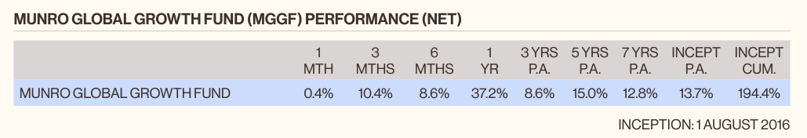
The Fund has consistently demonstrated its ability to deliver attractive absolute returns on a risk-adjusted basis. Atchison holds a high level of confidence in the manager’s capability to meet the Fund’s investment objectives and achieve sustained long-term growth. Notably, the manager employs a disciplined and methodical approach when implementing short positions, with robust stop-loss mechanisms in place to mitigate downside risks.
Atchison views the use of short positions as a valuable tool for alpha generation and is pleased with how effectively they have been managed to date. This disciplined execution, combined with the manager's strong track record, reinforces confidence in their ability to navigate diverse market conditions and deliver superior outcomes for investors.

