

January 2025

APL Inclusion – Global Equities

Vanguard All-World ex-US Shares Index ETF
ASX: VEU

Summary
The Vanguard All-World ex-U.S. Shares Index ETF (ASX: VEU) is a cost-effective passive solution that provides broad exposure to global equities outside the United States. Covering both developed and emerging markets, the ETF tracks the FTSE All-World ex US Index, offering diversification across regions, industries, and market capitalisations. Its low-cost structure and comprehensive market coverage make it an attractive choice for inclusion in the Global Equities APL, particularly as a core holding for international diversification.

APL Fit
The Vanguard FTSE All-World ex-US ETF (VEU) is a globally diversified equity fund that provides exposure to developed and emerging markets outside of the United States. It tracks the FTSE All-World ex-US Index, which includes large-, mid-, and small-cap stocks from over 40 countries, making it a highly efficient way for investors to gain broad international diversification.
With its low-cost structure and broad market coverage, VEU aligns well with the Atchison APL's goal of offering cost-effective exposure to global equities. The Fund's significant diversification across regions, sectors, and individual stocks complements existing strategies, while its exclusion of U.S. equities allows for a targeted approach to global market exposure. VEU offers an attractive solution to enhance global diversification without the complexity of managing multiple regional funds.
Atchison believes that VEU provides an effective solution to address the APL's current structural underweight to Japan, offering passive exposure to one of the world’s largest equity markets. Additionally, the fund allows for cost-effective European market exposure, providing a more economical alternative to the existing VEQ. Given the current market dynamics in Europe, Atchison prefers a more cautious approach to the region, and the diluted European exposure in VEU aligns well with this strategy, providing a more balanced approach that suits their market outlook.
Fund Overview
- Manager: Vanguard
- Fund Inception Date: 12 May 2009
- Firmwide Assets Under Management: $9.3tr
  - Vanguard All-World ex-US Shares Index ETFInvestment Strategy: $3.45bn
- Investment Strategy: The ETF replicates the performance of its benchmark by investing in over 3,000 stocks across developed and emerging markets, excluding the U.S. The fund is passively managed, ensuring low tracking error and operational efficiency.
- Benchmark: FTSE All-World ex US Index

BUSINESS
Vanguard Group is a leading global investment management company headquartered in Malvern, Pennsylvania, with offices around the world. Vanguard is known for its pioneering work in index investing and is one of the largest asset managers globally, overseeing trillions of dollars in assets. The company is privately held and focuses on providing low-cost, diversified investment options to individual and institutional investors. Vanguard has a long-standing reputation for offering investment strategies that emphasise cost-efficiency, long-term growth, and broad market exposure.

Vanguard's expertise extends across a range of investment products, including equity, fixed income, and balanced funds. The company has a strong presence in both the U.S. and international markets, and its funds are widely used by investors seeking passive investment strategies. Vanguard's investment management approach is centred on a disciplined, long-term perspective, using a combination of low-cost index funds and actively managed funds designed to meet specific client goals.

Team
The Fund is managed by the Vanguard Equity Investment Group. This team is led by a group of portfolio managers and supported by a large team of analysts and traders. Vanguard’s investment approach is known for being low-cost and passive, with a focus on maintaining broad market exposure across various sectors and regions. Vanguard typically does not highlight specific individuals leading each of its funds, as their investment strategy is built around a collaborative, team-based approach. Atchison consider the Vanguard equity team to one of the most resourced in the passive index space.

Passive index features
- Index Selection and tracking: Aims to track the performance of the FTSE All-World ex-US Index.
- Replication: Vanguard uses a full replication method.
- Weighting: The index is weighted by market capitalisation.
- Rebalancing frequency: Quarterly
- Distribution frequency: Quarterly
Fees and operational considerations
- Management Fee: 0.07% p.a.
- Performance Fee: Nil.
- Liquidity: Exchange Traded Fund
- Responsible Entity: Vanguard (related party)
Performance – 30/11/2024
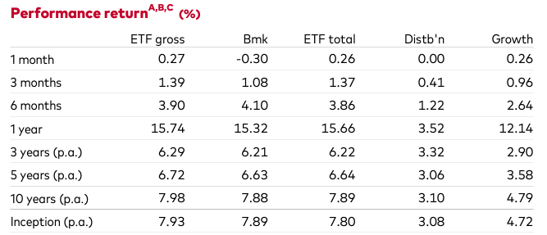
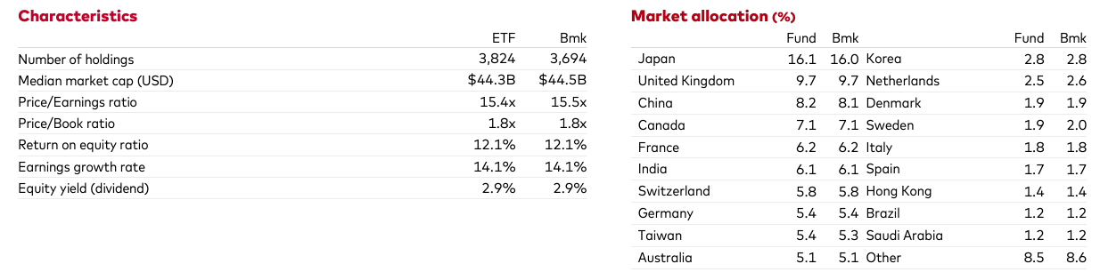
The Fund is an Exchange-Traded Fund (ETF) designed to closely track its benchmark index. As such, performance assessment is primarily cantered around tracking error, which measures how closely the fund’s returns align with those of the benchmark. In this case, the Fund has demonstrated strong performance, with returns that are in line with the benchmark, exhibiting minimal tracking error. This indicates that the Fund is efficiently replicating the performance of the index while maintaining low deviation from the expected returns.

