

January 2025

APL Removal – Australian Equities

Australian Eagle Trust (Long-Short Fund)
APIR: ALR2783AU

Summary
The Australian Eagle Trust (Long-Short Fund) (the “Fund”) is managed by Australian Eagle and was incepted in July 2016. Australian Eagle is a large cap Australian equities manager with a focus on quality. It employs a long-short, low turnover, portfolio with 25-35 longs and 12-25 shorts. The Fund is structured as an open-ended unlisted registered managed investment scheme.

Reason for APL Removal
A key concern lies in the limited universe of 130 stocks from which to construct a meaningful and alpha-generative short book, making the 50% short allocation particularly challenging. Ideally, a long/short strategy should deliver returns across market cycles, regardless of market direction. However, recent performance has highlighted weaknesses in the strategy, notably the Manager’s constrained stock selection and difficulty in exiting poorly performing short positions promptly. This lack of agility has amplified losses during periods of market volatility, raising significant doubts about the strategy’s adaptability and resilience in dynamic market environments.

Additionally, from a fee perspective the fund stands out as expensive on an Australian Long/Short peer comparison despite Atchison already receiving a rebate.

Fund Overview
- Manager: Australian Eagle
- Fund Inception Date: July 2016
- Firmwide Assets Under Management: $1.1bn (as at 30/11/2024)
  - Auscap Long Short Australian Equities Fund $450mn
- Investment Strategy: The manager seeks to buy quality companies with long term competitive advantages and a sensible risk buffer. The manager aims to hold those investments until their competitive advantages are materialised and reflected in returns.
- Benchmark: S&P/ASX 100 Accumulation Index

BUSINESS
Australian Eagle was established in Sydney in 2004 and specialises in Australian equities. The firm is owned and operated by the team and manages in excess of $1.1bn through a domestic long only strategy and the Australian Eagle Long Short Fund. In 2022 Australian Eagle partnered with Montgomery and took on the FUM from their Large cap long only strategy. Montgomery provides distribution and back-office support in exchange. A potential concern is the distribution focus of Montgomery, given their existing FUM has shifted into the Australian Eagle Long Only strategy. Their focus may be on distributing that fund over the long-short. However, the Australian Eagle Long Short Fund is the only Long Short manager in Montgomery’s suite and thus tempers concern to a degree. The distribution focus will be a watchpoint going forward.

Team
The team is led by CIO, Sean Sequeira, who has been at Australian Eagle since 2004. Sequeria is assessed as being experienced and a highly capable leader of the investment team. Alan Kwan is the named portfolio manager on the Fund, however, Sequeria has ultimate decision-making authority, veto rights and is the key figure head. Providing support are two additional analysts as well as an investment committee that includes a risk manager and Albert Hung. Hung was the architect of the strategy when it was being first built out. The manager has indicated that Hung is stepping back his involvement and acting more as a mentor. The team is considered to be adequately resourced given the narrowness of the investment universe and the length of time they have been working together. On a peer relative basis track-record and co-tenure is high.

Process
The Fund focuses on the ASX100 but maintains flexibility to include an additional 30 stocks of interest, creating a research universe of 130 names. It is benchmarked against the S&P/ASX 100 Accumulation Index and follows a philosophy of investing in quality companies with sustainable competitive advantages, aiming to hold them until these advantages translate into returns. Idea generation emphasises quality, valuation, and identifying catalysts for re-rating, with analysts selecting the additional 30 stocks outside the ASX100.
The portfolio consists of 25-35 long and 12-25 short positions, constructed using a structured scoring system combining quality and valuation metrics. Quality scores, re-evaluated semi-annually or with major news, must meet a threshold to be considered investable. This disciplined methodology enhances consistency and repeatability. Position sizing and sell decisions are determined by quality deterioration or overvaluation. Risk management includes flexibility to reduce short exposure during stress periods, though the one-year holding limit on shorts is seen as potentially detrimental to alpha generation. Overall, the structured and rules-based process is a key strength compared to peers.
Fees and operational considerations
- Management Fee: 0.93% p.a. (includes rebate original fee = 1.23% p.a.)
- Performance Fee: 20.50% of excess performance above benchmark with high watermark
- Liquidity: Daily applications and redemptions.
- Capacity: The Fund invests across the ASX 150 and is expected to remain in the large-cap region of the market. Capacity is not a concern at current levels.
- Minimum Investment: $25,000
- Responsible Entity: The Trust Company
Performance – 31/12/24
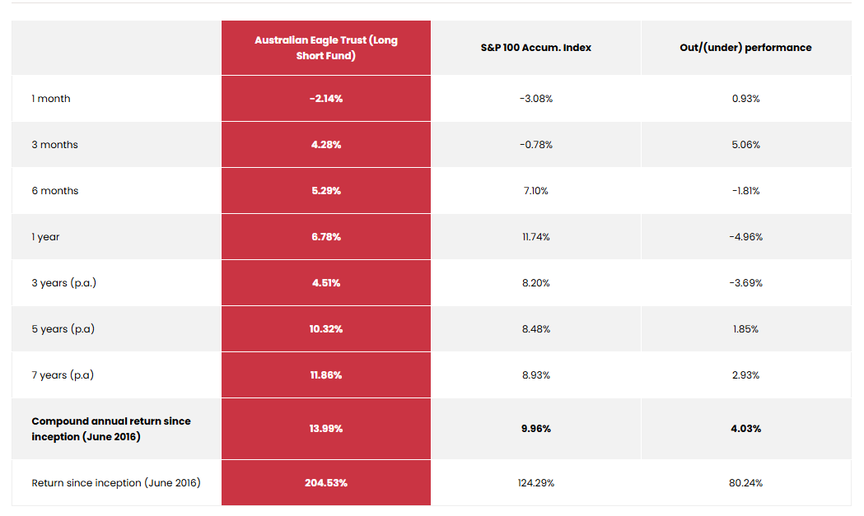
The Fund's performance has faced considerable pressure, underperforming the benchmark by 4.7% over the 12 months to December 2024. This underperformance has been largely driven by the short side, which contributed over 6% in negative attribution. The Manager’s relatively small investment universe has limited their ability to effectively construct a meaningful short book.
In theory, a long/short strategy should generate returns across market cycles, regardless of market direction. However, recent performance has exposed weaknesses in the strategy, particularly the Manager's constrained stock selection universe and the difficulty in swiftly exiting poorly performing short positions. This inability to adapt and rotate out of losing shorts has magnified the strategy's downside during periods of volatility, raising concerns about its resilience in dynamic market environments.

