**Lab_02**

**Roll :- 20K-0444**

**Task_01(a)**

INCLUDE Irvine32.inc

.code

main PROC

mov eax, 30

add eax, 45

add eax, 60

sub eax, 0bh

call DumpRegs

exit

main ENDP

END main

Output :-

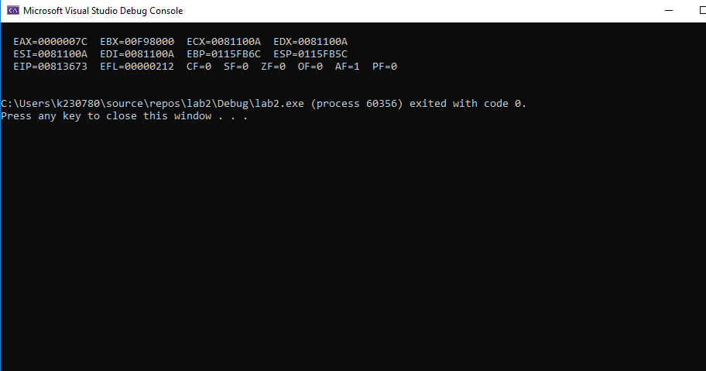

(b)

INCLUDE Irvine32.inc

.code

main PROC

mov eax, 20

sub eax, 10

add eax, 15

sub eax, 5

call DumpRegs

exit

main ENDP

END main

Output :-

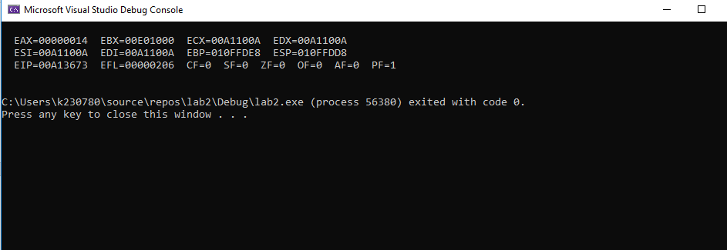

(c)

INCLUDE Irvine32.inc

.code

main PROC

mov eax, 10101b

add eax, 30h

add eax, 200

sub eax, 0Eh

call DumpRegs

exit

main ENDP

END main

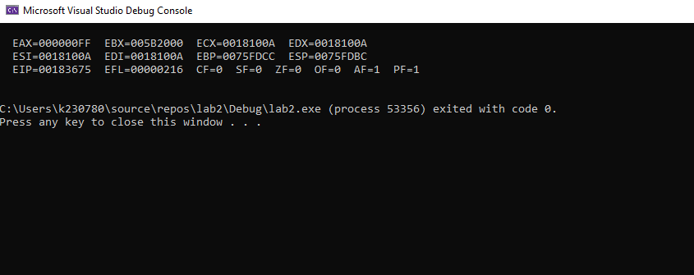

(d)

INCLUDE Irvine32.inc

.code

main PROC

mov eax, 52o

add eax, 1101b

sub eax, 21h

add eax, 10

call DumpRegs

exit

main ENDP

END main

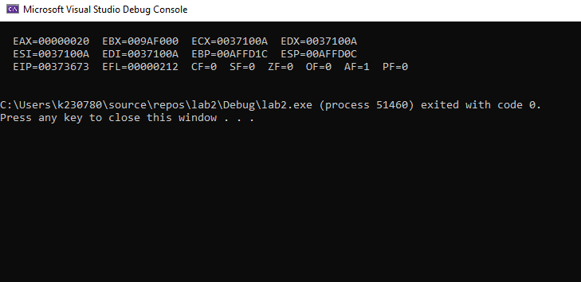

(e)

INCLUDE Irvine32.inc

.code

main PROC

mov eax, 50

sub eax, 31o

add eax, 110

call DumpRegs

exit

main ENDP

END main

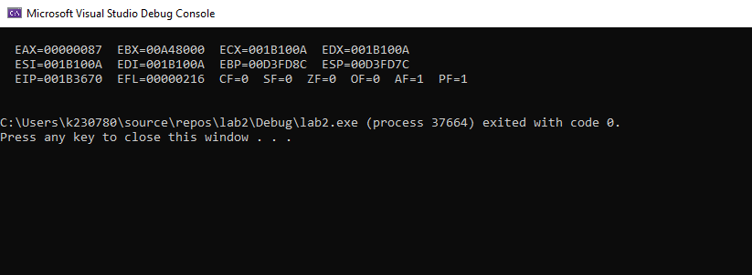

Task_2

(a)

INCLUDE Irvine32.inc

.code

main PROC

mov eax, 1

mov ebx, 2

mov ecx, 5

mov edx, eax

add edx, 4

add edx, ebx

sub edx, ecx

add edx, 0eh

sub edx, 24o

add edx, 63

call DumpRegs

exit

main ENDP

END main

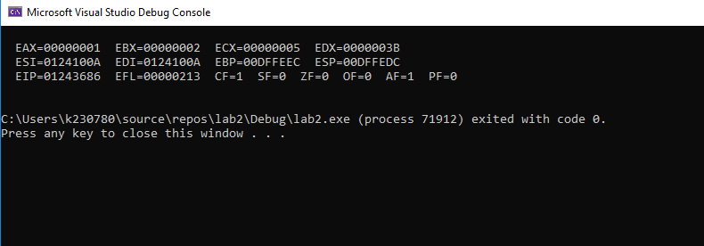

(b)

INCLUDE Irvine32.inc

.data

.code

main PROC

mov eax, 1

mov ebx, 2

mov ecx, 5

mov edx, 0

mov eax, 3bch

sub eax, ebx

add eax, 45o

add eax, 50

sub eax, 100110b

call DumpRegs

exit

main ENDP

END main

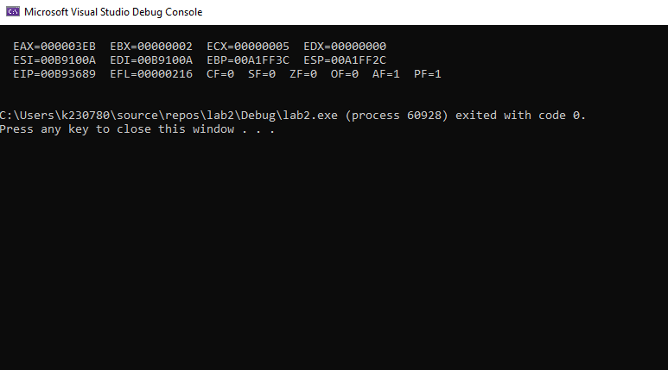

(C)

INCLUDE Irvine32.inc

.data

.code

main PROC

mov eax, 1

mov ebx, 2

mov ecx, 5

mov ebx, 001100b

add ebx, 06BDh

sub ebx, eax

add ebx, 25

add ebx, 41o

call DumpRegs

exit

main ENDP

END main

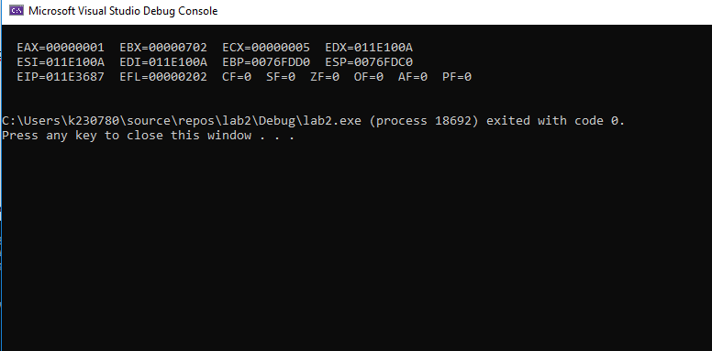

(D)

INCLUDE Irvine32.inc

.data

.code

main PROC

mov eax, 1

mov ebx, 2

mov ecx, 5

mov edx, 0

add ecx, eax

add ecx, ebx

sub ecx, ecx

add ecx, edx

call DumpRegs

exit

main ENDP

END main

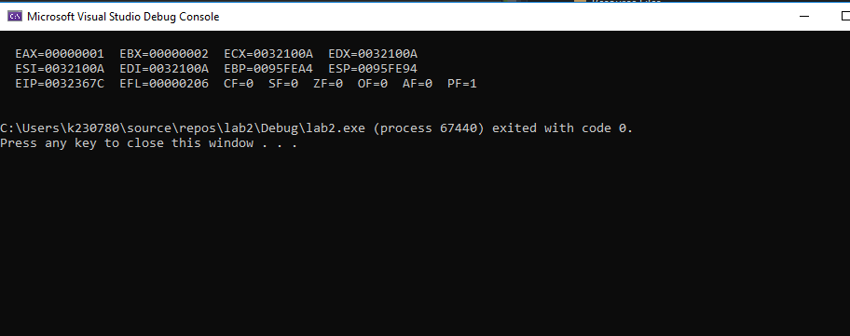

(E)

INCLUDE Irvine32.inc

.data

.code

main PROC

mov eax, 1

mov ebx, 2

mov ecx, 5

mov edx, 0

mov eax, 48h

sub eax, ebx

add eax, edx

sub eax, eax

call DumpRegs

exit

main ENDP

END main

